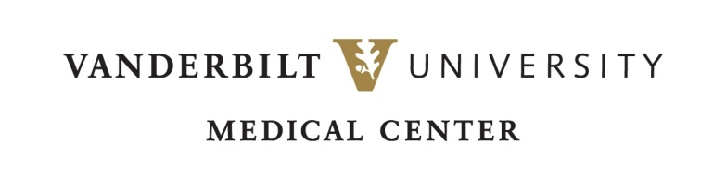

ALTERNATIVE INTERVIEW & REFLECTION FORM | 2021

**PERFUSION PROGRAM**

Due to the COVID-19 restrictions of many hospitals, you may not have been able to complete a Case Observation. While it is still encouraged to observe a case if possible, we are offering an alternative option. To meet the requirements of the Perfusion Program Admission Process, VUMC will accept the following in place of an observation:

* Interview with a licensed and practicing Perfusionist
* Viewing of perfusion videos with accompanying reflection

Please read the directions carefully and complete each section below. This completed form will be uploaded as part of your online application.

*You may print and complete this form *OR* you may complete it electronically. *

Should you have any questions regarding this form or its contents, please email the Program Director, Dawn Oles, at [dawn.m.oles@vumc.org](mailto:dawn.m.oles@vumc.org)

**APPLICANT INFORMATION**

Name of Applicant:

Current Job & Place of Employment ______________________________________________________________

E-mail Address: Phone Number:

**INTERVIEW INFORMATION**

Name & Credentials of Interviewed Perfusionist: _____________________________________________________

Place of Employment ____________________________________________ Start date_______________________

Years of experience ___________________________ Date of Interview ________________________________

*The responses to the below questions may be typed on separate sheets and attached to this document. The committee wants to see detail in your answers. Use as much space as needed.*

1. What did you learn about the daily life of a perfusionist?
2. Describe at least one challenge that the perfusionist must deal with, and then describe how a resolution was achieved.
3. To the applicant – In what ways did this interview alter your perspectives or beliefs about the Perfusion profession?

**VIDEO & REFLECTION INFORMATION**

In place of a live observation, please view the three videos below. Each view is approximately 10-15 minutes. After viewing, respond to the following reflection questions.

* Intro to the Operating Room: Cannulation <https://youtu.be/72SUUCIn3lE>
* Simulation Video of a Perfusionist <https://youtu.be/MaiJbds8DIk>
* Perfusion Communication from AmSECT <https://youtu.be/Fj2nlbmQl1I>

*The responses to the below questions may be typed on separate sheets and attached to this document. The committee wants to see detail in your answers. Use as much space as needed.*

1. Describe your reaction to the video in detail.
2. What observations did you make regarding the Perfusionist’s communication and demeanor?
3. Describe in detail what you learned about the role of a perfusionist in the OR.

**SIGNATURE**

By signing below, I hereby acknowledge that this information is representative of my interview and video viewing experience.

**Signature:** _________________________________________  **Date:** _______________

*For further information about the Perfusion Program at VUMC, please visit our website at* [*www.mc.vanderbilt.edu/perfusion*](http://www.mc.vanderbilt.edu/perfusion)*.*

Vanderbilt University Medical Center | Perfusion Program   
1301 Medical Center Drive, B-802 TVC, Nashville, TN 37232-5510 (615).875.3666