VCLIC News and Happenings

Hello and welcome to the August edition of VCLIC News! This month we have a brief update on Clickbusters, a feature on our new VDAWG, Dr. Chetan Aher, preliminary information on the Clinical Informatics Resident Elective, the story of the development of a life-saving BPA for Pulmonary Hypertension, and reminders of upcoming trainings and conference deadlines.
Please join us in congratulating our members on the variety of publications, speaking engagements, fellowships, and awards they have achieved since our last letter. We will be adding these accomplishments to the News and Publications pages of our website as well.
If you have any questions or would like to engage with our team, please email Elise (elise.russo@vumc.org).

Clickbusters Round 2 Will Wrap Up September 1st, 2020
BPA Clickbusters Round 2 kicked off on June 29th and is wrapping up on September 1st.
We have about 16 folks actively clickbusting (or who have already “busted” their assigned BPAs) for this round. Thank you again to all of our participants!
If you’d like to learn more about the impact of our first round, please see this article in the VUMC Reporter: Clickbusters program takes on EHR alert fatigue

Member Spotlight: Chetan Aher, MD

I am a General Surgeon, Vice Chair for Information Technologies in the Section of Surgical Sciences, Medical Director of General Surgery, and one of the HealthIT clinical directors. Despite a background more rooted in operational leadership than informatics, I became a Physician Builder in late 2018 with the intent of fixing a singular workflow issue in my practice. As anyone in this business knows, though, it never really works that way, and now I focus much of my effort on improved surgeon workflows and efficiency, patient access issues, and improved Revenue Cycle processes. Instituting Bariatric Procedure Pass at Surgical Weight Loss led to efficient documentation (with a yearly reduction of 100,000 clicks in our clinic), increased throughput with existing resources, and improved analytics and preoperative patient tracking. Just over a year ago, I was part of a team that helped launch Online Scheduling for patients new to Vanderbilt. I now have the privilege of working with HealthIT and Operational leadership on development of Online Scheduling 2.0, with the aim of improving the access experience for patients while maintaining operational efficiency in our ambulatory clinics.

I am currently working on additions to the perioperative workflow to facilitate a Retro-Authorization process that Vanderbilt has not previously utilized. This interfacing with insurance companies represents a major step forward in Vanderbilt’s ability to improve collections for services rendered.
These projects collectively demonstrated a gap in data collection and analysis in Surgical Sciences, which led me to become one of the first VDAWGs (Vanderbilt Database Access Working Group). VDAWGs is the program by which faculty members are able to access Epic’s Clarity database (please see here for more information). I thank Adam Wright and Jon Wanderer for putting together these extraordinary programs. The VDAWG and Physician Builder programs put powerful tools in the hands of trained clinicians, who can put years of clinical experience behind improvements in patient safety, clinician efficiency, and data analytics in unique and innovative ways.

Announcing the Clinical Informatics Resident Elective

Drs. Dara Mize and Travis Osterman are pleased to announce the start of the Clinical Informatics Resident Elective, which is a two week experience for physicians new to the field or for those who desire to solidify their knowledge in preparation for more advanced study. For more information, please see our website or email Travis or Dara.

Designing and Implementing a BPA for Pulmonary Hypertension

Rob Turer, MD brought to our attention that, in conjunction with Ian Jones, MD, two members of Health IT, Heather Freeman, and Charlie Valdez, created a life-saving set of BPAs for Pulmonary Hypertension. This is just one (but a significant) example of the thoughtful and impactful work our Health IT teams carry out on a regular basis to improve patient care and health outcomes.
Heather describes the reasoning and process behind the creation of these BPAs:
While there may not be a significant number of patients with pulmonary hypertension on IV prostacyclins, they can be some of the sickest patients seen in the ED. Ensuring IV lines and supplies are readily available, drug is ordered and dosed appropriately, and the consulting team is notified in a timely fashion, help to ensure we are providing pro-active, potentially life-saving care for these patients.
The BPA triggers when an IV or SubQ Prostacyclin is noted on the patient’s home medication list. If the patient has Pulmonary Hypertension in their medical history, a statement is included in the alert stating the diagnosis exists.
The BPA targeted at nursing will fire when the chart is opened with instructions to notify the provider, notify the ED pharmacist, evaluate the central line and establish a peripheral IV, and make sure a backup cassette is available.
The BPA targeted at providers includes additional information to assist in their decision making. We display the prostacyclin medication from the patient’s med list and some additional instructions to notify the Pulmonary Hypertension team and/or the MICU fellow based on the patient’s condition. We also included suggested inpatient units to admit patient should admission be indicated.
Nurse version:
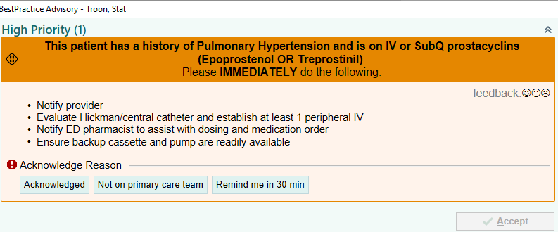
Provider Version:
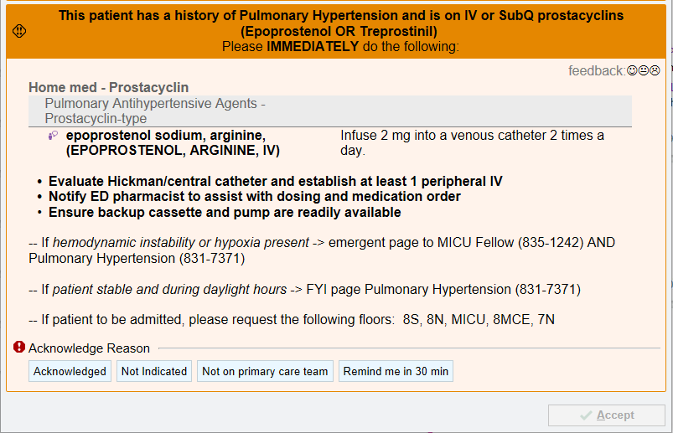
Thank you to Heather and Charlie for all your work on these essential BPAs and to Ian and Rob for helping inform the clinical process involved!
Heather Freeman | Charlie Valdez
Rob Turer | Ian Jones

Upcoming Conferences and Conference Deadlines

- CHI 2021: Abstract Submission Deadline is September 10th, 2020
- IHI Forum 2020: Abstract submissions are due September 10th, 2020
- ACC 2021: Abstract submissions are due October 20th, 2020
- AMIA Annual Symposium 2020: Virtual conference will take place from November 14th-18th, 2020
More information on upcoming conferences and conference deadlines can be found on our Confluence page, here.

Reminder about Epic Virtual Training

Epic has a variety of training and certification programs (Epic Training Resources) that may be of interest to VCLIC members, some of which we list on our Confluence site. Epic has always required travel to Verona, WI to complete trainings. Although Verona is lovely (especially in warmer months!) this travel requirement has sometimes been a barrier to completing training. Since COVID-19, Epic has temporarily started offering trainings remotely, through October 23, 2020.
This virtual option may be your chance to complete certifications like Physician Builder, Clinical Content Builder, Physician Builder Analytics, Chronicles Programmer, Research Informatics, or Cogito Clarity Clinical Data Model without needing to travel. In person training continues to be offered, so if you’d rather learn in person, you can still travel to Verona and take a course on Epic’s campus, with enhanced cleaning and safety protocols.

Publications, Presentations, Interviews, and Awards

Accomplishments
We have had a lot to celebrate over the past month, and this is only a small sampling of the fantastic work our Center members have been up to! Please continue to send me these accomplishments as you think of them!
Patty Sengstack, DNP, RN-BC, FAAN is giving a keynote presentation for the annual (virtual) American Nursing Informatics Association conference on 8/21/20. What’s an Informatics Nurse Worth? Using Data to Elevate Your Career
Patty was also appointed to serve on the American Nursing Association’s ANCC (American Nursing Credentialing Center) Informatics Nursing Continuous Item Writer Panel for the nursing informatics board certification exam.

Congratulations to the VUMC IAHSI Fellows!

VUMC and DBMI have three faculty members who will be inducted as Fellows into IAHSI (International Academy of Health Sciences Informatics) next month:
Congratulations to Martin Were (VCLIC Member), Steven Brown, and Brad Malin on this fantastic accomplishment!
Martin Were, MD, MS | Steven Brown, MD, MS, FACMI | Brad Malin, PhD, FACMI

In The News
As seen in the VUMC Reporter:
- Post-surgical bleeding associated with more deaths when compared to blood clots after surgery (Robert Freundlich, MD)
- New data offer insights on COVID treatments for people with cancer (Jeremy Warner, MD, MS)
- Study finds patients defer routine health care during pandemic (Adam Wright, PhD)

Recently Published

August 2020
Jelly CA, Ende H, Freundlich RE. Terminology, communication, and information systems in nonoperating room anaesthesia in the COVID-19 era. Current Opinion in Anesthesiology. 2020; 33(4): 548-53.

Turer RW, Arribas M, Balgord SM, Brooks S, Hopson LR, Bassin BS, Medlin R. Clinical Informatics Training During Emergency Medicine Residency: The University of Michigan Experience. AEM Education and Training. 2020;(Accepted Author Manuscript).
Wanderer JP, Nathan N. New Tools in the Tool Belt: Basic Science Research Updates for Anesthesia. Anesthesia & Analgesia. 2020;131(2):449.

Wanderer JP, Rathmell JP. Seeing the Forest for the Trees: Reconsidering Perioperative Gabapentinoids. Anesthesiology. 2020;133(2):A17.

Ward MJ, Vogus TJ, Bonnet K, Moser K, Schlundt D, Kripalani S. Breaking down walls: a qualitative evaluation of perceived emergency department delays for patients transferred with ST-elevation myocardial infarction. BMC Emergency Medicine. 2020;20(60).

Zhao J, Forsythe R, Langerman A, Melton GB, Schneider DF, Jackson GP. The Value of the Surgeon Informatician. Journal of Surgical Research. 2020;252:264-72.

July 2020
A.B. Yiadom MY, Domenico HJ, Byrne DW, Hasselblad M, Kripalani S, Choma N, Tucker-Marlow S, Gatto CL, Wang L, Bhatia MC, Morrison J, Harrell FE, Hartert TV, Lindsell CJ, Bernard GR. Impact of a Follow-up Telephone Call Program on 30-Day Readmissions (FUTR-30): A Pragmatic Randomized Controlled Real-world Effectiveness Trial. Medical Care. 2020;(Published Ahead of Print).

Baker LX, Byrne M, Martin P, Lee S, Chen H, Jagasia M, Tkaczyk E. Association of skin response in erythema and sclerosis with survival in chronic graft-versus-host disease. Journal of Investigative Dermatology. 2020;140(7):S57.

Baker LX, Chen F, Ssempijja Y, Dellalana L, Vain A, Jagasia M, Tkaczyk E. Direct mechanical measurements of skin to quantify evolution of sclerotic disease. Journal of Investigative Dermatology. 2020;140(7):S113.

Baker LX, Grilletta E, Zwerner JP, Boyd AS, Wheless L. Clinical and histopathologic characteristics of metastatic and locally aggressive basal cell carcinomas. Journal of Investigative Dermatology. 2020;140(7):S114.

Bellomy ML, Engoren MC, Martin BJ, Shi Y, Shotwell MS, Hughes CG, Freundlich RE. The Attributable Mortality of Postoperative Bleeding Exceeds the Attributable Mortality of Postoperative Venous Thromboembolism. Anesthesia & Analgesia 2020;(Published Ahead of Print).

Buell KG, Casey JD, Wang L, Wanderer JP, Self WH, Rice TW, Semler MW. Big Data for Clinical Trials: Automated Collection of SpO2 for a Trial of Oxygen Targets during Mechanical Ventilation. Journal of Medical Systems. 2020;44(153):1-4.

Franklin AD, Sobey JH, Brenn BR, Johnson SR, Schoenecker JG, Gartley AC, Shotwell MS, Gay JC, Wanderer JP. Financial and Clinical Ramifications of Introducing a Novel Pediatric Enhanced Recovery After Surgery Pathway for Pediatric Complex Hip Reconstructive Surgery. Anesthesia and Analgesia. 2020.

Freundlich RE, Li G, Wanderer JP, Billings FT, Domenico H, Byrne D, Pandharipande P. 4494 Predictors of Reintubation After Cardiac Surgery. Journal of Clinical and Translational Science. 2020;4(s1):50.

Howard LM, Edwards KM, Zhu Y, Williams DJ, Self WH, Jain S, Ampofo K, Pavia AT, Arnold SR, McCullers JA, Anderson EJ, Wunderink RG, Grijalva CG. Parainfluenza Virus Types 1-3 Infections Among Children and Adults Hospitalized with Community-Acquired Pneumonia. Clinical Infectious Diseases. 2020; (Accepted Manuscript).

Mapes BM, Foster CS, Kusnoor SV, Epelbaum MI, AuYoung M, Jenkins G, Lopez-Class M, Richardson-Heron D, Elmi A, Surkan K, Cronin RM, Wilkins CH, Pérez-Stable EJ, Dishman E, Denny JC, Rutter JL. Diversity and inclusion for the All of Us research program: A scoping review. Plos One. 2020;15(7):e0234962.

Parks K, Khera Z, Liu X, Reasat T, Baker LX, Jagasia M, Dawant B, Tkaczyk E. Redness has higher interrater reproducibility than body surface area in measuring extent of photographed cutaneous graft-versus-host disease. Journal of Investigative Dermatology. 2020;140(7):S110

Patrinely JR, Saknite I, Zhao Z, Byrne M, Jagasia M, Tkaczyk E. Increased leukocyte pausing in the upper dermal microvasculature of cutaneous acute graft-versus-host disease patients by noninvasive reflectance confocal video microscopy. Journal of Investigative Dermatology. 2020;140(7):S110

Rao S, Pitel B, Wagner AH, Boca SM, McCoy M, King I, Gupta S, Park BH, Warner JL, Chen J, Rogan PK, Chakravarty D, Griffith M, Griffith OL, Madhavan S. Collaborative, Multidisciplinary Evaluation of Cancer Variants Through Virtual Molecular Tumor Boards Informs Local Clinical Practices. JCO Clinical Cancer Informatics. 2020(4):602-13.

Sittig DF, Ash JS, Wright A, Chase D, Gebhardt E, Russo EM, Tercek C, Mohan V, Singh H. How can we partner with electronic health record vendors on the complex journey to safer health care? Journal of Healthcare Risk Management. 2020; (Published ahead of Print).

Vashistha V, Poonnen PJ, Snowdon JL, Skinner HG, McCaffrey V, Spector NL, Hintze B, Duffy JE, Weeraratne D, Jackson GP, Kelley MJ, Patel VL. Medical oncologists’ perspectives of the Veterans Affairs National Precision Oncology Program. Plos One. 2020;15(7):e0235861.

Willis VC, Arriaga Y, Weeraratne D, Reyes F, Jackson GP. A narrative review of emerging therapeutics for COVID-19. Mayo Clinic Proceedings: Innovations, Quality & Outcomes. 2020.

Wright A, Salazar A, Mirica M, Volk LA, Schiff GD. The Invisible Epidemic: Neglected Chronic Disease Management During COVID-19. Journal of General Internal Medicine. 2020.

Zhao Z, Patrinely JR, Saknite I, Byrne M, Jagasia M, Tkaczyk E. A guideline improves interrater reliability of assessing leukocyte motion in vivo in human skin. Journal of Investigative Dermatology. 2020;140(7):S109.

Reminder to Send Updates for Recognition

If you (or another VCLIC Member) publishes a paper; has an abstract accepted at a conference; are interviewed for or written up in a news article; receive any awards, accolades, or honors; or completed/are currently undertaking any projects you would like to highlight, please email me with or forward this information:
- Names of VCLIC members/VUMC staff who participated in or worked on the project, paper, or abstract (or who received the award/honor)
- The title of the Project, Paper, Abstract, Article, or Award
- The journal, conference, or news publication (this can be podcasts, radio, or more “traditional,” news mediums)
Nothing is too big or too small to celebrate, and this information will be featured on the News section of our website as well. As time goes on, I am hoping to also improve our Twitter presence, so feel free to add, tag, or tweet us at @VUMC_VCLIC too!
Thank you, and see you next month!

