### DEPARTMENT OF ORTHOPAEDICS

**INITIAL PATIENT ASSESSMENT/TREATMENT**

|  |  |  |
| --- | --- | --- |
| **R. Warne Fitch, MD**  Orthopaedics & Rehabilitation | **Non-Surgical Shoulders and Knees** | **Fellowship:** Vanderbilt University Medical Center  **Post Graduate Training**: Vanderbilt University Medical Center  **MD Degree:** Wake Forest University, Winston-Salem, NC |

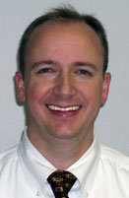

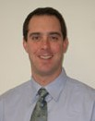

|  |  |  |
| --- | --- | --- |
| **Paul J. Rummo, D.O.**  Orthopaedics & Rehabilitation | General Orthopaedics, Non-Surgical | **Fellowship:** Primary Care Sports Medicine, Vanderbilt University  **Orthopaedic Training**: Memorial Health Care, Worcester, MA  **D.O. Degree:** Univ. of New England College of Osteopathic Medicine |

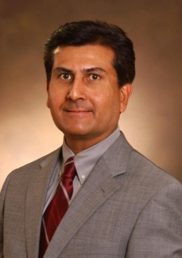

|  |  |  |
| --- | --- | --- |
| **N.K. Singh, M.D.**  Orthopaedics & Rehabilitation | Hand Center **Spine Center**  Non-Surgical | **Board Certified:** Occupational Medicine  **Post Graduate Training**: St. Thomas Hospital Medical Center, Akron, OH  **M.D. Degree:** University of Saskatchewan College of Medicine, Canada |

**SURGEONS**

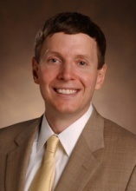

|  |  |  |
| --- | --- | --- |
| **Charlie Cox, M.D.**  Orthopaedics & Rehabilitation | Shoulders/Knees | **Fellowship:** Sports Medicine and Shoulder Surgery at Vanderbilt University Medical Center  **Post Graduate Training:** Tulane University  **MD Degree:** University of Tennessee College of Medicine |

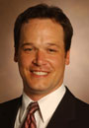

|  |  |  |
| --- | --- | --- |
| **Hudson Deeter, DPM**.  Foot and Ankle Clinic | Forefront Foot Injuries | **Post Graduate Training:** Parkway Regional Hospital, North Miami Beach, FL  **DPM Degree:** Ohio College of Podiatric Medicine |

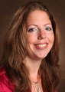

|  |  |  |
| --- | --- | --- |
| **Bethany Gallagher, M.D**  Foot and Ankle Clinic | Foot and Ankle SurgeryTotal Ankle Arthroplasty | **Fellowship**: Florida Orthopaedic Institute  **Orthopaedic Training**: Washington University, St. Louis  **MD Degree**: University of Texas Health Science Center, San Antonio  **Undergraduate:** University of PA in Bioengineering |

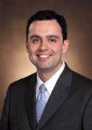

|  |  |  |
| --- | --- | --- |
| **A. Alex Jahangir, M.D**.  Orthopaedic Trauma | Orthopaedic Trauma | **Orthopaedic Training**: Campbell Clinic, Memphis; Hennepin County Medical Center, Minneapolis, MN  **MD Degree**: University of Tennessee, Memphis, TN |

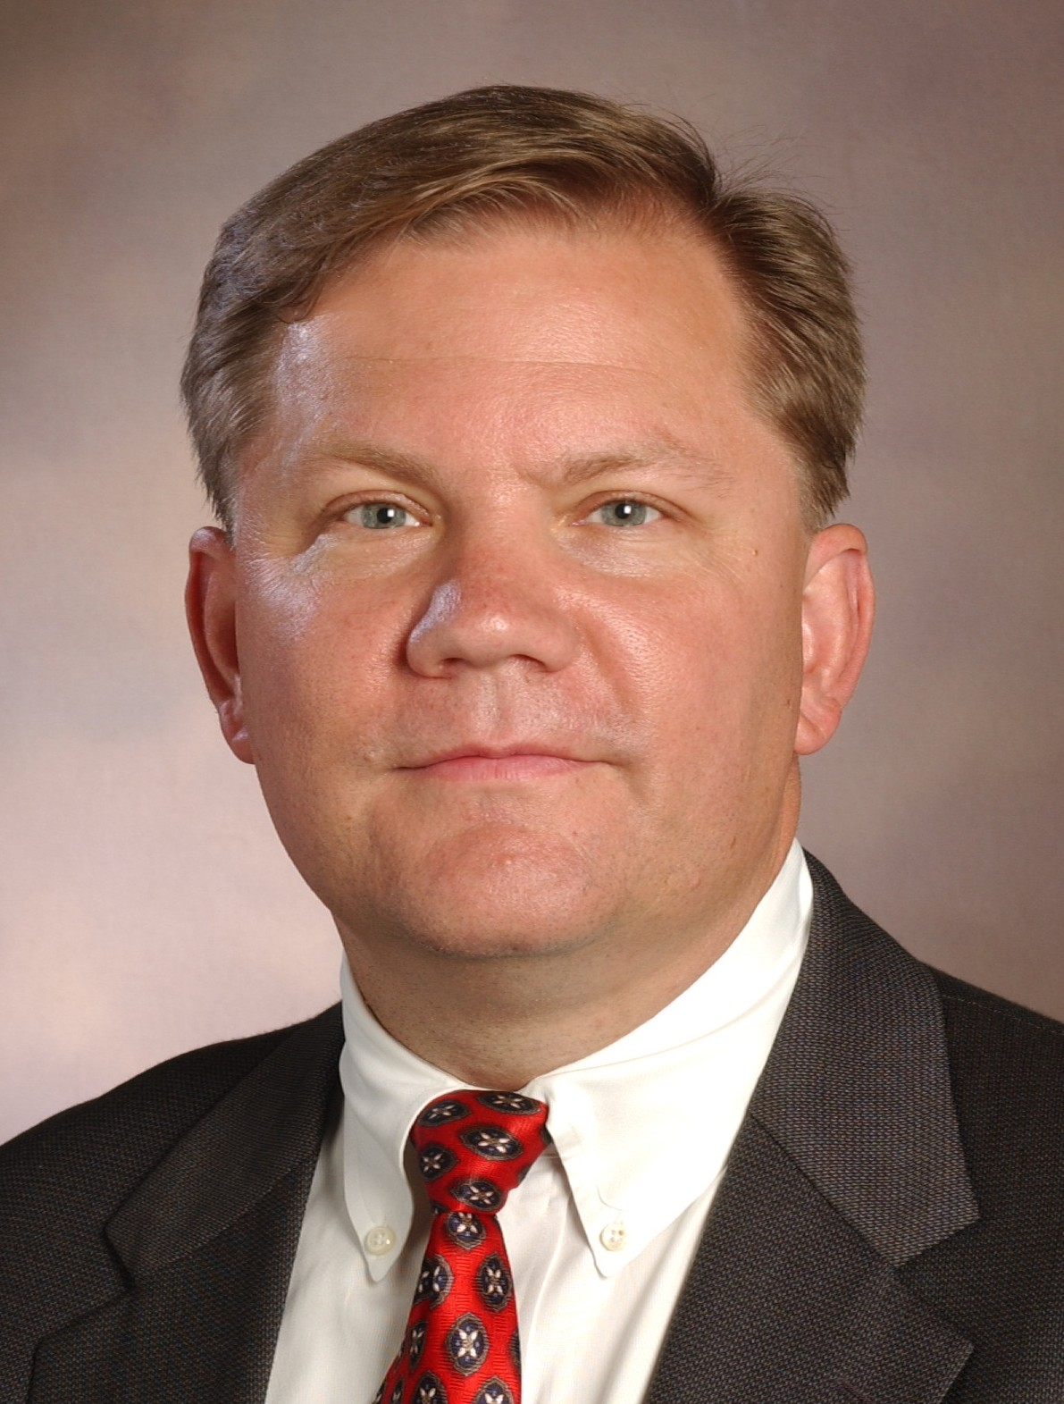

|  |  |  |
| --- | --- | --- |
| John. E. (Jed) Kuhn, M.D.  Chief of Shoulder Surgery,  Vanderbilt Shoulder Center | Shoulders(Limited acceptance of WC patients) | **Fellowships:** Ilizarov Techniques, Lecco, Italy; Orthopaedic Sports Medicine and Shoulder Surgery, Steadman Hawkins Clinic  **Orthopaedic Training:** University of Michigan  **MD Degree:** University of Michigan |

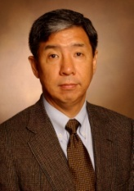

|  |  |  |
| --- | --- | --- |
| Donald Han Lee, M.D.  Hand Center | Hands, Elbows, Shoulders | **Fellowships:** National Institute of Health, Washington, D.C.; Columbia –Presbyterian Medical Center, New York, NY  **Orthopaedic Training:** West Virginia Univ. Hospital, Morgantown, WV; George Washington Univ. Hospital, Washington, D.C.  **MD Degree:** West Virginia Univ., Morgantown, WV |

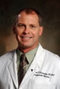

|  |  |  |
| --- | --- | --- |
| **William T. Obremskey, M.D**.  Orthopaedic Trauma | Orthopaedic Trauma | **Fellowship:** AO, Basel, Switzerland  **Orthopaedic Training**: Methodist Hospital of Indianapolis; University of North Carolina; University of Washington  **MD Degree:** Duke University |

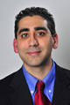

|  |  |  |
| --- | --- | --- |
| **Manish Kumar Sethi, M.D**.  Orthopaedic Trauma | Orthopaedic Trauma | **Fellowship:** Orthopaedic Surgery at Vanderbilt University Medical Center  **Orthopaedic Training**: Harvard Medical School  **MD Degree:** Harvard Medical School |

**Jaron Sullivan, M.D. Knees, Shoulders** **Fellowship:** University of Iowa Hospital and Clinics in Iowa City, IA, Hospital for Special

Surgery

Orthopaedics & Rehabilitation **Orthopaedic Training:** University of Iowa

**MD Degree:** Texas A & M

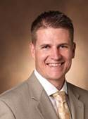

https://www.vumc.org/orthopaedics/sites/default/files/people/Bowman_Eric.jpg

**Eric Bowman, M.D. Sports Medicine Fellowship:** Kerlan-Jobe Institute, Los Angeles, CA

**Orthopaedic Training:** Campbell Clinic-University of Tennessee, Memphis, TN

Orthopaedics & Rehabilitation

**MD Degree:** University of Cincinnati, Cincinnati, OH

|  |  |  |
| --- | --- | --- |
| **Mihir Desai, M.D**.  Hand Clinic | Hands, Elbows | **Fellowship:** Duke Univeristy  **Orthopaedic Training:** Emory University  **MD Degree:** Emory University |

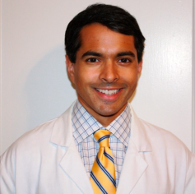

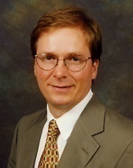

|  |  |  |
| --- | --- | --- |
| **Douglas Weikert, M.D**.  Director, Hand Clinic | Hands, Elbows | **Fellowship:** Hand and Upper Extremity, Indiana Hand Center  **Orthopaedic Training:** Vanderbilt University  **MD Degree:** Vanderbilt University |



|  |  |  |
| --- | --- | --- |
| **Byron Stephens, M.D**.  Comprehensive Spine Center-ONLY ACCEPTS REFERRALS FROM ORTHOPAEDIC OR VUMC PHYSICIANS | Ortho Spine | **Fellowship:** Emory University, Atlanta, GA  **Orthopaedic Training:** Campbell’s Clinic, Memphis, TN  **MD Degree:** Vanderbilt University |

|  |  |  |
| --- | --- | --- |
| **Ginger Holt MD**  Vanderbilt Orthopaedic Institute | Ortho Joint Replacement | **Fellowship:** University of Colorado Hospital, University of Toronto  **Orthopaedic Training:** Vanderbilt Medical Center, Nashvile TN  **MD Degree:** Vanderbilt University |

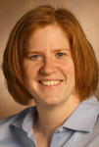

|  |  |  |
| --- | --- | --- |
| **Vincent Novak MD**  Vanderbilt Orthopaedic Institute | Ortho Hands | **Fellowship:** Allegheny General Hospital  **Orthopaedic Training:** Wake Forest University Medical Center  **MD Degree:** University of Maryland |

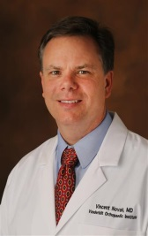

**ASTHMA-SINUS-ALLERGY PROGRAM (ASAP)**

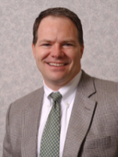

|  |  |  |
| --- | --- | --- |
| **David D. Hagaman MD**  **ASAP** | **Allergy and Asthma** | **Fellowship:** Vanderbilt University Medical Ceneter  **Post Graduate Training**: Ohio State University Medical Center  **MD Degree:** Ohio State University |

A TRIAGE SYSTEM IS IN EFFECT TO ENABLE TIMELY APPOINTMENTS TO BE SET WITH THE NEXT AVAILABLE PHYSICIAN AT THE VANDERBILT ASTHMA-SINUS-ALLELRGY PROGRAM (ASAP) FOR Other Physicians do TESTING ONLY

### BURN UNIT

### summitt-04-

|  |  |  |
| --- | --- | --- |
| **J. Blair Summitt, MD**  Dept. of Plastic Surgery | **Plastic Reconstructive Surgery**  **Facial Trauma**  **Burns** | **Fellowship:** Burns, Vanderbilt University  **Post Graduate Training**: University of Tennessee College of Medicine, Chattanooga, TN  **MD Degree:** University of Tennessee School of Medicine |

### CARDIOLOGY

|  |  |  |
| --- | --- | --- |
|  |  |  |

### DENTISTRY

### Rezk - 11

|  |  |  |
| --- | --- | --- |
| **Julie Wang Rezk, D.M.D.**  General Dentistry | **Dentistry Dept.** | **Post Graduate Training:** University of Alabama at Birmingham Hospital General Dentistry Residency  **DMD Degree**: University of Alabama at Birmingham |

### DERMATOLOGY

A TRIAGE SYSTEM IS IN EFFECT TO ENABLE TIMELY APPOINTMENTS TO BE SET WITH THE NEXT AVAILABLE PHYSICIAN AT THE VANDERBILT DERMATOLOGY CLINIC or at the FRANKLIN VANDERBILT SPECIALTY CLINIC.

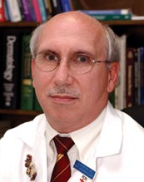

|  |  |  |
| --- | --- | --- |
| **Jo-David Fine, M.D.**  Department of Dermatology | Skin Patch Testing for Allergic Reagents  (only–must be referred) | **Fellowship Training**: National Cancer Institute in Immunodermatology  **Post Graduate Training**: Duke University, Harvard Medical School  **MD Degree:** University of Kentucky |

### 

### GASTEROENTEROLOGY

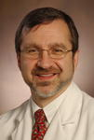

|  |  |  |
| --- | --- | --- |
| **Michael K. Porayko, M.D**.  Director, Liver Transplant Program  MD to MD referrals only | Liver Transplant | **Fellowship:** Advanced Hepatology, Mayo Clinic  **Post Graduate Training:** Michigan State University School of Medicine  **MD Degree:** University of Illinois |

### GENERAL SURGERY

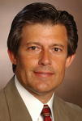

|  |  |  |
| --- | --- | --- |
| **Ralph J. LaNeve, M.D**.  General Surgery | General Surgery | **Post Graduate Training:** Letterman Army Medical Center  **MD Degree:** Thomas Jefferson University |

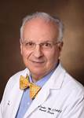

|  |  |  |
| --- | --- | --- |
| **Adrian Barbul M.D**.  General Surgery | General Surgery |  |

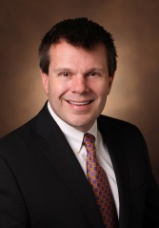

|  |  |  |
| --- | --- | --- |
| **Richard Allan Pierce M.D.**  General Surgery | Laparoscopic Hernia Surgery | **Fellowship:** Dr. Lee Swanstrom, Portland, OR.  **Post Graduate Training:** Washington University, St Louis  **MD Degree:** University of Virginia, MD/PhD |

### GYNECOLOGY

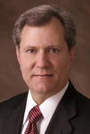

|  |  |  |
| --- | --- | --- |
| **Carl W. Zimmerman, M.D**.  Gynecology | Pelvic Reconstructive Surgery Only | **Board Certified:** Obstetrics & Gynecology  **Post Graduate Training:** Vanderbilt University Medical Center  **MD Degree**: University of Tennessee College of Medicine |

**INFECTIOUS DISEASE**

A TRIAGE SYSTEM IS IN EFFECT TO ENABLE TIMELY APPOINTMENTS FOR CONSULTATIONS WITH THE NEXT AVAILABLE PHYSICIAN

**JOINT REPLACEMENT**

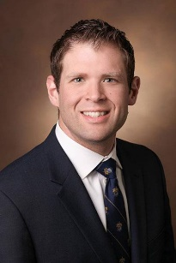

|  |  |  |
| --- | --- | --- |
| **Stephen Engstrom, M.D**.,  Vanderbilt Orthopaedic Institute | Knee and Hip Replacement | **Fellowship:** Washington University in St. Louis, St. Louis, MO, Joint Preservation, Resurfacing, Replacement  **Post Graduate Training:** Vanderbilt University Medical Center  **MD Degree**: University of Connecticut School of Medicine, Farmington, CT |

**LIMB LOSS CARE CLINIC**

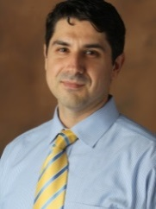

|  |  |  |
| --- | --- | --- |
| **Gerazimos Bastas, M.D**., PhD  Physical Medicine and Rehabilitation | Limb Loss PM&R | **Post Graduate Training:** University of Pennsylvania, Phiadelphia  **MD Degree**: Boston University School of Medicine, Boston, MA  **PhD:** Doctor of Philosophy (Molecular and Transitional Medicine), Boston University School of Medicine, Boston, MA |

**NEUROPSYCHOLOGY**

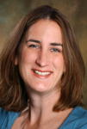

|  |  |  |
| --- | --- | --- |
| **Monica Jacobs, PsyD, ABPP-CN**  Psychiatric Hospital at Vanderbilt | Neuropsych Evaluations & Treatment recommendations (by referral only) | **Fellowship:** Neuropsychology at Mary Bed Free Rehabilitation Hospital  **Post Graduate Training:** University of Toledo Medical Center  **MD Degree:** Argosy University, Atlanta, GA |

### OPTHALMOLOGY

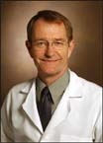

|  |  |  |
| --- | --- | --- |
| **James Felch, MD**  Vanderbilt Eye Institute - Williamson | **Ocular Trauma** | **Post Graduate Training**: Vanderbilt Medical Center  **MD Degree:** Vanderbilt Medical Center |

### Schenk at VEI in Lebanon.jpg

|  |  |  |
| --- | --- | --- |
| **William D. Schenk, MD**  Vanderbilt Eye Institute - Lebanon | **Comprehensive Eye Care** | **Board Certification:** American Board of Ophthalmology  **Post Graduate Training:** West Virginia University Hospital, Morgantown, W VA  **MD Degree:** University of Nebraska Medical Center, Omaha |

### Weikert - dan 07

|  |  |  |
| --- | --- | --- |
| **Daniel Weikert, MD, FACS**  Vanderbilt Eye Institute - Williamson | **Ocular Trauma** | **Fellowship:** Opthalmology at Vanderbilt Medical Center  **Post Graduate Training**: Vanderbilt University Medical Center  **MD Degree:** Vanderbilt University Medical Center |

### ORAL/MAXILLOFACIAL SURGERY

|  |  |  |
| --- | --- | --- |
| **Samuel McKenna, M.D., D.D.S., F.A.C.S.** | Facial TraumaCorrective Jaw SurgeryOral Surgery | **Post Graduate Training**: Vanderbilt University  **MD Degree**: Vanderbilt University  **DDS Degree**: University of California School of Dentistry |

Chief, Oral and Maxillofacial Surgery

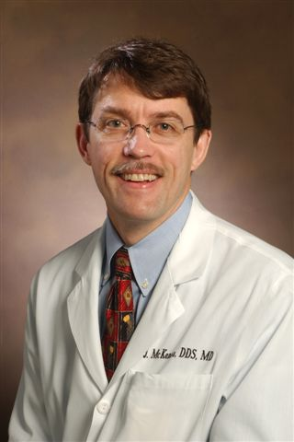

**PAIN MANAGEMENT**

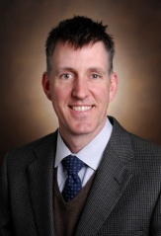

|  |  |  |
| --- | --- | --- |
| **John Corey, M.D.**  Dept. of Anesthesiology | Pain Management and Interventional Pain Management | **Fellowship**: Chronic Pain at Dartmouth-Hitchcock in Hanover, NH  **Post Graduate Training:** Naval Medical Center in San Diego  **MD Degree:** University of Missouri, Columbia School of Medicine |

**PLASTIC SURGERY**

|  |  |  |
| --- | --- | --- |
| **Kevin J. Kelly, M.D., D.D.S.**  Department of Plastic Surgery | Plastic Reconstructive SurgeryFacial Trauma | **Fellowship:** Cranial & Microsurgery, Johns Hopkins Medical System, Baltimore  **Post Graduate Training**: Kings County Hospital, Brooklyn, NY; Albany Medical Center, Albany, NY  **MD Degree:** State University of New York  **D.D.S. Degree:** Columbia University, New York |

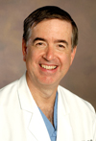

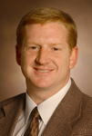

|  |  |  |
| --- | --- | --- |
| **Wesley P. Thayer, M.D**., **Ph.D.**  Department of Plastic Surgery | **Wrist/Hand Injuries**  **Compression Neuropathy**  **Brachial Plexus** | **Fellowship Training:** University of Alabama-Birmingham  **Post Graduate Training:** University of Virginia, Vanderbilt University  **MD & PhD Degrees:** Emory University |

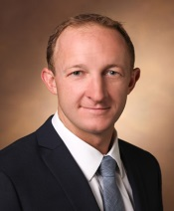

|  |  |  |
| --- | --- | --- |
| **Brian C. Drolet M.D**.  Department of Plastic Surgery | **Wrist/Hand Injuries**  **Nerve Repair, Tendon Injuries, Soft Tissue Reconstruction** | **Fellowship Training:** Johns Hopkins Hospital  **Post Graduate Training:** Albert Medical School of Brown University, Providence, RI  **MD Degrees:** Vanderbilt University |

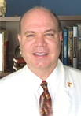

|  |  |  |
| --- | --- | --- |
| **J. Blair Summitt, MD**  Dept. of Plastic Surgery | **Plastic Reconstructive Surgery**  **Facial Trauma**  **Burns** | **Fellowship:** Burns, Vanderbilt University  **Post Graduate Training**: University of Tennessee College of Medicine, Chattanooga, TN  **MD Degree:** University of Tennessee School of Medicine |

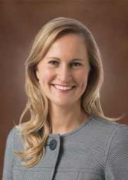

|  |  |  |
| --- | --- | --- |
| **Brinkley Sandvall, MD**  Department of Plastic Surgery | **Wrist/Hand Injuries**  **Nerve Repair, Tendon Injuries, Soft Tissue Reconstruction** | **Fellowship Training:** Washington University in St. Louis, MO, followed by pediatric hand and microvascular surgery The Royal Children’s Hospital, Melbourne, Australia  **Post Graduate Training:** University of Washington, Seattle, WA  **MD Degrees:** Baylor College of Medicine, Houston, TX |

|  |  |  |
| --- | --- | --- |
| **John Bradford Hill MD**  Department of Plastic Surgery | **Wrist/Hand Injuries**  **Nerve Repair, Tendon Injuries, Soft Tissue Reconstruction** | **Fellowship Training:** Curtis National Hand Center  **Post Graduate Training:** New York University  **MD Degrees:** Vanderbilt University Medical School |

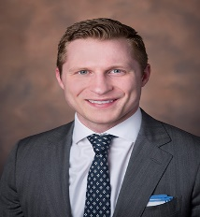

**PSYCHIATRY**

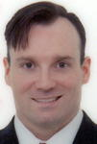

|  |  |  |
| --- | --- | --- |
| **Stephen A. Montgomery, M.D**.  Department of Psychiatry | **Forensic Psychology (One-time)**  **IME’s** | **Fellowship:** University of Rochester Medical Center  **Post Graduate Training:** University of Alabama at Birmingham Health System  **MD Degree:** University of Tennessee |

**PULMONOLOGY  
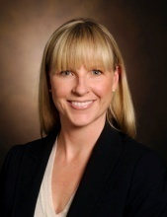**

|  |  |  |
| --- | --- | --- |
| **Carla Sevin, M.D**.  Pulmonary & Critical Care | Respiratory/Pulmonary Injuries/Occupational Lung Disease | **Board Certified:** Internal Medicine, Critical Care & Pulmonary Medicine  **Fellowship:** Vanderbilt University Medical Center; UniverstitatsSpital in Zurich, Switzerland; Univ. of California in San Francisco  **Post Graduate Training:** Vanderbilt University Medical Center  **MD Degree:** Univ. of So. Florida College of Medicine |

**SPINE SURGERY**

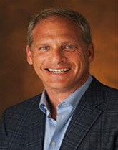

|  |  |  |
| --- | --- | --- |
| **Richard Berkman M.D.**  Neurosurgery | **Neurosurgery/Spine**  Must review records and actual films before accepting referrals | **Post Graduate Training**: New York University  **M.D. Degree**: Vanderbilt University School of Medicine |

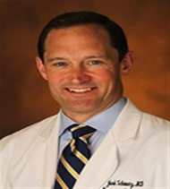

|  |  |  |
| --- | --- | --- |
| **Jacob Schwarz M.D.**  Neurosurgery | **Neurosurgery/Spine**  Must review records and radiology reports before accepting referrals | **Post-Graduate Training**: John Hopkins University  **M.D**. **Degree:** John Hopkins Hospital and Health System |

|  |  |  |
| --- | --- | --- |
| **Amir Abtahi M.D.**  Orthopaedic Spine | **Orthopaedic/Spine** | **Post-Graduate Training**: University of Utah-Orthopaedic Surgery  **M.D**. **Degree:** Vanderbilt University School of Medicine  **Fellowship Training:** University of Pittsburgh-Spine Surgery |

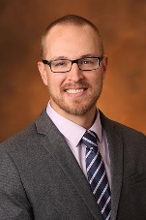

**UROLOGY**

|  |  |  |
| --- | --- | --- |
| **Douglas Milam, M.D**. | Adult Urology/Trauma Only | **Post Graduate Training:** University of Utah  **MD Degree:** West Virginia University |

Chief, Department of Urology

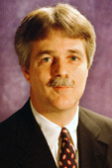

**VASCULAR SURGERY**

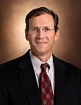

|  |  |  |
| --- | --- | --- |
| **C. Louis Garrard III, M.D**.  Division of Vascular Surgery | Vascular Surgery | **Fellowship:** Vascular Surgery at Alton Ochsner Foundation Hospital in New Orleans  **Post Graduate Training:** Vanderbilt University Medical Center  **MD Degree:** Vanderbilt University Medical Center |

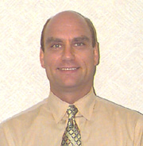

|  |  |  |
| --- | --- | --- |
| **Thomas Naslund, M.D**.  Chief, Division of Vascular Surgery | Vascular and Endovascular Surgery | **Fellowship:** Vascular Surgery, Oshsner Clinic  **Post Graduate Training:** Vanderbilt University Medical Center  **MD Degree:** Vanderbilt University Medical Center |

**Vanderbilt Neurosurgery at Maury Regional** – Medical Office Building, Ste. 302, 1222 Trotwood Avenue, Columbia, TN

**Call 931-490-7193 for to schedule appointments, obtain medical records and coordinate communication**

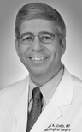

|  |  |  |
| --- | --- | --- |
| **Mark A. Cobb, M.D**.  Neurosurgery | Neurosurgery | **Fellowship:** Epilepsy Surgery at Yale University, New Haven, CT  **Post Graduate Training:** University of Arkansas, Little Rock, AR  **MD Degree:** Vanderbilt University Medical Center  **Board Certification:** Neurological Surgery |

**Vanderbilt Walk-In Clinics providing Workers’ Compensation Treatment/Services**

**Call these Clinics Directly for Appointments**

Vanderbilt Health and Williamson Medical Walk-In Clinic, Franklin

919 Murfreesboro Rd. (Hwy 96), Franklin, TN

615-791-7373

Vanderbilt Health and Williamson Medical Walk-In Clinic, Spring Hill

3098 Campbell Station Pkwy, Spring Hill, TN

615-302-1111

Vanderbilt Health and Williamson Medical Center Walk-in Clinic, Brentwood

134 Pewitt Drive, Suite 200, Brentwood, TN

615-371-2481

Vanderbilt Health and Williamson Medical Center Walk-In Clinic, Cool Springs

1834 West McEwen Drive

Franklin, TN 37067

615-875-4200

Vanderbilt Health Walk-In Clinic, Belle Meade

(615) 875-1000

4534 Harding Pike

Nashville, TN 37205

615-875-1000

Vanderbilt Health Walk-In Clinic, Bellevue, Nashville

7069-B Highway 70 South

615-514-5352

Vanderbilt Health Walk-In Clinic, Melrose

2608 8th Avenue South, Suite 102

Berry Hill, TN 37204

615-875-5515

**Vanderbilt Wilson County Hospital and Emergency Department**

1411 W. Baddour Parkway

Lebanon, TN 37087

615-444-8262