Section Project/Grant Scoring Sheet
Grant applicant: _______________________________
Referee name: _______________________________

CRITERION | SCORE (1-9)
Significance (including potential impact of the research on improving the lives of patients with surgically focused conditions)
Investigator (including academic track record)
Approach (including the feasibility of the project and stated goals)
Environment
Likelihood of obtaining eventual external funding
TOTAL SCORE (between 5 and 45)

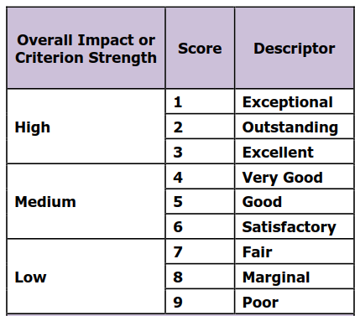

List major and minor strengths and weaknesses below for PI review:

*Once complete email to jay.wellons@vumc.org

