Section Project/Grant Scoring Sheet
Grant applicant: _______________________________
Referee name: _______________________________

CRITERION | SCORE (1-9)
Significance (including potential impact of the research on improving the lives of patients with surgically focused conditions)
Investigator (including academic track record)
Approach (including the feasibility of the project and stated goals)
Environment
MEAN SCORE

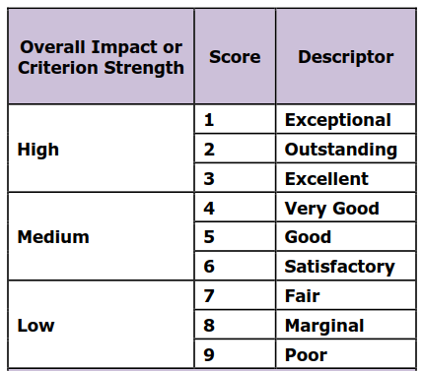

List major and minor strengths and weaknesses below for PI review:

