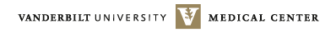

Office of Sponsored Programs

Date:

To:

From:

Principal Investigator

Subject: Grant #

Vanderbilt University Medical Center (VUMC) hereby certifies that the below VUMC and/or Consortium Performance site Key Personnel on the referenced grant, who are involved in the design and conduct of human subjects research have complied with NIH’s education requirements on the protection of human research participants as prescribed in HHS regulations 45 CFR part 46 Subpart A also known as Common Rule.

Key Personnel | Human Subjects Involvement (Y/N) | Performance Site

D. Clinton Brown, Associate Vice President
Office of Sponsored Programs Date

