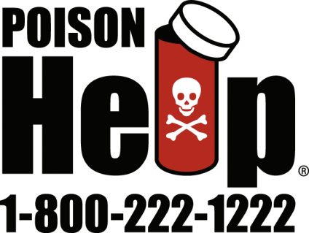

Tennessee Poison Center Newsletter
Fall 2011 Volume 2, Issue 3 www.tnpoisoncenter.org
-----------------------------------------------------------------------------------------------------------------------------------

Safety Counts When Using Art Supplies

What child doesn’t love to draw, paint and color? What parent doesn’t have a refrigerator covered in children’s artwork? It’s important to keep in mind, however, that art products are a mixture of chemicals that deserve respect and careful handling to avoid poison exposures.

When glues, paints, ink and other art supplies are handled correctly, children can safely enjoy art activities. However, young children often like to taste pretty, colorful art products, and older children may be exposed if some is splashed into eyes or spilled onto skin.

In 2009, the nation’s 57 poison control centers received more than 35,000 calls about exposures to art products; of these, more than 26,000 calls concerned children younger than 6. Although most exposures cause only minor effects, and very few require treatment by a doctor, it’s still important to handle art supplies with care.

The following are some of the art supplies that often cause concern:
- Chalk contains calcium, and swallowing some typically does not cause poisoning. More serious problems can occur if the chalk lodges in the throat or is breathed into the windpipe, blocking the airway and causing coughs, difficulty breathing, or wheezing.

- Water-soluble markers usually don’t cause harm. Most other felt-tip markers don’t cause poisoning if small amounts of the ink are swallowed. A few markers may contain aniline dyestuffs, which, if a large amount is swallowed, can be poisonous.
- Erasers are not considered poisonous but could cause blockage or injury if lodged in the throat or breathed into the windpipe.
- School-type glues (such as Elmer's®) generally are considered nonpoisonous. “Super glues” do not cause serious poisoning if a mouthful is swallowed; however, they cause mucous membranes and skin surfaces to stick together instantly. If “super glue” gets into the eye, the eyelids can be sealed together, resulting in lid injury and loss of lashes. Worse, “super glue” can cause serious damage to the eye’s cornea.
- If children swallow small amounts of water-based paint – including latex, tempera and poster paint – poisoning is not likely. Some latex paints do contain measurable amounts of glycols, so poisoning could happen if someone swallows a very large amount. Oil-based paints contain solvents that can cause poisoning if swallowed.

The American Association of Poison Control Centers recommends the following safety tips:
- Read the label carefully, and follow all instructions for safe use and disposal.
- Discard products that have passed their expiration dates.
- Don’t eat or drink while using art products.
- Wash up – skin, equipment and environment – after use.
- Never use products to paint skin or decorate food unless the product is specifically labeled for that use.
- Store art products in their original containers locked up and out of the reach of children.

When choosing art supplies for use by children, consider the product’s certification. Many art supplies are imprinted with the seals of the Arts and Crafts Materials Institute. Products with the AP (Approved Product) seal are certified “to contain no materials in sufficient quantities to be toxic or injurious to humans, including children, or to cause acute or chronic health problems.” These products are best for use by young children. Products with the CL (Cautionary Label) Seal are certified “to be properly labeled for any known health risks and with information on the safe and proper use of these materials.” CL-certified products are more appropriate for adult use.

If a young artist does chew on a crayon, eat some glue, or splash paint into eyes, help is just a phone call away. Call Tennessee Poison Center at 1-800-222-1222 for advice or information.

-----------------------------------------------------------------------------------------------------------------------------------

When Sniffing Has Deadly Consequences

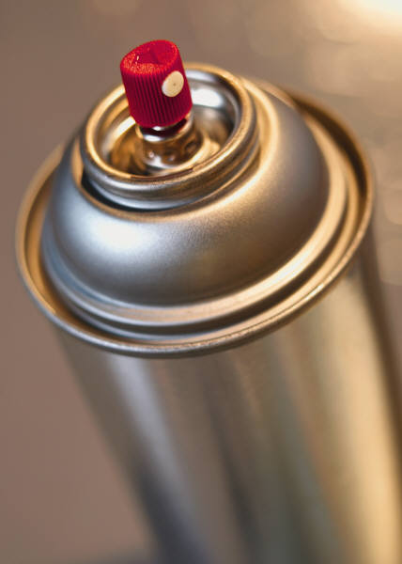
Kids call it “huffing,” “sniffing” and “bagging,” and it’s not a harmless childhood game. In fact, it’s inhalant abuse, and it’s dangerous and deadly.

Inhalant abuse is the deliberate breathing of a fume or gas for an immediate, intense and usually brief “high.” Children as young as 10 try inhalants, and abuse peaks among children ages 13 to 15.

Unfortunately, it’s an all-too-common practice – nearly one of every seven eighth-graders has tried inhalants. Tennessee is 7th in the U.S. for inhalant abuse.

According to the American Association of Poison Control Centers, the list of common household products children inhale to get high is staggering: adhesives, nail polish remover, butane lighters, aerosol deodorant, gasoline, spray paints, air conditioner refrigerants, air duster, permanent markers and many more. These products are cheap and easy to get, and many adults don’t realize their danger.

Just how dangerous are they? A child who has abused inhalants may seem drunk, with symptoms like confusion, slurred speech, lack of coordination and passing out. Inhalants can kill a child by triggering an irregular heartbeat and heart failure – even for a first-time inhaler. Some people high on inhalants have died as a result of serious injuries such as drowning or falling. Plus, inhalants can permanently damage a child’s brain, bone marrow, lungs and other organs.

Experts at Tennessee Poison Center recommend these steps to help protect your children from inhalant abuse:
- Education is the key to prevention. Begin to teach your children about the dangers of inhalants in elementary grades. It’s important to let them know that these products are dangerous poisons that cause harm if used incorrectly. Continue to discuss the issue openly as children become teens.
- Be a good role model in safe use of chemical products. Always read and follow label instructions, ventilate properly and store them safely. Require adult supervision when children use these products.
- Be on the alert for signs of inhalant abuse. Some important clues that someone may be abusing inhalants include chemical odors on breath or clothes, paint or other stains on skin or clothing, lots of empty product containers, smelly rags or bags, and frequently red or runny eyes or nose.
- Get help if you think a child may be using inhalants. If you think someone is high from inhalants, keep calm; overexcitement can cause a dangerous heartbeat. Get the person into fresh air. Call Tennessee Poison Center at 1-800-222-1222 for immediate, expert treatment advice.
-------------------------------------------------------------------------------------------------------------------------
Stock Your Hurricane Kit With Poison Help
It’s that time of year again – the peak of hurricane season.

To prepare, many people in the Eastern and Southern U.S. have assembled hurricane or disaster kits complete with food, water, medicines, important documents and supplies. What they may have forgotten is something simple but very important – the nationwide 1-800-222-1222 Poison Help phone number.

The doctors, nurses and pharmacists who staff your local poison control center provide help 24 hours a day, seven days a week, 365 days a year – even during emergencies. Poison centers have disaster plans in place so that if one center is damaged by a hurricane or other emergency, calls from that area can be routed immediately to another center for seamless coverage. In a disaster, this may be the only route to medical assistance.

Many poison emergencies happen in the period during and after natural disasters. Typical storm-related dangers include:

- Gasoline-powered generators – In 2009, nearly 12,500 people called poison centers about carbon monoxide exposures, 97 percent of whom were unintentionally exposed. According to the U.S. Centers for Disease Control and Prevention, more than 400 Americans die each year from unintentional carbon monoxide poisoning, more than 20,000 visit emergency rooms, and more than 4,000 are hospitalized.

Carbon monoxide poisoning is the most common poison-related cause of hospitalization and death in the wake of hurricanes. It is called a “silent killer” because there are no odors or symptoms that signal a problem. When people use generators improperly – too close to homes, in garages or outside bedroom windows – carbon monoxide can seep in and sicken or even kill.

- Power outages – In the dark, people often confuse their medicines and take the wrong one or too much. Many foods begin to spoil within hours of getting warm, and the “sniff test” is not foolproof in determining if food has gone bad. Sometimes people store supplies such as chemicals or medicine in old food containers. This can lead to “look-alike” poisonings if family members mistake one product for another.

- Bites and stings – During storms, bugs, spiders and snakes get displaced along with human residents. People can come across snakes in their damaged homes or in temporary shelters. Poison control centers around the country are familiar with local venomous animals and can walk callers through important first aid techniques for all sorts of bites and stings, as well as determine whether further emergency care is necessary.

The American Association of Poison Control Centers offers the following tips to protect your family from poisonings associated with natural disasters:
- Include the Poison Help phone number in your disaster plan, and program your cell phone with the nationwide, toll free number: 1-800-222-1222. Keep your phone charged, and limit calls to emergencies.
- Secure all routine medications and necessary chemicals in watertight containers with their original labels intact. Without accurate product information, poison centers are limited in how much information they can provide.
- Carefully follow the manufacturer’s safety instructions for gasoline-powered generators. If you believe you have been exposed to carbon monoxide, call your poison center immediately.
- Keep a full first aid kit with your disaster supplies, including an up-to-date list of all medications taken routinely by household members.

Hopefully, you won’t need to call your local poison center during hurricane season this year, but if you do, you’ll be glad you stocked your disaster kit with Poison Help!

-------------------------------------------------------------------------------------------------------------------------

Use Melatonin With Care
You may have heard about a substance called melatonin marketed as a sleep aid or to help you relax. But what is it? How does it work? And are there any side effects?

According to the American Association of Poison Control Centers, melatonin is a hormone made naturally in the body that also can be found as an ingredient in pills, drinks and food. It is sold in head shops, health food stores, online, and in grocery and convenience stores. Because some foods contain melatonin naturally, it does not need to be approved by the Food and Drug Administration or shown to be safe or effective in the same way as drugs.

Melatonin helps control sleep-wake cycles in the body, possibly helping some people to fall asleep faster or stay asleep longer. It is sold as an aid in preventing or reversing jet lag. Because it is not categorized as a drug, the “dose” on product labels may not be accurate, or the amount of melatonin may not be listed on the package. Taking a dose of 1 to 3 milligrams may elevate melatonin levels in a person’s blood as much as 20 times normal. The dose needed to bring on sleep in adults ranges from 2 to 5 mg. Children should not take melatonin without talking to a doctor first.

If melatonin makes you feel drowsy, do not drive or operate machinery when you are taking it. Other side effects include vivid dreams, headaches, trouble being alert the day after using it, and changes in blood pressure. Those who should not use melatonin unless under a physician's supervision include pilots, truckers, or others whose lack of alertness on the job could endanger themselves or others

Recently, America’s 57 poison centers started receiving calls about brownies containing melatonin and labeled for “relaxation” that were sold mostly in convenience stores. (A “serving” of the brownie is actually only half of a package, according to the label.) The problem is that the brownies contain a very large dose of melatonin (8 milligrams per brownie), and people were eating them as a snack food, giving them to children, and, most worrisome of all, driving and working after eating the brownies made them drowsy.

In July 2011, the FDA notified one brownie manufacturer that it must stop promoting them to kids and teens, and that the brownies may be seized from stores because they are an unsafe and adulterated food. At least one state has passed legislation banning these products. Melatonin also is found in beverages promoted for relaxation. So-called “downer drinks” are promoted to counteract caffeine-containing products, and to allow a person to unwind. Again, they are intended only for adults, but the sale of these products is not restricted.

If a child or teen has consumed a melatonin-containing food or beverage, be aware of the possibility of severe drowsiness. For adults, never consume these products and attempt to drive. In case of accidental exposure or consuming too much, call Tennessee Poison Center at 800-222-1222 immediately for help and advice.

This newsletter is brought to you by Tennessee Poison Center and was produced with assistance from the American Association of Poison Control Centers and local poison centers across the country.
When you dial 1-800-222-1222, your call is answered by a medical professional with special training in poison management. Help is fast, free, confidential and available 24 hours a day, every day.
This project is funded under an agreement with the State of Tennessee.

