A Step-by-step Guide to Microsoft Teams
Navigating Microsoft Teams 2
How do I open Microsoft Teams? 2
How do I set my profile picture and availability? 2
What does each icon on the taskbar mean? 5
How do I create or join a team? 8
Communicating in Teams 9
How do I make/answer a phone call? 9
How do I set up a meeting? 10
What functions are available during a video call? 11
How do I post a message or file to a team? 14
How do I mention someone in a comment? 15
Collaborating in Teams 15
How do I upload files? 15
How do I keep my files organized? 16
What are channels used for? 16
How do my colleagues and I work on a document at the same time? 17
Additional Resources 18
Planner/Tasks 18
Wiki 21
OneNote 21
Stream 22
Microsoft 365 Support Links 25

Navigating Microsoft Teams

a. How do I open Microsoft Teams?Navigating Microsoft Teams

a. How do I open Microsoft Teams?

b. How do I set up my profile picture and availability?a. How do I open Microsoft Teams?Navigating Microsoft Teams

a. How do I open Microsoft Teams?Navigating Microsoft Teams

How do I open Microsoft Teams?

To Open Teams, click into the search icon on the taskbar at the bottom of the screen and type in Microsoft Teams.
The Microsoft Teams Icon will appear.
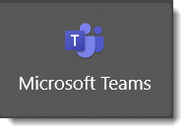
To pin the icon to your taskbar or to the Start menu, search Microsoft Teams in the search bar. From there you will see options to Pin to Taskbar or Pin to Start.

Table of Contents

How do I set my profile picture and availability?

Once Teams is open, you will see your avatar, or profile, in the top right corner of the window. By clicking on your avatar, you can:
- Change your profile picture
- Set your status to let others know your availability
- Set a status message for when you are out of the office
- Find and learn keyboard shortcuts to navigate Teams quickly and efficiently

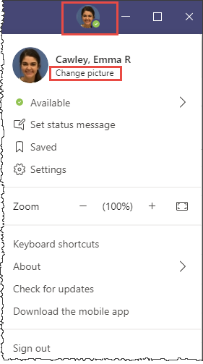
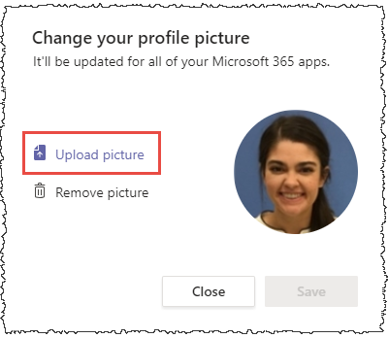
To change your profile picture:
Click on your avatar on the top navigation bar.
Change your picture by clicking Change picture under your name.
Click Upload picture to choose a picture from your device.
When you have the image you would like, click the Save button.

Pathway: Avatar > Change picture > Upload picture

To set your availability:
Hover over Available and your options for availability will appear. These options include:
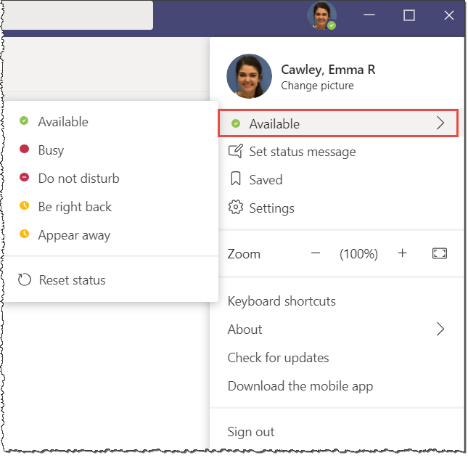
    - Available
    - Busy
    - Do not disturb
    - Be right back
    - Appear away
Your availability automatically changes to Busy when you are in a meeting or on a call.
If you go a certain amount of time without moving your cursor, your availability will change to Appear away.
You can manually change your availability or let Teams automatically set it based on your activity.

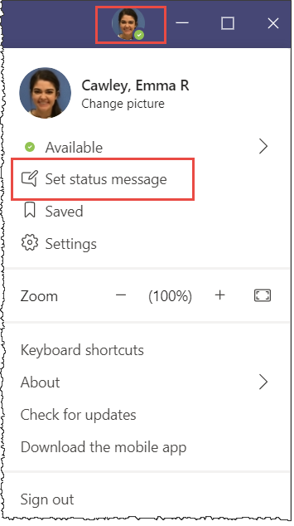
If you are going to be out of the office for an extended amount of time and would like to leave an out of office reply:
- Click on your avatar
- Select Set status message
- Type your message into the text box and set the end date for your message
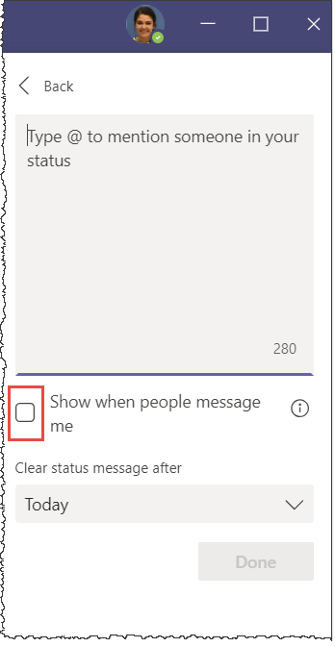
- You can also select whether you would like to be notified when someone tries to message you while you are away by clicking this box

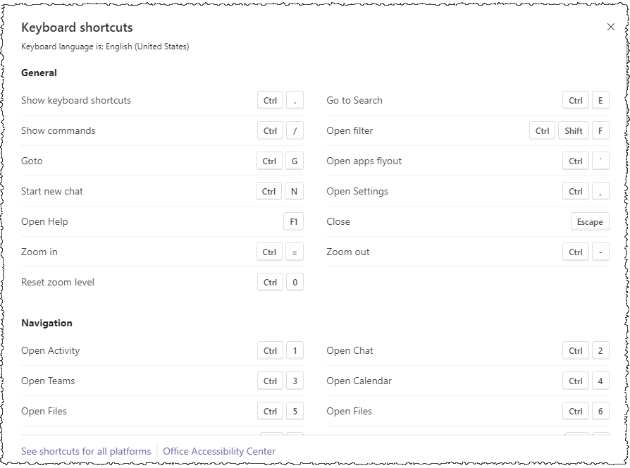
To learn keyboard shortcuts to help navigate, manage meetings and make calls click on your avatar and click on Keyboard shortcuts.There you will see the list of shortcuts available organized by category.

Table of Contents

What does each icon on the taskbar mean?

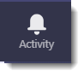
Activity
Here you can track and manage your activity within teams.

Use the filter icon to change how much information you can see in your feed.

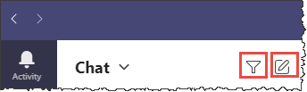
To search for what specific activity you want to see type into the search bar or click on the three dots and select a filter.

Chat
To start a new chat, click on the new chat icon on the top right of the chat stream. Type in the name of the person you would like to chat.

To set your contacts click the arrow next to chat and select Contacts. Here you can set your favorites (individuals you contact frequently). Their names will be in your stream so you can easily access them.

To send an attachment in chat, click on the paper clip icon underneath the text box.

From here you will have the option to upload an attachment from OneDrive or your device.
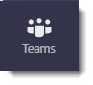
Teams
The teams you are a part of appear in a list on the left-hand side.

Each team has a general feed by default. Specific channels can be set up by clicking the three dots (More options) to the right of the team name and selecting Add channel.
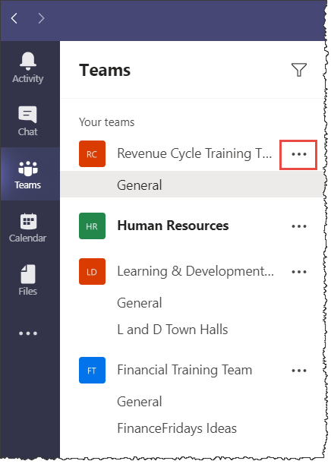
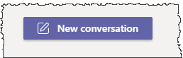
Each team has its own feed. Post in the feed by selecting new conversation and type your message in the text box or attach your material.

At the top of the team feed is the navigation bar. This is where posts in the feed and files are organized. Other tabs and apps can be added to the team navigation bar as well.
The eye icon denotes that only members of this team can see the feed.
To meet with your team click Meet and select Meet now or Schedule a meeting.
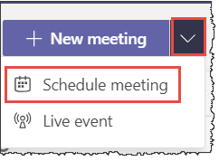
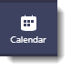
Calendar
Calendar is synced to your Outlook calendar.

To create a calendar event or schedule a meeting click on New meeting > Schedule meeting.

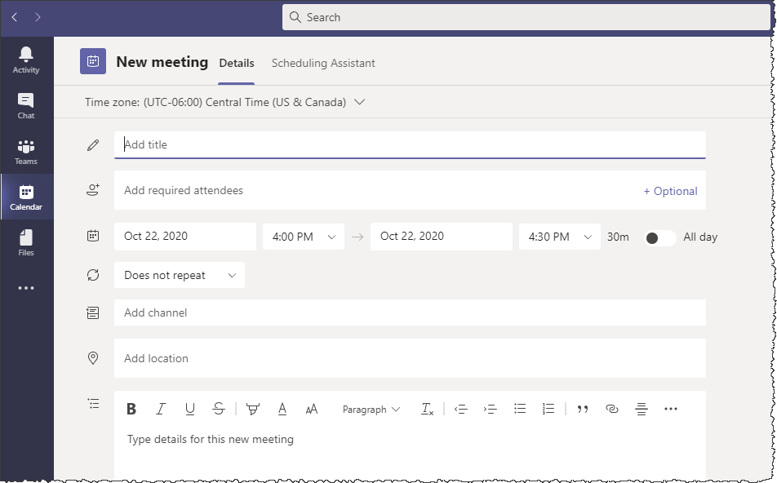
Input your meeting details and click Save to invite guests and add to your calendar.

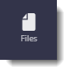
Files
To upload a file anywhere in Teams, look for the icon.
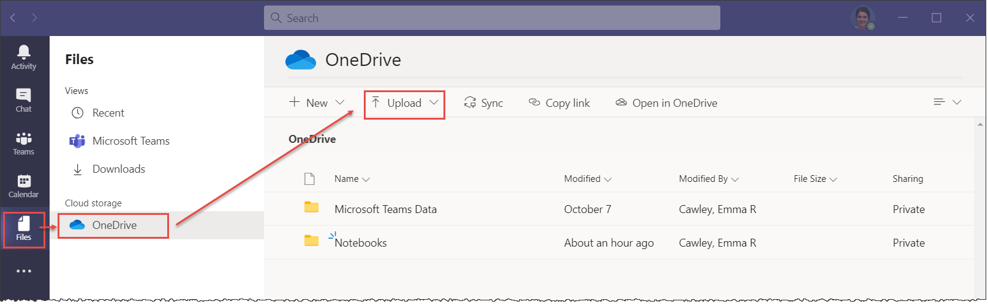
Or click on Files > OneDrive > Upload.

To find a file in Teams click on Files and apply a filter.
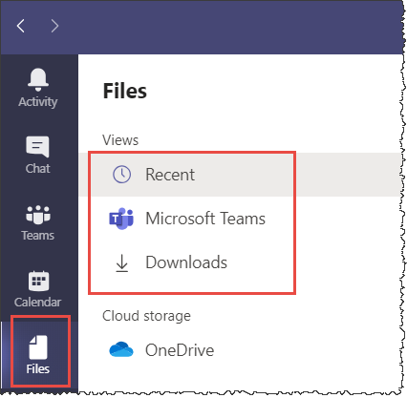
The Recent filter shows you files that you recently worked on or viewed.
The Microsoft Teams filter shows you all files in all your channels.
The Downloads filter shows you files that you have downloaded.

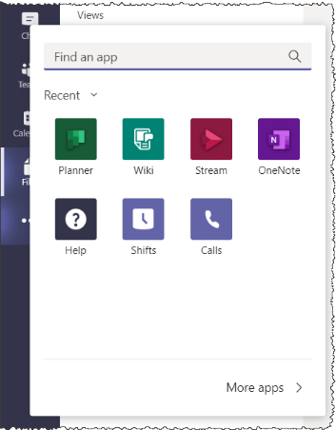

More apps
Select More options to view other apps available to use.

You can pin any of these apps to your icon bar by clicking on the app you want to pin, right clicking, and selecting Pin.

Table of Contents

How do I create or join a team?
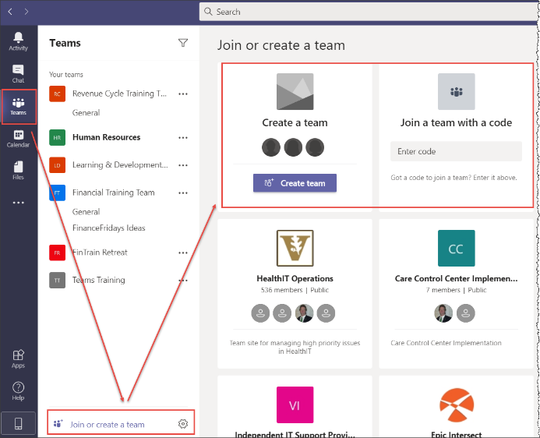
To create or join a team click Teams > Join or create a team and select the Create a team or Join a team with a code tile.
Once you select Create a team, you will have the option to create From scratch or From a group or team.

You will then have the option to make your team Private so that members need permission to join or Public so that anyone within the organization can join the team.
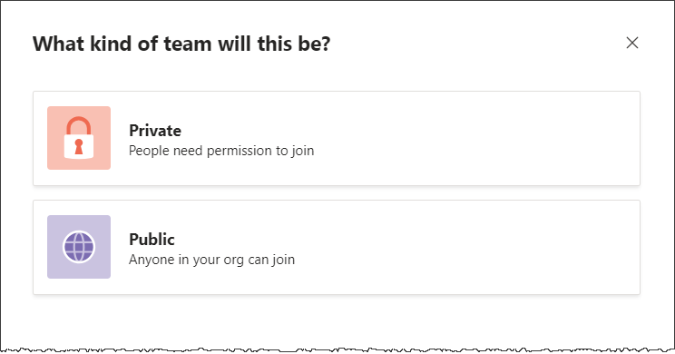
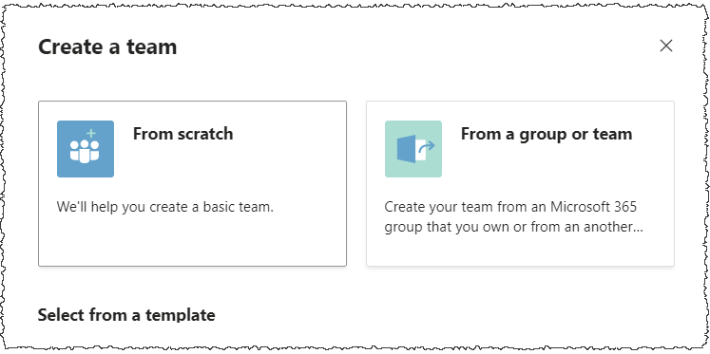

Table of Contents

How do I make/answer a phone call?

Communicating in Teams

II. Communicating in Teams

II. Communicating in Teams

II. Communicating in Teams

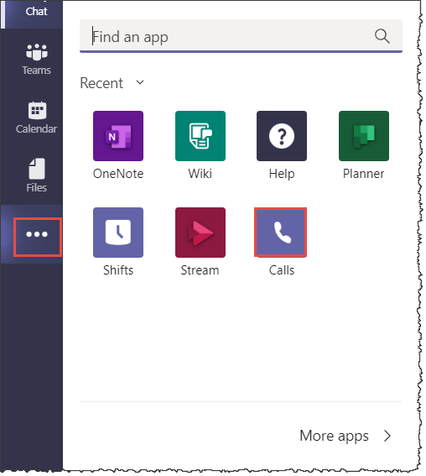
To make a call click the More options tab on the icon bar.
Select Calls.
From there, you can set your contacts to include colleagues you frequently call by selecting Contacts or you can search for someone’s name by selecting Make a call.
History will show you recent calls.
Voicemail allows you to check on missed messages.
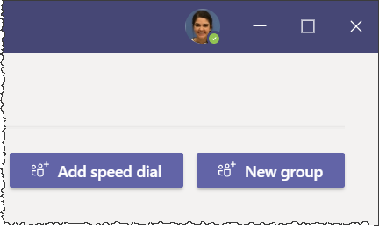
You can set up speed dials for colleagues or groups of colleagues you frequently call by selecting Speed Dial > Add speed dial or New group.

To make a call from chat:
Open the chat of the specific person or group you want to call.
Select Video call or Audio call.
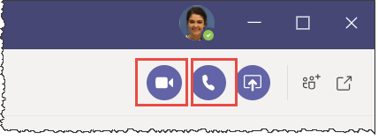

To make a call to a team:
From the Teams tab, click on the team channel you would like to call. Make sure you are in the posts feed.
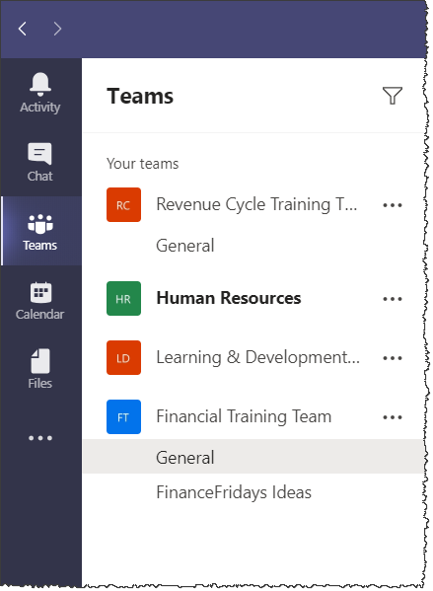
In the top right corner, click Meet. Choose the audio and video functions you would like to be available for the call, give the meeting a title, and then click Join. This will begin a meeting immediately.
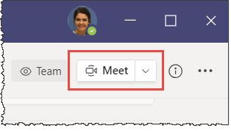
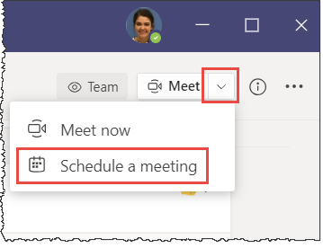
To schedule a meeting for a later date or time, click the drop-down arrow next to Meet and select Schedule a meeting.

Using the keyboard shortcut to make a call:
In the command bar at the top of the window type /call and the name of the person you would like to reach.
Hover over their profile avatar and select audio call to start the call.

Table of Contents

How do I set up a meeting?

To schedule a meeting from your calendar, select the Calendar icon on the left icon bar.
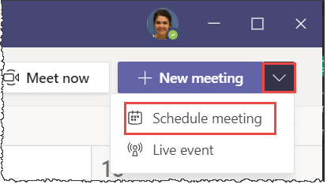
Click on New meeting > Schedule meeting.
Type your meeting details into the invitation and click Save to invite your guests.

To meet with a team in a channel you can schedule a meeting within that channel.
Select New meeting > Schedule meeting > Add channel. A drop-down menu will appear for you to select which channel you will meet with.
This allows you to schedule a meeting for specific team members without inputting names in the required attendees box.
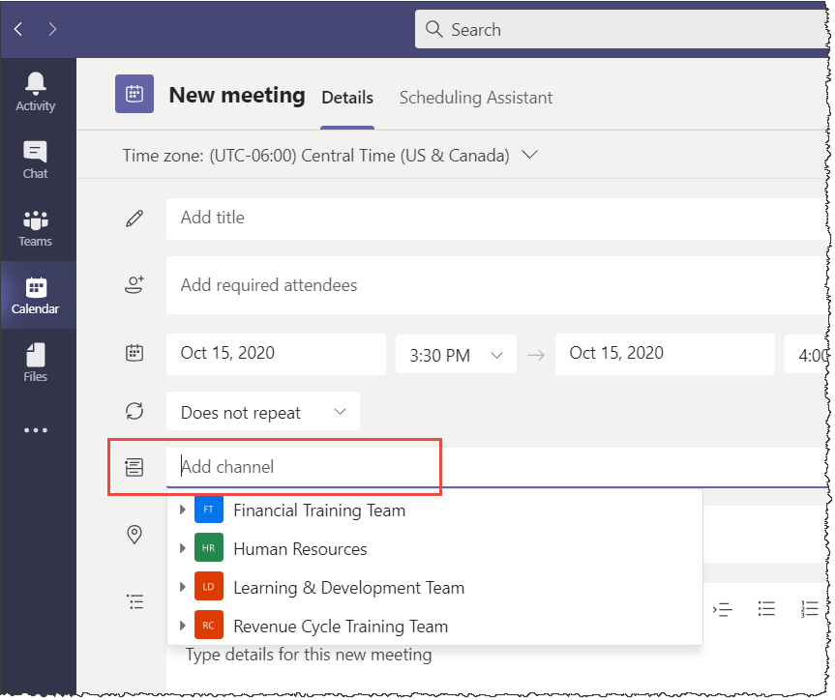

Table of Contents

What functions are available during a video call?

Recording a meeting:
Any meeting in Teams can be recorded to capture video, audio, and screen sharing.
To record the meeting after joining go to the meeting controls and select More options > Start recording.
You will select More options > Stop recording to end the recorded portion of the meeting.
All participants in the meeting are notified when the recording begins. The meeting recording will be accessible in OneDrive and SharePoint. It is also posted in the Chat stream for seven days after the meeting.
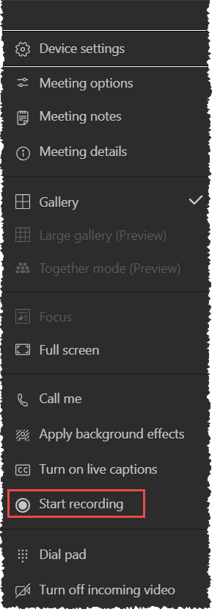
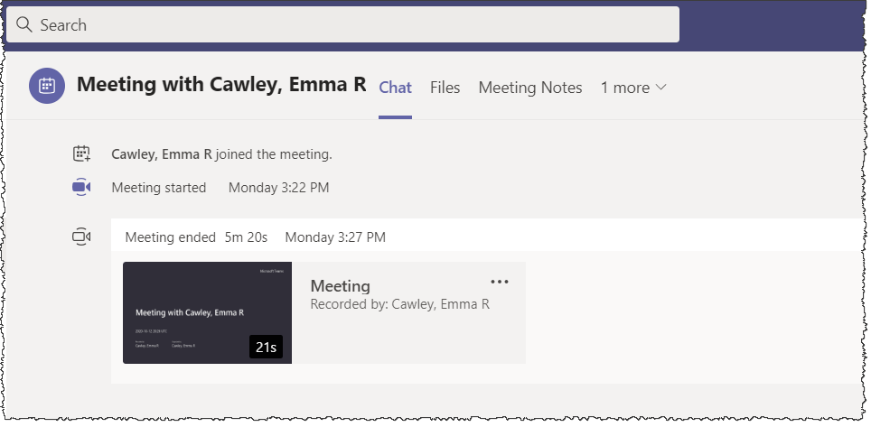

Present during a meeting:
Meeting participants and organizers can present materials on their screen during a meeting.
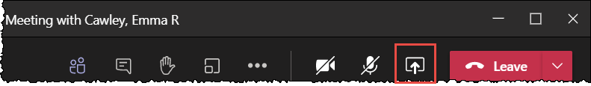
Once in a meeting, select the Share content icon from the taskbar at the top of the video window.
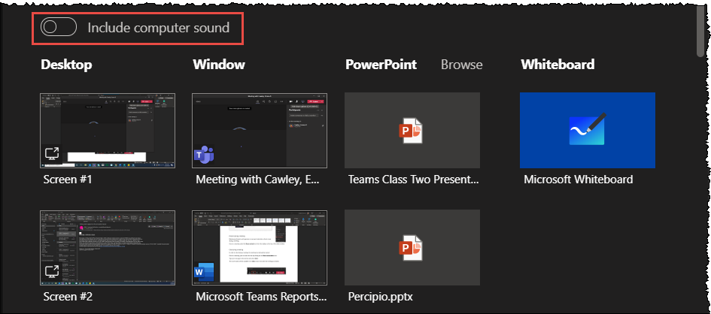
From there you will have the option to select which screen or window you would like to present.
If you are sharing a video presentation with the meeting participants, you must select Include computer sound so that all participants will be able to hear the audio during your presentation.
To stop presenting your screen, select the same Share content icon at the top of your window.

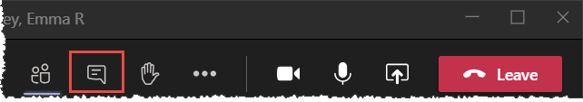
Chat during a meeting:
In order to chat during a meeting, the meeting must already be started.
Once in a meeting, you can start the chat by clicking on the Show conversation icon.
Type your message in the text box and select Send.
The conversation will be available in the Chat stream even after the meeting has ended.
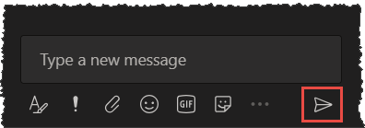

Using Breakout Rooms in a meeting:
Breakout rooms enable participants to split off into groups or smaller meetings, with the ability to rejoin the larger meeting at any point.
Only the meeting organizer can send participants into breakout rooms.
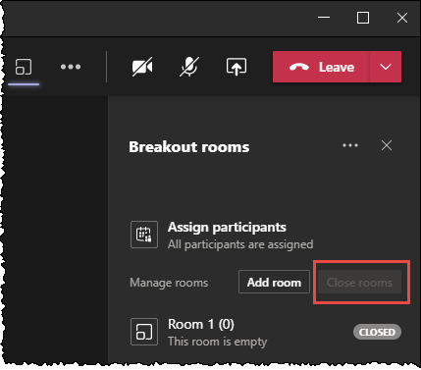
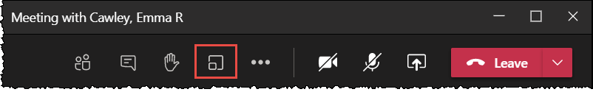
To set up breakout rooms, select the Breakout rooms icon from the taskbar at the top of the video window.
To end a breakout rooms session, select the breakout room icon > Close rooms.

Live captions during a meeting:
To turn on Live captions, select More options > Turn on live captions.
Live captions allow spoken text to appear at the bottom of the meeting screen.
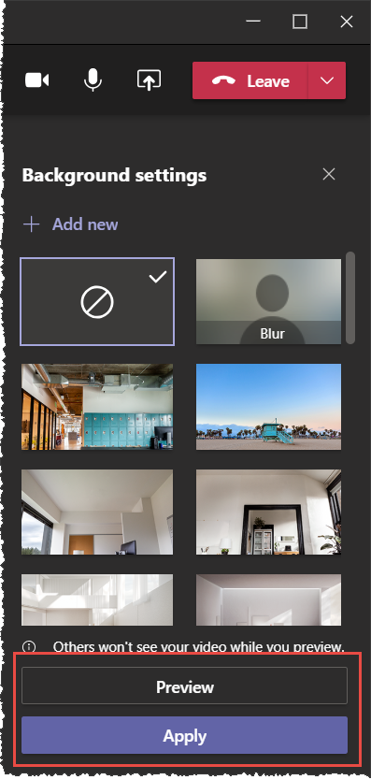
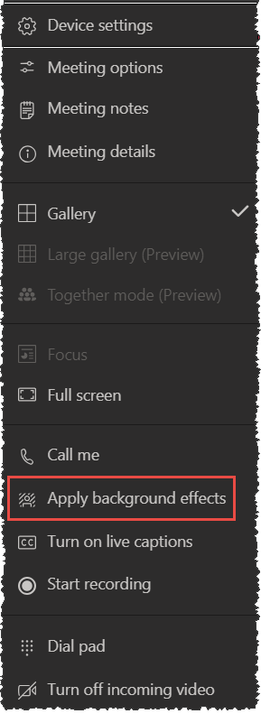
Customizing your background:
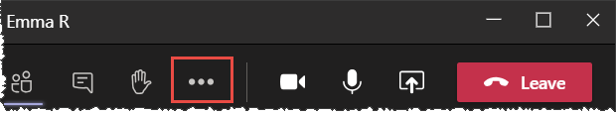
To add a background effect, select More options > Apply background effects. To test out the background effect select the background you like and then select Preview. When you decide what background you would like, select the background and then select Apply.

Raise your hand:
To raise your hand during a meeting select the Raise hand icon.
To lower your hand, select the Raise hand icon again.
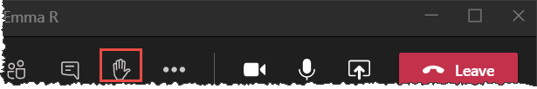

Table of Contents

How do I post a message or file to a team?

To post a message to a Team select Teams on the left icon bar, the team you want to send a message to, and in the Posts tab select New conversation.
Teams > Your team > Posts > New conversation.

To share a file with your team, select Teams > Your team > Files > New or Upload.
From New you can create a new folder or document within Teams.
Upload will allow you to upload a folder or document from your computer to Teams.
Table of Contents

How do I mention someone in a comment?

Any comment you make in Teams can be sent to a colleague by using the @ symbol and typing the person’s name. Whether you are commenting in a team chat or feed post, during a meeting, or on a document, that person will get a notification in their Activity feed that a comment has been directed toward them.

Collaborating in Teams

III. Collaborating in Teams

III. Collaborating in Teams

III. Collaborating in Teams

How do I upload files?

To upload any files into Teams, you must be in the OneDrive tab.
To get there, select Files > OneDrive. 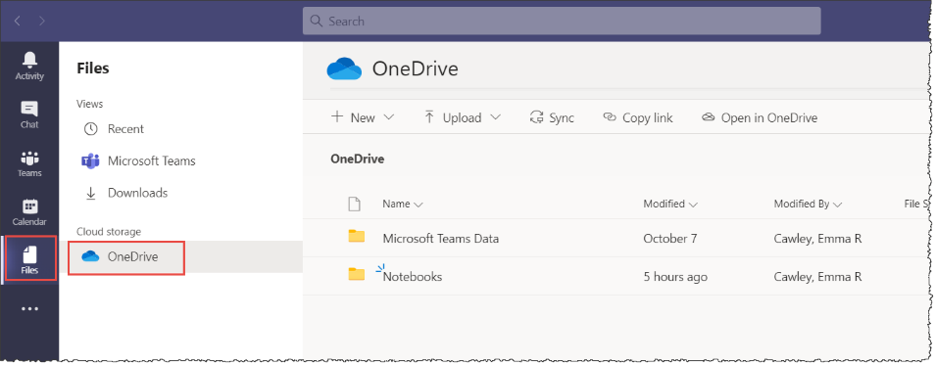
From there you have the option to create a new folder or document in Teams by selecting New, upload a document from your device by selecting Upload, sync your files on your device to OneDrive by selecting Sync, or open documents in OneDrive by selecting Open in OneDrive.
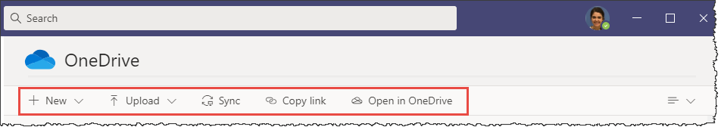
Table of Contents

How do I keep my files organized?

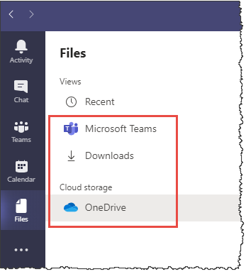
Files are stored in OneDrive, Downloads and Teams all of which can be accessed on the left-hand Files menu.
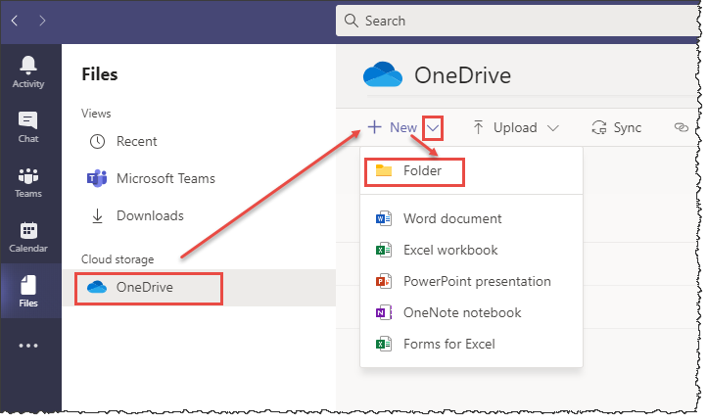
To create a folder to organize your files, select OneDrive and then the drop-down arrow next to New and then Folder to name and create your folder.
In the same drop-down menu, you can also create new documents in Teams by selecting Word, Excel, PowerPoint, etc.

Table of Contents

What are channels used for?

Channels are specific to each team that you are a part of and can be used to as mode of communication for a smaller or specific sub-team within the team and a place to collaborate and store files and documents.
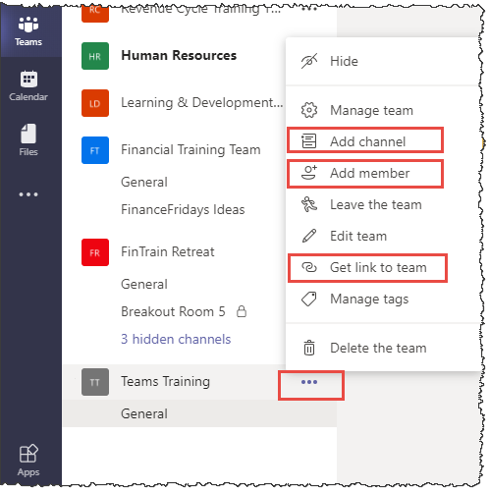
Every team has a General channel where members can post in the feed and access Files, Wiki, and other apps.
To add another channel, select More options (three dots) next to the team name and then Add channel.
This is also where you would go to add members to the team or get a link to the team channel to invite members to the team.
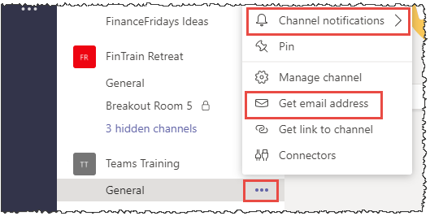
Once a channel has been created, clicking More options next to that channel allows you to set notification preferences, get the email address to the channel to share materials and resources efficiently and more.
Table of Contents

How do my colleagues and I work on a document at the same time?

To share a link to a document within a team select the channel you want the link to be accessible.
From there, select New conversation and attach the file.
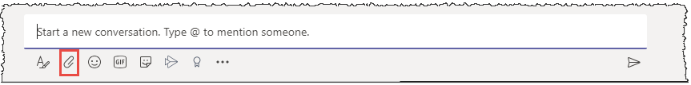
Once the file is attached your colleagues can edit the file by selecting More options > Edit in teams.
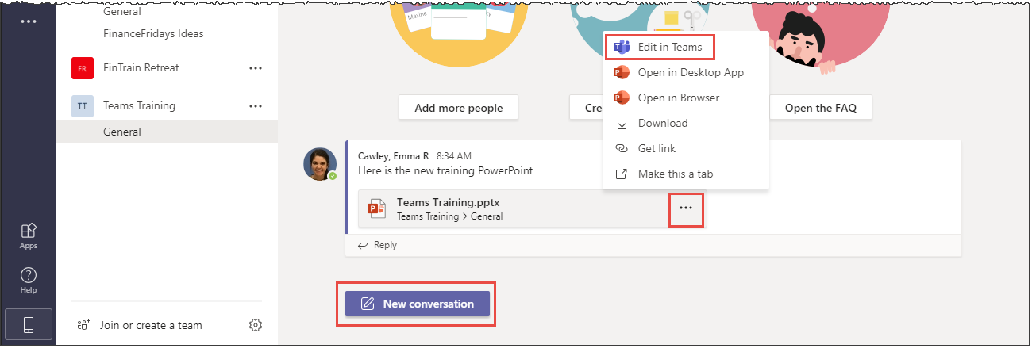
More options also gives your colleagues the opportunity to open the file on their desk top, download the file, or make it a tab so that it is easily accessible from the top of the channel navigation bar.

Use the Comment button on the document toolbar to make comments on a specific piece of the document to your colleagues.
If you use @ and your colleague’s name in your comment, they will receive an email alerting them of the comment.
If two colleagues are working in the document at the same time, they can chat in real time by clicking Conversation on the toolbar.
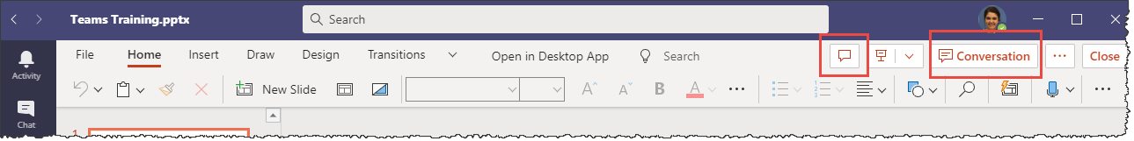
Table of Contents

Planner/Tasks

Additional Resources

IV. Additional Resources

IV. Additional Resources

IV. Additional Resources

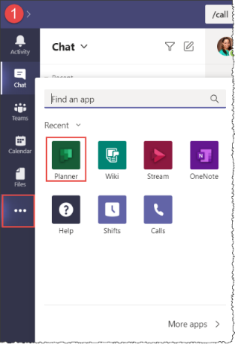
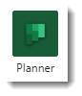
Planner is an app that allows you to organize your tasks and monitor projects with your team.
To access Planner, click on More apps > Planner.
To create a Task List for yourself, select Tasks and click on New task.
Type a title for your task, such as the name of the project you are working on and hit enter to create the task.

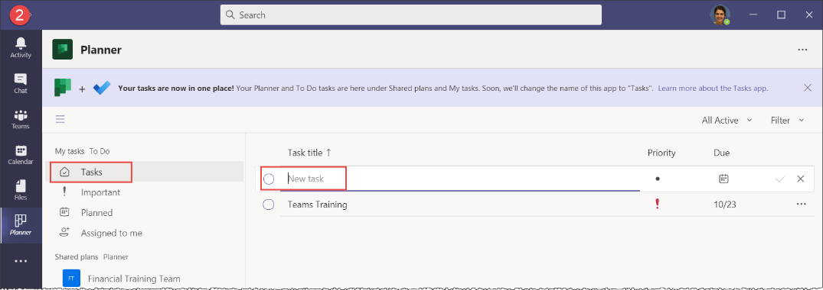
Once the task has been created, you can edit the name of the task, mark as done, set the priority, due date, write a description and add tasks within the task by clicking on the title of the task in your tasks list.

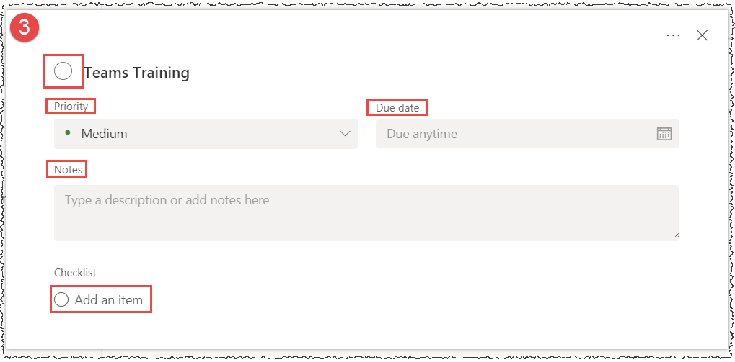

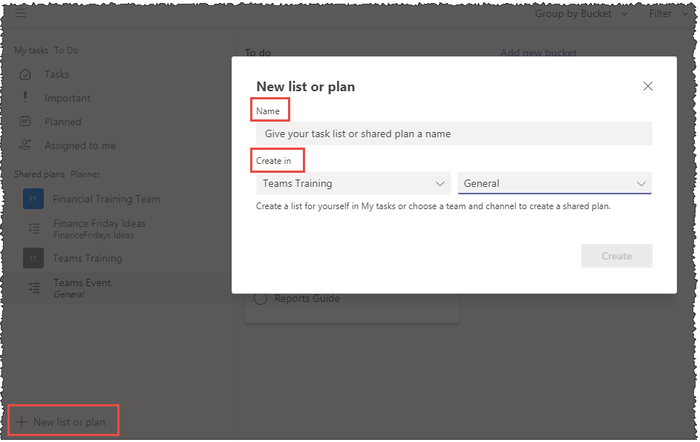
To create a plan for a team, select New list or plan.
This allows you to name your task list or shared plan and choose a team and channel to assign the plan or task list to.
Once the plan is created add tasks, set the priority and due date, and assign specific tasks to team members.

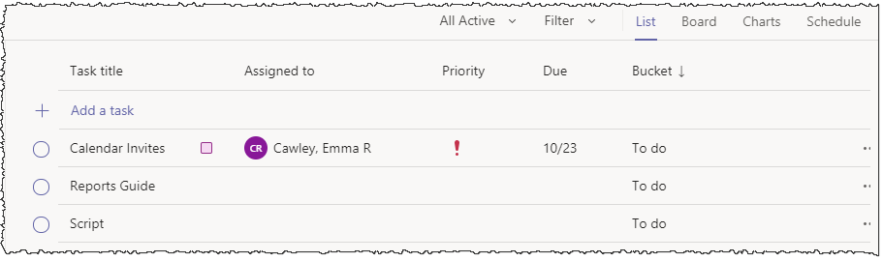

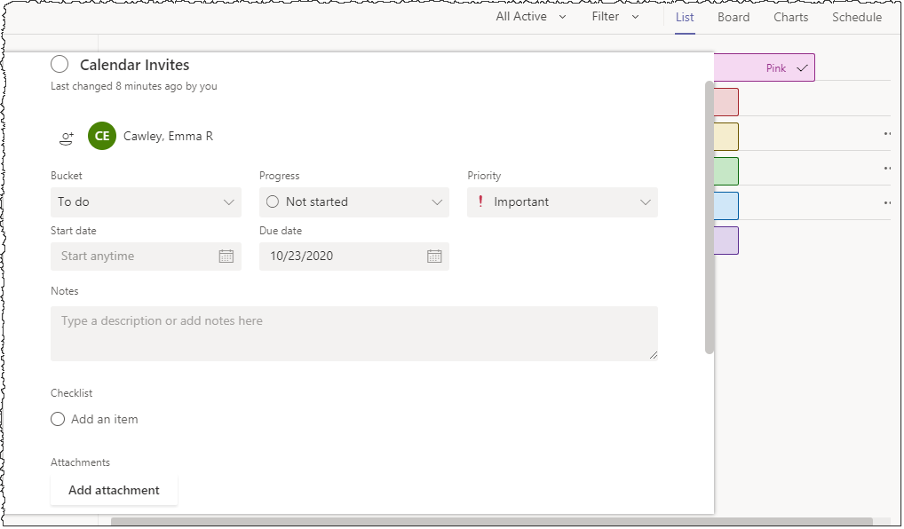
For each specific task, share notes, attachments, or create task lists for the task by selecting the task title from the List tab.
Color tabs will appear on the right side of the window.
Assign each color a label and use it to classify each task.

The Board view from the top right-hand navigation bar allows you to see each project laid out as tiles, organized by buckets such as to do tasks.
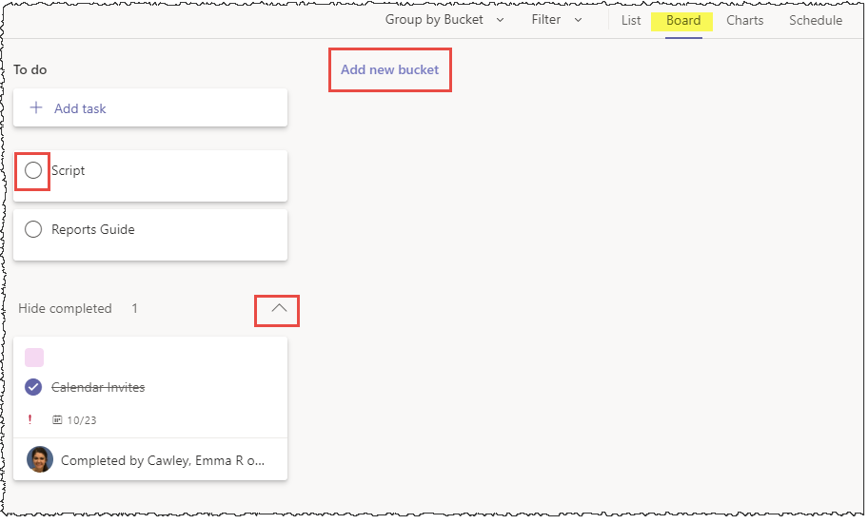
To do shows each task that has been planned or assigned.
Once a task has been completed, click the circle next to the task name and it will move to Show or Hide completed below.
To create a new bucket, select Add new bucket.

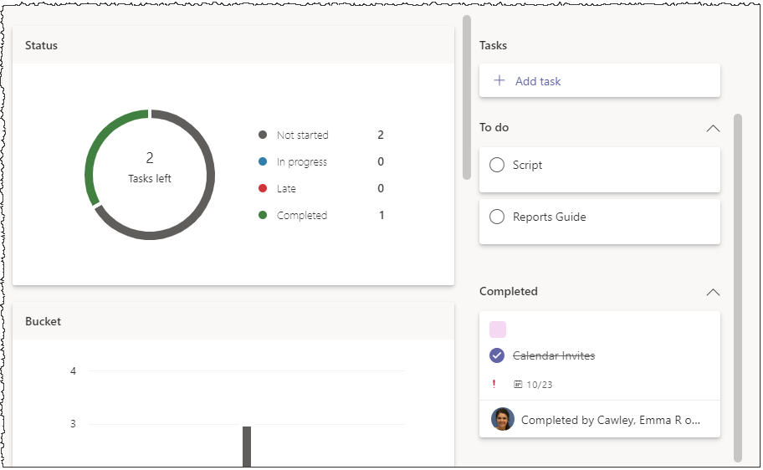
Charts tracks the progress of each task.
Charts shows several different graphs to represent the progress of the whole project (Status).
Bucket displays progress of each task.
Priority shows what tasks have been done at each priority.
Members shows which members of the team have completed tasks.

Table of Contents

Wiki

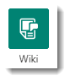
Wiki is a way to keep notes within a team.
Each Team comes with a Wiki tab included.
To access a wiki tab from a team, select the team and then select Wiki from the tab bar at the top.

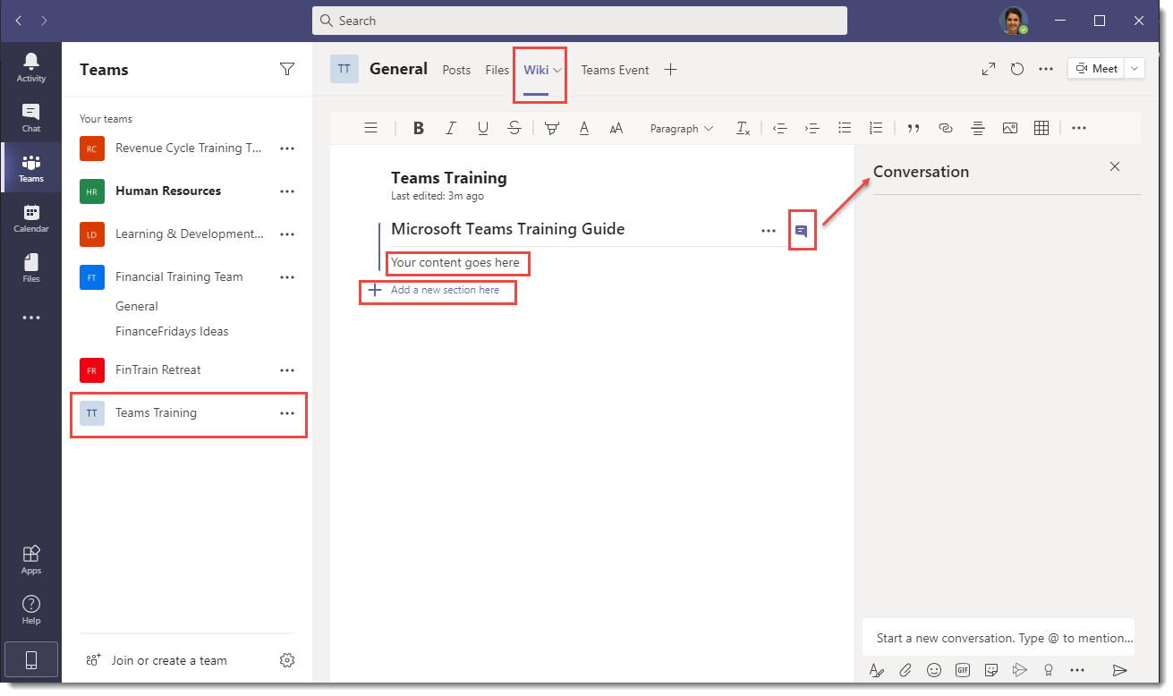
All Wikis are organized by pages and each page is organized by sections.Type your content under the title page and add a new section by hovering your mouse over the left side of the page and selecting + add new section here.
To converse with a colleague who is in the Wiki, select the Show section conversation icon on the right.
Table of Contents

OneNote

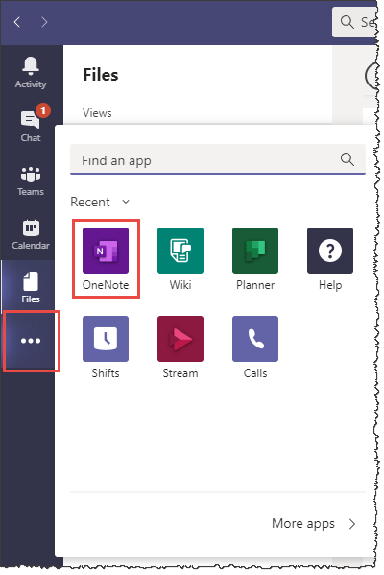
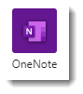
OneNote is a notebook that lets you collaborate on digital content with your team.
To access OneNote, select More options > OneNote.
From there, a new notes page will open.
Title your note and click onto the page where you want to insert text and a textbox will appear.

The tabs at the top of the page show you Recent notes in Teams and Teams that have created notes.
Notes are automatically saved to OneDrive.
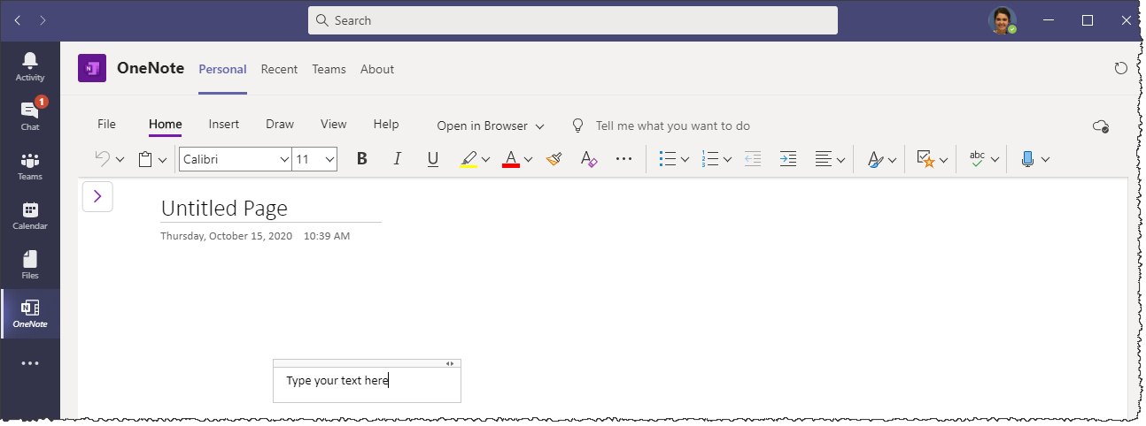

Table of Contents

Stream

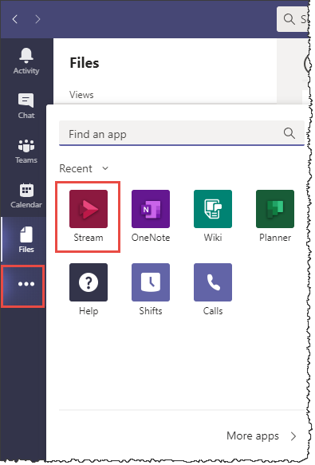
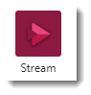
Stream allows you to create and share videos company-wide or within a team or stream live events.
To access Stream, select More options > Stream.
Once Stream opens, it will take you to the Watchlist homepage.
To access all of Stream’s features, select Microsoft Stream on the top right.

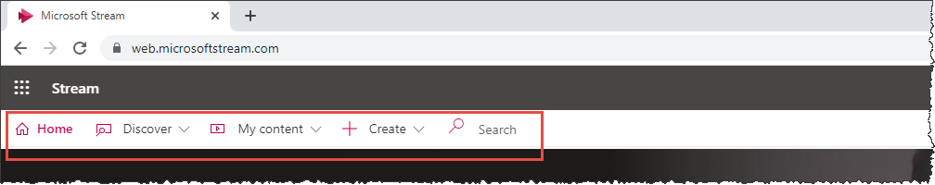
This will take you to the Stream website where you can, Discover new channels, videos, groups, and people, manage your videos under My content, and Create live events, groups, channels, record your screen, and upload videos from the navigation tabs on the top of the webpage.

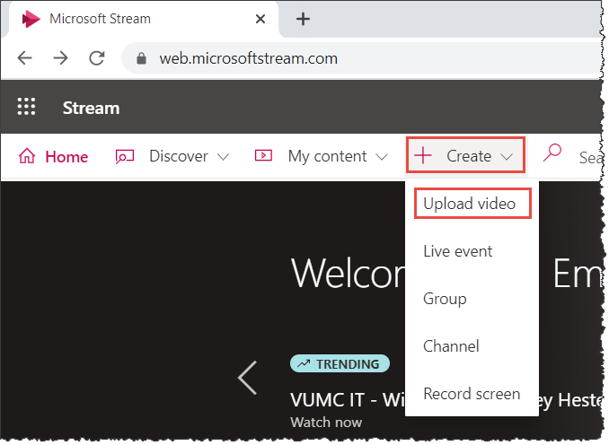
To upload a video from your device, select Create on the navigation bar and then Upload video.
From there, you can upload a file from your computer.

To schedule a live stream event, select Create > Live event.
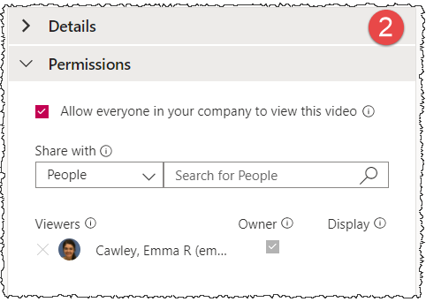
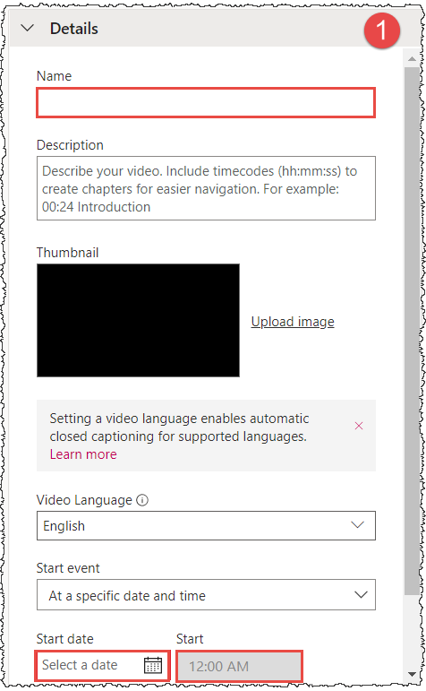
From there, you will set a default language, event details, permissions, and options for comments, captions, and subtitles.

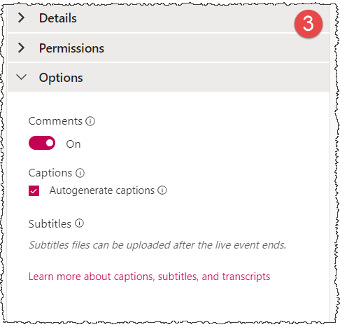

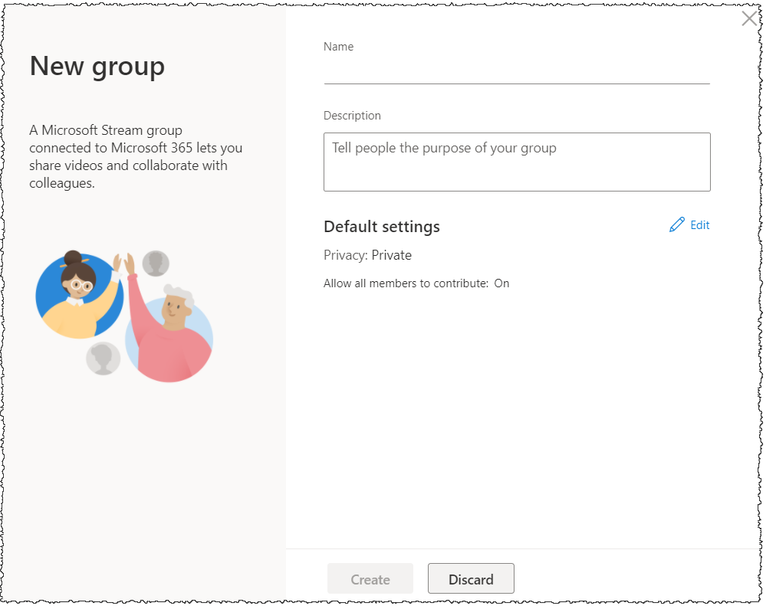
You can create a group to help colleagues keep up with your video content by selecting Create > New group.
Title your group, give it a description, and determine the settings before creating the group.

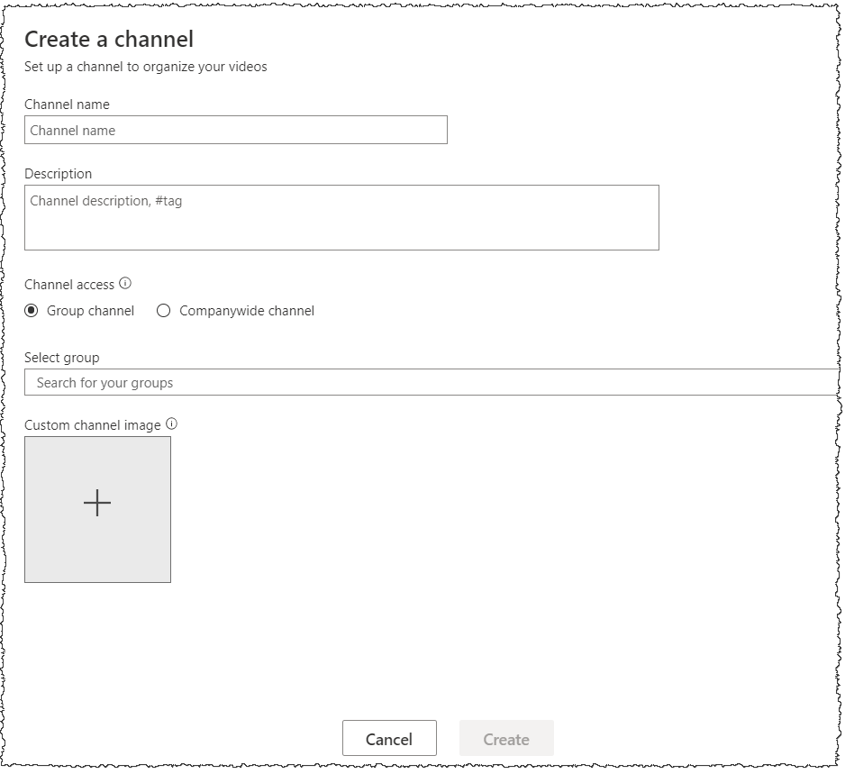
Like groups, you can create a Channel to organize your videos by selecting Create > Channel.

The Record your screen function is useful if you are creating instructional material or showing a demonstration of an online process.
To record your screen, select + Create > Record screen.
You have the option to turn your webcam on or off during your recording as well as your microphone by selecting the webcam and microphone icons at the bottom left of the screen.
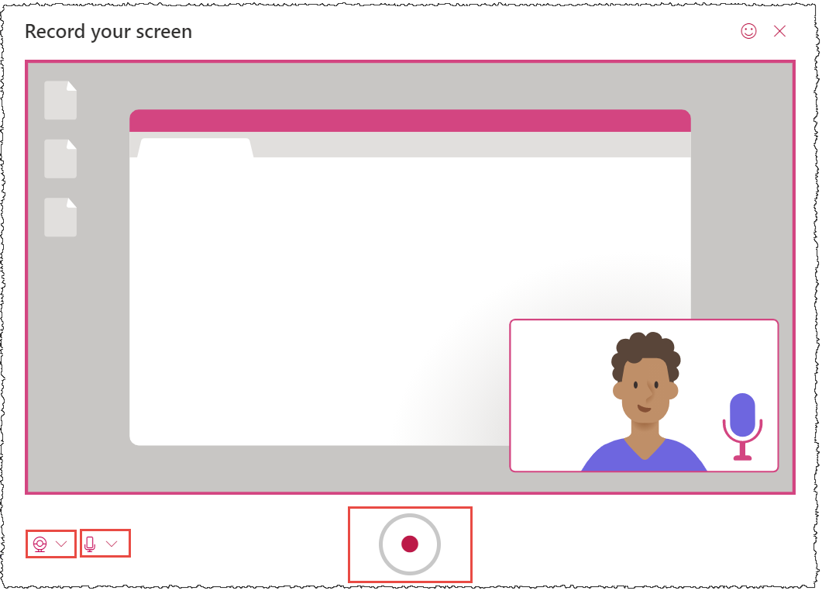
If you choose to leave both of these on, your video will appear in a small box at the bottom right of the video screen and viewers will be able to see and hear you as you narrate the steps of your demonstration.
To begin your recording, select the red Start recording button in the bottom center of the window.
There is a 15-minute time limit on screen recordings.

Table of Contents

Microsoft 365 Support Links

Microsoft Support website: https://support.microsoft.com/en-us/office/microsoft-teams-video-training-4f108e54-240b-4351-8084-b1089f0d21d7?wt.mc_id=otc_home

Microsoft Planner support: https://support.microsoft.com/en-us/office/sign-in-to-microsoft-planner-fe43c972-5a95-4071-86d4-423a64a3b21e

Microsoft Stream support: https://docs.microsoft.com/en-us/stream/overview

Top of Page

