PRODUCTS LOCATED ON THE UNIT / ORDER FROM SERVICE CENTER | Description
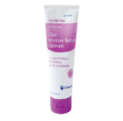  Critic-aid Cream  #83555 | Located on most units, this is the “GO TO” barrier ointment that will adhere to denuded skin.
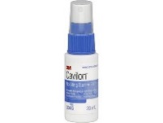  3M barrier spray  Spray # 1396  Wipe #1276 | 3M barrier spray or wipe (liquid Band-Aid) provides an invisible, waterproof layer of protection to the area of skin applied.
Calmoseptine ointment #26267 (also located in pharmacy)  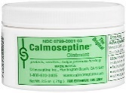 | Has calamine lotion to help with itching, and menthol to provide a cooling & drying effect.
ILEX protectant paste  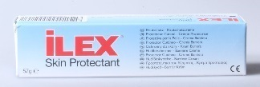  #123819 | May cover the Ilex with Vaseline or Xeroform gauze to keep from sticking to the under pad or hair.
PRODUCTS LOCATED IN PHARMACY | Description
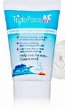  Triple Paste AF  *Miconazole Nitrate 2%  ointment | Moisture barrier with antifungal properties, use for fungal rash with incontinence. Will not stick to denuded skin.
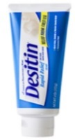  Zinc Oxide, Desitin, Boudreaux Butt Paste  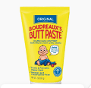  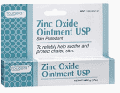 | OTC Moisture barrier products
Vanderbilt Happy Hiney ointment | Contains Questran to help break down the fats from the irritants in the stool.

