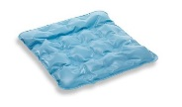Head Pressure Prevention
The Wound Care team and Pressure Prevention Committee have streamlined the many products for occipital pressure relief down to one recommendation for the VUH adult units.
Use the Regular Waffle Cushion (AKA Blue air chair cushion) (PMM# 1782) with a pillowcase for any patient with a Braden of 18 or less that does not reposition their own head, has an existing head wound, or anyone that has a neck contracture.
Do NOT use on unstable spine patients
For proper positioning place the cushion under the shoulders not just under the back of the head.

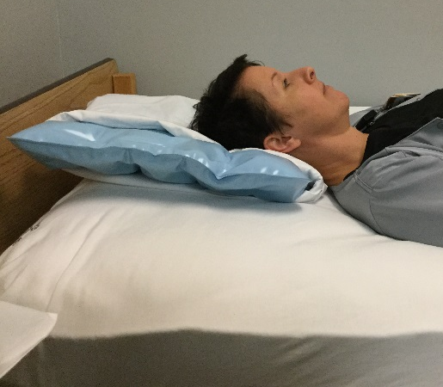
CORRECT WRONG
Z-flow cushions, Head Cradles, and Doughnuts should be REMOVED from all supply rooms and they should NOT be requested for adult units from Central Supply.
