Pressure Injury Prevention Items
Interventions based on the Braden Scoring of 1 or 2 for the risk assessment factors
BRADEN RISK FACTORS (if yes) | Then consider these INTERVENTIONS for your patient
Mobility  - Makes no changes in body positions  - Very limited on movements  Activity  - Bedfast  - Ambulation is limited to non-existent  Sensory  - Unresponsive  - Very limited response to stimuli | 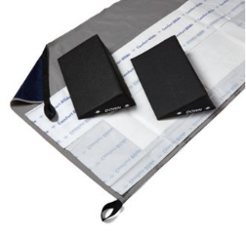  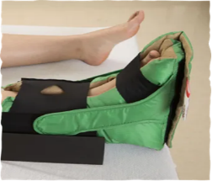  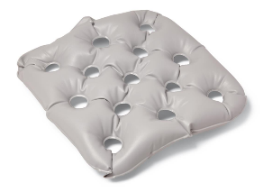  Repositioning system tshee# 143154  #112080  Chair Cushion #1782  Heel boot  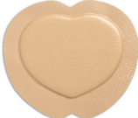  Reposition q 2 hours  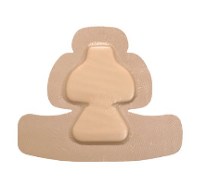  Mepilex heel  #137351  Mepilex sacral  #84549  heel foam #137351
Shear/Friction  - Needs maximum or moderate assistance in moving  - Slides down in bed or chair frequently | 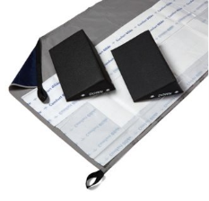  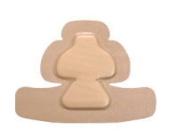  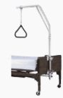  Repositioning system  Mepilex sacral  #84549  Mepilex heel  #137351  Trapeze
Nutrition  - NPO or clear liquids for greater than 5 days  - Eats less than 50% of meals per day  - Receives less than optimum tube feeds | 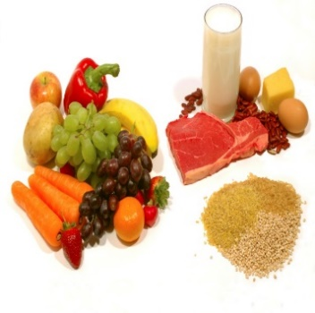    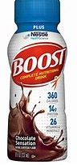  Consider Nutrition Consult
Moisture  - Constantly wet from urine or stool  - Linens changed once per shift |     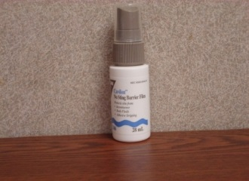  Other items to consider:  -Condom catheter  -PureWick female catheter  -Rectal pouch  -Bowel management system  Barrier cloth wipes  3M barrier #1396  Criticaid ointment #83555
11/20/2023

