User Guide:
Guide to using VA funds to purchase VUMC Core Services

Table of Contents
Activation of VA Funds (99999####) 2
Important Notes Regarding VA Funds 2
VA Fund Number: Viewing Remaining Balance 2
Requesting a Service or Equipment Reservation using VA Funds 3
Running Reports - Viewing Total Amount Invoiced 4
Reviewing Invoices 10
VA Rebate Voucher Program 11
VA Voucher: Activation and Granting Access to the VA Voucher: 11
VA Voucher: Requesting Services & Reservations 12
VA Voucher: Viewing Remaining Balance 13

Questions? Contact the Office of Research at VUMCcores@vumc.org

Activation of VA Funds (99999####)
Each investigator that has been authorized for use of VA funds will be assigned a “VA-TVHS” lab group in the system. When wishing to pay for core services with VA Funds, the PI or Lab member will need to select the VA Lab in order to access the assigned VA Billing Number (999999xxxx)
- The Office of Research will activate your VA fund number (999999####) upon approval from the VA Research and Development Administration Office (Contact: Marc Delgado).

Important Notes Regarding VA Funds
Investigators using VA funds will need to monitor the total spend against the VA fund to prevent the funds from being overspent. The PI or Lab Manager can use the reporting module to report on the total spend against a VA fund across all members of the lab.

VA Fund Number: Viewing Remaining Balance & Controlling Lab Member access to the VA Fund Number:
Lab members must be granted access by the PI or lab manager(s) to have the ability to purchase VUMC core services. Contact the Office of Research to grant other lab members access to use the VA fund. Our support team can be reached at VUMCcores@vumc.org.

PIs and Lab Managers can view the remaining voucher balance via the PI’s lab group module.
- Navigate to any VUMC core iLab module.
  - In the left-hand menu, click core facilities.
  - Open any of the VUMC core groups (This must be a VUMC core, not a VU core). You may have to change your view to ‘cores at partner institutions’.
- Once one of the VUMC core iLab sites is open, click the purchase order or PO tab.
- The VA billing numbers that you have access to will display.
- Click on the number directly for additional information. Once the detail view is open, you can then see the following items:
  - Allocated amount for the year.
  - Remaining balance (note, this may also include any encumbered activity that the core has not yet invoiced, such as pending equipment reservations or open project request.
  - List of lab members that have access to the number.

Requesting a Service or Equipment Reservation using VA Funds
Each investigator that has been authorized for use of VA funds will be assigned a “VA-TVHS” lab group in the system. When wishing to pay for core services with VA Funds, the PI or Lab member will need to select the VA Lab in order to access the assigned VA Billing Number (999999xxxx)

- When requesting the service or reservation, select the VA-TVHS Lab group.
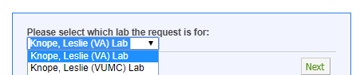

- Complete the service request or reservation request.

- In the payment information section, select your VA Fund Number (999999####) as the standing PO.
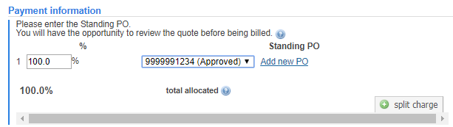

Troubleshooting: If you do not see your VA billing number, email the Office of Research at VUMCcores@vumc.org.

Running Reports - Viewing Total Amount Invoiced
From the left menu click the “reporting” label. The reporting functionality within iLab will allow users to generate reports of amount spent of specific funds or across a Lab.

- Click on the Reporting label in the left menu to navigate to the reporting module.
- Select Load Default to load the iLab default report settings (recommended).
- Enter the Report Settings:
  - Select the date range for the report.
    - Start Date: Day funding started for the current VA fiscal year.
    - End Date: Today’s date.
  - Select the date field: Change to Billing date.
  - OPTIONAL: Click Charts & Tables to adjust and modify the reports that will populate.
- Click Run Report

To refine the report and specify the data down to the specific VA Fund Number (‘PO Number”):
- Using the filter panel on the left side, adjust the filters (i.e., “payment number”) to refine the report to just your VA rebate voucher or VA Fund Number (999999xxxx)
- Click Apply filters.
- The report will update with data specific to those filters.
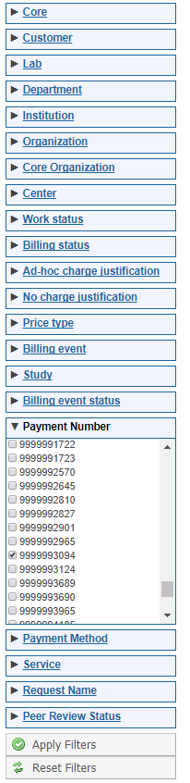
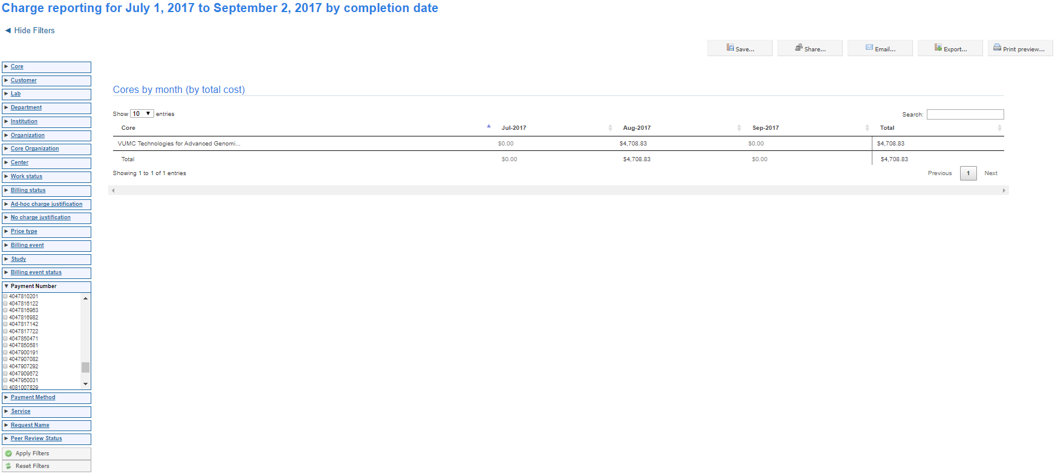
To review the expense activity, download the data or export the reports to excel.
- Click Export
- Select Source data as CSV/XLS.
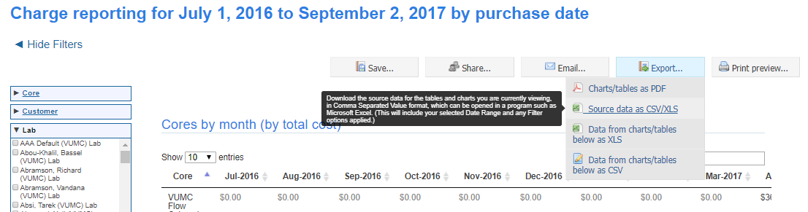

- An excel document will download. All activity set to charge to your VA billing number will be included.

- Sum the Total Price column to calculate the total amount spent on your VA billing number with the specified date range.

- For Reference Only: Date columns:
  - Purchase Date: Date the service was requested or date of reservation
  - Completion Date: Date the core completed the work and billed the charge.
  - Billing Date: Date the core finalized all charges for the period.

- Charts & Tables: This information can also be viewed without generating an export file through the Charts and Table option.

  - In the report settings, click the Charts and Tables icon.
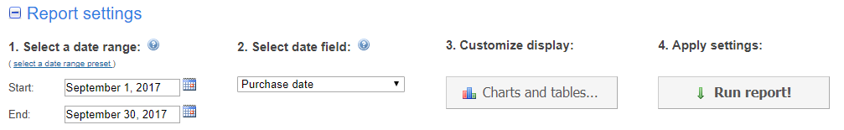

  - TIP: Click the red x to remove all the pre-populated charts.

  - Click Add a new chart or table.
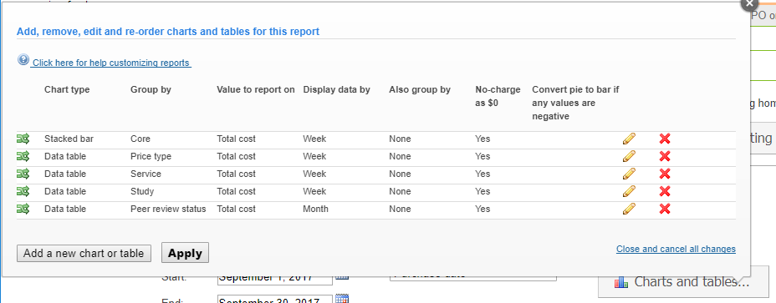

  - Select the following options from the drop down options for each of the fields.
    - Click the green check icon to save the filter choices.
    - Click Apply to save the changes.
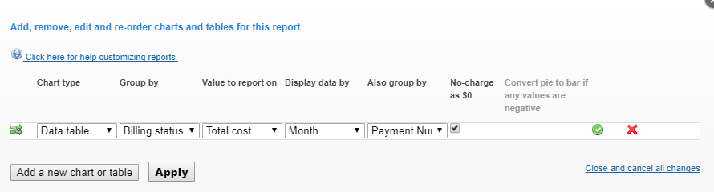

  - A data table for each cost center within the user’s purview will display.
    - Tip: Use the filter panel to drill down to a specific center number.
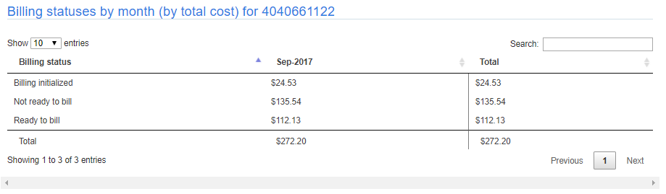

User can save report settings including the Charts and Tables to quickly run as needed.
- Enter the report settings.
- Enter the Charts and Tables Settings
- Run the Report
- Click the Save icon.
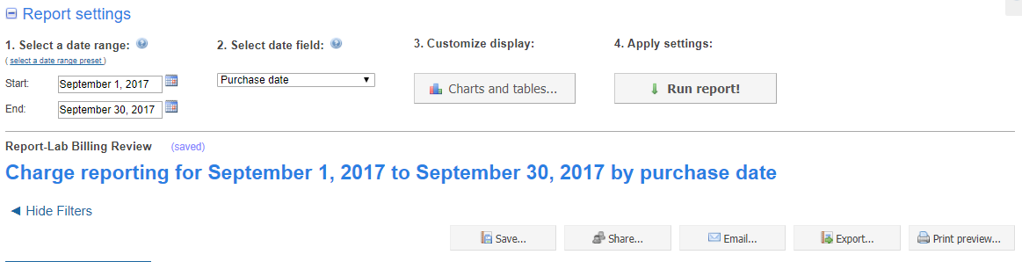

- Enter a name for the report. Click Save.
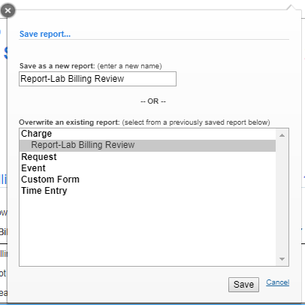

- To run a saved report:
  - Click Load saved
  - Select the saved report.
  - Click Load

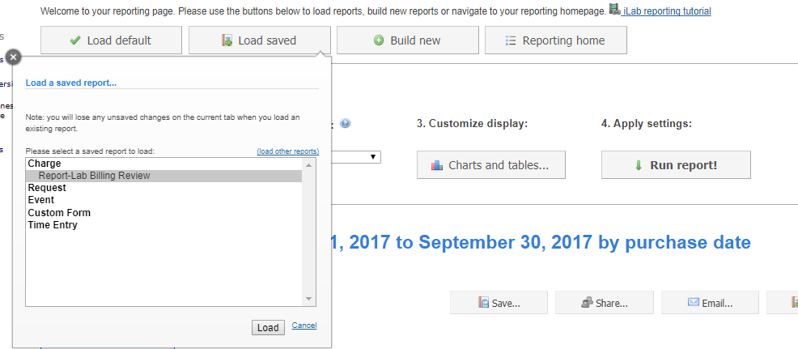

  - Update the dates for the report and click Run report!
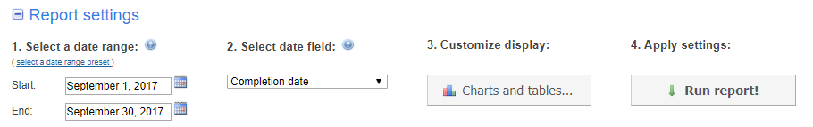

Reviewing Invoices
Invoice copies can be downloaded from the iLab Application. The invoice copy contains detailed information about the charges.

Who can view invoices in iLab Application?
- The invoice owner assigned for the PI’s lab group will receive the email notice when an invoice is created.
- PIs or Lab Managers have access to view invoices charged to their PI’s lab group.
- Department Administrators have access to invoices charged to their department’s cost centers.

How to Review Invoices in iLab Application:
- Click on Invoices in the left-hand navigation menu.
- A list of invoices will appear.
- Use the filter panel on the left to reduce and sort the invoices that display.
  - Example: Use the ‘payment number’ filter and select the invoice number. Click ‘Apply Filters’.
  - Example: Use the ‘keyword search’ and type in the invoice number. Click ‘Apply Filters’.
- On the far right, click the magnifying glass to view the actual invoice.
- To download a copy, click the pdf icon in the top left of the screen.

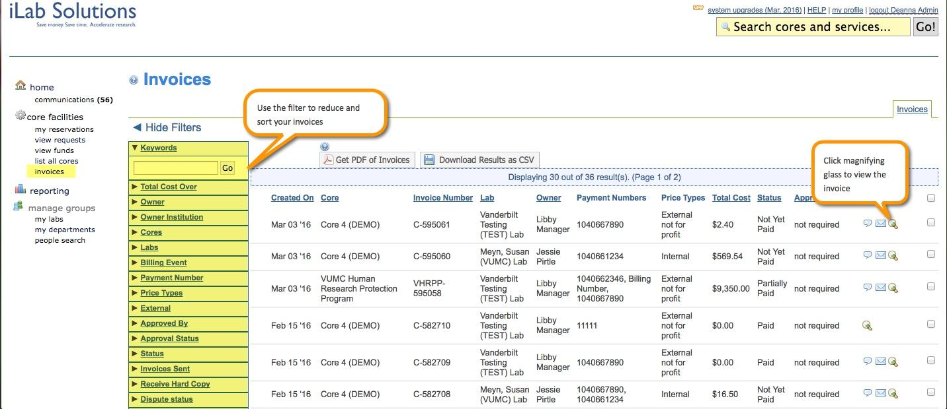

VA Rebate Voucher Program
The VA Rebate Voucher Program is designed to offset the 10% administrative fee incurred by VA funded investigators for the School of Medicine core purchases. Distributions will be based on the aggregate 10% fees assessed on actual core purchases. Faculty who have not spent VA funds in a SOM core are not eligible for these rebates.
Guidelines for the program:
- We expect to distribute rebate vouchers to eligible faculty every six months, based on VA-funded core purchases made in that period.
- Budget for rebate vouchers is limited to $40,000 per fiscal year. Therefore distribution may be halted if the limit is reached in any given year.
- Eligible faculty will be asked to select the core(s) for redeeming their rebate vouchers. Rebate vouchers will be redeemable only in the specified core(s).
  - NOTE: Vouchers must be used for VA-related projects, per guidance from the VA Research and Development Administration Office (Contact: Marc Delgado)
- Rebate vouchers will typically expire in the same fiscal year in which they are awarded. Once expired, vouchers cannot be reactivated.

VA Voucher: Activation & Controlling Lab Member Access to the voucher:
Vouchers are activated in iLab via an automatic feed from StarBRITE. The Office of Research will send an email to the PI once the VA Rebate voucher has been activated.

Once a voucher has been added to iLab, it will automatically be assigned to the PI only. The PI and/ or the Lab Manager will need to grant access to the center for any lab members or lab managers.
- Click on my groups on the left side of the iLab page.
- Click the lab name under the Labs/Groups I Manage section.
- Click the Membership Requests & Billing Numbers tab to view the fund grid.
  - All fund numbers for the lab.
  - Expired funds will display in red text.
- All lab members and active centers will be displayed.
  - Check the box on the row for the user to grant access to the specific voucher number.
- The system will automatically save your changes.
  - All new changes will be highlighted green.
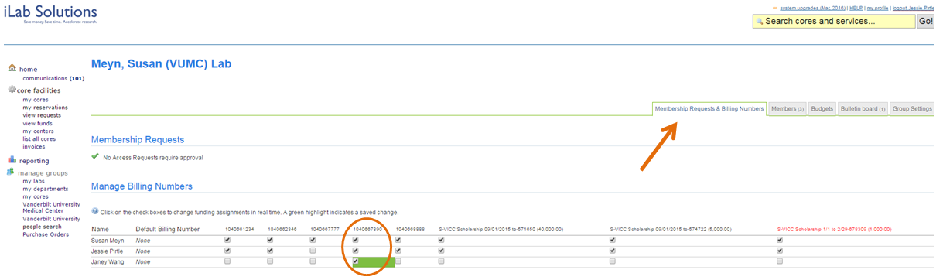

VA Voucher: Requesting Services & Reservations
Vouchers are activated in iLab via an overnight feed from StarBRITE. The Office of Research will send an email to the investigator once the VA Rebate voucher is activated. Since this funding is provided by VUMC, the voucher will display in the PI’s VUMC lab group.

When wishing to pay for core services using the VA Rebate Voucher, the PI or Lab member will need to select the PI’s VUMC Lab group in order to access the voucher fund.

- When requesting the service or reservation:

VUMC investigators select your (VUMC) Lab Group:
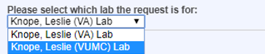

VU investigators select your (VUMC Scholarship and Voucher) Lab Group:
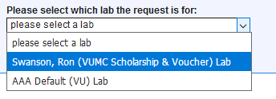

- Complete the service request or reservation request.

- In the payment information section, select your VA Rebate Voucher Number (V00000#####).
  - NOTE: The remaining balance of the voucher displays in the payment dropdown menu.
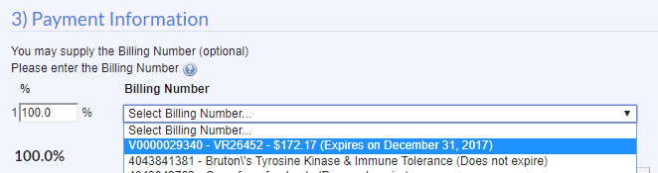

VA Voucher: Viewing Remaining Balance
PIs and Lab Managers can view the remaining voucher balance via the PI’s lab group module.
- Click on my groups on the left side of the iLab page.
- Click the lab name under the Labs/Groups I Manage section.
- Click the Membership Requests & Billing Numbers tab.
- Hover over the VA rebate voucher fund, an information box will display the following:
  - StarBRITE VR Award Number
  - Expiration date
  - Assigned core facility
  - Remaining Balance
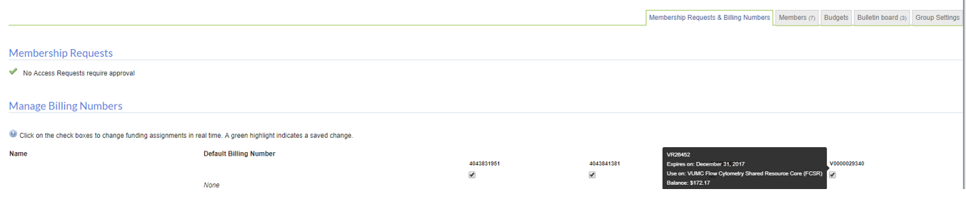
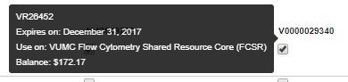

All lab members with access to the specific voucher fund can view the remaining balance when requesting core services or reservations.
- The remaining balance and expiration date displays in the payment information drop down field.

