Registration Instructions:
Access to iLab Solutions for VUMC Users
(VUMC PIs, Lab Managers, and Lab Members)

Account Access & Login Credentials
VUMC Users (PIs, Lab Managers, & Lab Members) must register for an iLab account before being able to access VUMC Cores in the iLab System.

Once registered, All Vanderbilt University Medical Center (VUMC) users will use their VUNet ID and ePassword to access the application.

Account Registration for First-time VUMC PIs, Lab Managers & Lab Member Users
If you’ve not logged into iLab before, you’ll need to register. To register, complete the following steps:

- Go to the iLab application here: https://vumc.corefacilities.org
  - All users will use their VUNet ID and ePassword to access the application.

- Click the here link under the header Internal VUMC or VU user.
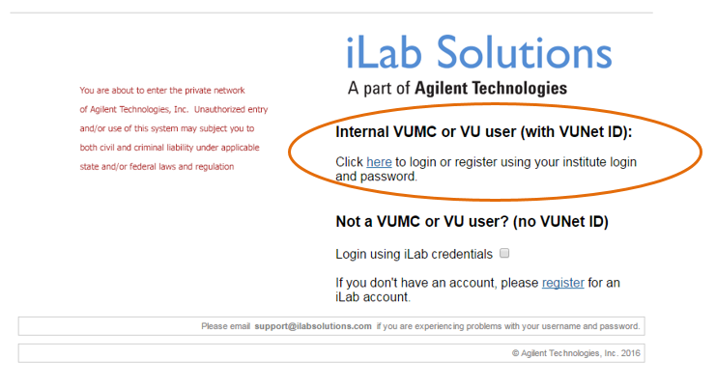

- A VUNet ID login screen will display.
  - Enter your VUNet ID and ePassword.

- A registration page will open.
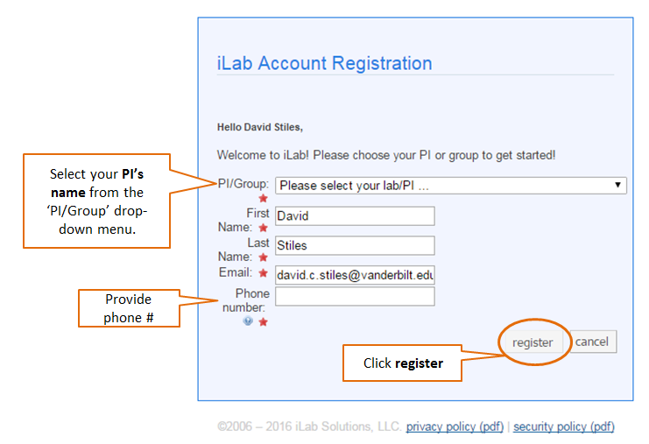

- It will pre-fill you first name, last name and phone number.
  - Complete any fields that have not been pre filled.

- In the PI/Group drop down menu, search for the PI’s last name and choose the PI as the lab.

  - If you do not see the PI’s name in the PI/Group drop down menu, select the AAA Default (VUMC) Lab as the lab name.
    - The Office of Research will have a Lab created in the PI’s name and contact you with additional instructions.
    - NOTE: The PI will need to register for an account before the Office of Research can finish your registration.

  - If you work with multiple PIs, please select one to initially set up the iLab account.
    - Next, send an email to VUMCcores@vumc.org with a list of the other PI names.
    - The Office of Research will update your iLab account and send a confirmation email.

- Click register.

- Once you register, the following message will display.

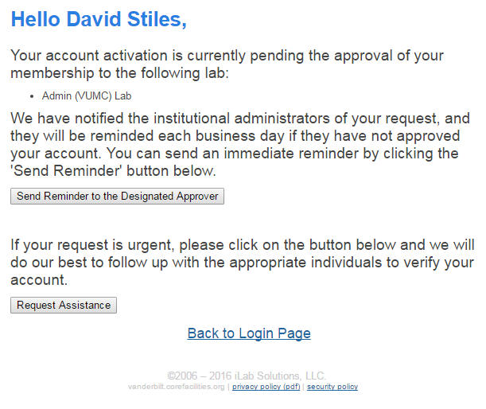

- Your account will need to be approved.
  - The Office of Research will approve requests within 24-48 hours.
  - The PI and/or the Lab Manager also have the ability to approve research requests as needed.

- Upon account request approval, you will be able to access and request services from VUMC cores and review invoice reports.

iLab User Support
User Guides and FAQs can be found on the VUMC Office of Research website. Please visit the following webpage to access user support materials.

https://medschool.vanderbilt.edu/oor/vanderbilt-cores-ilab-solutions-transition

