Assignee ID Overview
The assignee ID can be selected on an iLab request or calendar reservation when paying with a VUMC program worktag.
- The assignee ID field will only display after a VUMC program worktag is selected as the payment number.
- All available assignee IDs will display as an option. The customer will need to ensure the correct number is selected. No additional access is required.
- Use of an assignee ID is optional.
Assignee ID selection is not available when paying with a cost center, grant worktag, or gift worktag per Workday system behavior.

Utilizing the Assignee ID on New Requests

Service Requests

- Request the service as usual. Remember to select the PI’s “VUMC” lab group when submitting the request.
- In the payment information section, select the program worktag.
Reminder: the assignee ID option is only available for VUMC program worktags and is not a required field.
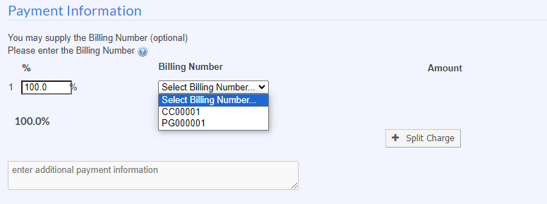

- The assignee ID filed will display after the program worktag is selected. The assignee ID filed is a searchable field. You will need to enter at least 6 characters to begin the search.
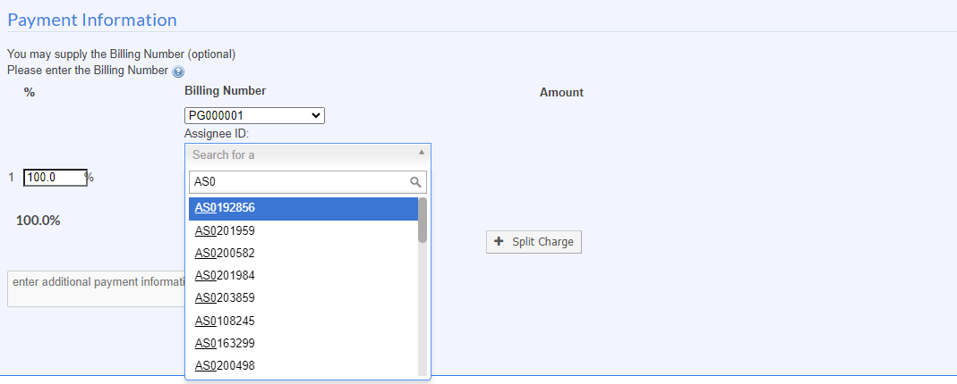

- Select the assignee ID that corresponds to the PI and program worktag selected on the request.
Note: all VUMC assignee IDs will display in this search. It is the customer’s responsibility to ensure the correct assignee ID is selected for the PI and funding.
- Submit the request.

Calendar Reservations
- Start the reservation, by dragging and dropping on your preferred timeslot.
- Select the PI’s “VUMC” Lab Group.
- In the payment Information section of the reservation screen, select your program worktag.
  - The additional field for assignee ID selection will display.
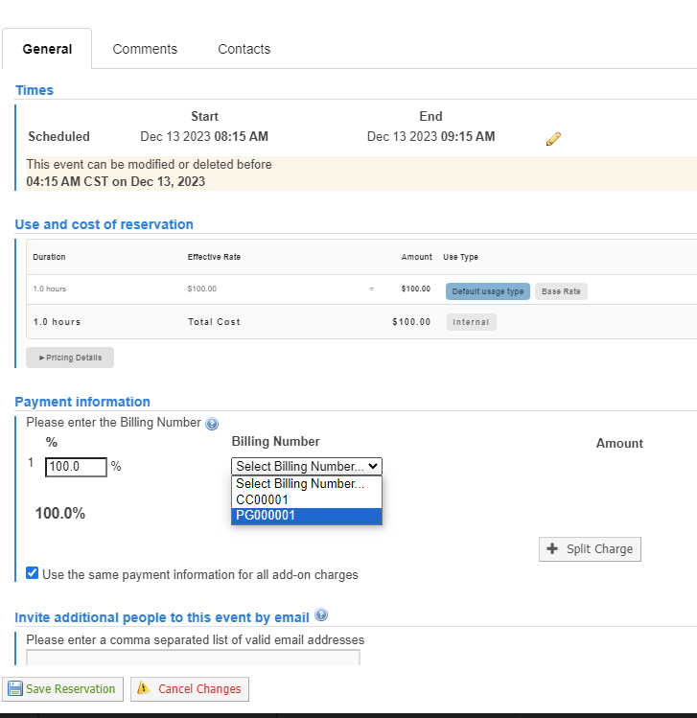

- To select an Assignee ID, begin to key in your assignee ID to search for the ID number. Given the number of assignee IDs available, please type at least the first 6 characters of the assignee ID to start seeing the results.
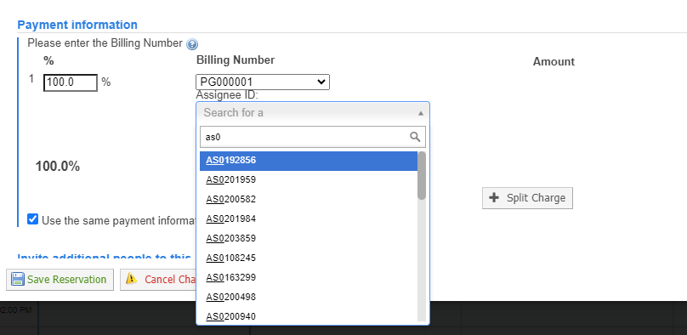

- Select the assignee ID that corresponds to the PI and program worktag selected on the request.
  - Note: all VUMC assignee IDs will display in this search. It is the customer’s responsibility to ensure the correct assignee ID is selected for the PI and funding.
- Submit the reservation.
Additional Notes

- The assignee ID will not display on the iLab invoice.
- The assignee ID will be available for review on the service request or calendar reservation.
- The Workday Department Transaction Detail report will display the assignee ID if included during the iLab billing process.

Working with Cores that use workflows outside of iLab to request services.
Some VUMC Cores do not use iLab service request submission or instrument reservations. However, all charges are entered and invoiced via iLab. For these cores, please provide the billing number to the core facility, including the assignee ID number if appropriate.

The core will have the option to enter the Assignee ID during the charge entry process. This option is not available to cores billing via the charge entry upload process.
      - In the billing number field, if a Program Worktag is selected (PG), then the additional Assignee ID field will display. This is optional.
      - To select an Assignee ID, begin to key in your assignee ID to search for the ID number. Given the number of assignee IDs available, please type at least the first 6 characters of the assignee ID to start seeing the results.
      - The Assignee ID field will not display if a Cost Center, Gift Worktag, or Grant Worktag is used in the billing number field.

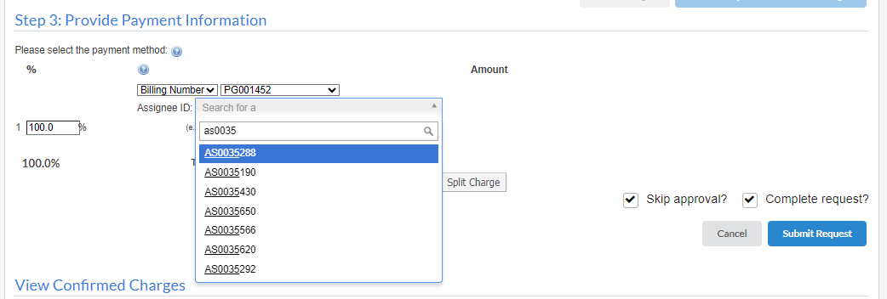

Questions? VUMCCores@vumc.org

