Center Administrator Allocates Scholarship Funds to PIs

Once the scholarship period and core allocations have been set up in iLab by the VUMC Office of Research, the designated center administrator can view and manage the allocation of funds to each core under their center or Center Fund.

* The center administrator will receive an email once the center fund has been created.
* They can log into iLab to view the center fund by clicking on the Center Fund tab once they access the center’s page.

**NOTE: Scholarship allocation amounts must be a whole number (example: $1,000). The system will not accept decimals.**

Overview of Workflow:

1. Center Administrator submits Core Allocation to the Office of Research.
   1. Provide supporting documentation: (a) NIH Budget Document (b) Breakdown of Budget by Core.
2. OOR will review with core’s administrative officer and document OOR Approval.
3. OOR will create allocation to the specific VUMC cores in the iLab Center Modules.
4. Click the **Center Name** to open the center module

Center Administrator assigns the Core Group Allocation to the Member PIs

1. Open the Center Module by clicking **My Centers** in the left-hand navigation panel. Click the **Center Name** to open the center module.
2. Click the **Research Groups** tab. Validate that all PIs to receive an allocation are listed.
   1. Add new lab groups as needed.
   2. For more details and instructions on this process, review the “*TROUBLESHOOTING: PI is not available in the dropdown list when allocating the specific scholarship fund*” section of this iLab SOP.
3. Click the **Scholarships** tab of the Center Module

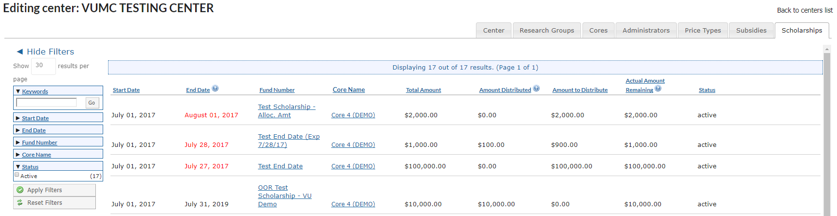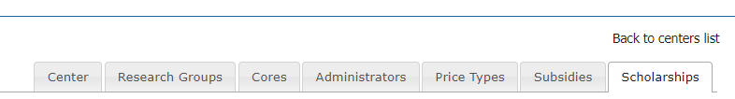

1. Click on the **Fund Number** to view the fund details and assign values for the center’s PI members.

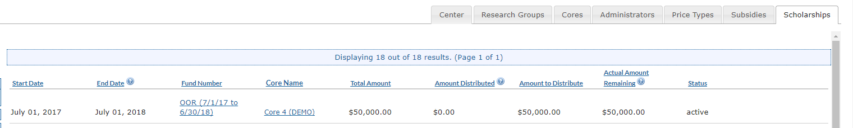

1. 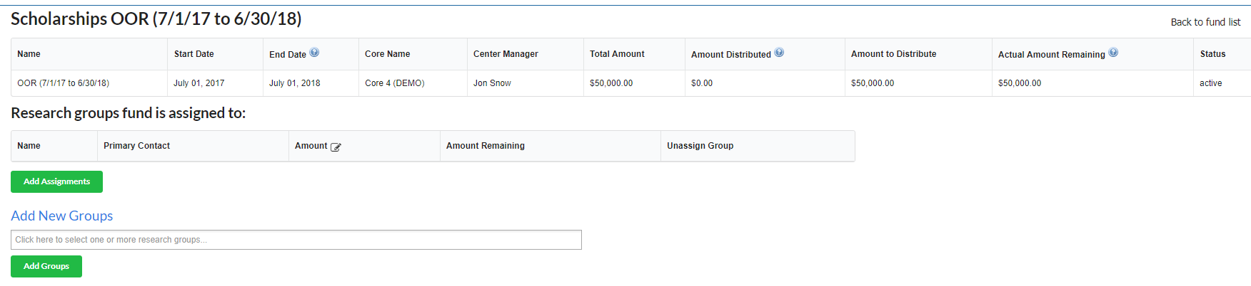**A new page will open with the scholarship fund details.**

1. **Below the details is a list of all the research groups (Member PIs) that have been associated with the specific scholarship fund.**
   1. To add additional PIs to this specific scholarship period, search in the **Add New Groups** section**.**
   2. **Select** the name (s).
   3. Once all names are selected, click **Add Groups**.

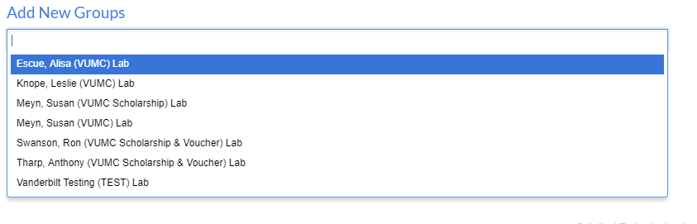

1. **Allocate the core’s total amount by assigning a value in the amount field for each of the PI Lab Groups.**
   1. ***NOTE***: the amount **MUST** be a whole dollar amount to prevent any system errors (Example: $1,240)
2. **After entering the allocation amounts for each PI Lab Group, click Add Assignments.**
   1. We recommend adding all amounts for each PI in the grid before clicking the ‘Add Assignments”. Each time the “Add Assignments” button is selected an email is generated to all PIs in the grid.

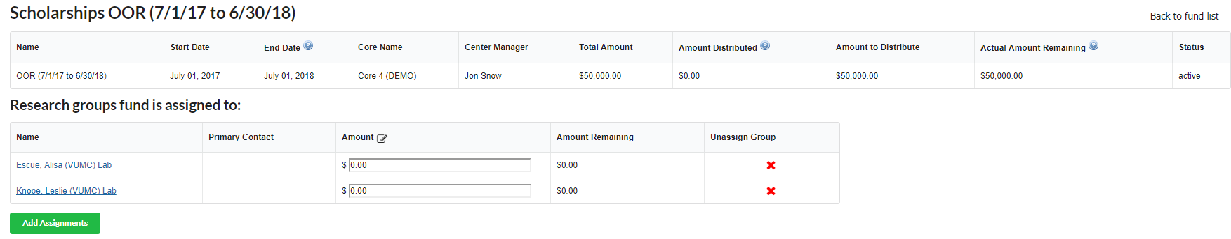

1. 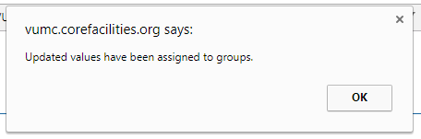A notification window will display. Click **OK.**
2. **The amount still available to be distribute will update on the scholarship period details section.**

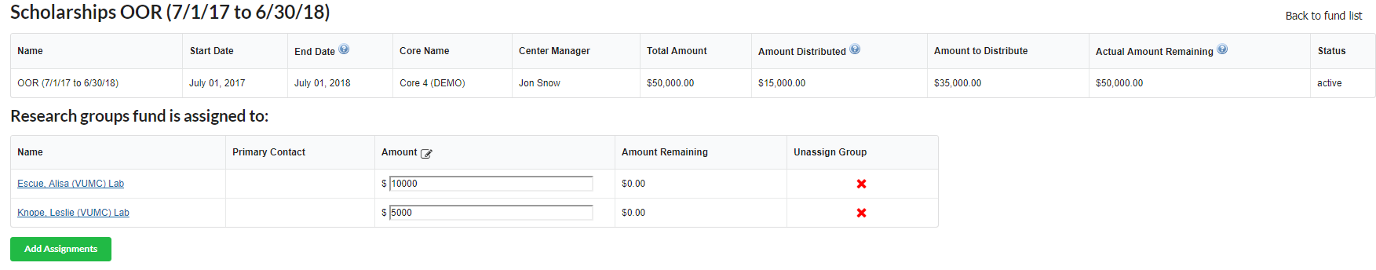

1. **The PI and the PI’s financial manager will receive an email notification regarding the new scholarship allocation.**
   1. This email does not include the scholarship fund number. The investigator will need to access this information in the iLab system.

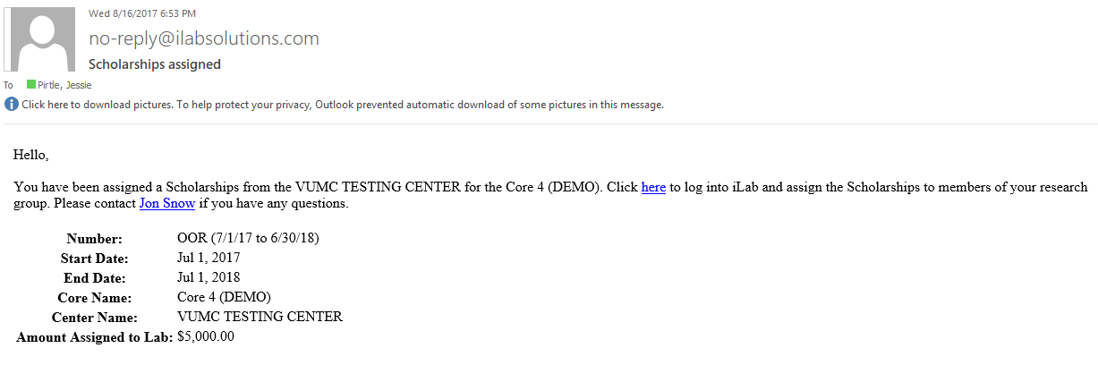

1. Click **Back to Fund List** to exit the research allocations page.



1. **The PI or the PI’s Lab Manager will need to log into iLab and grant access to the newly created scholarship fund for the PI and any other lab members that wish to use this fund to make core purchases. | The Department Administrator can also do this on behalf of the PI or Lab manager.**
   1. See the troubleshooting section at the end of this user guide for additional details on fund grid management.
   2. **Troubleshooting: Fund Grid Management**

## TROUBLESHOOTING: PI is not available in the dropdown list when allocating the specific scholarship fund.

1. The **research groups** must be added to the center module on the **Research Groups** tab before they can be added to the scholarship period.
2. At the bottom of the **Research Groups** tab, search for the name of the PI within the Search for a Group field.
   1. A list of the PIs will display, select the PI’s name.
   2. Select the PI’s Lab Group name, and the click **Add**

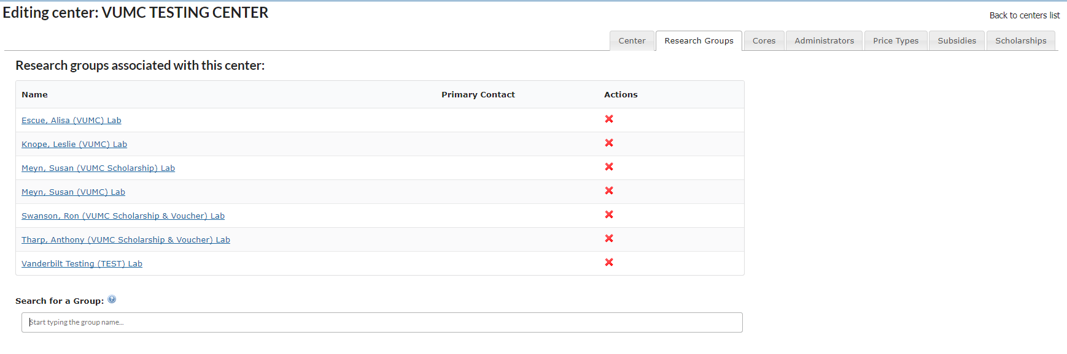

1. **NOTES:**
   1. If you do not see the PI’s lab group in the list, contact the VUMC Office of Research at [VUMCcores@vumc.org](mailto:VUMCcores@vumc.org).
   2. Scholarship allocations to VUMC Faculty are allocated to the PI’s (VUMC) Lab.
   3. Scholarship allocations to VU Faculty are allocated to the PI’s (VUMC Scholarship & Voucher Lab)

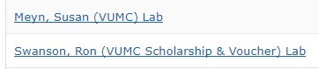

## TROUBLESHOOTING: Fund Grid Management

The PI or the PI’s Lab Manager will need to log into iLab and grant access to the newly created scholarship fund within the PI’s fund grid.

1. Click on ***my groups*** on the left side of the iLab page.
2. Click the lab name under the ***My Groups***section.
3. Click the ***Membership Requests & Billing Numbers*** tab to view the active fund numbers for the lab.
4. All lab members and active funds will be displayed.
   1. ***Check the box*** on the row for the user to grant access to the specific scholarship fund number.
5. The system will **automatically save** **your changes**. All new changes will be **highlighted green**.

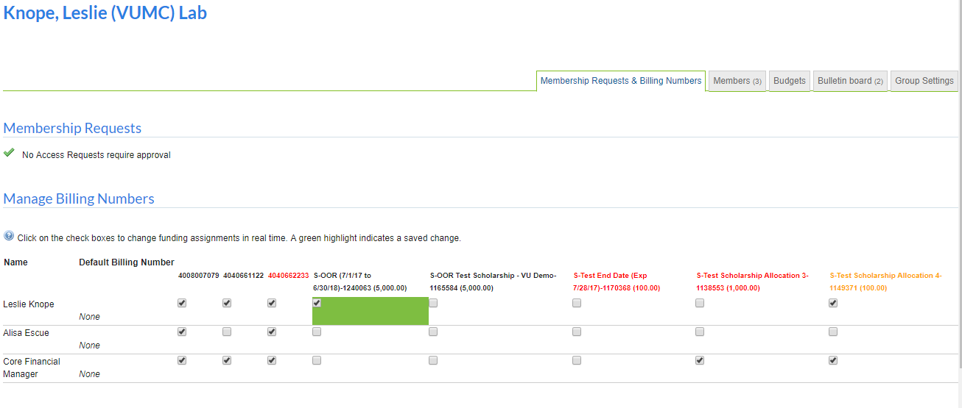

## Investigator Support

The email sent to the PI will not include many details. We recommend emailing the following information so that the investigator is aware of steps needed to utilize the issued scholarship. Note, the VU investigators must select their “VUMC Scholarship & Voucher” lab to view the scholarship.

**EMAIL TEMPALTE:**

Once a new scholarship number has been activated in iLab, it will display in the PI’s fund grid. **The PI or Lab Manager** will need to grant individuals access to the specific scholarship number before it can be used to request services.

**Instructions for PIs or Lab Managers to grant an individual access to a scholarship fund:**

1. In iLab, click on ***my groups*** in the left-hand menu.
2. Click on the **PI’s lab group.**
3. Click the **Membership Requests & Billing Numbers** tab. The fund grid will display.
4. **Check the box** under the scholarship number and next to the user’s name that will need to purchase services using this scholarship fund.
   1. The box will display in a green color to indicate a change has been made.

|  |  |  |
| --- | --- | --- |
| **VUMC Investigators** | Select the PI’s “VUMC” Lab Group | Example: Jones, Jake (VUMC) Lab |
| **VU Investigators** | Select the PI’s “VUMC Scholarship & Voucher” Lab Group | Example: Smith, Jim (VUMC Scholarship & Voucher) Lab |

**Instructions: Requesting a core service or reservation using scholarship funds:**

1. Navigate to the core’s iLab site and request a reservation or service.
2. When requesting the service, the user will need to select the investigator’s VUMC Lab group.

|  |  |  |
| --- | --- | --- |
| **VUMC Investigators** | Select the PI’s “VUMC” Lab Group | Example: Jones, Jake (VUMC) Lab |
| **VU Investigators** | Select the PI’s “VUMC Scholarship & Voucher” Lab Group | Example: Smith, Jim (VUMC Scholarship & Voucher) Lab |

1. In the **payment information section**, change the option from ‘billing number’ to ‘scholarships.
2. A list of all the scholarships the user has access to will display.
3. The scholarship is only available in the specific core. It cannot be used in other core facilities.

**Resources & Help:**

* + User Guides : <https://www.vumc.org/oor/vumc-ilab-application>
  + **Contact** [**VUMCcores@vumc.org**](mailto:VUMCcores@vumc.org) **for additional help.**