Requesting a Service on behalf of a user
Core personnel can request services on behalf of a user.

- Access your core’s site.

- Click on the Request Services tab.
  - On the Request Services page, there will be a list of available services.

- Click on the Initiate Request button to the right of the service you would like to request.
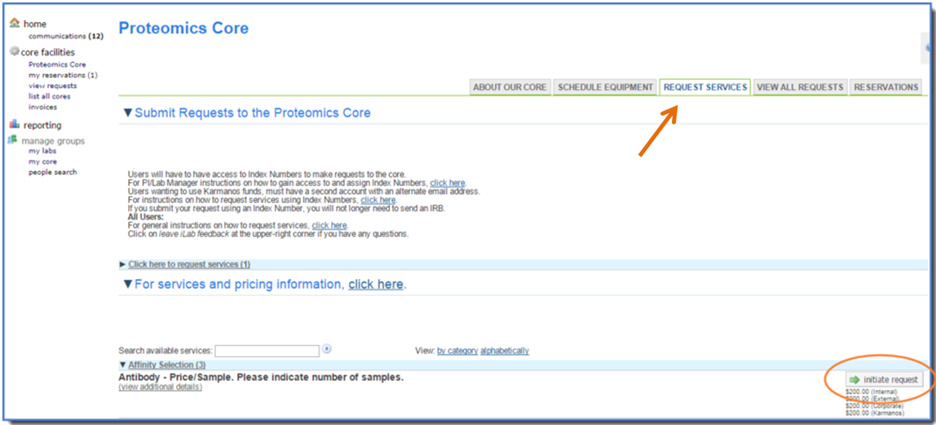

- Select the user by entering the name of the person for which you wish to make the request and click the Proceed button.
  - Note: Make sure you are searching within “this institution” or “all” if you are looking for a user that has not yet used the core.

- Complete the submission form.
  - Be sure to complete all required fields marked by a red star.

- If known, in the payment information section, select the correct center number from the drop down menu.
  - If you do not know the payment number, do not select a billing number from the drop down menu. The core user will be able to update the request with the correct billing information.

  - Split Charge: The cost of service requests can be allocated across center numbers.
    - To allocate across multiple center number, click split charge.
    - Select the additional center number from the drop-down menu.
    - Enter the % allocations to split the cost across the center numbers.
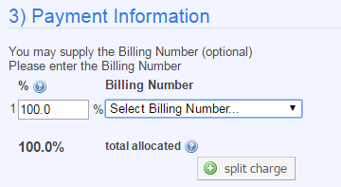

  - Center Number Notes:
    - Lab members will need to be granted access to activated center numbers by the PI and/or the Lab Manager.
    - PI or Lab Managers will need to contact the department administrators to activate new center numbers in iLab.

- You may wish to route the request to the researcher for approval.
  - If so, click the submit request to researcher button at the bottom of the page to submit the request.
    - Once the request is submitted, the View All Requests tab will open to display the new request.
    - The status of the request will typically be Waiting for Researcher Approval indicating that the request owner needs to review the request to approve the proposed work and projected cost.

- If you wish to skip the approval process, check the Skip approval? option. Then click, submit request to researcher button to submit.
  - Once the request is submitted, the View All Requests tab will open to display the new request.
  - The status of the request will typically be Waiting for Core to Begin.
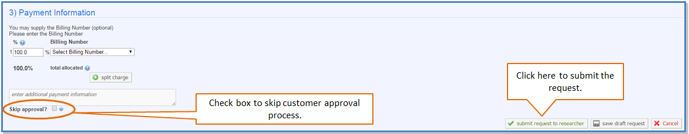

Processing Service Requests
The core can view all new and active services requests on the View all Requests tab. The core should check this section iLab to approve and process any new service requests.

To review new requests:
- All new service requests will be in the Waiting for Core to Agree status.

- Click the blue arrow to expand the service request.

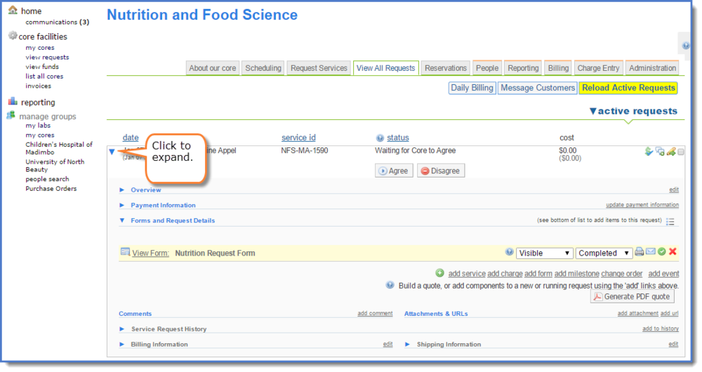

- The details of the request are displayed. The following areas may be updated.
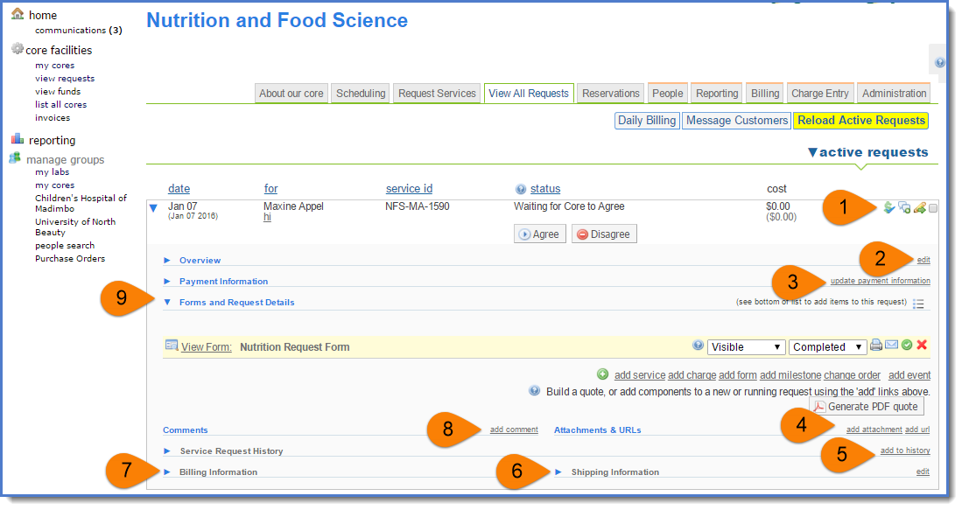

  - Item 1: Action icons. These buttons allow you to update payment information (dollar sign icon), add a comment (text box icon), or print or cancel the request (pencil icon).

  - Item 2: Edit Overview information, such as Project Description, Status, and Projected Cost.

  - Item 3: Update payment information (functions same as the dollar sign icon).

  - Item 4: Add an attachment or url.

  - Item 5: Add a note to the history section.

  - Item 6: Edit Shipping Information.

  - Item 7: Edit Billing Information.

  - Item 8: Add a comment. An email will be sent to notify designees copying the comment.

  - Item 9: Add/delete a form and view request details.

To agree to request and provide a customer quote:

- Click add service to add services from the core’s service list to build the quote and calculate the project’s projected cost.
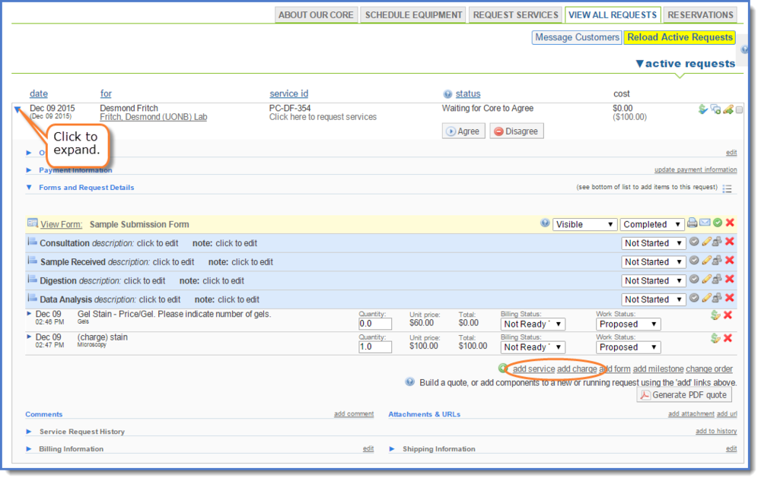

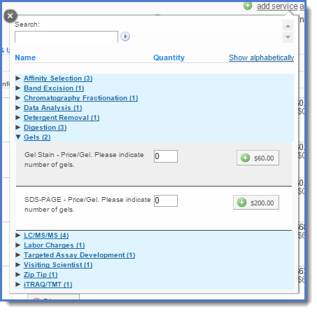
- If there are multiple services available, you may choose to scroll down the list to locate the service of interest. Alternatively, you may start typing the service name in the search field to view a restrict set of services.

- Enter the unit quantity and then click the green plus button to add the service.
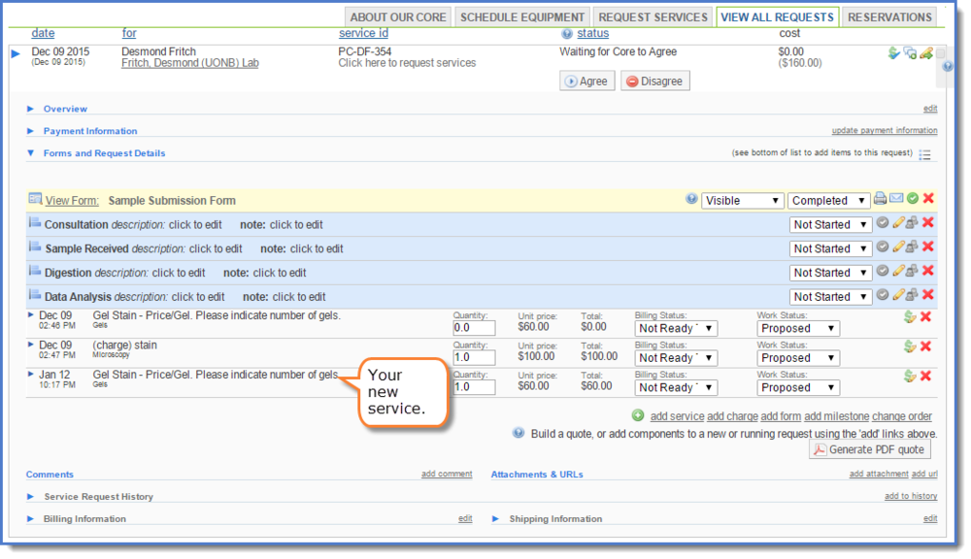
  - The service line item is added.

- Agree to the service request by clicking the agree button.
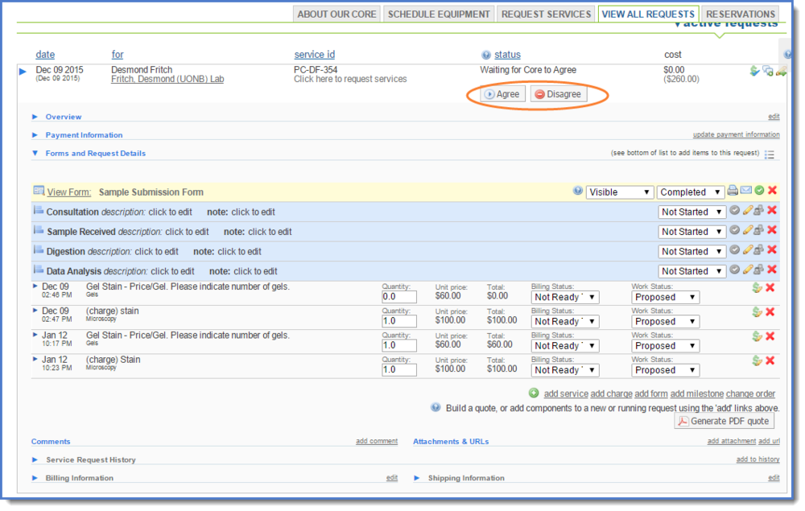

- Create the quote. Review the project cost, enter in the quote expiration date if applicable and indicate which items on the request you want included on the PDF quote.
  - Check the box next to include pdf quote.
  - Click on submit to send the PDF quote and link to the request in iLab in an email to the request owner.
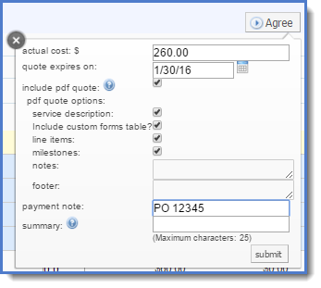

- When you click submit on the quote, an email will be generated and sent to the email addresses designated with a summary of the project and a quote included.
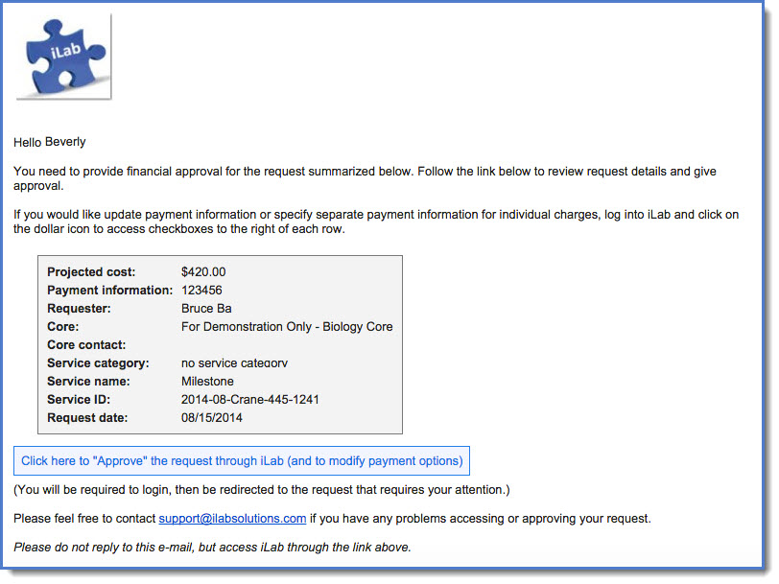

- The new information displays in the request and the request status is now Waiting for Researcher to Agree.
  - IMPORTANT: The request will need to be approved by the customer before the core begins work.
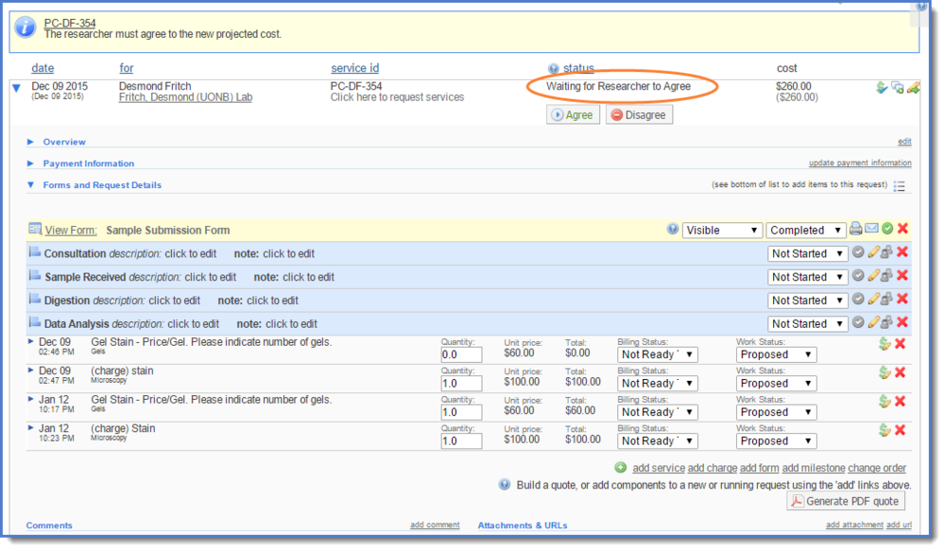

To indicate that work has started on a request:

- If the user and core have agreed to the work, and the Financial Approver has approved the projected cost and payment, work may begin on the request. The status of the request will be Waiting for Core to Begin.
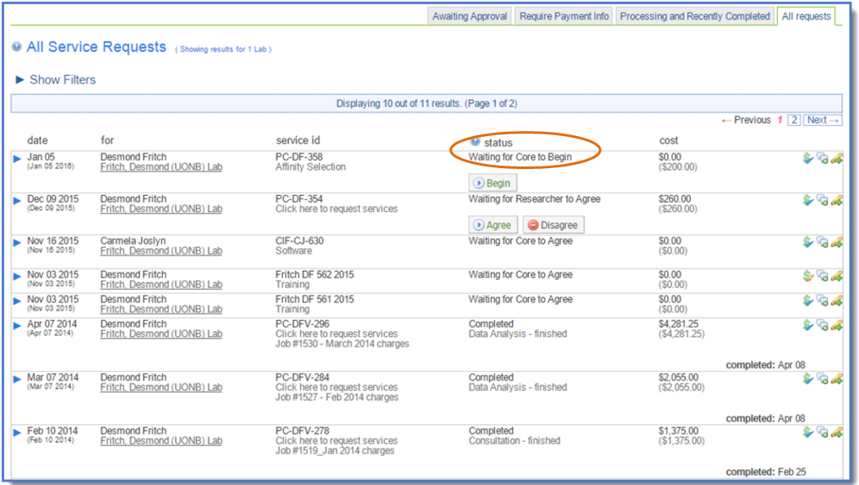

- Find the appropriate service request on the View All Requests tab. Click the Begin button.

- The process will update to processing.

- Once the status is processing, core staff can add services, comments, milestones, attachments, and other items as they work on the project.
  - For details on advanced features of iLab, please visit http://help.ilabsolutions.com/managing-service-and-project-requests.

To mark a request as complete:

- Once the work has been finished and the core is ready to bill, locate your service request on the View all Requests tab.

- Click on the green complete button.

- A confirmation message displays, and the status of the request is updated.
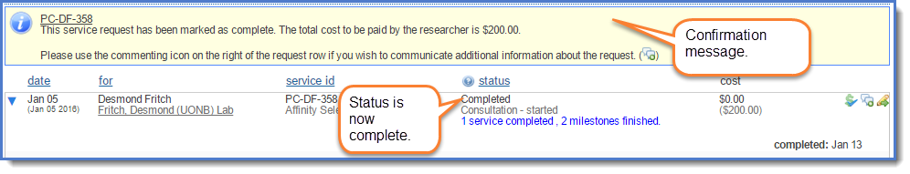

- When a request is marked Complete all service items and milestones that have not been updated ill update to Completed or Finished. Unless otherwise designated on the line item, the completed services will then then be available for billing.
  - Note, if you wish to leave the service project open, but bill for specific service items. Click Process and then Complete on the individual service line.
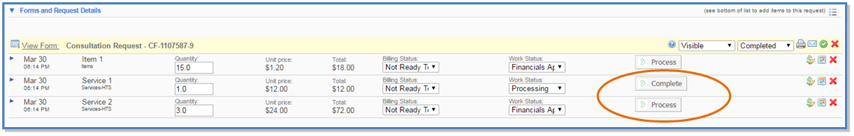

- All requests with a Completed status will be removed from your active requests list but can be searched for using filter options at the upper right of the request list table.
  - Click active requests to display these filter options.
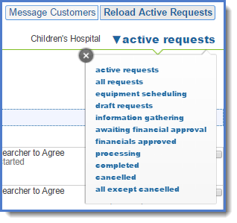

Communicating with Customers
Cores can communicate directly with users within iLab. This feature allows all messages to be saved directly on the service requests and can be viewed at any time by the customer and the core.

- The core can view and access all active requests on the View All Requests tab.
- Click on the comment icon to the right of the request to use the communication tool.
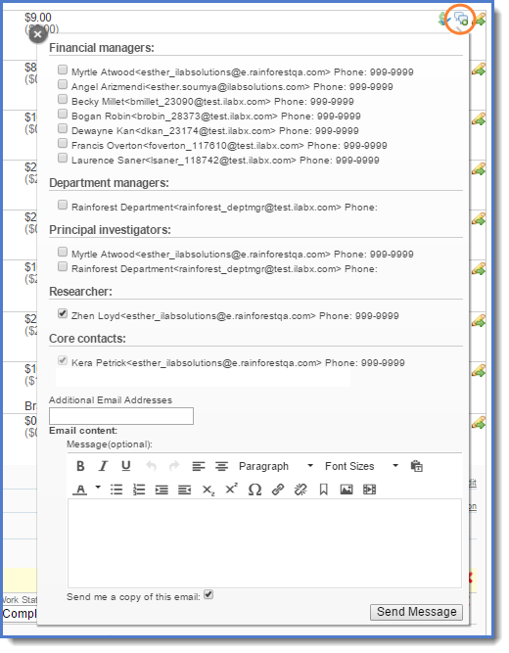
  - The email interface window will be displayed.
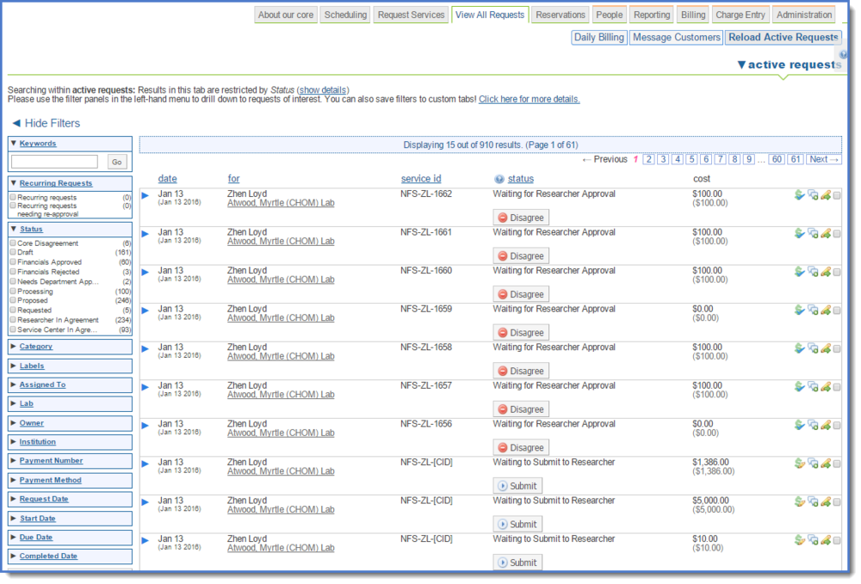

- Complete the information and click send message.
  - After you click on Send Message, the selected recipients will receive the email. An audit trail of the email exchange through iLab can be seen under comments on the request.
