OVERVIEW: New External User
STEP 1: External User Account Creation (Core Manager or External User)
STEP 2: Purchase Order Creation (Core Manager)
STEP 3: Pricing Panel – Add institution & price type (Office of Research)

NEW EXTERNAL USER ACTIVATION PROCESS:
Complete registration process directly in iLab. Cores will manage the creation of new external users.
Option 1: Ask the user to register directly in iLab
Option 2: The core will register on behalf of the external customer.

Information Required to Register for an Account:
External PI Information
External PI Name:
Email Address:
Phone Number:
Billing & Invoicing Information
External Organization Name:
Billing Contact Name:
Billing Email Address:
Billing Address (including city, state, zip code):
Billing Phone Number:
Billing Reference Number: Customer should provide the preferred billing number.
This can be an official PO or simply a reference number to be included on the invoice.
If customer does not have a preference, the core can assign a reference number at their discretion.

Step 1: Verify the external user does not already have an existing iLab Account
- To search to see if the external user already an account has, attempt to add a PO.

  - Click Purchase Orders in the left-hand menu.
      - Click “+ New Purchase Order” button
      - In the “Who are you creating this purchase order for?” box enter the external customer’s name.
        - Important: Uncheck the “Search for Current customers only” box.
        - TIP: Try searching by last name, first name & Try searching by first name last name

    - If name appears, the user has an account.
      - Skip to step 3 for instructions on how to create the PO.

    - If name does not appear, the user does not have an account. Continue with the following instructions to register on behalf of the external user.

Step 2: Register on behalf of the external PI
- Log out of iLab. On the log-in screen, select sign up.
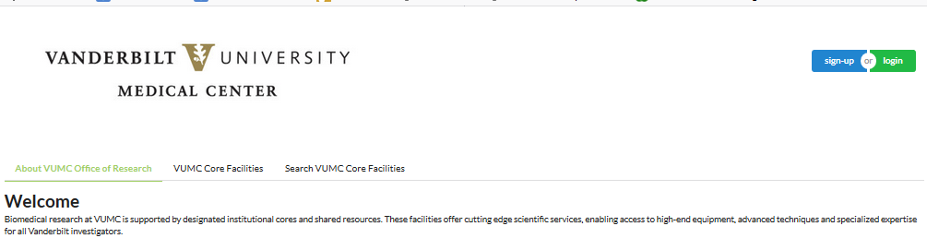

- Under “Not a Vanderbilt University Medical Center user? (no VUNetID)”:
Click the register hyperlink to create a new account.
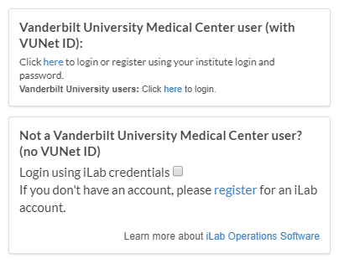

- Complete the Start section.
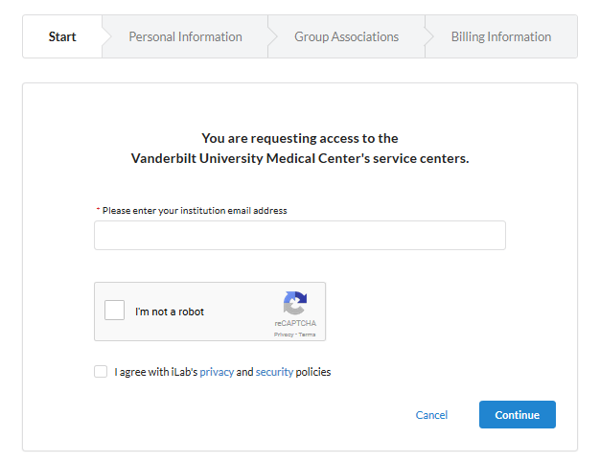
  - Enter the external PI’s email address.
  - Follow all remaining prompts.

NOTE: You may receive an error message if the user’s institution has an ID integration with iLab. To resolve, either submit an iLab ticket to activate the user’s account or email the Office of Research for assistance.

- Complete the Personal Information section.
  - List the PI’s name and phone number in this section.
  - Enter in the external institution’s name.
    - If it doesn’t already exist, (create new) will display beside the institution name that is typed in.
  - Select “Principal Investigator” as the primary role.
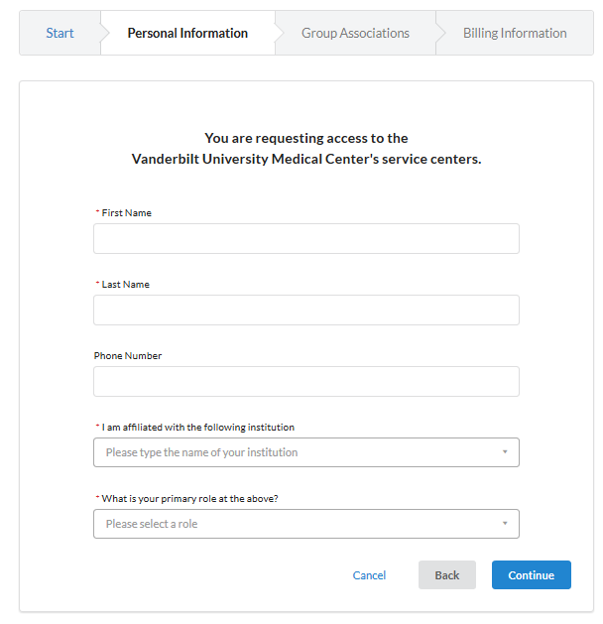
- Complete the Group Associations screen.
  - If the institution is new for iLab, “Create New Group…” will pre-populate for the lab group question.
  - The PI First name, last name, email address, and phone number will pre-populte.
  - Answer YES to the “Is there another person in your lab who helps manage…” question?
    - Complete the Financial Administrator’s details. (This is the billing contact)
  - The “Your Group’s Name” will pre-populate.

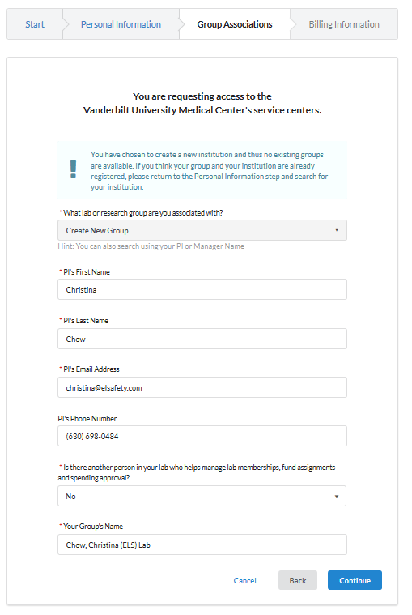

- Complete the Billing Information screen.
  - Enter the billing contact details again on this screen.
  - Don’t check the “Add shipping address…” box.

- Click Complete to submit.
  - A confirmation message will display.

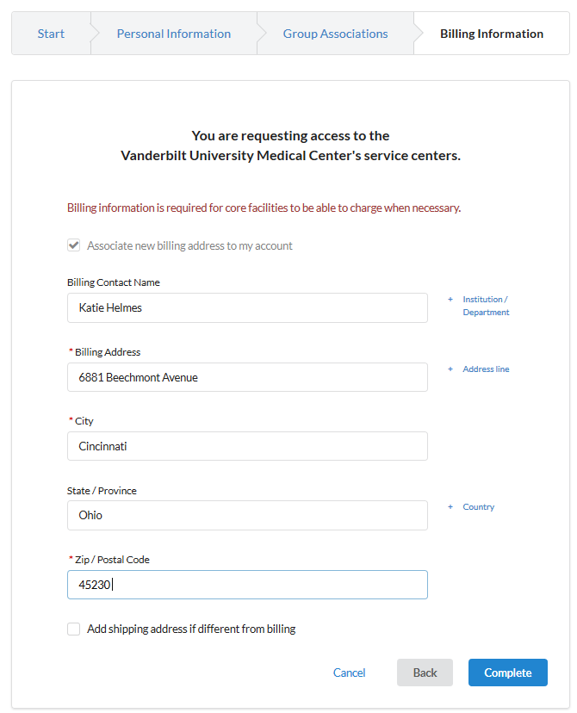

Step 2: Add the PO for the external customer.
IMPORTANT: Core manager are authorized to add purchase orders for most external users.
Core managers should not create an account or PO (external billing number) for following institutions. Contact the Office of Research for help assisting these users.
(VUMC) Vanderbilt University Medical Center
(VU) Vanderbilt University
(VA) Veteran Affairs

NOTE: It typically takes at least 24 hours for iLab to create an external account. The PO cannot be created until the external account registration request is processed by iLab
- Core iLab Site: click Purchase Orders tab.
  - On the right, click the + New Purchase Order button. A new purchase order window will display.

- Purchase Order Details:
  - Uncheck the search for current customers only box
  - Enter the name of the PI in the search box and choose the correct user.
  - Click Proceed

NOTE: If the name does not appear, the registration request has not yet been processed. If it’s been more than 2 days, submit an iLab ticket.

- Complete remaining fields on Purchase Order Details tab:
  - Number: Enter the customer’s assigned PO or billing reference number

  - Name: Enter the description of the PO (if available).
    - If not, leave blank. Field is optional.

  - Initial Amount: Unless otherwise specified, use a large amount (e.g., 100000000)
    - TIP: Do not enter commas in this field.

  - Expiration Date: Unless otherwise specified, expire the PO one year from current date.
    - TIP: Always choose the last calendar day of that month.

- Click Save & Approve to save the purchase order.

Step 3: Notify the Office of Research (OOR)

- Email VUMCcores@vumc.org and provide the following information.
  - Institution Name
  - PI Name

- The OOR will add the institution to the core’s pricing panel and assign the price type.
  - If this is not completed, pricing will not display when the core attempts to charge the customer.

- The OOR will also ensure iLab activates the invoices link view.
  - If this is not completed, the customer will not be able to search for invoices directly in iLab.

- The OOR will send a confirmation email once institution is activated on the core’s pricing panel.

External Customer Invoice Distribution
Auto-Email Notification: All external invoices are automatically distributed to the invoice owner during the closing process. This message includes a link to login to iLab to view invoices. The email does not include a pdf copy of the invoice.
- The auto-invoice notification process only distributes the email to the invoice owner.
OPTIONAL: Additional Invoice Distribution: If the core wishes to also distribute the invoices to other financial contacts in the lab group, then they will need to distribute via the iLab system. This option will also attach a pdf copy to the email notification.
Distribution Workflow:
- Open Core’s iLab Site >> Billing Tab >> Click Invoices next to the month’s billing event. A list of invoices will display.

- Use the filter panel to filter to external invoices:
  - Price Types: Select options for “External-not-for-profit” & “External-for-profit”
  - Click Apply Filters

- Click “Email Admins with Access to Invoices”. All invoices will display.
  - Click the box to Select All Invoices
  - Click in the contacts boxes to add additional contacts.
    - If the lab group has others with ‘financial manager’ access they will display.
Email Subject VUMC Core Name Invoice – Please remit payment
Message (Recommended Language)
Please see the attached invoice for Vanderbilt University Medical Center research core services. If you have any questions, please contact us at (enter email address)
Remit Payment To: Vanderbilt University Medical Center
Department of Finance
Dept. 1236 P.O. Box 121236
Dallas, TX 75312-1236
Make checks payable to: Vanderbilt University Medical Center
Reference the invoice number & (enter cost center) on the check.

External Lab Group Management

Lab Primary Contact | Invoice Owner: The invoice owner is the individual that will receive the initial auto-generated email from iLab during the monthly closing process.
If the “Lab Primary Contact” is set to a specific individual, that person will be designated the ‘Invoice
Owner”. If not officially set, the invoice owner will default to the first financial contact in the lab group
list. The Invoice Owner name displays on the invoice.

Financial Managers: The financial managers are all individuals (including the invoice owner) that have access to view the invoices directly in iLab. These users will also display as an option when using the optional workflow for additional distribution of invoices.

Troubleshooting – User reports they did not receive the invoice notification email:
- Verify user is assigned as a financial manager.
  - Purchase Orders tab >> Find user >> Click Requestor name hyper link
  - The user’s lab group information window will display.
  - Click “Information about labs” to view lab group name and additional information.
  - All users with a $ icon are financial managers.

- Ask external user to check their junk mail. Emails are distributed from no-reply@ilabsolutions.com.
  - RECOMMENDATION: If this user is a frequent user of your core, they may need to contact their institution’s IT department to whitelist this no-reply@ilabsolutions.com email address.
iLab Support: To submit a ticket, email ilab-support@agilent.com

To add Financial Managers to existing lab groups: Submit an iLab Ticket and provide the users name and email address.
Ticket Message (recommended language):
Please add the following individual as a Financial Manager to my lab group in iLab.
(1) User Name:
(2) User Email:
(3) PI’s Lab Group Name:
NOTE: If that person needs to be set as the invoice owner, in the iLab support ticket request to add the person as “Lab Primary Contact”

To update billing address: Submit an iLab Ticket
Ticket Message (recommended language):
Please update this lab’s billing address. This is the address that should display on the invoice.
(1) PI Name:
(2) PI’s Lab Group Name:
(3) New Billing Address:

How to edit the billing address on Project Requests:
- Go to the “View All Requests” tab of the core site.
- Toggle open the project request.
- Scroll down to the Billing Information section. It’s located under comments and service request history.
- Click edit next to the Billing Information header.
- Update the billing information to reflect the correct information. This information will display on the invoice.
- Click Save to finalize the changes.

How does an external customer access VUMC iLab core group sites?
External users may need to login to iLab to either view invoices or to request core services (depending on core’s workflow). Users may need to access a custom URL to view the VUMC core groups if their institution currently uses iLab to manage their institutional core billing or operations.

- Users from an institution that do not currently use iLab:
  - https://vumc.corefacilities.org

- Users from institutions that are a client of iLab:
  - Instruct user to use their institution’s iLab website to login to iLab.
  - After logging the user can then navigate to invoices or the VUMC core iLab site, as needed.

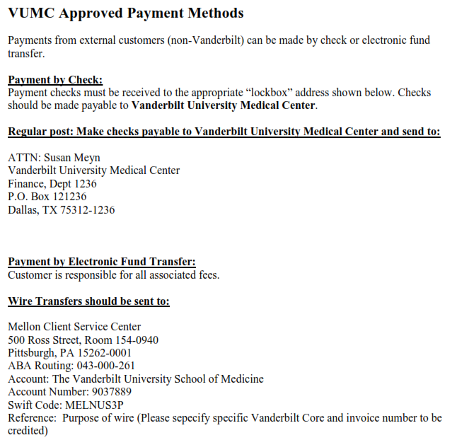
Accounts Receivable Review & Marking Invoices as Paid
Cores are responsible for managing the AR for all external invoices. Upon request of the core, Office of Research will mark invoices as paid. Work with your assigned Office of Research Core Administrator for assistance with marking invoices as paid.
Payment Methods:
VUMC can accept payments by check or electronic fund transfer. Unfortunately, we are unable to accept credit card payments.

Credit Card Payment Options: Effective Jan. 1, 2015, VUMC stopped accepting credit cards as a form of payment for core charges due to increased PCI Compliance requirements.
Cores that opt to obtain their own PCI compliance and purchase a credit card processing machine are allowed to accept credit card payments.
Guidelines include:
(1) Core leadership/ home department are responsible for maintaining PCI compliance and procuring
credit card processing machine.
(2) Payment should only be accepted after monthly invoice has been generated.
Pre-payments are not allowed.
(3) Core leadership/ home department are responsible for preparing & submitting journal entries to
record credit card transactions.

