iLab: Creating a Billing Event (Core Billing Instructions)
- Cores are required to create a draft billing event at the end of each month.
- If preferred, cores can create draft events more frequently throughout the month. Please do not create billing events between the 1st and 10th days of each month.
General guidelines for core billing schedule: The monthly core billing schedule is distributed via email each month one week before the billing deadline. The schedule is also available of the VUMC Office of Research website. The cores must complete the billing event by the last business day of each month.
Invoices will be generated once a month when the central office combines all billing events created by the core groups.
- Internal payments (VUMC users) are automatically transferred from the customer’s center number to the core’s center number during this process.
- The core books the revenue from the external customers. However, they will still need to ensure the payment (i.e., check) is received from the external customer.
  - Exception: VU customer payments are received 30 days later from VU Finance. The VU users do not submit payments directly. It is centrally managed between VU & VUMC.

Notes: Draft Billing Events
- All billing events are retained within the application. Previous billing events can be viewed on the billing tab at any time. Select “Summary” next to the billing event to display the billing summary.
- After a core creates a billing event, the PI and/ or user can view pending charges. If needed, the core can edit billing lines on the drafted billing event file if the status is “Draft”.
- The Office of Research will compile all created billing events and close the billing cycle at the end of each month.
  - The status on the events will change from “Draft” to “Billing Initiated” | Customers will have a brief window to review the month’s invoices and request adjustments or center changes.
  - The OOR will conduct the final close for the month. The status will change to “File Sent”.
    - Adjustments are no longer possible in this status.
    - Users can dispute invoices and request refunds by contacting the core directly.
    - Any refunds issued will be included in the next month’s billing event.

Step 1: Initiate a New Billing Event.

- Select ‘New Billing Event’ on the top right-hand side of the page.
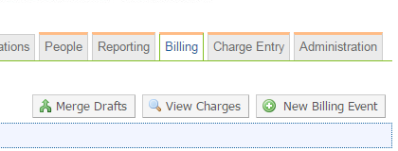

- The settings will all be set to the correct option by default. No changes should be made.
  - “End Date” will reference the last day of the current month.
  - “Event name” will reference core name and month of billing.
  - “Include” field will be ‘all’.
  - “Group By” field will be ‘payment info’.

- Click “Load Charges” to create a list of all services that have been marked as complete and ready to bill.
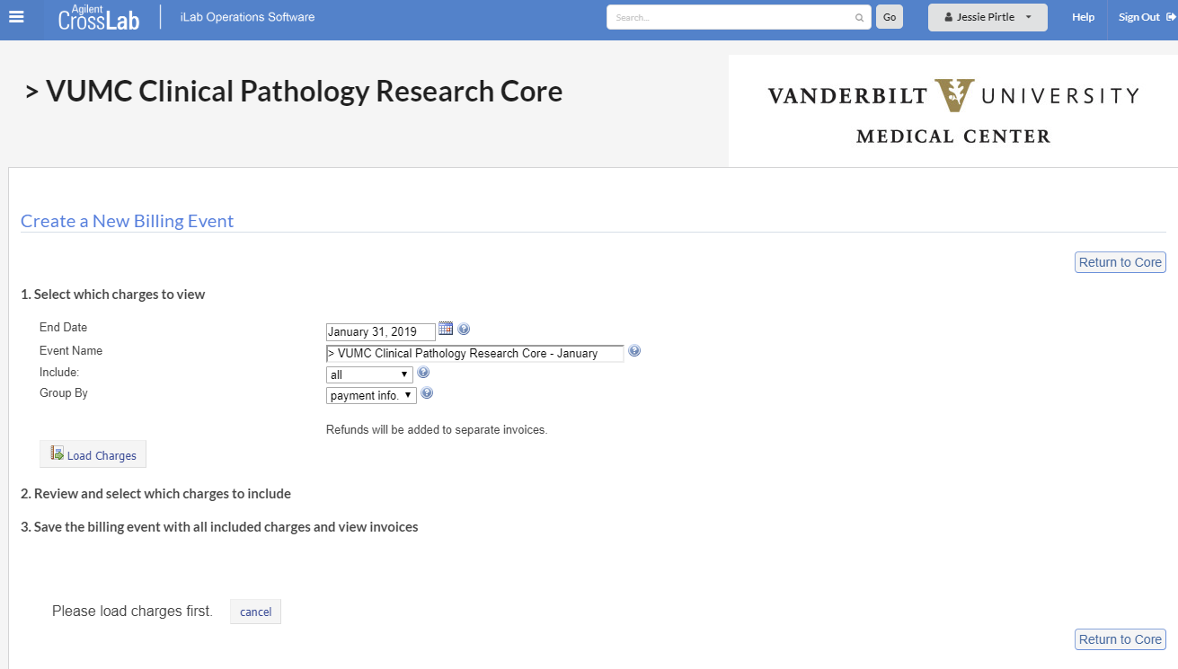

Step 2: Review and select which charges to include in the billing event.
A list of unbilled charges will be displayed. Review the charges to ensure all items should be included in the billing file for the month.
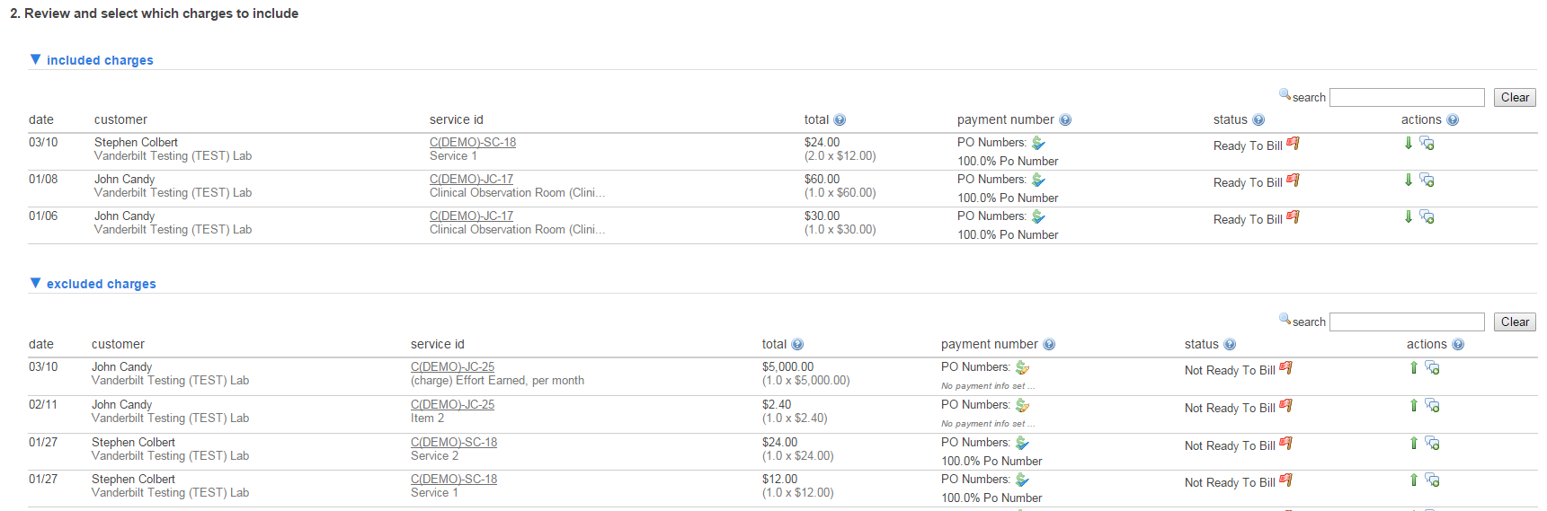
- If needed, exclude billing line items by clicking the green down arrow.
  - This will move the line item to the “excluded charges” list.
  - The line item will be added to the “included charges” list the next time a billing event is created.

- If needed, add billing line items by clicking the green up arrow.
  - This will move the line item to the “included charges” list. The line will be included on the billing event file.

- Resolve all Red Flags. This icon indicates that payment information is missing.
  - Click the Payment Info tool to update payment information.

  - IMPORTANT:
    - The Office of Research cannot process billing files with missing payment information.
    - Billing files received will not be submitted to Finance until all payment information is provided. This could delay billing your core charges for at least one month.

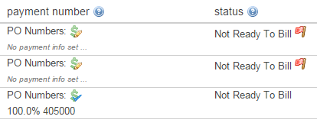

Step 3: Save the draft billing event.
- When ready to bill, select “Save as Draft” to create the billing event.
NOTE: We highly recommend selecting the “save as draft” button instead of “Submit Draft for Review”. OOR can still process any events submitted for review; however, the core manager will no longer have the option to edit the event before it is finalized.
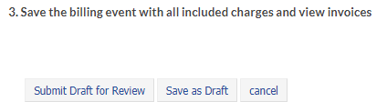

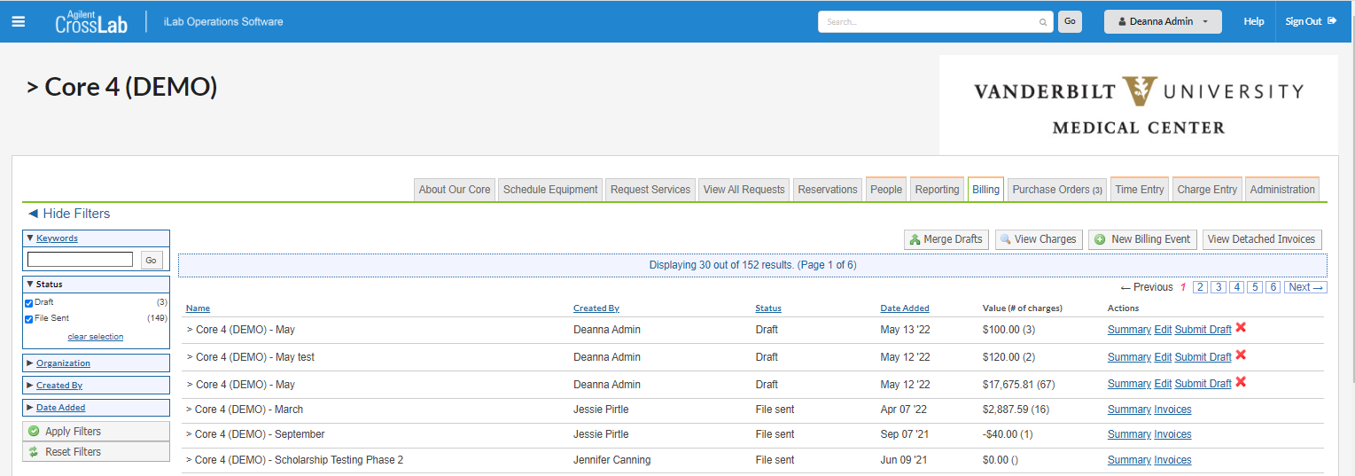
- The status of created billing event will be “Draft”.

