N LOT SHUTTLE SCHEDULES
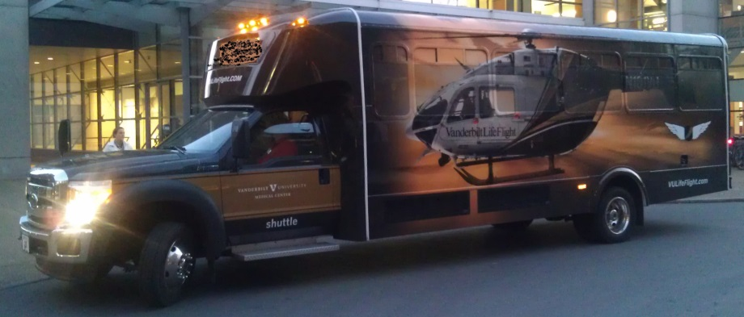
GREEN ROUTE
4am-12am Monday-Friday
Non-Peak(Wait Time: 15 Minutes) |  | Peak Time(Wait Time: 5 Minutes)
4am-6am |  | 6am-9am
9am-3pm |  | 3pm-6pm
6pm-12am
Boarding Location Order
VCH |  | Lot 74 |  | Lot 73 |  |  |  | 73A

BLUE ROUTE
4am – 12am Monday - Friday
Non-Peak(Wait Time: 15 Minutes) |  | Peak Time(Wait Time: 5 Minutes)
4am-6am |  | 6am-9am
9am-3pm |  | 3pm-6pm
6pm-12am
Boarding Location Order
Round Wing |  | Lot 74 |  | Lot 73 |  |  |  | Lot 73A

