


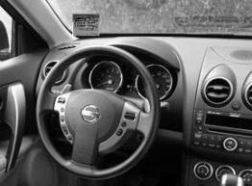
Remove both protective covers of the permit.
While sitting inside the vehicle affix the permit to the lower left corner of the front windshield.
The permit can be repositioned or removed easily.
VUMC Parking Permit Privileges
- Parking decals have numbers/letters which correspond to a specific garage or parking surface lot.
- DAY Parking Permits are valid in your designated parking area 24 hours 7 days a week.
- NIGHT Parking Permits are valid in your designated parking area for the night times only.
INFORMATION ON YOUR PERMIT TO PARK

- Vanderbilt University Medical Center requires all vehicles parked by faculty, staff, students, vendors, and construction workers be registered with VUMC Parking & Transportation Services. VUMC Parking & Transportation reserves the right to control parking and move your designated parking space as needs demand.
- All Vanderbilt Faculty, Physicians and Staff are payroll deducted monthly.
- To Cancel the payroll deduction, the permit must be returned to the VUMC Parking Permit Office. The gate card should also be returned.
- The permit must be completely displayed while in your permit area. Failure to properly display your permit will result in a citation.
- Permits on hangtags must face outward so that the officers can see the permit.
- Replacements for lost Permits or Gate Cards are $60 each and payable at the time of the replacement via cash, check, or credit/debit.
- View the VUMC Parking & Transportation website for all the Rules and Regulations.

615-936-1215 option 3
www.mc.vanderbilt.edu/parking
-ENTRANCE
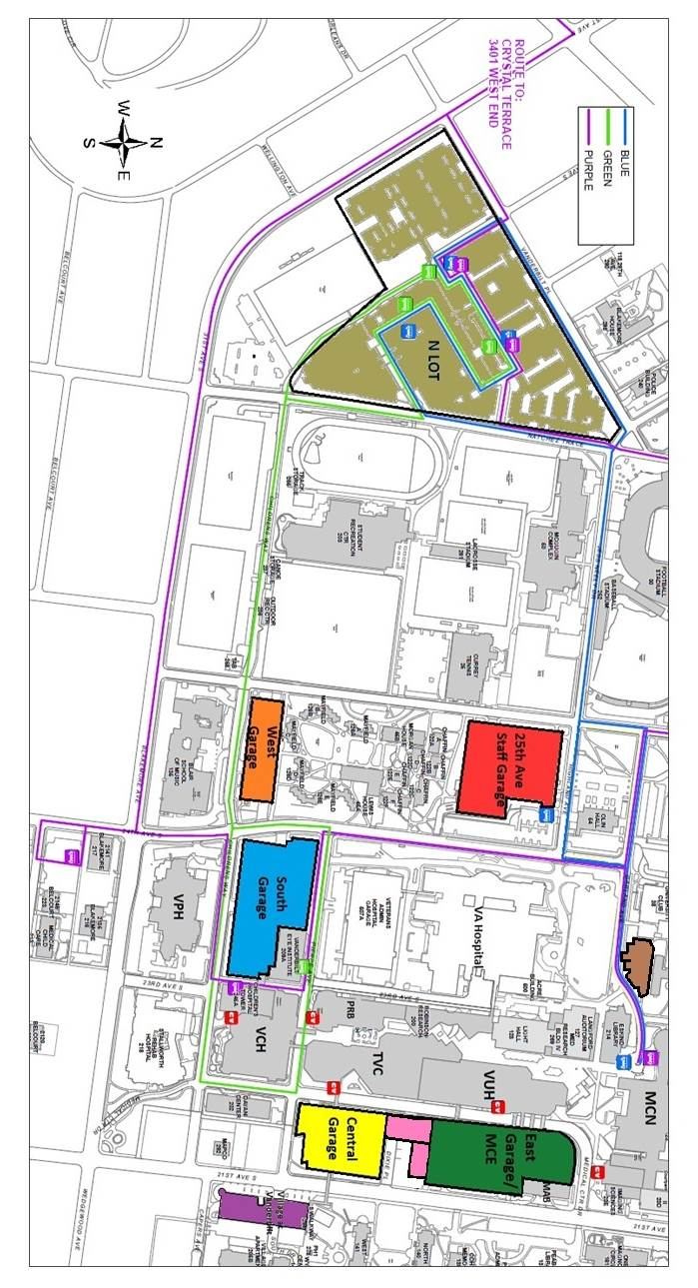
N LOT | WEST GARAGE | 25TH AVE GARAGE | Location
N | WT | 25T | Permit
(73, 73A, 74, and 75) | Sub-Level 1-7 | Level 3-10 | Primary Privileges
M-F 5pm to 7am: South (Levels 5-7), Central (Roof Level) and 25th Ave (3-10) & all day Saturday & Sunday until Mon at 7 am. | M-F from 5pm to 7am: South (Levels 5-7), Central (Roof Level), 25th Ave garage & all day Saturday and Sunday until Monday at 7am. | M-F from 5pm to 7am: South (Levels 5-7), Central (Roof Level) & all day Saturday and Sunday until Monday at 7am. | Cross Parking

