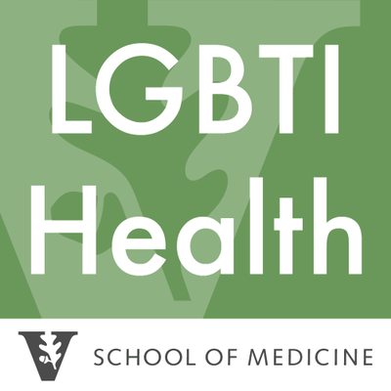

Program for LGBTQ Health Student Employee Application

The Program for LGBTQ Health, located in the Vanderbilt University Medical Center Office for Diversity Affairs, employs 1-4 graduate and/or undergraduate research assistants every semester. Past student research assistants have helped develop and manage the TransBuddy patient navigator program; monitored LGBTQI patient quality assurance metrics; developed strategic planning documents to advance the systematic development and expansion of the Program; and developed LGBTQ health training videos to improve medical provider LGBTQ cultural competency. Student research assistants will work on the available projects most in line with their academic and professional development interests. Student research assistants play a crucial role in the success of the Program for LGBTQ Health. Their efforts help the Program for LGBTQ Health meet our mission of improving the health of LGBTQ patients.
Please email completed applications to del.r.zimmerman@vumc.org
Name you use:
Legal name (for employment purposes only):
Pronouns you use:
Email:
Phone:
On-Campus Mailing Address:
Anticipated graduation year:
VU Net ID:
Birthday (without year):

Why would you like to work for the Program for LGBTQ Health?

What talents, skills, knowledge, experiences, or interests do you have that would enhance the ability of the Program for LGBTQ Health to achieve our mission and vision?

Will you be receiving Federal Work Study funds? If so what is the amount? Do you have another job on campus?

Please reference the job descriptions on the pages below and explain your experience with one or more of these projects/responsibilities. Please also indicate if you would have an interest in completing specific work or project types not listed in these postings.

Job Functions

Below is the title and description of the undergraduate research assistant and graduate research assistant positions.

_____ Graduate Research Assistant – This position works in conjunction with the Program in LGBTQ Health Director and Director of Research to assist in the design and conduct of LGBTQ research studies housed in the Program. The GRA position is tailored to the skills and talents of the graduate student, but past workers have created and managed the TransBuddy Program; developed LGBTQ care quality metrics using electronic health records (EHR) data; and designed and evaluated LGBTQ cultural competency trainings for VUMC health workforce staff. Experience in LGBTQ community engagement or health research is preferred for this position. [up to 29 hrs/week, $10/hr]

_____ Undergraduate Research Assistant - This position works in conjunction with the Program in LGBTQ Health Director and Director of Research to assist with participant recruitment and data collection of LGBTQ research studies housed in the Program. The GRA position is tailored to the skills and talents of the undergraduate student, but past student workers have increased public awareness about the Program for LGBTQ health through community engagement and social media postings; assisted with organizational and capacity planning for the Program; and assembled reports documenting the status of LGBTQ health programs nationwide. Experience in LGBTQ community engagement and leadership is preferred for this position. [up to 19 hrs/week, $9/hr]

Fall Calendar 2016:
Please strike through the times you are NOT available to work during the average week:
 | Monday | Tuesday | Wednesday | Thursday | Friday
8-8:30
8:30-9
9-9:30
9:30-10
10-10:30
10:30-11
11-11:30
11:30-12
12-12:30
12:30-1
1-1:30
1:30-2
2-2:30
2:30-3
3-3:30
3:30-4
4-4:30
4:30-5

