Smartsheet – Sheet Request Access Request Tip Sheet

- If the user receives this notification that they do not have access to a sheet, and they need access, Smartsheet provides the opportunity to request access by clicking on ‘Request Access’ as shown in the below screenshot.
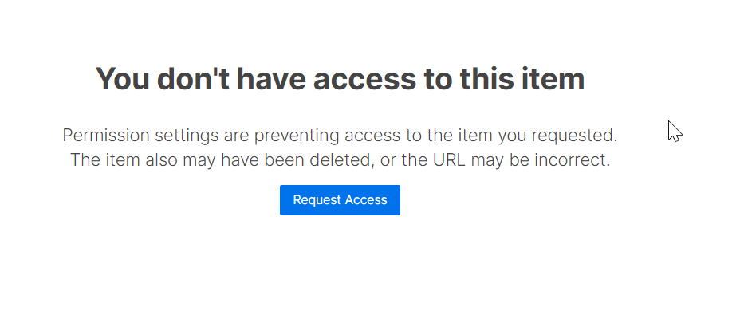
- The owner of the sheet gets an automated email from Smartsheet to approve/deny access. Click on ‘Share Sheet’ to provide access to the requestor.
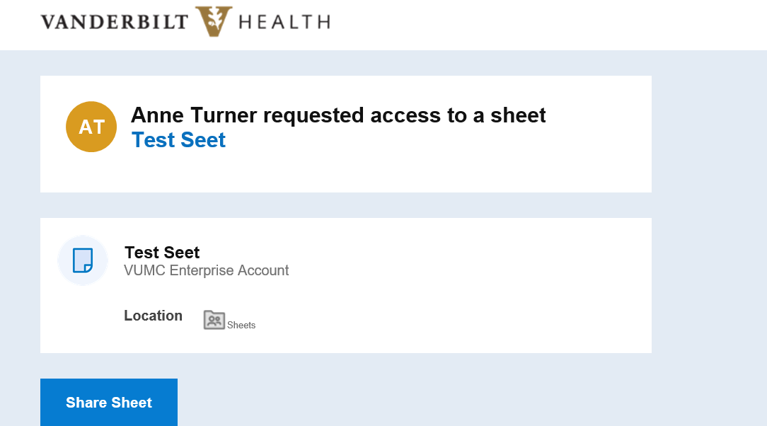

- Select the permission levels and click on ‘Share’.

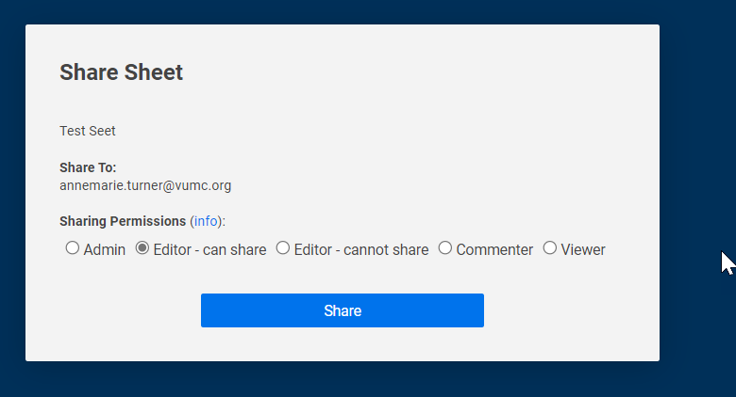

- Requestor gets an automated email from Smartsheet once the sheet has been shared.

