|  |
| --- |
|  |
| Winter 2018 Newsletter |
|  |

**Participant Page**

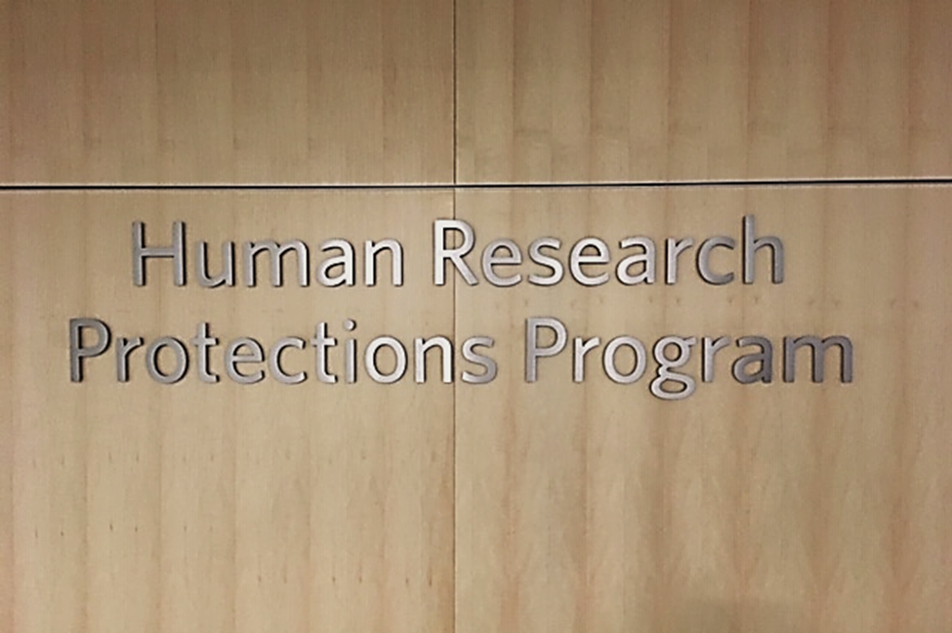

# Helpful Hints

## October 1

Time to get a flu shot

## November 4

Change your clocks

## December/January

Stay healthy by washing your hands frequently

|  |
| --- |
|  |
| Important Announcement The Clinical Research Center is moving!!!  The Clinical Research Center (CRC) is scheduled to move in 2018 and will be located at S2400 Medical Center North in the Round Wing.  We cannot wait for you to come see our new space! |

A Newsletter for our Research Community

|  |
| --- |
|  |
| **Why our Research Participants are Important** |
|  |

## Whether you know a person who has been diagnosed with a chronic or terminal disease or are suffering from one yourself, the medications you are taking were at one time part of a clinical trial. The only way new drugs, devices or biologics (such as vaccines) make it to market are by going through a testing process called a clinical trial. And that’s where you, our participant’s, come in. As an institution, Vanderbilt would not be able to advance its commitment to improve the personal health and wellbeing of our patients and community members without your study participation.

|  |
| --- |
|  |
| **Did you know?** |
|  |

The Vanderbilt Human Research Protection Program (VHRPP) has a Research Participant Advocacy program that includes a page on its website dedicated to our research participants. In addition, we have a Research Subject Advocate (RSA) who is available to assist you with any questions or concerns you may have related to a research study or your research experience. The RSA is also able to be with you during the informed consent process. For more information, please go the VHRPP website at <https://www.vanderbilt.edu/irb/for-participants/> or feel free to contact the RSA at (615) 322-2918, toll free at (866) 224-8273.

Please see the “Have we Met?” article on the next page for more information about our Research Subject Advocate and how to contact her directly.

# More Important News

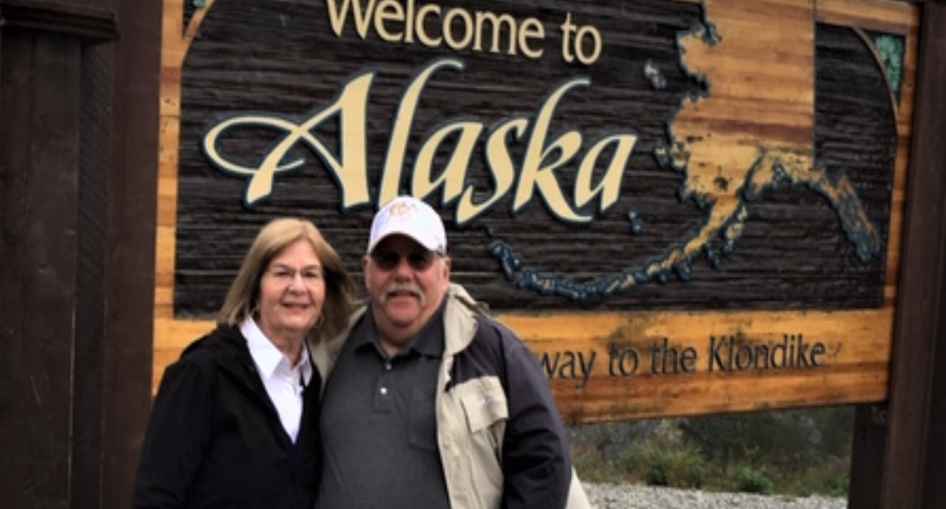

|  |
| --- |
|  |
| Have we Met? My name is Jan Zolkower and I am the Research Subject Advocate (RSA). I have worked at the Vanderbilt Human Research Protection Program (also known as the IRB) for 18 years and have served as the RSA for 10 of those years. Over the years, I have been able to assist countless numbers of individuals who were new to research and those who just needed additional information.  If you, a family member or a friend are thinking about participating in a research study I want you to know that I am here to help answer any questions you may have or provide any other type of assistance you may need. I am also available to be with you during the informed consent process and can help you identify the questions you should ask to determine if participating in a research study is right for you.  Please feel free to contact me at (615) 322-2918 or via email at [jan.zolkower@vumc.org](mailto:jan.zolkower@vumc.org). |

|  |
| --- |
|  |
| **Your rights as a research volunteer can be found in the**  **Research Subjects’ Bill of Rights** |
|  |

Anyone who is asked to participate in a research study at Vanderbilt University or Vanderbilt University Medical Center or is asked to consent on the behalf of another has the following rights:

* To be fully informed of the nature and purpose of the research study including all procedures to be performed/followed.
* To be treated with respect in every aspect of the research process.
* To have adequate time to consider whether to participate.
* To be given a description of any risks, discomforts and/or inconveniences reasonably expected from participation.
* To be given a description of any benefits you may reasonably expect from participation or be informed of no possible benefit.
* To be provided an explanation of any alternative procedures that might be available to you, as well as the relative risks and benefits.
* To ask any questions about the research study or other procedures involved.
* To be told about how you may be withdrawn and that you may ask to withdraw, at any time, without changing your rights to healthcare or other services.
* To decide whether to participate in the research study without force, fraud, deceit, duress, coercion, or undue influence.
* To be given a signed and dated copy of the consent form, when one is required for the research.
* To be provided an explanation of any alternative drugs, biologics, or devices that might be available to you, as well as their relative risks and benefits, for biomedical research.
* To be informed of where to get medical treatment if problems from the research study arise, if applicable.

If you have questions regarding your rights as a research participant, please contact Jan Zolkower, Research Subject Advocate at (615) 322-2918.

|  |
| --- |
|  |
| **While you wait** |
|  |

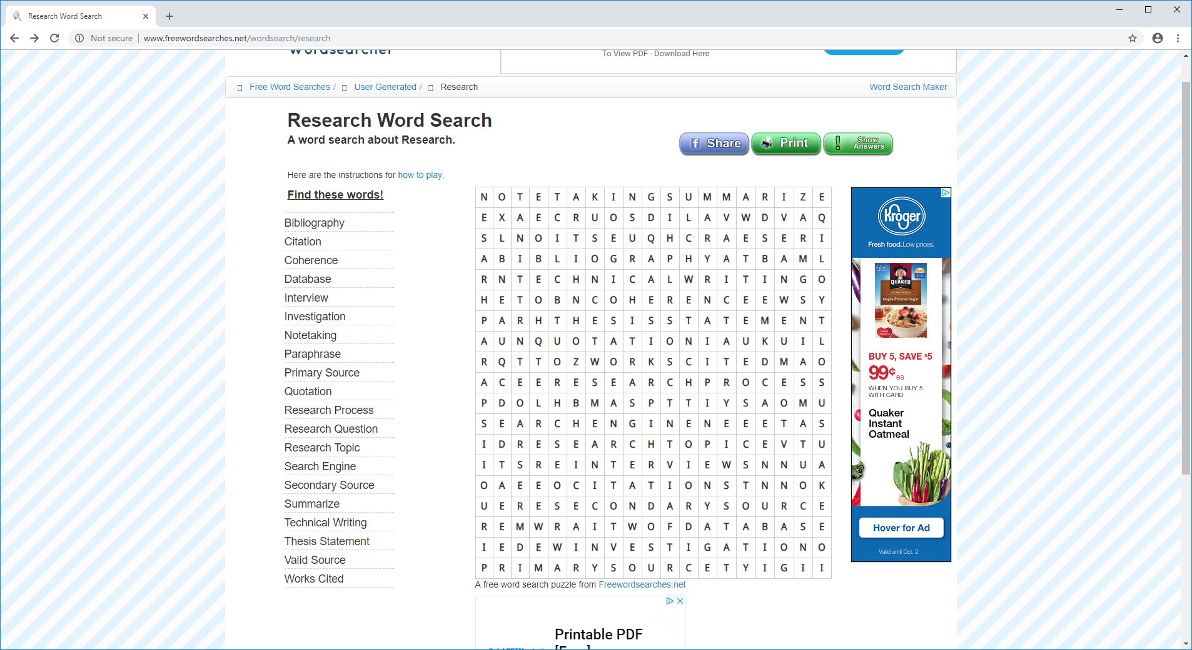

***Vanderbilt Human Research Protection Program***

***Supporting the work of the Institutional Review Board and providing human research protection program oversight***

If you have a topic you would like to see featured in an upcoming issue of the Participant Page, please reach out to Jan and let her know.

Jan Zolkower, MSHL, CIP, CCRP

(615) 322-2918

[jan.zolkower@vumc.org](mailto:jan.zolkower@vumc.org)

Vanderbilt Human Research Protection Program

3319 West End Avenue

Crystal Terrace, Suite 600

Nashville, TN

(615) 322-2918

[www.mc.vanderbilt.edu/irb](http://www.mc.vanderbilt.edu/irb)