|  |
| --- |
|  |
| **Spring 2019 Newsletter** |
|  |

**Participant Page**

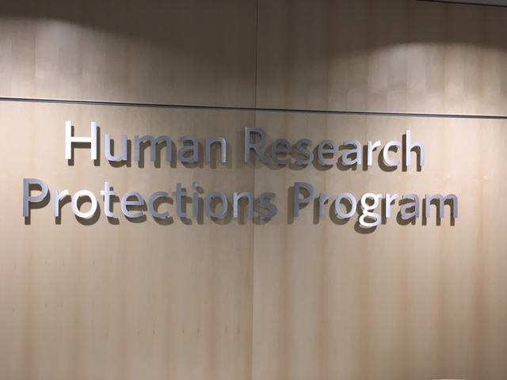

# Dates to Remember

## April 22

Earth Day

## May 27

Memorial Day

## June 21

Summer Solstice

|  |
| --- |
|  |
| Important Participant Drop Off Information for the Clinical Research Center The Clinical Research Center now has a drop off/pickup zone to the left of the **Round Wing Patient Units** entrance at the end of the circle (the area in front of the bushes). |

A Newsletter for the Vanderbilt Research Community

|  |
| --- |
|  |
| **How YOU make a difference!** |
|  |

## Whether you are listening to the news on the radio or watching it on the television, chances are on any given day you could hear Vanderbilt University Medical Center mentioned. It could be because it’s a Level One Trauma Center treating sick or wounded patients, or it could be because of a new medical breakthrough. For the later, we could not make discoveries without our participants who dedicate countless hours of their time to participate in research studies. We recognize these selfless acts may not help that participant, but it never stops our research volunteers from giving of themselves repeatedly. We thank you for your dedication and willingness to help us make our world a better place.

|  |
| --- |
|  |
| **Did you know…the Federal Regulations for research have changed. What does this mean for you?** |
|  |

Changes to the Federal Regulations governing human subject research went into effect on January 21, 2019. As a research participant, you will see changes to the Informed Consent Document (ICD) that you will be asked to sign. The first change is the form will now begin with “key information” about the study. This includes what will happen during the study, the risks and discomforts as well as any benefits and alternatives in case you do not want to participate in the research. Other new items include information regarding how your data/specimens will be stored, who will have access to them and if this information will be used for future research. Finally, the ICD will also let you know if and how study results will be shared. Please remember, giving your consent to participate in a research study is not just the one time signing of a document, but rather an ongoing exchange of information between you and the research team.

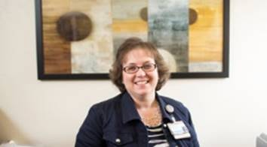

|  |
| --- |
|  |
| Have we Met? My name is Lana Howard and I am the Clinical Research Center Clinical Nurse Manager  If you agree to participate in a research study that will take place in the Clinical Research Center (CRC) chances are you will see me sticking my head in the door or passing you in the hall.  The CRC has a full-time staff of research nurses, care partners, schedulers, and environmental services team who all work together to ensure you have a good experience. If at any time you have a question or concern about the study you are participating in, please be sure to let one of us know. We are here to help and value your contribution to our research. |

|  |
| --- |
|  |
| **ResearchMatch** |
|  |

Are you looking for a research study to participate in? ResearchMatch brings together people who are trying to find research studies/clinical trials with the researchers who are looking for volunteers. The goal of ResearchMatch is to make it easier to find the right research study for you or your family members.

Too many times research studies end early because there are not enough volunteers. At the same time, people are looking for research studies to join, but may have a hard time finding them. As a result, key questions that may affect a community’s health go unanswered.

To help address these concerns ResearchMatch was created by academic institutions across the country. This free and secure online tool has the potential to include everyone in its mission of helping studies improve our health. Once you enroll, ResearchMatch will send you an email when there are studies that may be a good match for you. If you would like to learn more about the study, you simply respond to the email and more information is provided.

Anyone living in the United States, including Puerto Rico, can join ResearchMatch. People of all ages and backgrounds are welcome. A parent, legal guardian, or caretaker can register a child under 18, or register an adult that may not be able to join on their own.

Many studies need healthy volunteers as well as those with all types of health conditions. It is always your choice to decide what studies may interest you. You are not required to participate in a study if you join ResearchMatch. It is always your choice!

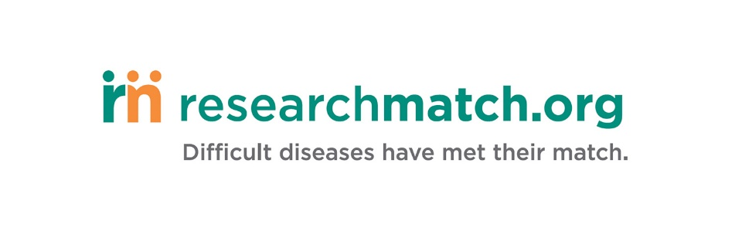



|  |
| --- |
|  |
| “For Participants” The Vanderbilt Human Research Protections Program (VHRPP) website has a tab just for its participants. On this page you will find information regarding how to participate in a study, questions to ask before agreeing to participate in a research study as well as contact information for the Research Subject Advocate in case you would like someone to be with you during the informed consent process. Copies of previous newsletters can also be found on this site.  The VHRPP website is located at: [www.vumc.org/irb/participants](http://www.vumc.org/irb/participants).  If you have suggestions for the “For Participant” tab, please use the “Voice Concerns” link to let us know. |

|  |
| --- |
|  |
| **Your voice: If you could change only one thing** |

Have you ever wished someone would ask you the question, “If you could change only one thing, what would that be?” Sometimes the request may be too complex to make it happen, but other times it could be an easy fix.

One concern that was recently brought to our attention is the need for a drop off/pick up spot in front of the new Clinical Research Center (CRC) and to have at least a few parking spots close by for regular and handicap parking. In fact, you may be one of the participants who was asked to provide your comments so we could share them with the Parking and Transportation department. As a result, there is now a drop off/pick up location in front of the CRC and we are working on getting permanent parking spots in the lot that is just a block away.

So, I’m asking you the question, “If you could change only one thing, what would that be?” I sincerely hope you will share your thoughts so we can explore ideas to see how we can make things better or a little easier for you and/or someone else.

Please feel free to contact Jan Zolkower, Research Subject Advocate at 615-343-8395 or [jan.zolkower@vumc.org](mailto:jan.zolkower@vumc.org) with any thoughts you may have.

***Vanderbilt Human Research Protection Program***

***Supporting the work of the Institutional Review Board and providing human research protection program oversight***

Vanderbilt Human Research Protection Program

3319 West End Avenue

600 Crystal Terrace

Nashville, TN

(615) 322-2918

[www.vumc.org/irb](http://www.vumc.org/irb)

Please contact the Research Subject Advocate at the number above if you would like additional information about giving consent or your rights as a research volunteer, to discuss problems, concerns, and questions as well as offer input or suggestions.

|  |
| --- |
|  |
| **While you wait** |
|  |

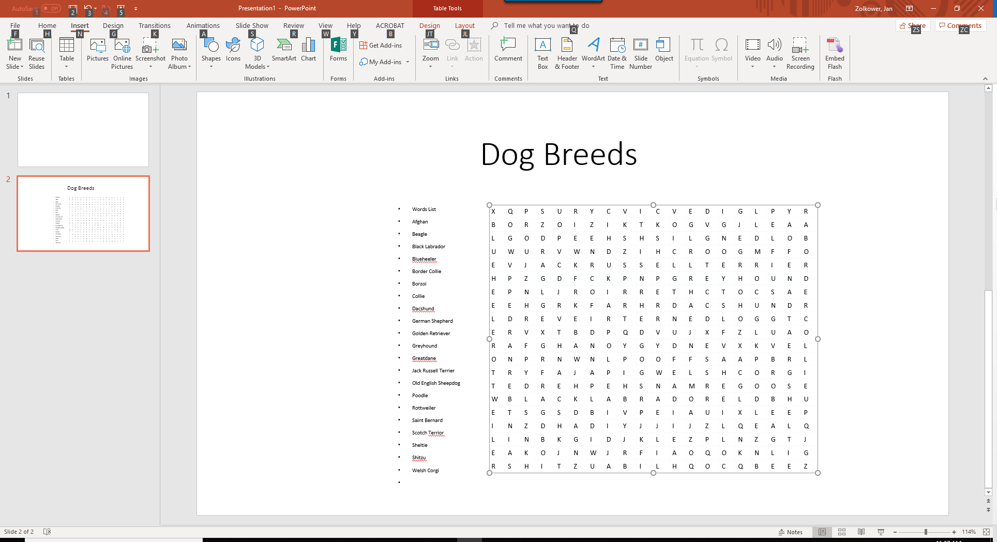

A free word search puzzle from www.freewordsearch.net