Spring 2020 Newsletter
Participant Page
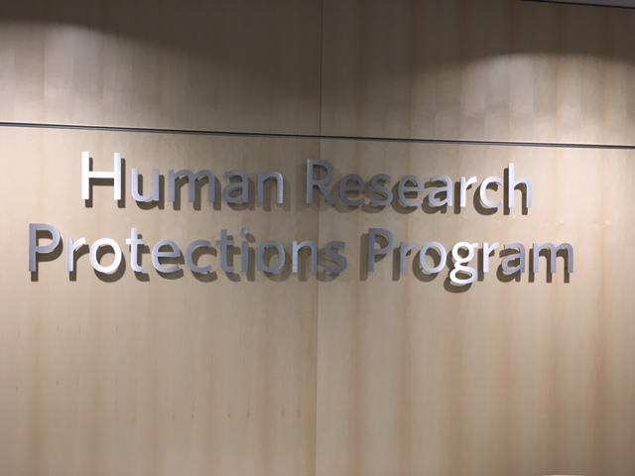

Dates to Remember

April 24
Arbor Day

May 25
Memorial Day

June 20
Summer Solstice

Where to search for research studies
If you are interested in finding a research study to participate in, you can check www.clinicaltrials.gov or sign up to receive email notifications through www.researchmatch.org

A Newsletter for the Vanderbilt Research Community

Participating in Research During a Pandemic
Our lives have changed so much over the past few months. We have learned we are “safer at home” and how to do “social distancing.” We also know things will not be the same for our research participants. So, we asked, “how has study participation changed due to COVID-19 and what changes can our participants expect to see?”
To answer this question required looking at more than one source. The search started with the Vanderbilt Human Research Protection Program (VHRPP). This is the department that oversees research in humans at Vanderbilt. On its website (https://www.vumc.org/irb/) there is a special section under “Tips” entitled, “Did you know...” There you will find several updates and guidance documents from the FDA regarding COVID-19. On March 18, 2020, the FDA issued guidance on “Clinical Trials During a Pandemic” to assist study sponsors and others with ensuring the safety of study participants. Because some participants will not be able to come to the study site for a visit, this guidance suggests an investigator or study staff member may conduct the study visit virtually instead of requiring an in-person visit. This will allow contact between the study staff and participants to continue while protecting both parties. During the visit the study staff will provide their participants with a plan for any study procedures that cannot be performed virtually or within the stated timeframe. Although some study changes may require the investigator of the study to submit a formal amendment (change request) to the Institutional Review Board (IRB) for review and approval, other changes may not since they fall under the current Federal Emergency. For visits

Have we Met?
My name is Julie Ozier, and I am the Director of the Human Research Protection Program (HRPP) at Vanderbilt. I have been the Director since 2014, at the HRPP since 2002 and at Vanderbilt since 1996.
The HRPP oversees the Institutional Review Board and provides oversight for research projects being conducted in humans. In addition to ensuring the Federal Regulations and institutional policies and procedures are being followed, my responsibilities also include ensuring our program continues to meet the requirements to maintain our accreditation with the Association for the Accreditation of Human Research Protection Program (AAHRPP), which we received in 2004.
The HRPP currently has just over 5000 active studies. We support 4 IRB Committees (3–Health Science and 1-Social/Behavioral), the Radioactive Drug Research Committee and the Institutional Biosafety Committee.

Participating in Research During a Pandemic (Continued)
that need to take place in person so participants can be assessed, or study drugs can be administered or dispensed, we contacted Lana Howard, the Clinical Research Center (CRC) nurse manager to see what changes have been implemented. She stated that the following items can be expected when coming to the CRC and/or Vanderbilt University Medical Center:
- As of Friday, May 1st, all participants, visitors and staff must wear a mask (cloth or paper) to help protect one another. If you do not have a mask, one will be provided at the screening station. Participants will be screened in the front lobby of the hospital or at the garage entrance.
- All participants, visitors and employees will be screened with temperature checks and symptom questions prior to entering Vanderbilt.
- Only one visitor over the age of 16 is allowed with outpatient participants and no visitors are allowed with inpatient participants.
- We will continue social distancing.
- We have limited the number of appointments we schedule to ensure we are able to get participants into rooms immediately upon arrival to minimize the amount of time participants spend in our waiting room.
- Our limited schedule will allow our awesome Environmental Services and nursing team extra time to complete a thorough cleaning between participant visits.
We are all hopeful that additional guidance for re-opening will be coming soon. In the meantime, regardless if you have an in-person or virtual study visit, the bottom line is that all of us involved in research at Vanderbilt University Medical Center want to ensure your safety. If you have any questions regarding your study visit or would like additional information about your rights as a research volunteer, please feel free to reach out to the Research Subject Advocate at (615) 322-2918.
Did you know…the Clinical Research Center plays a role in emergency preparedness?

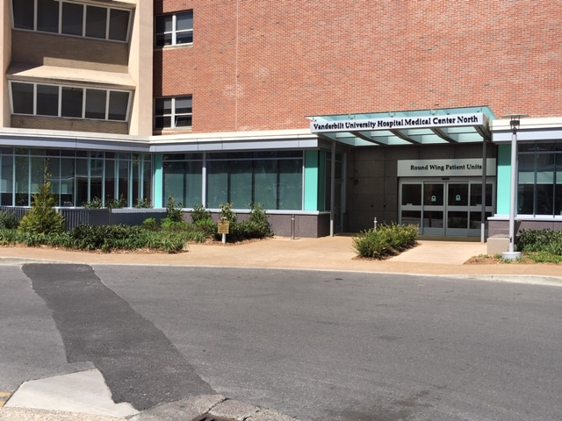
In addition to providing space for investigators to conduct their studies, the Clinical Research Center also partners with the Communicable Disease Response Unit (CDRU) to provide infrastructure and training facilities. This allows Vanderbilt to be ready to handle emergency preparedness needs in the event a situation would arise.
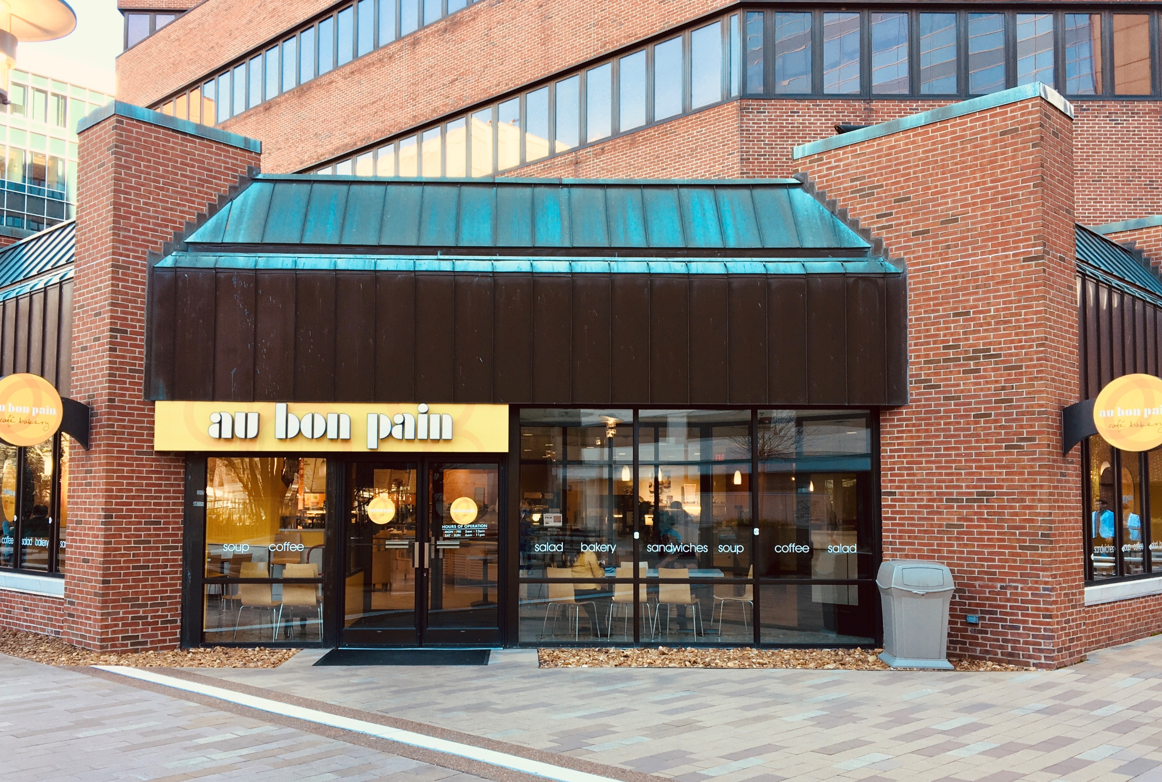

“FAQs For Participants”

Making your time at Vanderbilt Better
What are my Food Options while I am at Vanderbilt?
Main Hospital/Adult CRC
The Courtyard Café is located on the second floor of the Vanderbilt hospital. Their hours are 6am to 2am each day.
Au Bon Pain is located at the main hospital on the second floor near the courtyard. Their hours are Monday-Friday: 6 a.m. to 11 p.m.
Children’s Hospital/Peds CRC
The Children’s Way Café is on the second floor of Children’s Hospital.
Within Walking Distance
On 21st Avenue you will find:
Pancake Pantry
Pizza Perfect
Kay Bobs
Fido
Hopdoddy Burger Bar

Your voice: Tell us about your research experience
At Vanderbilt we want to hear it all: the good, the bad and the ugly. Of course, we never want to hear that someone had a bad experience, but we recognize mistakes happen and situations are sometimes unavoidable. When they do happen, our focus turns to “what can we do to ensure this does not happen again?” and “how do we make it right?” If you have had a research experience you would like to share, I would invite you to reach out to Jan Zolkower, Research Subject Advocate at 615-343-8395 or jan.zolkower@vumc.org with any thoughts, stories, or concerns you may have.
Vanderbilt
Human Research Protections Program
Supporting the work of the Institutional Review Board and providing human research protection program oversight

Vanderbilt Human Research Protections Program
3319 West End Avenue
600 Crystal Terrace
Nashville, TN
(615) 322-2918
www.vumc.org/irb

Please contact the Research Subject Advocate at the number above if you would like additional information about giving consent or your rights as a research volunteer, to discuss problems, concerns, as well as offer input or suggestions.

While you wait
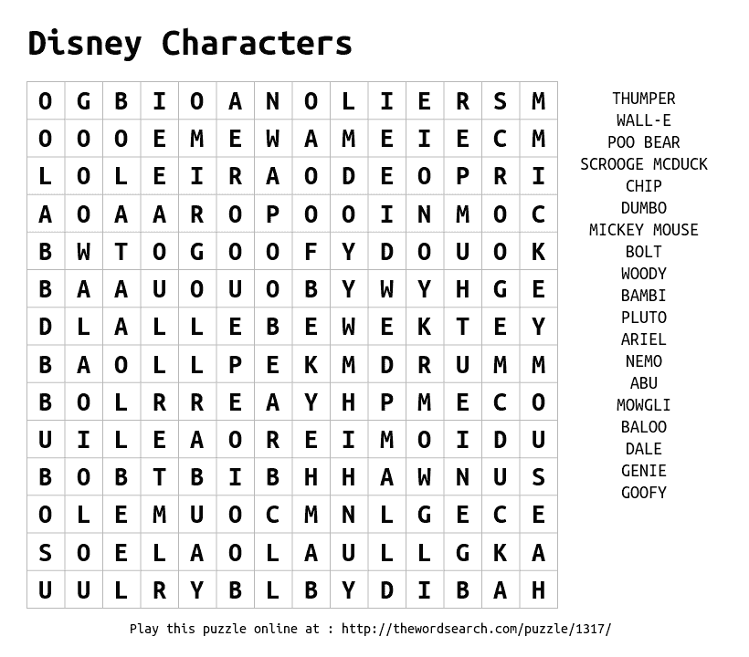A free word search puzzle from thewordsearch.com

