Instructions: The purpose of this document is to provide language for researchers and their institutions to adapt for federal grant applications when 1) the grant falls under the NIH Single IRB review policy or the researcher expects to streamline IRB review by using a single IRB, and 2) all or most of the institutions collaborating on the research have joined the SMART IRB Master Reliance Agreement and have access to the IRB Reliance Exchange (IREx).

Language that is in brackets [ ] and shaded in yellow should be completed by the IRB (pages 1 & 3). Information shaded in gray may need to be modified by the study team (pages 1 & 2) as appropriate to the funding situation.
TEMPLATE DESCRIPTION OF THE SINGLE IRB INFRASTRUCTURE AND PLAN FOR GRANT APPLICATIONS USING [insert institution name here] AS THE SINGLE IRB

This project will use the SMART IRB Master Common Reciprocal Institutional Review Board Authorization Agreement (SMART IRB Agreement) and the IRB Reliance Exchange (IREx) to support single IRB review in compliance with the NIH policy on the Use of a Single Institutional Review Board (sIRB) for Multi-site Research.
- SMART IRB: Development of the SMART IRB Agreement was funded by the National Center for Advancing Translational Sciences (“NCATS”) at the National Institutes of Health (NIH) to be responsive to and serve as a roadmap for implementing the NIH sIRB policy. SMART IRB streamlines and advances collaboration by establishing a common IRB authorization agreement and standardizing the roles and responsibilities of all parties involved in the review and conduct of multisite research. Further, the SMART IRB Agreement outlines the responsibilities of all Participating Institutions, the Reviewing IRB, and Relying Institutions, in addition to detailing the communication plan between the Reviewing IRB and Relying Institutions.
- IRB Reliance Exchange (IREx): Development of IREx was funded by NCATS at the NIH as part of the Trial Innovation Network (TIN), and can be used to support non-TIN studies implementing sIRB review, too. It was developed to support Human Research Protection Programs (HRPPs) and IRBs, coordinating centers, and study teams implementing single IRB review for their study. This freely-available web-based portal is used to capture sIRB documentation – including cede decisions, study-specific local considerations, and site’s IRB approval documents. IREx is also used to support sIRB coordination, which includes tracking site readiness for sIRB review, facilitating submission to the sIRB and communicating when sites receive sIRB approval.

To date approximately # of the # planned participating sites already have signed onto the SMART IRB Agreement and have access to IREx (see table below). It is anticipated that all participating sites will be fully onboarded prior to the planned award date to rely on [insert institution name here] as the Reviewing IRB.

Each site PI has verified that their HRPP is agrees that IRB review, regulatory oversight, and roles and responsibilities of the parties will be governed by the SMART IRB Agreement and the [insert SMART IRB or sIRB Name] Policies and Procedures (P&Ps) throughout the life of the project.

In joining SMART IRB, each site has designated a Point of Contact (POC) to provide the Reviewing IRB with knowledge about local considerations and facilitate coordination among the sites. In accordance with the SMART IRB Agreement and SOPs:
- [Name] will serve as the Overall PI, and
- [Name], [role] at [lead site], will serve as the primary contact on the Lead Study Team, and will distribute the results of IRB reviews and manage ongoing communications across site study teams.
- The POC for the Reviewing IRB will ensure appropriate communication with Relying Institution POCs.

Study Team Communication Plan
Study initiation conference calls will be scheduled by the Lead Study Team/Coordinating Center and include a presentation by the Single IRB and IREx Teams to inform all sites about the single IRB process, required agreements and reliance arrangements, use of IREx, as well as the review processes and reporting requirements of the Reviewing IRB. In addition [name or role of person (e.g., coordinating center)] will provide each site with a summary of the Reviewing IRB’s reporting requirements to be distributed to their study teams.

The Lead Study Team/Coordinating Center will be responsible for ensuring ongoing communication with all participating study teams via teleconferences, IREx-facilitated reminders, and regular emails throughout the study. The IREx Status Summary (see image) will be used to track each site’s progress towards reliance.

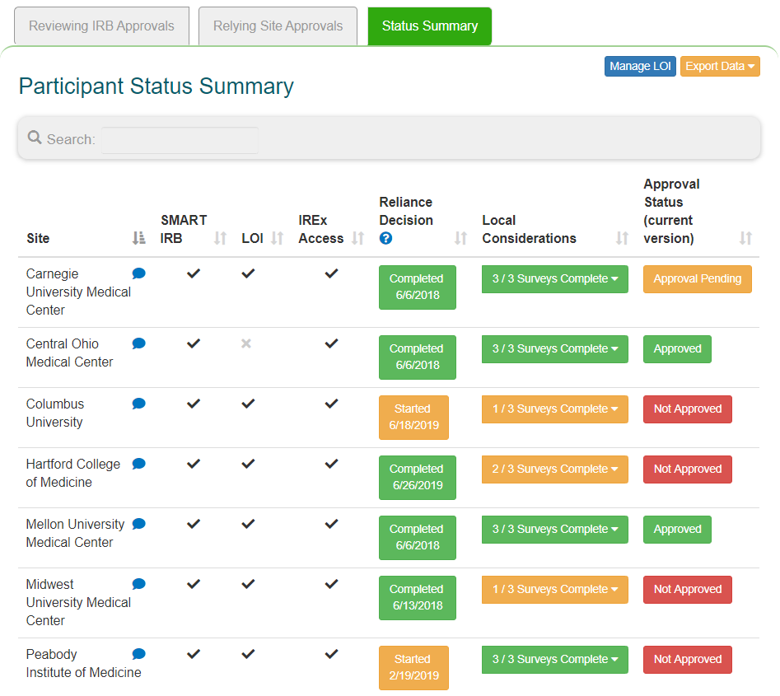

- Track site’s agreement status
- Track relying site HRPP’s cede decisions
- Track relying site’s local considerations completion
- Track site’s approval status

KEY POINTS OF COMMUNICATION:
- The Single IRB and IREx Teams will provide the following to the Lead Study Team/Coordinating Center:
  - An introductory training to the Single IRB review process, the responsibilities of the Lead Study Team/Coordinating Center, the requirements of using VUMC as the single IRB, and the system used to support the reliance process (IREx).
  - Site-specific reliance instructions detailing the status of each required agreement and the steps required of each site study team and their HRPP in IREx. See template.
  - An informed consent form template to be used for each site.
  - Relevant [insert institution name here] HRPP policies.

- The Lead Study Team/Coordinating Center will do the following:
  - Disseminate the above materials to all participating site study teams.
  - Alert study teams to problems that may affect the conduct of the study or the rights and welfare of research participants, such as unanticipated problems and serious noncompliance
  - Inform study teams of any changes in study status (e.g., temporary suspensions of recruitment) or new information
  - Facilitate submissions to the Reviewing IRB, including:
    - Inclusion of site-specific requirements in consent documents
    - Identification of any variability in study implementation across sites that must be communicated to the Reviewing IRB
    - Collection of information from participating sites to include in continuing review reports to the Reviewing IRB
    - Site-specific amendments
    - Personnel updates (as required by the Reviewing IRB)
    - Reportable events (e.g., noncompliance, unanticipated problems)
    - Closure reports
  - Ensure revisions to applicable conflict of interest management plans are provided to the Reviewing IRB

- IREx will be used to do the following:
  - Document and track reliance arrangements between FWA-holders and component sites;
  - Track participating site progress towards initial IRB approval;
  - Streamline and centralize the capture of participating sites’ local considerations on a study-by-study basis;
  - Capture and notify participating sites of IRB determinations and IRB-approved documents.
  - Facilitate communications to participating sites when actions are required; and
  - Automate notifications to participating sites of new approvals.

