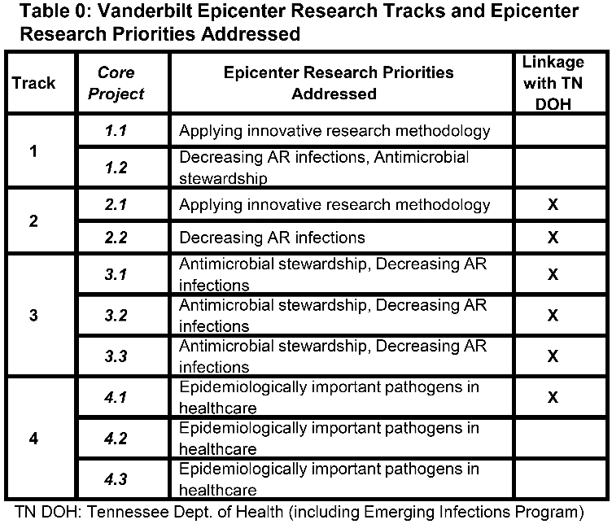
Healthcare-associated infections (HAIs) result from an intertwined relationship between vulnerable hosts (patients and healthcare workers), opportunistic pathogens (antibiotic-resistant organisms [AROs]), and conducive environments (breaks in infection prevention practices or inappropriate antibiotic prescribing). While strides have been made in preventing these important patient harms, much is unknown regarding their epidemiology, risk factors, and methods of prevention. Thus, there is a clear need for novel and innovative approaches to expand our understanding. In the pages that follow are the proposed research tracks and Core and Collaborative Projects for the Vanderbilt Epicenter for Infection Prevention and Antimicrobial Stewardship. The projects follow the aforementioned thread of the host-pathogen-environment triad. They address stated Epicenter research priorities (Table 0) in innovative and novel ways and are designed to harness existing partnerships with our public health colleagues, to develop a lasting collaborative research infrastructure, and to mentor young investigators interested in healthcare epidemiology and antibiotic stewardship. Track 1 focuses on developing an innovative research infrastructure with a project that examines host risk factors for ARO persistence, which could impact antibiotic selection. Track 2 focuses on the organism, using an open-access platform to identify patients at high risk for ARO colonization. Track 3 examines environmental factors (prescribing barriers) leading to inappropriate antibiotic use (AU). Track 4 blends a focus on organism (respiratory viruses) and the environment (poor clinician recognition). Finally, the Collaborative projects examine methods to improve AU in different environments (outpatient vs. inpatient) with pragmatic, multicenter trials that illustrate Vanderbilt’s ability and enthusiasm for collaboration within the larger Epicenter network.

CORE TRACK 1: Using an Innovative Informatics Platform for Novel Infection Prevention and Antibiotic Stewardship Research Questions (Track Lead: Nelson)

With the increased focus on preventing HAIs, halting the spread of AROs, and improving AU, there have been impressive improvements in patient care; however, preventable harms still exist. There is a critical need for insight into novel aspects of these issues, whether increasing understanding of the epidemiology of ARO infections, identifying new risk factors or harms associated with these infections, or assessing nuanced risks for developing these outcomes. Use of novel analytic methodologies for these purposes may optimize appropriate AU and individual patient outcomes, improve the quality of care, and provide critical patient safety processes while reducing antimicrobial-associated adverse events (AE).¹⁻³

Vanderbilt, an international leader in personalized medicine, biostatistics, and bioinformatics, has developed the Synthetic Derivative (SD), a unique, highly detailed informatics platform structured for targeted academic inquiry.⁴ The SD, containing over 3.3 million unique patient electronic health records (EHRs), allows for efficient chart abstraction and analysis with ready access to deidentified patient-level data that avoids the need for laborious individual chart review required by traditional study designs. Vanderbilt Epicenter investigators have previously utilized this valuable resource to define the risk of myositis following daptomycin use, including the first clear description of the risk of concurrent statin therapy.⁵ In this project, our team was able to abstract patient and encounter-level data efficiently from 3,042 patient charts to identify this risk association. This powerful clinical data platform is linked with the BioVU sample repository, the largest collection of DNA samples (288,421, as of 02/25/2020) coupled to EHRs at a single academic institution world-wide. Together, these electronic and biological archives comprise one of the world’s largest resources for patient phenotype correlation studies and highlight the clinical functionality and translational impact of the SD with enhanced capabilities proposed below.

This track will utilize and enhance this innovative and efficient tool to create a novel research framework for HAI, ARO, and antibiotic harm research. While this infrastructure will be used to answer the innovative research question posed in this track (Core Project 1.2), it will also provide a lasting framework to allow for other investigator-initiated research studies focused on these topics. In addition, while the SD is only present at Vanderbilt, the findings from the potential research studies can inform the larger evidence base around HAI and ARO risk and prevention that can be utilized at other healthcare facilities.

Specific Aim 1.1: Incorporate standardized healthcare-associated infection and antibiotic-resistant organism outcomes into the Synthetic Derivative to allow for efficient, innovative, and reproducible risk factor and outcome analyses. (CORE PROJECT 1.1)

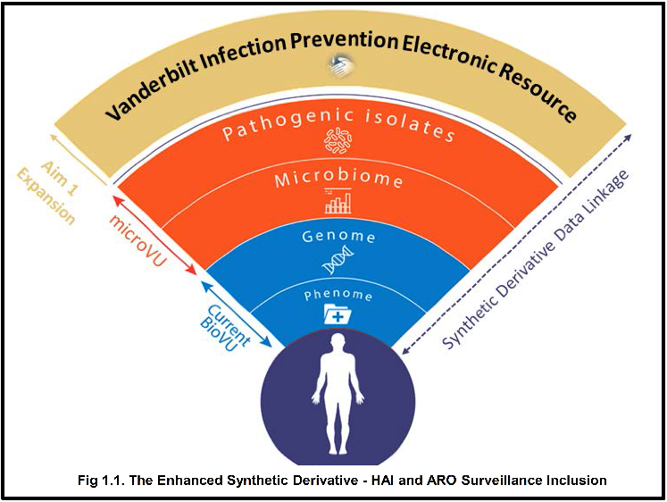
The SD currently has tremendous ability to examine important questions efficiently such as AEs related to antibiotics (e.g. VUMC Epicenter daptomycin project⁵); however, the SD’s utility for novel research approaches for HAIs and ARO epidemiology is limited, as HAI surveillance outcomes as captured by the gold standard Centers for Disease Control and Prevention’s (CDC) National Healthcare Safety Network (NHSN) methodology are not captured within the tool. Thus, natural language processing (NLP) algorithms, which are complex to implement effectively, have been the primary tools available to examine these outcomes. Recently, the SD team has partnered to incorporate patient-level data captured through standardized data registries, such as the Vermont Oxford Network. The use of these standardized data sources in conjunction with the existing robust SD platform analytic tools has amplified the power of the SD.

This project aims to enhance the SD to incorporate and validate important HAI and ARO-focused outcomes, which will allow novel investigations into these topics (Fig. 1.1). This project will consist of two key portions: 1) incorporation of the NHSN HAI and ARO data into the SD and 2) development and validation of key HAI and ARO-related disease phenotypes to utilize for related questions. Specifically, the creation of clinical “phenotypes” (as opposed to reliance on administrative coding outcomes used by many large data platforms) is an important aspect of the SD tool. Research-grade clinical phenotypes can be created from EHR data for use in a variety of applications, from quality improvement to complex patient or population health outcomes.⁶ Phenotype algorithms employ heuristic or machine learning algorithms, combining multiple data sources to achieve high positive predictive values (PPVs) for desired phenotypes.

Importantly, the SD team has also validated SD-developed phenotypes within other EHR systems to illustrate the generalizability of the work to other healthcare systems. Prior analysis of published phenotypes demonstrate high precision across different EHRs with nearly identical PPV.⁶ Through the VUMC-led PheKB Network,⁷ to date >70 phenotype algorithms have been developed and deployed, including drug-induced liver injury, pneumonia, and antibiotic-associated Stevens-Johnson Syndrome.⁶ The VUMC Integrated Data Access and Services Core (IDASC) has developed and implemented >50 phenotype algorithms using EHRs, including medication-related AEs.⁸⁻¹¹ IDASC’s prior successes demonstrates a track record for scientific achievement applicable to Track 1’s proposed Aims. HAIs and ARO phenotypes included within NHSN data incorporated into the SD will be immediately available within the enhanced SD platform; clinical phenotypes for additional infectious conditions of interest (e.g. asymptomatic bacteriuria) as well as ARO status (colonization vs infection) will require development. All HAI and ARO phenotypes will be created through open source coding for broader application and study in sites able to query an EHR but without the capabilities of SD.

Data Sources: The Vanderbilt Infection Prevention Electronic Resource (VIPER) is VUMC’s HAI surveillance platform, which utilizes NHSN HAI surveillance definitions to identify HAIs, capture device days and surgical procedures, and flag cultures growing an ARO. HAI data are entered into the NHSN platform using standardized data fields. In partnership with the SD and the IDASC, HAI and ARO data captured by VIPER will be integrated into the SD.

Data import period: Data from the years 2010 onward for all HAIs within VIPER will be incorporated into the enhanced SD. Standardized data dictionaries will be created that will also note changes in CDC NHSN surveillance definitions over the data period. Discrete HAIs and microbiology (specimen type, pathogen, susceptibility patterns, etc.) data fields and processes for regular upload of the NHSN data will be developed.

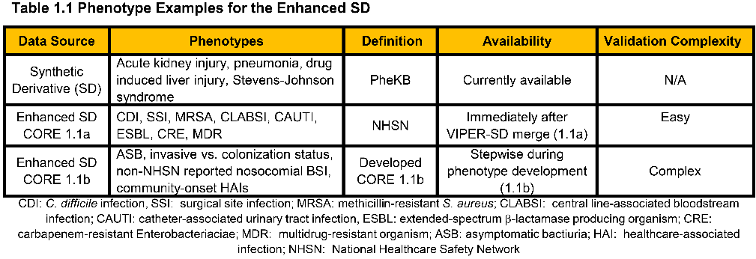
Data validation: Importation of VIPER data will utilize the Observational Medical Outcomes Partnership (OMOP) Common Data Model (CDM) which has been used for >50 databases comprising >680 million patient records.¹² Recent VUMC studies demonstrated the feasibility of implementing the OMOP CDM across sites to speed phenotyping execution.^{13,14} Therefore, the importation of VIPER data in OMOP offers tremendous opportunities for its scalable deployment. For NLP methods, text strings will undergo secondary review with potential misidentifications analyzed to determine error attribution (e.g. concept mapping or documentation errors) to produce a confirmation of structured data and unstructured free text fields available to identify clinical conditions of interest.

Phenotype Development: Phenotype algorithm creation, validation, and implementation will be performed within the SD through an iterative refinement process, a method that IDASC has >10 years of experience and expertise conducting.¹⁵ NHSN HAIs included in VIPER will not require additional validation and will be available for immediate use after database construction (Table 1.1). All variable definitions and metadata labels, including methods and modalities used in the phenotype criteria, will be regularly updated. These criteria are based, in part, on phecode, a widely used biomedical research method developed at VUMC, which utilizes custom ICD groupings to define cases and controls for 1,886 diseases or traits to date; prior VUMC research demonstrates superior results to ICD codes alone.¹⁶ We will develop and validate our phenotype definitions through two approaches: 1) hypothesis-driven or rule-based; (i.e. an algorithm proposed by domain experts incorporating numerous laboratory, microbiologic, and patient factors as well as NLP approaches will be refined with resulting algorithm to be validated until PPV >90% to contextualize results when the results alone are not representative of disease state) and 2) non-hypothesis-driven; machine or deep learning methods applied to EHR data to classify cases and controls.¹⁷

Specific Aim 1.2: Evaluate the risk for subsequent antibiotic-resistant organism identification in patients with an antibiotic-resistant organism identified on prior cultures to guide appropriate antibiotic utilization. (CORE PROJECT 1.2)

Aim 1.2 provides an example of the analytic power of the enhanced SD tool created for Aim 1.1. Traditional ARO risk factor analyses recognize discrete patient characteristics, often relying on labor-intensive chart abstraction. ARO predictive models remain limited¹⁸⁻²² and are hindered by reliance on claims data and a lack of longitudinal patient-level characteristics, including prior ARO status.¹⁹ Better tools and recognition of patients at risk for ARO colonization are critical to improve appropriate AU.²³ Optimizing AU by reserving broad-spectrum antibiotics for use only when necessary can be challenging when caring for patients with prior ARO colonization or infection. The conventional approach for empiric antibiotic selection in this scenario relies on patient-specific risk factors (e.g. healthcare exposure) and prior culture results, which may reflect the patient’s colonization status and likelihood of continued ARO presence. In patients with prior ARO+ cultures, this approach may lead to overuse of valuable antibiotics if the prior culture no longer indicates the patient’s actual ARO colonization status. The interval between prior ARO identification and impact on subsequent recovery of ARO at either the same or alternative site of detection requires further investigation. For example, the need to empirically treat a patient with a previous isolation of an extended spectrum beta-lactamase producing (ESBL+) E. coli urinary isolate who is again presenting with a UTI with a broad-spectrum antibiotic likely varies based on the interval between prior ARO identification and presentation with subsequent infection. Even less clear is whether the ARO-targeted empiric antibiotics are necessary for future presentation with an infection at an alternative culture site (e.g. if a previously ARO+ patient presented with a new hospital-acquired pneumonia, would he or she still need ARO-specific empiric therapy?). Patient risk for developing an ARO infection changes over time; most studies to date treat dynamic risk factors as static which significantly impacts clinical application. Even recent, well-designed studies encounter reduced sensitivity due to limited patients available for inclusion and capacity for external validation. In contrast, the SD contains >493,000 unique patients with >2.3 million clinical cultures and associated clinical data (Fig 1.2).

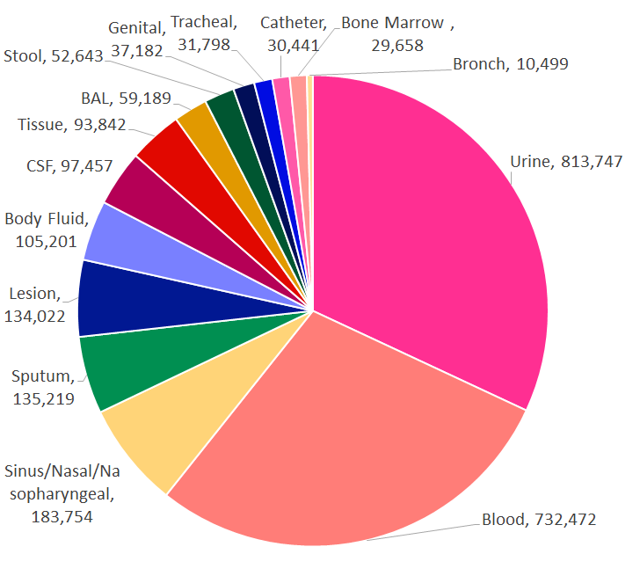
This core project will analyze the temporal relationship between prior patient-specific ARO identification and the risk of subsequent ARO infection stratified by infection site (localized vs. distant site) to inform appropriate empiric AU. We have intentionally selected a clinically important question with enough complexity to illustrate the unique attributes of the SD for HAI and ARO research. It captures the power (evaluable subjects) and data efficiency of prior large claims database analyses alongside the descriptive capacity of studies incorporating patient-level clinical data. While the analytic work proposed is complex, traditional research methods would be time-prohibitive. Recently, VUMC successfully applied three machine learning algorithms to a similar clinical risk model (logistic regression, random forest, and gradient boosting), showing superior performance compared to traditional clinician-derived risk assement.²⁴
Fig 1.2: Synthetic Derivative Clinical Isolates by Site >10,000Specimens

Study Outcomes: The primary outcome will be the risk of subsequent ARO detection at any site within predefined time intervals. Secondary outcomes include risk of subsequent ARO infection at localized vs. distant site and pathogen and resistance phenotype specific analyses.

Study Population/Period: Patients ≥18 years of age with ≥ two microbiologic cultures (≥ 14 days apart) collected between Jan 1, 2010-Dec 31, 2019 present in the enhanced SD (Fig. 1.3).

Outcome Definitions: ARO+ culture is defined as any clinical culture with ARO growth, and ARO recurrence is defined as growth of the initial ARO in subsequent cultures. Recurrence will be categorized as localized (same ARO+ culture site as initial growth) and distant (different specimen type, [Fig. 1.3]).

Statistical Analysis: Descriptive statistics will be presented as median (interquartile range) or frequency (%). Continuous variables will be compared using Wilcoxon rank-sum test, and categorical variables using Pearson chi-square test. Candidate predictor variables will be selected based on clinical expertise, literature review, and data availability in the enhanced SD and will be evaluated for completeness, strength of marginal relationship with outcomes and other variables via Spearman rho. Outcomes will be evaluated in both development and validation cohorts, using the same definitions and inclusion criteria with c-statistics reported for the prediction model. All pairs of same-patient cultures will be binned by time interval (t=t₁−t₂ [early - late culture date]) and included in the regression model. Two ARO risk prediction models will be developed for localized and distant recurrence using multivariable logistic regression. Continuous predictors will be appropriately transformed using restricted cubic splines. Internal model validation and calibration will use several complementary methods (logistic regression, random forest, and gradient boosting) and potential tensor-factorization for dynamic temporal outcome analysis.²⁵

CORE TRACK 2: Novel Antibiotic-Resistant Organism Surveillance (Track Leads: Talbot, Staub)

Identifying patients colonized with AROs as they move between healthcare facilities is an essential strategy to stem regional transmission of these important pathogens.^{26,27} Such awareness can actively direct interventions to prevent ARO spread within the accepting facility. The most commonly proposed tool to aid in this communication relies on individual notification upon patient transfer (usually via a standardized interfacility communication form), and compliance with such tools is suboptimal. In Oregon, hospital self-reported compliance with a state requirement for such communication was 87%, while nursing home compliance was only 68%.²⁸ In TN, where such communication is recommended but not required, use is much lower. Thus, there is a need to utilize novel tools and data to link and visualize the movements of patients who are colonized with AROs throughout the healthcare system to better understand the risk these patients pose for ARO transmission. Additionally, with this understanding, one can proactively implement infection prevention interventions to reduce pathogen transmission. Our hypothesis is that a data-driven intervention coupling transfer volume and ARO prevalence will lead to effective and targeted interventions to reduce organism transmission within the receiving healthcare facility. This track will build upon a successful Tennessee Department of Health (TN DOH) project that utilized statewide hospital discharge data and aggregated facility-level patient sharing data from the Centers for Medicaid and Medicare Services' Minimum Dataset to construct patient sharing networks.²⁹ It will also utilize an open access tool for data visualization and analysis (RShiny) which allows for broad applicability of this surveillance application.³⁰

Specific Aim 2.1: Design a Visual Surveillance Tool for inter-healthcare facility Antimicrobial Resistance (V-STAR) using an index facility’s microbiology data linked to admission-discharge-transfer (ADT) information to identify epidemiologic antibiotic resistant (AR) “hot spots” in the index facility’s patient-sharing network. (CORE PROJECT 2.1)

RShiny allows users to create web-based applications to visualize and engage with datasets.³⁰ In 2019, Rany Octaria MD MPH, an Epicenter consultant, worked with TN DOH to use RShiny to produce a dynamic visualization of TN patient transfer and admission data obtained via the TN Hospital Discharge Data System (HDDS). This tool allows individual TN healthcare facilities to visualize their interconnectedness to other facilities based on patient ADT volume and was built to aid facilities in predicting the risk of receiving patients colonized with an ARO from an index facility in the event of an outbreak or notification of novel ARO emergence in the region (Fig. 2.1). While this tool looks at patterns of patient transfer, it does not include ARO data. To meet this need, we will develop a visualization model, based in principle on the TN DOH tool, that links VUMC-specific ADT data and patient-level microbiological culture data to visualize the movement of patients who are infected or colonized with AROs throughout TN. VUMC’s inter-facility network encompasses estimated >90% of TN healthcare facilities, making it an excellent pilot site for this effort.

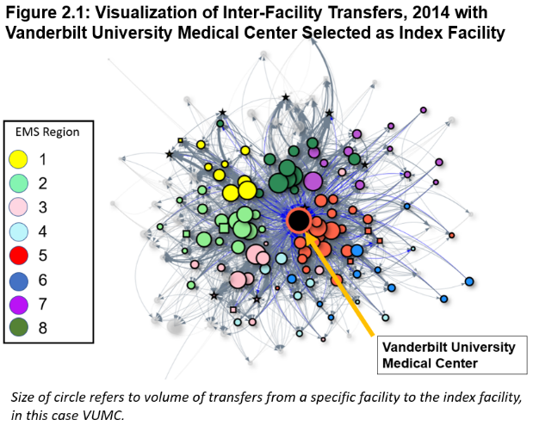
Data Collection: All patients with a direct transfer into and from VUMC (ADT Data) from January 1, 2019 to December 31, 2020 will be extracted from VUMC’s EHR data repository. The patient’s medical record number (MRN), encounter number, gender, county of origin, dates of transfer, transferring facility name, facility name to which patient was discharged, and encounter-specific VUMC microbiological cultures will be captured. All microbiological cultures from any site, sterile or otherwise, demonstrating an ARO, defined as either an ESBL+ producing organism or a carbapenem-resistant Enterobacteriaceae (CRE), will be flagged. ADT data will be cross-referenced and linked with microbiology data, matched by unique patient MRN and encounter. Only the initial culture of a unique patient encounter in which an ARO is identified will be linked in order to avoid falsely inflating the effect of an individual patient with repeat ARO cultures in a single encounter. The ARO culture will then be “assigned” to either the transferring facility or VUMC based on the initial culture date (i.e. cultures obtained within 72 hours of patient transfer are assigned to the transferring facility; those obtained >72 hours after patient transfer will be assigned to VUMC). All patient encounters without an ARO identified will be included to visualize overall volume of patient movement and to assess the proportion of ARO colonized patients transferred between two facilities. The finalized dataset after sensitivity analyses (see below) will be transferred into RShiny for creation of V-STAR.

Data Visualization: Utilizing RShiny and VUMC data, a transfer network map will be created (hosted on a secure Vanderbilt server website) using the above dataset. Patient flow volume will be represented by facility circle size. Transfers in which a patient was identified to have a culture-proven ARO will be color-coded: red for incoming transfers and blue for outgoing transfers. Transfers without an identified ARO will be color-coded gray. Increasing volumes of transferred patients with AROs will be represented by a deepening of the assigned color. Data will be able to be filtered on the population level by date of transfer (in month intervals), patient gender, patient age at time of transfer, type of transfer (in, out, both), presence of ARO, type of ARO, and site of ARO culture (e.g., blood, urine, etc.). V-STAR will show the comparative effect of an individual facility’s ARO colonized patient transfers from VUMC’s perspective.

Outcomes: V-STAR will be used to calculate a risk score of receiving an ARO-colonized patient from each facility in the visualized network. This risk score will be calculated based on volume of shared ARO-colonized transfers within the prior 12-month period and weighted by proximity to other high-risk facilities based on pre-defined TN Emergency Medical Services regions. Secondary outcomes will include the correlation between ESBL+ and CRE prevalence within each inter-facility relationship to predict whether high volumes of ESBL+ transferred patients necessarily predict a higher probability of sharing a CRE-colonized patient within that same inter-facility relationship. We will also analyze whether there is a difference in ARO movement based on patient gender, age and season of the year.

Sensitivity Analysis: To evaluate the clinical utility and generalizability of V-STAR, we will compare the difference in visualization of network and ARO risk based on two models of patient colonization status. The first treats each patient encounter with a documented ARO culture as a single event. This model does not presume sustained ARO colonization for future encounters unless a new ARO culture is obtained during that specific future encounter. The second treats patients with an ARO+ culture as persistently positive during future encounters for a time period of 6 months after the initial ARO culture encounter. We will also test whether using the weighted risk score differs from using a more simplified proportion measured as the number of ARO-colonized transfers divided by all transfers to/from a single facility.

Study years: The aggregation, validation and data linking will occur from October 2020-July 2021. V-STAR development will occur from August 2021-May 2022 with pilot testing from May 2022-September 2022.

Challenges and Opportunities: V-STAR’s accuracy may be limited by the lack of access to culture results obtained at outside facilities. To estimate this limitation, we will randomly select a convenience sample of 10% of all patient transfers not already identified as an ARO transfer who received broad-spectrum, ESBL+ or CRE treatment antibiotics (carbapenems, tigecycline, colistin, etc.) within the initial 24 hour period after transfer to review whether there was documentation of prior outside facility cultures via scanned documents to assess the percentage of patients not captured as an ARO patient transfer by the V-STAR algorithm.

Specific Aim 2.2: Evaluate the impact of an EHR notification to alert infection prevention personnel of patient admissions from facilities associated with a high-risk ARO colonization prevalence. (CORE PROJECT 2.2)

Using the surveillance data from Core Project 2.1, this project will involve development of an alert within the VUMC EHR to notify infection prevention team members (IP) when patients have been admitted from high risk ARO transfer facilities. The alert will allow for proactive interventions, including empiric placement into contact precautions, active surveillance testing for ARO colonization, and decolonization strategies (e.g. chlorhexidine [CHG] application).

Study Period: Funding years 3-5 (~ October 2022-October 2025) with an intervention study period of 2 years

Intervention: Using the data from Core Project 2.1, high risk transfer facilities will be identified. An EHR-based notification, sent directly to IPs, will be developed that will identify patients transferring from high-risk facilities to VUMC. The EHR currently contains other IP-directed alerts that direct specific action upon patient admission (e.g. instituting isolation precautions when a patient with a contagious infection is readmitted), and this high ARO risk alert would follow a similar workflow. Upon receipt of the alert, IP would order empiric contact precautions, perirectal ARO surveillance cultures, and CHG decolonization if not already indicated by current VUMC policy (standard practice for all intensive care unit [ICU] patients and all non-ICU patients with a central vascular or midline catheter). Current IP workflow consists of on-call personnel who review all alerts daily as part of a standardized workflow, within which this intervention will readily fit. Currently, usual care at VUMC does not include routine surveillance cultures for AROs.

Study Design: We will study the impact of the notification using a pragmatic design in which the intervention will be turned on hospital-wide (“notification period”) and off (“usual care”) for 3-month blocks over the course of the 2-year study period. A washout period of 2 weeks between each study block will be used in the analysis to account for potential impact across the blocks (e.g. screened patients still hospitalized during the usual care blocks who could impact risk of ARO transmission, Fig. 2.2). As the IPs during usual care would not be accessing individual patient charts to assess transferring facility information, we anticipate minimal contamination across the time periods.

Outcomes and Analysis Plan: Rates of the 2 ARO classes, calculated as both an aggregate and separately by specific AR type, per 1,000 patient days (with 95% CI) will be compared between the notification and usual care periods. Cultures obtained as a result of the active screening intervention in the notification period will be excluded from the analysis. Baseline annual rates of cultures positive for ESBL or CRE organisms were 2.19 per 1,000 patient days (aggregated). With this baseline rate over a 2-year study period with an estimated 400,000 patient days (224,000 annual in 2019), there is 80% power to detect an 18% rate reduction.

Challenges and Opportunities: Variations in other infection prevention practices could impact ARO transmission. To assess this potential confounder, we will examine inpatient unit hand hygiene compliance rates over the study period. At VUMC, hand hygiene is measured in all clinical units by trained observers as a part of a foundational safety program.³¹ Annually, over 30,000 observations are captured. Daily compliance with CHG application is also tracked and will be compared between the two study periods. Finally, any seasonal alterations in ARO epidemiology could also affect ARO rates; however, such seasonality has not been described. Future projects using this research infrastructure include development of a clinical predication model for ARO colonization that includes clinical data as well as development of a decision support tool to direct empiric antibiotics that accounts for patients admitted from high risk ARO facilities.

CORE TRACK 3: Improving Appropriate Outpatient Antibiotic Utilization (Track Leads: Staub, Katz; Mentored by: Nelson, Banerjee)

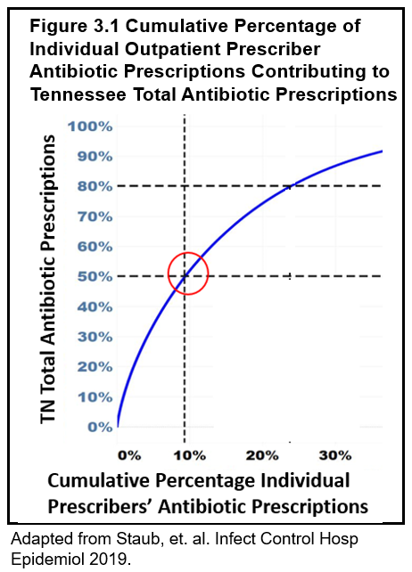
Annually, about 2.8 million Americans are diagnosed with and 35,000 die from an ARO infection.³² Antimicrobial resistance is driven by AU,³³ and an estimated 85-90% of all AU occurs in outpatient settings.³⁴ There are few published large-scale outpatient antibiotic stewardship (AS) intervention studies in the United States.³⁵⁻³⁷

Vanderbilt Epicenter investigators have collaborated with the TN DOH to evaluate Tennessee outpatient AU using IQVIA™ Xponent (IQVIA) (Durham, NC, formerly IMSQuintiles) outpatient TN antibiotic prescription data. IQVIA uses a patented method incorporating 100% of wholesale pharmacy distribution data and ~90% of retail pharmacy sales data to project 100% of dispensed prescriptions.³⁸ Our results showed that 9.3% of prescribers accounted for 50% of all TN outpatient antibiotic prescriptions (Fig. 3.1).³⁹ For the pediatric population, 2% of prescribers accounted for >25% of pediatric outpatient antibiotic prescriptions.⁴⁰

This track builds on successful collaborations with the TN DOH to address important deficits surrounding our knowledge of outpatient prescribing. Specifically, Core Project 3.1 will evaluate provider-perceived barriers to reducing inappropriate AU in the outpatient setting across TN. A paucity of data exists about barriers to reducing AU in the United States outpatient setting (particularly for adult, specialty, urgent-care, retail and non-physician providers),⁴¹⁻⁴⁸ and data about these barriers are necessary to design effective AS interventions. Core Project 3.2 will employ user-centered design (UCD) strategies to create AS interventions that specifically address the barriers identified in our first aim. Existing studies show mixed results in terms of efficacy and sustainability for tested AS interventions, and no published study has focused on involving outpatient prescribers in the development of AS interventions. For Core Project 3.3, we will pilot these outpatient-specific AS interventions to test their feasibility, utility and effectiveness in reducing inappropriate AU. Results of the initial quantitative surveys are crucial to inform subsequent AS interventions crafted in Aim 3.2 that will be piloted in Aim 3.3. Our ultimate goal is to disseminate these successful AS outpatient interventions across TN and, potentially, other states, as currently no clear AS intervention exists that spans differing prescriber specialties, practice locations, healthcare system affiliations, patient populations.

Tennessee, as the 6th highest-antibiotic prescribing state, especially needs large-scale AS interventions. The history of successful VUMC-TN DOH collaborations coupled with VUMC’s unique clinic mix that not only includes primary, specialty, and urgent care clinics but also Walgreens retail clinics makes our site an excellent development and testing ground.

Specific Aim 3.1: Assess barriers to reducing inappropriate antibiotic use for TN outpatient providers using qualitative survey methods. (CORE PROJECT 3.1)

The ambulatory care setting functions differently than inpatient settings in respect to time constraints, illness acuity, and access to AS expertise. Additionally, over 1/3 of prescribers in TN are nurse practitioners (NPs) or physician assistants (PAs) who may not share the same perceptions and attitudes as physicians towards AS.³⁹ We hypothesize that common barriers to reducing inappropriate AU will be shared across practice locations, specialties, and provider types (physicians, dentists, NPs, and PAs).

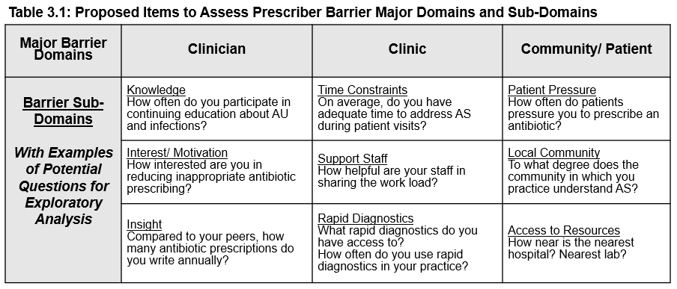
Survey Design: We will work with the Effective Health Communications Core (a part of Vanderbilt’s Health Services Research Center) to design a self-administered, web-based survey via REDCap. Questions will be designed to assess provider-perceived barriers to recognizing and reducing inappropriate AU. We will map barriers to three major categories (“barrier domains”), adapted from the consolidated framework for advancing implementation science (CFIR).⁴⁹ Barrier domains include the individual clinician, the clinic setting and the surrounding community. Each barrier domain will have 3 categories (“sub-domains”) selected based on prior studies evaluating areas of concern in outpatient antibiotic prescribing.^{41-47,50-57} Three questions per barrier domain, consisting of Likert scale and short-response questions, will assess sub-domain barriers. The totaled scores will comprise an overall score for each domain (Table 3.1).⁵⁰ The initial survey will be piloted in a representative subgroup of VUMC clinicians to assess the survey’s ability to effectively communicate questions to respondents and to accurately and reliably reflect respondents’ barriers.

Survey Administration & Population: We will create a list of prescribers from the 2018 IQVIA Xponent data, ordered from highest to lowest by each prescriber’s total antibiotic prescriptions. We will exclude the lowest 50% of prescribers based on our knowledge that the highest 50% of prescribers (~16,500) account for 95% of all outpatient antibiotic prescriptions (Fig 3.1). We will send a personalized survey link to all 16,500 prescribers with a goal of 4,200 (~25% response rate) responses. Respondents will represent the diversity of TN providers in terms of prescribing behavior, practice location, specialty, gender and birth decade. Partnering with TN DOH, we will use a mixed-mode survey administration strategy to increase study participation.⁵⁸ Repeat invitations will be sent to non-responders two additional times at two-week intervals. For those still not responding, we will mail a personalized letter with the corresponding survey URL included. We will then target under-sampled populations via phone calls to ensure adequate representation from each demographic defined above.

Outcomes: The primary outcome is the difference in mean scores across the three barrier domains (Table 3.1). Secondary outcomes will be the correlation of each barrier domain score to prescribing behavior as a continuous variable of individual total prescriptions and the differences in provider-perceived barrier domain scores based on gender, practice location, birth decade, prescribing behavior or specialty.

Data Analysis: We will obtain an aggregate score for each barrier domain by summing the 3 barrier subdomain question Likert scale scores from 1 to 5 (yielding a potential score of 1-15 for each respondent for each barrier domain). A lower score indicates a stronger barrier. We will use a one-way analysis of variance (ANOVA) to analyze the difference in perceived barriers. For our primary outcome, assuming an overall 25% response rate (~4200 total respondents), we estimate an 80% power to detect a 5% difference in perceived barrier domain scores (α=0.05). For our secondary outcome, we estimate that with 4,000 prescribers, we will be able to estimate the correlation between prescribing frequency and any one of the barrier domain scores with a margin of error (half-width of 0.95 CI) that does not exceed +/- 0.03 (calculated for the Pearson's r linear correlation coefficient; this will also apply closely to Spearman's rho, which we will use to allow for a nonlinear relationship).

Study period: Survey development, administration and analysis will occur from October 2020-October 2021.

Challenges and Potential Solutions: There is no validated tool with which to compare our survey. We will pilot the study and revise as needed to mitigate this challenge. The target sample size is large and may be difficult to achieve; however, by pairing with the TN DOH, we can leverage their community relationships to target specific clinician groups and increase response rate and sample representativeness. Additionally, we will use mixed-mode email and mail survey solicitation and telephone-based solicitation to ensure adequate response.

Based on the survey responses from TN outpatient providers, we will identify their greatest barriers to reducing inappropriate AU. This information will guide and ensure success of Project 3.2.

Specific Aim 3.2: Employ user-centered design to develop effective outpatient AS interventions applicable to a variety of practice settings. (CORE PROJECT 3.2)

Existing ambulatory AS studies have evaluated interventions (e.g. use of point-of-care rapid diagnostics, communication skills training, antibiotic accountable justification, prospective peer comparison, best practice alerts, and suggested alternatives) and have found mixed results on their efficacy and sustainability.^{35-37,59-63} The most effective and sustainable ambulatory AS interventions are unknown. Only a few studies have evaluated ambulatory AS interventions implemented across healthcare systems or different regions of practice.^{35-37,63} No studies exist evaluating design and implementation of ambulatory AS interventions across a state like TN, with high prescribing rates and a high proportion of non-metropolitan, rural counties.

We will design outpatient AS interventions to address the high-priority, specific barriers identified in Core Projects 3.1 and 3.2 that will be piloted in Core Project 3.3. For Core Project 3.2, we will use the UCD approach in addition to existing expertise that includes: Dr. Amanda Mixon (an implementation science expert who will be advising this project); TN DOH; and the VUMC Center for Research and Innovation in Systems Safety (CRISS), which has successfully partnered with Dr. Katz previously.⁶⁴ UCD methods have been employed by several industries, including healthcare, to improve acceptance and functionality of their products.^{65,66} UCD uses an iterative approach to product design, involving end-user feedback to develop products that meet users’ needs and facilitate end-user interaction.⁶⁷ By using this approach we hope to create partnerships with TN providers to create a truly useful and effective AS intervention.

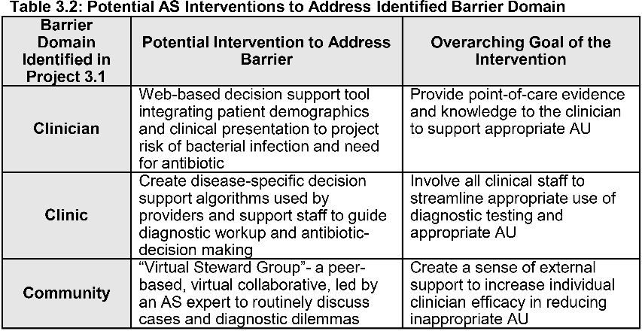
Methods: Targeted interventions will be selected and designed based on the Expert Recommendations for Implementing Change (ERIC) project’s list of implementation strategies that specifically address the barriers identified in Core Project 3.1 (Table 3.2). A representative subset of clinicians surveyed in Core Project 3.1 from diverse practice regions in TN will be invited to participate in a series of UCD focus groups to evaluate and improve proposed AS interventions. Focus groups will ascertain participants’ insight into an intervention’s ability to address and mitigate specific barriers identified in Core Project 3.1 and an intervention’s feasibility of implementation and potential efficacy in reducing inappropriate AU if implemented. We will seek guidance on how to best approach clinicians, gain buy-in and disseminate interventions. While individualized prescriber AU feedback using IQVIA data will be provided in conjunction with these interventions, it will not be considered a singular intervention. The top 2 interventions, based on ability to address the most-challenging barriers and applicability to a variety of practice settings and types of prescribers (Table 3.2), will be selected for pilot study in Core Project 3.3.

Data Collection and Analysis: Focus groups will be recorded and transcribed. Two separate investigators will review these transcripts and code responses into the following categories for each intervention discussed: factors supporting, factors detracting, and resources and/or steps needed to successfully implement. This process will be repeated as changes and improvements are made to the intervention design.

Results: Potential intervention feedback will be further reviewed by an interprofessional committee of 3-5 members who will collectively determine the feasibility and effectiveness of each proposed intervention. Subsequently, this committee will decide on the top 2 interventions that will be piloted in Core Project 3.3.

Study Period: The UCD process to develop interventions will occur from October 2021 to September 2023.

The interventions designed and selected for piloting at VUMC clinics for Core Project 3.3 will be based on the outcomes of Core Project 3.2 (Table 3.2). This approach offers the advantage of piloting interventions designed by clinicians, which will optimize clinical utility and reduce barriers to implementation.

Specific Aim 3.3: Develop, pilot, and analyze UCD ambulatory AS interventions within VUMC primary, specialty, urgent care and Walgreens retail clinics. (CORE PROJECT 3.3)

VUMC offers unique outpatient settings, different from other academic centers, allowing our pilot to more accurately predict the success of these interventions in settings outside of traditional academic clinics. VUMC not only has primary and specialty adult and pediatric clinics geographically co-located with the adult and children’s hospitals, but also primary care, urgent care, and retail Walgreens clinics located from 2 to 40 miles away from VUMC campus. This diverse mix of clinics serves as a proxy for the range of different specialties, practice locations, clinician backgrounds and patient mix of TN and will allow us to assess the generalizability of the proposed interventions. Furthermore, VUMC is currently building a multi-faceted, outpatient AS dashboard, with a “go-live” date of July 1, 2020. This dashboard can evaluate AU filtered by antibiotic category, individual antibiotic, encounter diagnosis, division, clinic, or individual prescriber. Additionally, this dashboard will incorporate antimicrobial cost data. This tool will provide the data for our proposed pilot and analyses.

Methods: We will perform a randomized pragmatic trial using stratified block randomization to determine the feasibility and efficacy of the proposed interventions from Core Project 3.2 (Table 3.2). All prescribers practicing at internal medicine, general pediatrics, primary care, walk-in, Walgreens retail, urgent care, urology, dermatology, oral surgery and otolaryngology clinics will be included. These specific specialties were chosen based on our prior work that demonstrated that these specialties have a greater likelihood of being a TN high prescriber and are target populations for antibiotic prescribing reduction efforts.^{39,40} Providers will be randomized in blocks based on degree type and stratified by primary clinic site and clinical experience (<5 years or >5 years of practice) to one of three arms: control; intervention #1; or intervention #2. At the end of the study, prescribers will be given a web-based, self-administered survey that will include: 1) a 4-item Likert scale survey to evaluate the feasibility of implementing the intervention (the Feasibility of Intervention Measure); 2) three questions assessing prescriber-perceived usefulness of the intervention (self-reported frequency of use, self-perceived changes in prescribing behavior due to the intervention and barriers to adoption of the intervention); and 3) three questions assessing prescriber satisfaction with the intervention, likelihood of continued use, and suggested improvements.⁶⁸

Outcomes: We will utilize the Conceptual Model of Implementation Research to define outcomes.⁶⁹ This framework outlines three types of measurable outcomes: the primary outcome (“service outcome”); the degree of success of the implementation strategy to deploy the intervention (“implementation outcomes”); and the effect on end-users, in this case the prescriber, (“client outcomes”). The primary outcome (“service outcome”) is the difference between the pre- and post-intervention overall antibiotic prescribing rates (the number of visits in which an antibiotic was prescribed/total visits for that time period) between the three study arms. Secondary outcomes include the pre- and post-intervention change in broad-spectrum antibiotic prescribing rate (oral or intramuscular 3rd generation cephalosporins, macrolides, amoxicillin-clavulanate, and fluoroquinolones) and change in duration of antibiotic prescriptions based on indication. The primary implementation and client outcomes will be the difference in mean scores on prescriber evaluation surveys between intervention arms for each outcome subsection (implementation and client separately).

Data Analysis: We will perform an interrupted time-series analysis to separately compare the average rate of antibiotic prescribing, the average rate of broad-spectrum antibiotic prescribing, and the average duration of antibiotics across all three study arms before and after intervention implementation. We will evaluate data from 18 months prior to intervention start until 18 months after intervention implementation. Utilizing a repeated-measure ANOVA as a conservative estimate of power, assuming a high correlation between repeated measures (rho = 0.6 to 0.8), we calculate that for the ~900 prescribers meeting inclusion criteria (divided into three equal arms), we will have an 80% power to detect at least a 10% decrease in antibiotic prescribing rate among the three arms. This 10% difference has been estimated in prior studies to represent a clinically meaningful reduction.³⁶ For evaluation of our implementation and client outcomes, we will assign a subcategory score to each specified outcome and report aggregated averages with interquartile ranges.

Challenges and Proposed Solutions: The VUMC clinics are located in metropolitan or suburban locations, which limits our ability to assess the effectiveness of implementing these AS interventions in more rural areas; however, these data can inform which interventions may be successfully implemented to a large population and subsequently tailored to account for variations in prescriber efficacy and practice location.

CORE TRACK 4: Novel Healthcare-Associated Infection Epidemiology and Prevention: Healthcare-Associated Viral Respiratory Infections (HA-VRI, Track Lead: Talbot)

Transmission of respiratory viruses within healthcare settings leads to dramatic patient morbidity, mortality, and increased healthcare costs. Healthcare-associated outbreaks of viral respiratory disease have been documented in a variety of patient populations and clinical settings;⁷⁰⁻⁷³ however, comprehensive assessments of the burden of HA-VRI have been hampered by a lack of standardized definitions, varying methods of surveillance, and poor clinician recognition of viruses as causes of nosocomial respiratory illnesses.⁷³ In one of the few examples of rigorous HA-VRI surveillance, a prospective laboratory-based hospital surveillance program in Canada found that 17.3% of all adult laboratory-confirmed influenza cases were healthcare-associated.⁷⁴ Because HA-VRI, particularly those due to non-influenza and respiratory syncytial virus (RSV) infections, are poorly understood HAIs, through the projects in this track, we will better define the burden, risk factors, and prevention strategies for these important infections. HA-VRI are especially underrepresented in the scope of published evidence (often limited to reports of outbreaks), infection prevention research, and prevention guidance.⁷⁵ They are also not included in the group of publicly-reported HAIs and are rarely used as assessments of healthcare quality despite the morbidity associated with these infections. Our own data suggest HA-VRI are not unusual events in acute care settings (Fig. 4.1), and respiratory viral testing is likely currently underutilized for hospital-onset respiratory illnesses.

This track will examine the burden of HA-VRI using existing public health and operational surveillance infrastructures and will assess the impact of a novel inpatient intervention to improve identification of HA-VRI to mitigate healthcare-associated transmission of respiratory viruses. This track leverages the expertise of VUMC Epicenter investigators in the areas of the epidemiology and prevention of HA-VRI (specifically Dr. Talbot’s work on healthcare personnel immunization⁷⁶⁻⁷⁹ and risk of transmission of viral pathogens in healthcare settings⁸⁰⁻⁸²), the longstanding leadership of Vanderbilt in the field of respiratory virus surveillance,⁸³⁻⁹⁰ and the TN Emerging Infections Program (TEIP) and will capitalize on ongoing surveillance programs examining influenza and RSV burden in TN.

Specific Aim 4.1: Estimate the population-level burden of healthcare-associated viral respiratory illness due to influenza and RSV using an existing public health surveillance infrastructure. (CORE PROJECT 4.1)

The TEIP has conducted surveillance for laboratory-confirmed influenza infections among hospitalized patients since 2003 for pediatric patients and 2005 for all inpatients as part of the Influenza Hospitalization Surveillance Network (FluSurv-NET).⁹¹ FluSurv-NET monitors community-acquired, laboratory-confirmed influenza-related hospitalizations (i.e. hospitalization of persons residing in the surveillance area at a catchment area hospital <14 days after or <3 days before a positive influenza test result between October 1–April 31 each year). This well-established platform was adapted to conduct surveillance for RSV hospitalizations in 2016. This core project will leverage the existing TN FluSurv-NET surveillance data to assess the population-level burden of acute care HA-VRI due to influenza and RSV. Examination of FluSurv-NET RSV and influenza cases diagnosed after hospital day (HD) #3 (traditional HA-VRI, Fig. 4.2A) will be assessed as well as VRI due to these pathogens diagnosed on admission in patients with a hospital admission within the prior 3 days (Fig. 4.2B), an outcome missed in traditional measures of HA-VRI (i.e. these are often considered community-onset and not related to a healthcare exposure).
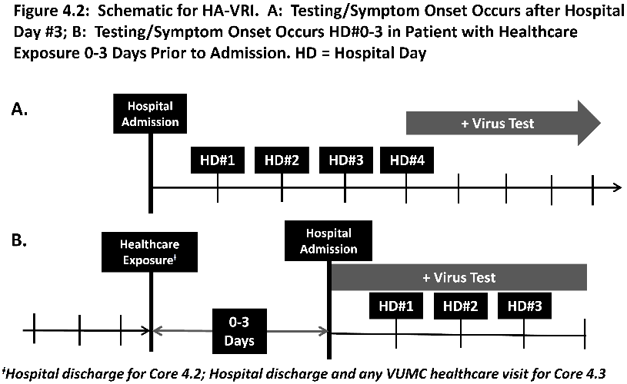
FluSurv-NET Case Ascertainment: Involving 18 acute care hospitals, surveillance is prospective and utilizes hospital and state public health laboratory databases, hospital infection control practitioner databases, reportable condition databases, EHRs, and/or review of hospital discharge records to identify hospitalized cases of influenza and RSV. Cases are residents of pre-identified catchment areas that encompass 8 counties (~1.2 million people [22% of TN population]) with laboratory-confirmed infection who are hospitalized during the surveillance period. Medical chart reviews are conducted to collect clinical and epidemiologic information including patient demographic characteristics and clinical course of illness during hospitalization by use of a standard form. Clinical data collected depict presence of underlying chronic medical conditions, treatment and vaccination (for influenza), clinical outcomes during hospitalization (including admission to an intensive care unit, need for mechanical ventilation, and death), and hospital discharge diagnoses (see Appendix for Case Report Form).

Outcomes: Laboratory-confirmed RSV or influenza infection identified within FluSurv-NET. HA-VRI will be defined as a laboratory-confirmed influenza or RSV infection in FluSurv-NET diagnosed (as defined by date of symptom onset) after HD#3 (Fig. 4.2A) or diagnosed between HD#0-3 in patients with an associated hospital admission or nursing home stay in the 3 days prior to admission (Fig. 4.2B). Hospital discharges will be captured using the TN Hospital Discharge Data System (HDDS).

Study years: The study will assess HA-VRI using FluSurv-NET surveillance data from CY2012 (influenza) and CY2016 (RSV) through CY2020.

Data Analysis: Overall and age-specific rates (with 95% confidence intervals) of laboratory-confirmed influenza and RSV HA-VRI, HA-VRI-associated hospitalizations and HA-VRI-associated mortality will be determined. Secondary outcomes include a description of severe HA-VRI and risk factors associated with severe HA-VRI. Age-specific rates of laboratory-confirmed HA-VRI-related hospitalizations and associated severe complications will be calculated using population denominators from the most recent census data available for the surveillance area and/or market share data. Denominators for hospitalizations will come from the HDDS. Severe outcomes will be defined as admission to the ICU or death.

Challenges and Proposed Solutions: Because the TEIP surveillance does not include any prospective testing of ill persons, laboratory-confirmation is dependent on clinician-ordered testing. As a consequence, cases identified are likely an underestimation of the true number of persons hospitalized with influenza/RSV. Also, other types of pre-admission healthcare exposures (e.g. outpatient clinic visits) are not captured in this surveillance, which may underestimate overall burden. Finally, using HD#3 as the cutoff may misclassify some community-onset infections with delayed testing as HA-VRI. Even with these limitations, the above project will still meet the unmet need of measuring HA-VRI burden.

Specific Aim 4.2: Determine the incidence of healthcare-associated viral respiratory infections due to non-influenza/RSV respiratory viruses among hospitalized adult and pediatric inpatients. (CORE PROJECT 4.2)

With the emergence of diagnostic testing for an array of respiratory pathogens beyond influenza and RSV (e.g. parainfluenza, coronaviruses, human metapneumovirus), the recognition of HA-VRI due to these viruses has emerged, mostly via outbreak reports, such as the VUMC Epicenter investigators’ experience with parainfluenza.^{81,82} VUMC data suggest these viruses may account for a larger burden of HA-VRI than influenza and RSV (Fig. 4.1). Thus, there is a need to better understand the impact and burden of HA-VRI due to these viruses. This core project will utilize existing VUMC Department of Infection Prevention surveillance data to identify cases of laboratory-confirmed non-influenza/RSV HA-VRI among hospitalized inpatients.

Study Population and Period: All adult and pediatric patients hospitalized at VUMC (Vanderbilt University Hospital [VUH], Vanderbilt Children’s Hospital [MCJCHV], and Vanderbilt Wilson County Hospital [VWCH]) between November 2017 (the implementation of the EPIC EHR) and the anticipated study start (~January 2022 based on 5-year Epicenter project plan). VWCH data will start with April 2020, the date of EPIC EHR implementation at that facility.

Surveillance Data: The VUMC Department of Infection Prevention currently tracks all positive respiratory tests among VUMC patients and designates all tests positive for hospitalized patients after HD#3 as hospital-onset. The tests captured include all respiratory virus viral culture testing, molecular assay testing (multiplex respiratory pathogen panel PCR assay, flu/RSV PCR assay]), and rapid antigen diagnostic testing for RSV/Influenza. Based on VUMC surveillance data for 2019 (Fig. 4.1), we anticipate ~150 hospital-onset non-influenza/RSV positive tests annually, which would provide ~600 cases over the 4 year proposed study period.

Outcome Definitions: HA-VRI will be defined as a laboratory-confirmed respiratory viral infection with symptom onset (as captured by chart review) after HD#3 (Fig 4.2A) or diagnosed between HD#0-3 in patients with an associated hospital admission or VUMC-related healthcare visit in the 3 days prior to index admission (Fig. 4.2B). Hospital discharges will be captured as outlined for Core Project 4.1. VUMC healthcare visits will be captured via EHR abstraction report.

Chart Abstraction: Chart review will occur for all patients with an identified positive test for non-influenza/RSV respiratory viruses that are defined as hospital-onset as well as patients with positive tests from HD#0-3 that have had a hospital discharge within 3 days prior to admission. Information abstracted will include clinical presentation and diagnosis on admission, comorbid conditions, medications administered during hospitalization (including antimicrobials and antiviral agents), clinical symptoms around the date of the positive test, clinical course including ICU admission, discharge, and in-hospital death.

Data Analysis: Rates of laboratory-confirmed HA-VRI (non-influenza and RSV) per 1,000 patient days (with 95% confidence intervals) will be described in aggregate and individually for each virus in the surveillance data (adenovirus; coronavirus HKU1, 229E, OC43, and NL63; human metapneumovirus; parainfluenza types 1-4; and rhinovirus/enterovirus). Rates will also be stratified by adult and pediatric populations. Secondary outcomes include a description of severe HA-VRI (i.e. infection resulting in ICU stay, prolonged LOS attributed to the infection, or death attributed to the infection as assessed by chart review) and risk factors associated with severe HA-VRI.

Challenges and Proposed Solutions: These are similar to those outlined for Core Project 4.1.

Specific Aim 4.3: Evaluate the impact of a novel clinical decision support advisor to prompt respiratory virus testing among patients with a hospital-onset respiratory illness. (CORE PROJECT 4.3)

One of the major challenges to fully capturing the burden and effectively preventing the spread of HA-VRI is the reliance on clinicians to consider and then test for respiratory viruses as a cause of hospital-onset respiratory illness. Under recognition of viruses, traditionally considered “community-based” pathogens, as causes of HA-VRI is suggested by some available surveillance data. In the CDC’s 2015 HAI national prevalence survey, while healthcare-associated pneumonia was the most prevalent HAI (with a majority of those events being non-ventilator related), only 1 case out of the 110 identified across the surveillance population was attributed to a virus.⁹² While data on the frequency of respiratory virus testing in this clinical scenario are lacking, this finding suggests a reduced awareness of respiratory viruses as a cause of serious hospital-onset respiratory illness. This core project will assess an intervention that rapidly identifies inpatients with a new respiratory illness after HD#3 and then provides a decision support advisor that actively directs clinicians to assess for the need for respiratory virus testing. Our hypothesis is that such an intervention will lead to an increase in respiratory virus testing with a subsequent increase in identified cases of HA-VRI and implementation of key infection prevention interventions, such as isolation precautions, to prevent nosocomial spread to others. This project leverages the Vanderbilt Epicenter investigators’ prior experience with developing other HAI-related decision support advisors (e.g. an active reminder of diarrheal medication receipt when ordering C. difficile testing⁹³) with the existing infrastructure at VUMC to assess clinical decision support (CDS) advisors within the EHR. Specifically, this project leverages resources and insight developed for a CDS study of community-acquired pneumonia (CAP) treatment guidance currently underway at VUMC (PI D. Williams, an advisor on this core project). In addition, we have extensive experience at Vanderbilt of not only conducting randomized crossover pragmatic trials in our Learning Healthcare System but doing so in a sufficiently rigorous way to publish in high-profile journals.^{94,95}

Study Population and Period: Hospitalized adult and pediatric patients admitted to VUH or MCJCHV between January 1, 2023 and December 31, 2024 with new hospital-onset respiratory illness (HO-RI).

Development of HO-RI Phenotype: Accurately defining HO-RI with high specificity to avoid CDS advisor fatigue will be important and will be the first portion of this project. Using the identified cases of HA-VRI in Core Project 4.2, an assessment of various factors (including vital signs [e.g., fever, change in oxygen saturation], changes in oxygen support, chest radiograph orders and results, and clinical diagnostic test ordering [e.g. respiratory specimen culture]) will be used to identify a clinical phenotype with high sensitivity and specificity for HA-VRI.

EHR-based Decision Support Intervention: We will then develop and implement a usable, EHR-based CDS strategy provided at the point of care of inpatients. Inpatients with a new HO-RI after HD#3 will be identified using a CDS advisor that will then activate and ask the clinician to assess if the patient could have a HA-VRI and encourage respiratory viral testing, if indicated. If selected, ordering such testing is already linked at VUMC to empiric placement into contact and droplet isolation precautions, which mitigates transmission if the HO-RI was due to a viral infection. The advisor will also capture rationale in the event respiratory testing is not felt to be indicated by the clinician.

Study Design: Because ordering clinicians care for patients throughout the hospital, a unit-based cluster randomized trial of the intervention would have risk of substantial contamination across clusters. Therefore, we will study the impact of the advisor using a pragmatic design (similar to that used for the aforementioned CAP treatment study) of permuted blocks in which the intervention will be turned on (“intervention period”) and off (“usual care”) for 1 month blocks, with the blocks in an 4 month permuted randomized crossover design. This will also provide variation of implementation across respiratory virus seasons to account for the seasonal change in infection incidence. Due to the nature of the intervention, blinding of treating clinicians is not possible.

Outcome Definitions: The primary outcome of interest will be the frequency of respiratory virus testing among patients with HO-RI. Secondary outcomes will include HA-VRI rates per 1,000 patient days (as described for Core Project 4.2 with the addition of influenza and RSV infections) and total isolation days (contact and droplet precautions only) per 1,000 patient days.

Data Analysis: We will use a weighted, cluster-level logistic regression⁹⁶ to compare respiratory virus testing rates for HO-RI between the two groups. In this analysis, data for each cluster are collapsed into a single summary measure, and the summary measures are then analyzed as if they were raw data, facilitating simple data reporting and interpretation. We will also use a hierarchical logistic regression model with cluster effects treated as random, a more complex analytic approach but one which offers additional flexibility regarding model assumptions and incorporation of cluster-level and individual-level covariates.⁹⁶ An important consideration in the analysis is the possibility of contamination effects in the usual care arm related to changes in provider behavior due to past exposures and awareness of the intervention. Such contamination would be expected to bias toward the null hypothesis. Based on our extensive experience with similar trials,⁹⁵ we posit that such effects will be of minor concern since 1) we anticipate the HO-RI is an uncommon event so that repeated exposure to the intervention by any one provider would be infrequent; and 2) resident physicians, the providers responsible for the majority of order entry and thus directly exposed to the intervention, rotate monthly and only work in inpatient units for portions of the year. We have designed our randomization and monthly crossover periods around these important considerations.

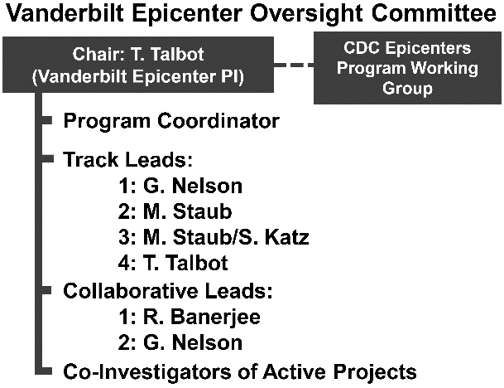
Challenges and Proposed Solutions: We do not anticipate major difficulties designing or implementing our CDS advisor given the experience with the aforementioned CAP CDS study. If challenges arise, our experienced team possesses the necessary expertise, past experience, and institutional resources to address and overcome them. Design challenges (such as alert fatigue risk) will be addressed by our usability and decision support experts to troubleshoot and develop effective solutions prior to and following implementation. The severity of annual virus seasons may impact the findings, but the use of a multiyear study period should help mitigate this risk.

Information Applicable to All Proposed Projects:

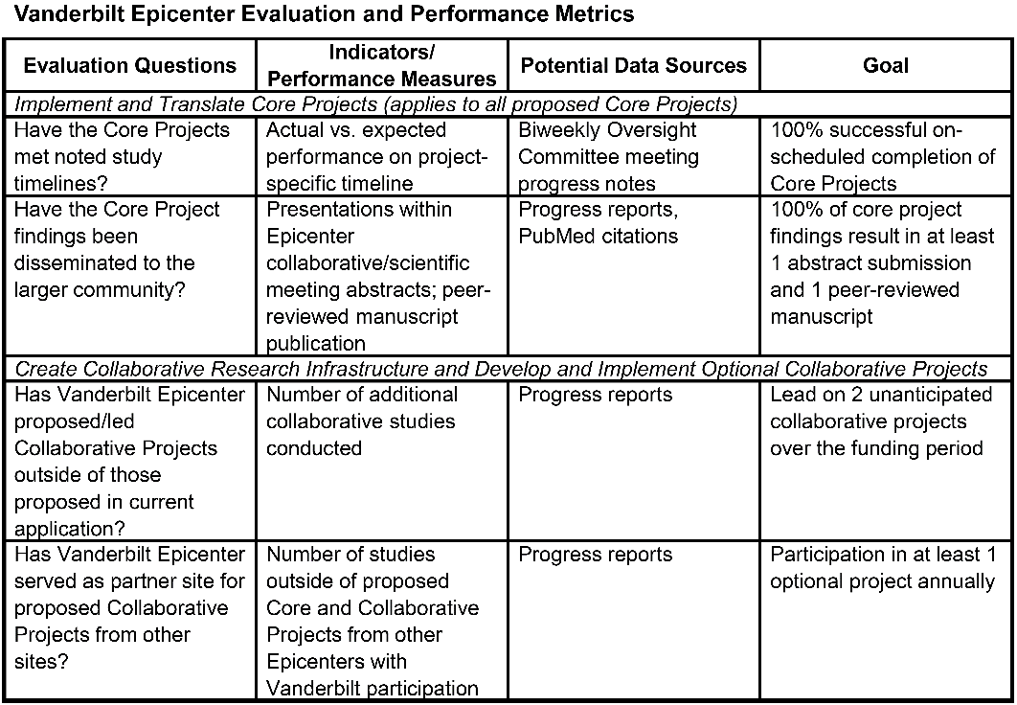
Communication and Leadership Plan: The Vanderbilt Epicenter Oversight Committee (Figure) will consist of the PI and all track leads. This group will meet biweekly to ensure all projects are completing tasks as per study timelines. Vanderbilt Epicenter Investigators will actively participate on all CDC-guided Epicenter meetings and will maintain frequent, regular communication on study progress and other tasks as requested.

Evaluation and Performance Metrics: Performance metrics (Table) will be used to ensure successful performance of the overarching Epicenter program’s major goals.

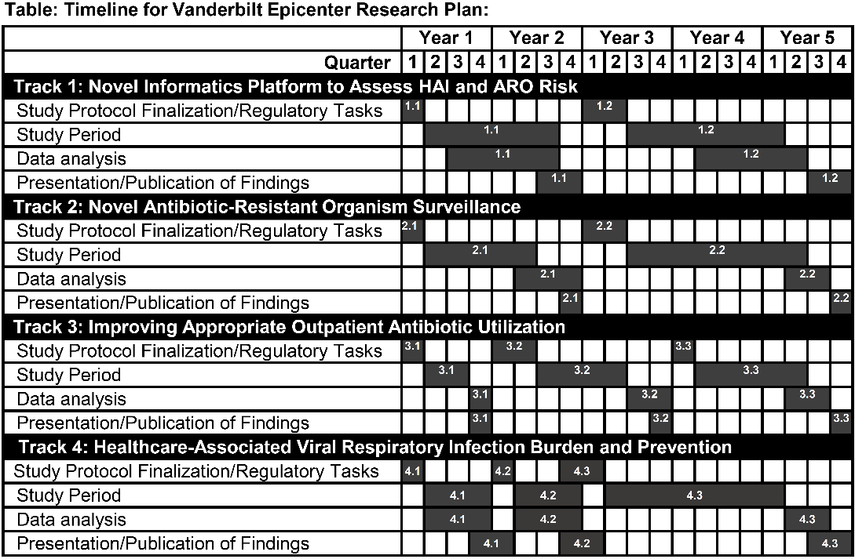
Dissemination of Vanderbilt Epicenter Findings: The results of all proposed projects will be presented within the Epicenter collaborative, at appropriate scientific meetings, and, as appropriate, will be made available to policy makers and federal advisory committees. Timely publication of study findings in peer-reviewed literature will be expected and is noted in the overarching timeline (Table). In addition, tools developed from these projects (e.g. RShiny platform, any EPIC EHR tools) can be disseminated hospitals if found effective.
OPTIONAL COLLABORATIVE PROJECT #1: Impact of Rapid Respiratory Pathogen Diagnostic Testing on Inappropriate Antibiotic Use in Urgent Care and Retail Health Clinics: A Multicenter Prospective Cluster Randomized Trial (Leads: Banerjee, Katz)

This proposed study will utilize the expertise of Vanderbilt Epicenter investigators in the areas of outpatient antibiotic stewardship, particularly in urgent care and retail clinics, and pragmatic, randomized controlled trials of rapid diagnostic tests to address knowledge gaps regarding optimal test implementation strategies, clinical impact and cost effectiveness of rapid diagnostics in the outpatient setting, and interventions to improve judicious antibiotic use for respiratory tract infections.

BACKGROUND: Antibiotic overuse is common among outpatients and drives antibiotic resistance. In the outpatient setting in the United States (U.S.), up to 30% of antibiotic prescriptions are unnecessary or for the wrong drug, dose, or duration.⁹⁷ Approximately 50% of these unnecessary antibiotics are given for acute respiratory conditions, which are most often viral and do not require antibiotics.⁹⁸ The majority of inappropriate antibiotics for respiratory tract infections (RTIs) are prescribed in urgent care and retail health centers, the fastest growing sectors of U.S. healthcare.^{99,100} Point-of-care molecular diagnostic tests that are rapid, sensitive, and can identify a variety of viral pathogens during an outpatient visit have potential to reduce unnecessary antibiotic use for patients in outpatient settings, including urgent care and retail clinics.

No outcome-focused studies of viral diagnostics have been conducted in urgent care or retail settings, where 40% of outpatient antibiotics are prescribed.⁹⁹ Prior outcomes studies, performed primarily in emergency department settings, have been heterogenous in terms of study design, testing methods, study populations, and implementation strategies, and have been limited by small sample sizes and observational study designs, often with historical control groups.¹⁰¹⁻¹⁰⁹ While some studies have shown that rapid viral detection is associated with decreased use of antibiotics and ancillary laboratory testing and increased antiviral use,^{101,102,104,109} others demonstrate no impact on the rate of ancillary testing or antibiotic prescriptions.^{103,107,110} A 2014 Cochrane Review of rapid viral diagnostics in the outpatient setting¹¹¹ and a recent systematic review evaluating molecular testing for influenza and respiratory syncytial virus (RSV) both concluded that there was insufficient evidence to support routine use of viral diagnostics.¹¹² Implementation strategies for viral testing and the impact of non-influenza virus detection on medical decision making have also not been rigorously evaluated, yet clinicians must decide whether to routinely perform viral testing on all RTI patients or select populations, and whether to preferentially use tests that detect single or multiple targets. Despite the markedly limited data about clinical utility and implementation strategies, a variety of costly molecular viral diagnostics are now widely available and used in the U.S.

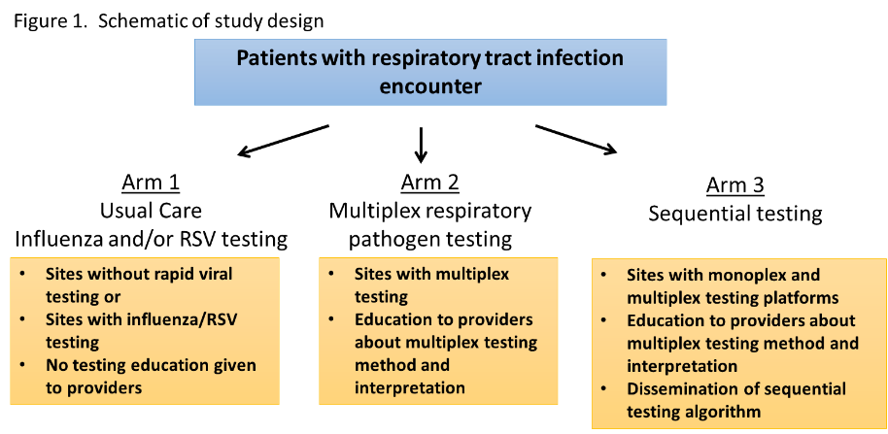
There is great need to rigorously evaluate the clinical utility, cost-effectiveness and optimal testing strategies of viral diagnostics in outpatient settings. We hypothesize that diagnostic tests detecting influenza/RSV or other respiratory pathogens, used either alone or sequentially, can promote judicious antibiotic use for RTIs in urgent care and retail clinics. To test this hypothesis, we will conduct a 3-arm, multicenter, cluster randomized controlled trial in adult and pediatric urgent care and retail settings. Urgent care and retail clinics will be randomized to one of three arms: 1) usual care with either no viral testing or influenza and/or RSV testing only; 2) multiplex testing for multiple viral and atypical bacterial targets; 3) sequential testing, in which influenza and/or RSV testing is performed initially, followed by multiplex testing on influenza/RSV-negative specimens (Fig. 1).

SPECIFIC AIMS

- Determine the impact of respiratory pathogen detection on antibiotic prescribing for acute respiratory tract infection (RTI) among patients evaluated in urgent care and retail clinics. We will compare the percent of RTI encounters that result in an antibiotic prescription. We will test the hypothesis that the antibiotic prescription rate will be lower in sites with multiplex testing (arms 2 and 3) compared to sites without multiplex testing (arm 1).

- Determine the most cost-effective strategy for respiratory pathogen testing. We will test the hypothesis that sequential testing will be more cost-effective than usual care or multiplex testing only.

- Evaluate the impact of respiratory pathogen diagnostics for RTI on patient-reported satisfaction in the urgent care and retail clinics. We will compare patient satisfaction scores between the arms to test the hypothesis that patients in the multiplex testing group will have higher patient satisfaction scores than the usual care and sequential testing groups.

RESEARCH DESIGN AND METHODS

Study Design: The proposed study is a prospective, pragmatic, cluster randomized, controlled, multicenter 3-arm trial among patients older than 60 days seeking care in an urgent care setting (walk-in clinic, after-hours clinic), or retail health clinic during one influenza and RSV season (September through April). Other Epicenters that meet site criteria (as detailed below) will be selected as collaborating sites. To implement the study, we will work with Vanderbilt’s Learning Health System which has extensive experience designing and conducting pragmatic clinical trials. Vanderbilt investigators are currently engaged in qualitative research projects at these clinic locations at VUMC and have long-standing relationships with providers and medical directors in each setting. We anticipate that these relationships will facilitate provider engagement with the study.

Patient Population: Adults and children older than 60 days evaluated in urgent care or retail health clinics for RTI between September through April of the study year. Of note, while some of these clinics will also be study sites for Core Project 3.3, the timing of the Collaborative trial described here and that of Core Project 3.3 differs by several years (Epicenter funding year 2 for the Collaborative and years 4-5 for Core Project 3.3). Thus, we do not anticipate any unintended conflicts between these two studies.

Inclusion/Exclusion Criteria: Patients seeking care for an upper respiratory tract illness with at least two of the following signs/symptoms: history of fever (≥38.0º Celsius), cough, rhinorrhea, sore throat, or nasal congestion will be eligible for study inclusion. Eligible participants will be identified for respiratory pathogen testing by the treating provider. We will exclude patients who are admitted to the hospital on the same day as the index encounter.

Collaborating Epicenter sites selected to participate in this study must have the ability to track outpatient encounters and antibiotic prescribing rates in urgent care or retail clinics and have sufficient number of RTI encounters during the study period. Participating sites must also employ usual care diagnostic testing methods (either no viral testing or influenza and/or RSV testing) with similar sensitivity and turn-around-time as usual care methods used at VUMC sites, should have sufficient space and personnel to be able to house and use the multiplex testing instrument, and should have the ability to track patient satisfaction domains similar to those collected at VUMC, as detailed below.

Consent: We will apply for a waiver of consent for study participation, as this is a pragmatic clinical trial evaluating different strategies of routine clinical care in a real-world clinical setting. The goal of the study is not to evaluate the performance of the rapid tests (which has previously been rigorously determined during the FDA approval process), but rather to determine if implementation of the rapid tests impact clinical management. As such, the research involves no more than minimal risk to subjects. There will be no subject contact by investigators for this trial and all subjects will receive standard of care laboratory and clinical practices, including treatment with antibiotics, if recommended by treating providers. The study cannot practicably be conducted without the waiver given the high volume of RTI encounters and the need for testing to be performed immediately, during an encounter. We will also have as a resource the IRB Reliance Exchange joint IRB review model operated by Vanderbilt for multisite studies that provides a mechanism to streamline IRB submission and the IRB review process at all phases of IRB review through the sharing of and reliance on IRB-approved documents between IRBs.

Randomization and Blinding: We will randomize each individual clinic to one of 3 arms. Randomization will be stratified by clinic type (urgent care or retail health clinics). Treating providers and investigators will not be blinded to the study arm.

Study Procedures: The decision to obtain respiratory pathogen testing for participants in each arm will be left to treating providers; however, providers in all arms other than the usual care arm will receive education from investigators about multiplex testing used either alone (arm 2) or sequentially following influenza testing (arm 3), as well as interpretation of results and implications for antimicrobial prescribing Providers in the usual care arm and the multiplex molecular testing arm will obtain 1 nasopharyngeal swab to use for viral testing. In the sequential testing arm, providers will obtain 2 nasopharyngeal swabs at the time of initial testing. The second swab will be set aside for use in the event that initial influenza or RSV testing is negative. Due to the 1-hour time from specimen collection to result reporting for the multiplex test, patients will have the option to wait at the clinic for test results or have phone follow-up regarding test results and possible electronic antibiotic or antiviral prescription if needed. The decision to prescribe antibiotics or antivirals will be left to the treating providers.

Respiratory Pathogen Testing: All testing will be performed by clinic personnel on-site, as point-of-care testing. Usual care at VUMC urgent care and retail clinics includes influenza testing via the Quidel® Sofia® Influenza A+B Fluorescent Immunoassay (FIA), which uses immunofluorescence-based lateral-flow technology to detect influenza A and influenza B viral nucleoprotein antigens. Sensitivity and specificity using nasopharyngeal swabs range from 90-97% and 95-97%, respectively. The test requires approximately 2 minutes of hands-on time and 15 minutes from test start to result report.¹¹³ The multiplex molecular testing method we will use is the BioFire® FilmArray® Respiratory EZ (RP EZ) Panel, an FDA approved, CLIA-waived instrument that uses nested multiplex polymerase chain reaction to test for 14 targets (adenovirus, coronavirus, human metapneumovirus, human rhinovirus/enterovirus, influenza A, influenza A/H1, influenza A/H3, influenza A/H1-2009, influenza B, parainfluenza virus, respiratory syncytial virus, Bordetella pertussis, Chlamydophila pneumoniae, and Mycoplasma pneumoniae) using a nasopharyngeal swab. The test requires 2 minutes of hands-on time and takes approximately 1 hour to result. Sensitivity and specificity range from 91-100% and 96-100% for all targets, respectively.¹¹⁴

Data Collection: We will utilize an electronic data collection system that captures information about outpatient diagnoses, antibiotic prescriptions, ancillary laboratory tests and radiographs ordered during a visit, and patient comorbidities from the participating clinics. Ancillary testing that will be captured includes complete blood count with differential, basic or complete metabolic panel, Group A streptococcal rapid antigen or PCR testing, urinalysis, blood or urine cultures. Patient satisfaction scores will be collected by each clinic using the Press Ganey and Quality Reviews, or other instruments that are currently in use and will be provided monthly in de-identified form to investigators. Patient satisfaction domains to be analyzed include the amount of time the provider spent with the patient, friendliness and courtesy of providers and staff, the provider’s discussion and explanations of conditions and proposed treatment, and efforts to include the patient in decisions about care, provider and nurse concern, degree to which patients are informed about delays, explanations around test procedures, instructions on follow-up care, and likelihood of recommending the clinic and care provider to others. Other Epicenter sites that track patient satisfaction scores will compare similar domains.

Definitions: (1) Acute respiratory tract infections (RTI) encounters will be defined as those having diagnosis codes for non-streptococcal pharyngitis, sinusitis, bronchitis, bronchiolitis, pneumonia, viral upper respiratory infection, or otitis media.¹¹⁵ (2) Antibiotic prescriptions will be extracted from the medical chart at the time of electronic prescribing and will include oral or intramuscular routes. (3) Broad-spectrum antibiotics include amoxicillin-clavulanate, azithromycin, third generation cephalosporins, and fluoroquinolones.

Outcomes: The primary outcome is percent of RTI encounters with an antibiotic prescription within 3 days of the index encounter. We will analyze this outcome in the following pre-specified subgroups: subjects with influenza detected; subjects with non-influenza pathogens detected; subjects with no pathogens detected; pediatric subjects (<18 years); adult subjects. Secondary outcomes include the percent of RTI encounters with rapid testing performed per protocol; percent of all encounters (RTI and other diagnoses) with an antibiotic prescription in the 3 days following the index encounter; percent of RTI encounters with an antibiotic prescription by clinic type (retail health, pediatric only clinic or adult and pediatric walk-in clinic); percent of RTI encounters with an oseltamivir prescription; median days of antibiotic prescribed per encounter, among encounters with antibiotic prescriptions; median days of broad-spectrum antibiotics prescribed per encounter, among encounters with antibiotic prescriptions; patient satisfaction scores; cost per encounter; number of ancillary laboratory and radiographic tests ordered per encounter; number of repeat visits within 1 week of an encounter.

Sample Size Justification and Statistical Analysis Plan

There are 30 urgent-care and retail clinics affiliated with VUMC and integrated into the VUMC electronic medical record (EMR), including 14 retail health clinics (Walgreen’s), 10 walk-in clinics, and 6 Pediatric After Hours Clinics). This partnership between retail health clinics and an academic medical center is unique. In these urgent care and retail clinics, between September through April, there are roughly 6,835 total RTI encounters each month, and the antibiotic prescription rate for RTI is approximately 52.9%. An 8-month study conducted September to April will provide an average cluster size of 1822.7 RTI cases. Assuming an intra-cluster correlation of no greater than 0.03 and a coefficient of variation in cluster size (the standard deviation in cluster sizes divided by the average cluster size) of no greater than 0.75, this provides 80% power to detect a reduction in antibiotic prescription rates of 11.8% (52.9% to 41.1%) in the intervention arms of the study. The addition of a second site of similar size, under the same assumptions, will provide 80% power to detect a reduction of 8.3% in the intervention arms. These calculations use a two-sided Type 1 error rate of 5%.
Descriptive statistics characterizing the patient population will be reported at the encounter level. Continuous variables will be reported as medians and interquartile ranges. Categorical variables will be reported as frequencies and proportions. Comparisons involving these variables will use a Kruskal-Wallis test or Pearson chi-square test, respectively. The primary analysis will compare the proportion of RTI encounters prescribed antibiotics within three days between arm 1 and arms 2 and 3 combined using a generalized linear mixed effects model including treatment assignment, clinic type, and continuous date (to adjust for seasonality) as fixed effects, and clinic as a random effect. The primary analysis will use intention to treat group assignment. Subgroup analyses will measure treatment effect within the sub-populations described above using a similar mixed effects model and limiting to these populations. Secondary analyses will use a similar mixed effects model using the secondary outcomes described above.

Potential Challenges and Alternative Approaches
This study is powered for the primary outcome only and may have insufficient power to detect differences in secondary outcomes and subgroup analyses. We may encounter a lower than expected compliance rate with testing strategies. In that case, we will perform targeted outreach to these clinics to understand barriers to testing, enroll an additional center and/or extend the study period. There may be regional differences in respiratory pathogen prevalence across Epicenters. We will attempt to adjust for this in the analysis using random effects logistic regression. We will not have the ability to follow-up patients for hospitalizations or clinic visits at locations outside of participating institutions, so may have incomplete capture of this outcome. Because we will be evaluating antibiotics that are electronically prescribed but will not assess whether prescriptions are filled, we will not be able to ascertain whether clinicians employed delayed prescribing or watchful waiting prescriptions that patients are instructed to fill in 2-3 days if symptoms fail to improve.

Study Timeline

 | Year 1 |  |  |  | Year 2 |  |  |  | Year 3
Quarter | 1 | 2 | 3 | 4 | 1 | 2 | 3 | 4 | 1 | 2 | 3 | 4
Protocol finalization/planning
Enrollment
Data analysis
Presentation and publication of findings

OPTIONAL COLLABORATIVE PROJECT #2: Improving Antibiotic Utilization by Prescriber Feedback: A Multicenter Prospective Cluster Randomized Trial (Lead: Nelson)

Antimicrobial resistance (AR) is a serious national and global problem. The Centers for Disease Control and Prevention (CDC) has emphasized the threat that AR presents²³ with numerous, high-profile reports highlighting the need for a multifaceted, coordinated approach to reduce inappropriate antimicrobial use (AU), the primary driver of AR.^{3,98,116} Antimicrobial stewardship (AS) is a critical component of intervention strategies to reduce AU.¹¹⁷ Mounting evidence demonstrates that AS programs (ASP) can optimize individual patient outcomes, improve the quality of care, and provide critical patient safety processes while reducing inappropriate AU. In addition to promoting AR, inappropriate AU causes increased morbidity, mortality, and adverse outcomes including C. difficile infection, drug toxicities, increased lengths of stay and healthcare costs.^{2,118} Reasons for inappropriate AU are myriad and include diagnostic uncertainty, unawareness or deviation from treatment guidelines, and fear of undertreating a potentially lethal infection. Novel diagnostic tests, innovative AU surveillance methods, and behavioral interventions focused on improving healthcare professional (HCP) performance are all important, but failure to develop methods to drive desired AU behaviors will reduce the overall impact of advancements in AS. Given the above difficulties faced by individual HCP, expert ASP guidance through HCP collaboration emerges as essential approach. Surveillance data on AU are equally important to identify improvement opportunities, guide and track interventions and raise awareness of current performance at the individual and population level. A core ASP strategy championed by the CDC is standardized AU surveillance and feedback of AU data to HCPs. An awareness of AU can potentially drive prescriber behaviors to reduce inappropriate AU, but the optimal methods to provide such feedback are unknown.

While the majority of evidence demonstrating ASP benefits arose from studies within acute care settings, most research evaluating the impact of providing AU data to HCPs comes from the outpatient arena.^{36,37,63,119,120} In outpatient settings, provision of AU data to HCP with peer comparison reduces inappropriate AU, although there is no firm conclusion on the optimal method for such feedback. Various populations (entire clinic practice vs. individual providers), HCP targets (highest AU prescribers vs. all prescribers), and comparator groups (target AU goal, peer performance, or top performers) have been investigated.¹²¹ Research evaluating the impact of AU data feedback and comparison methodologies in inpatient settings is even more limited.

Prospective audit and feedback (PAF) is an ASP strategy where ASP personnel interact directly with HCP to tailor AU for individual patients after an antimicrobial has been prescribed. PAF is considered a “priority intervention” supported by substantial evidence.^{118,122,123} The most important barrier to PAF is the required ASP resources necessary to conduct individualized audit, particularly in larger facilitites.¹²⁴ The resources required to support comprehensive PAF varies by hospital factors, including bed size, and feedback method (e.g. by phone vs. in person).¹²⁵ Developing resource-efficient methods incorporating PAF principles are needed given the extreme resource constraints of ASPs and sheer number of inpatient HCPs and burden of AU at individual hospitals. A complementary and less resource-intensive approach is to provide aggregate AU data to HCPs paired with interpretive guidance (e.g. general suggestions on how to reduce broad-spectrum antibiotics); however, this strategy lacks the direct link to individual patient treatment decisions. CDC added AU surveillance to the National Healthcare Safety Network (NHSN) in 2011 to provide facility, regional, and national AU data to assist in prevention and improvement aims. Standardized AU metrics are reported in days of therapy [DOT]/1000 patient days present to provide a Standardized Antimicrobial Administration Ratio (SAAR), a risk adjusted AU benchmark.¹²⁶ AU surveillance is based on antimicrobial and patient care location (e.g. medical care unit vs. surgical intensive care unit) groupings and does not provide AU data at the service level (e.g. urology vs. general medicine). Service lines coordinate diagnostic and therapeutic services that apply to similar diseases and conditions, organizing them under a single clinical structure. Evaluation of the impact of location-based AU feedback is limited, and the effect of service level AU feedback has not been studied.¹²⁷ Understanding the benefit of direct service-based aggregate AU feedback compared to aggregate AU feedback in the inpatient setting is critical to inform ASP strategies and is the focus of this Collaborative Project.

Preliminary Data

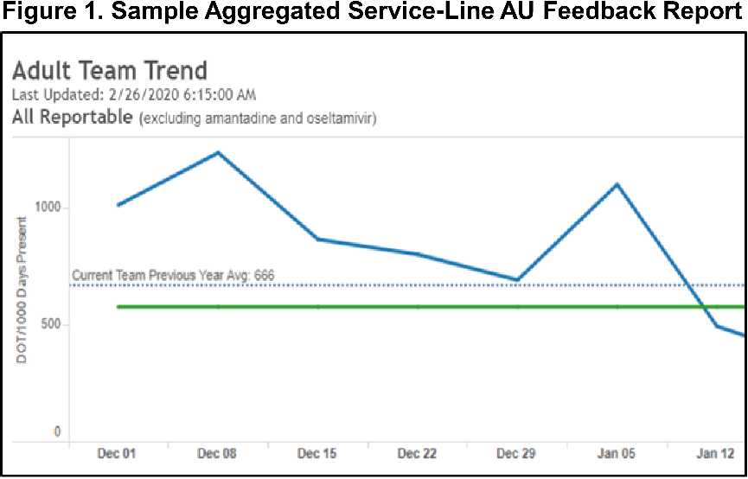
Vanderbilt University investigators have extensive experience in the creation and successful implementation of data feedback programs designed to change HCP behavior. Some of the initial research in outpatient AU data feedback methodology was conducted at Vanderbilt,¹²⁸ which informed subsequent research promoting patient safety by identifying outliers from data gathered from nearly 80,000 national HCPs with >2.5 million codable reports.¹²⁹ This model was then utilized to improve hand hygiene compliance through standardized auditing and data feedback with marked and sustained improvement in a population of over 14,000 HCP.³¹ Given the lack of consensus on optimal AU feedback methodologies, prior research by Vanderbilt Epicenter investigators described provider attitudes and preferences on AU attribution and data feedback to inform optimal implementation methodology.¹³⁰ Results showed that providers wanted AU feedback on a quarterly basis (69%), via email (73%), and grouped by and compared within their service (63%).

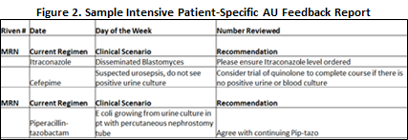
Starting in December 2018, quantitative AU data feedback has been provided biweekly by the Vanderbilt University Hospital (VUH) ASP to the Geriatrics service via an email report card (Fig. 1) with total and class-specific AU and comparator and prior year performance benchmarking (a.k.a. “aggregated AU feedback”). In April 2019, VUH ASP began providing the 5 non-teaching inpatient general medical services with the above biweekly data feedback coupled with ASP review of all patients on antimicrobials with patient specific AU recommendations relayed to the primary team electronically (a.k.a. “intensive patient-specific feedback,” Fig. 2). To date >1,119 patients have received the intensive patient-specific feedback intervention with >250 recommendations provided. Unadjusted raw pre-post grouping analyses demonstrate total AU (DOT/1000) was lower post enhanced feedback implementation, though not statistically significant (741.1 vs. 725.4, p=0.60); however, statistically significant reductions were noted in the rate of use of broad spectrum antibiotics for antibiotic-resistant Gram-negative pathogens (342.4 vs. 292.3, p=0.03).

This proposed Collaborative Project will compare the impact of aggregated service-based quantitative AU data feedback, resource-efficient intensive patient-level audit and feedback, and usual ASP approaches.

SPECIFIC AIMS

- Evaluate the impact of two antimicrobial use feedback methodologies (aggregated antimicrobial use and intensive patient-specific feedback) among inpatient general medicine services. We will test the hypothesis that provision of any AU feedback will reduce AU compared to baseline stewardship strategies.

- Determine if intensive patient-specific feedback is more effective than aggregated antimicrobial use feedback. We hypothesize that intensive patient-specific feedback will demonstrate larger AU reductions compared to aggregated AU feedback.

- Evaluate healthcare professional knowledge, attitudes, and practices associated with the two AU feedback methods. To understand future opportunities, stakeholder acceptance, and assessment of self-identified behavior modifications, a post-implementation survey will be conducted.

RESEARCH DESIGN AND METHODS

Study Design: We will conduct a prospective, pragmatic, cluster randomized, crossover, multicenter 3-arm trial among hospitalized patients on general medical services ≥18 years of age. General medical services will be randomized 1:1:1 to two AU feedback intervention arms and one control arm. Other Epicenters that meet site criteria (detailed below) will be selected as collaborating sites. To implement the study, we will work with Vanderbilt’s Learning Health System (LHS), which has extensive experience designing and conducting pragmatic clinical trials. For Specific Aim 3, a standardized survey will be sent to all general IM service HCP present during the study period to assess knowledge, attitudes, and practice modification after study completion. Responses will be attributed to the primary method of feedback received by HCP (i.e. aggregated, intensive patient-specific, or no feedback), based on cumulative percentage of exposure.

Patient Population: All inpatients ≥18 years old admitted to a general internal medicine (IM) service, including geriatric IM, non-teaching or hospitalist IM services, and IM services for patients in observation status.

Inclusion/Exclusion Criteria: Inpatients hospitalized and present in an NHSN-defined inpatient location who are enrolled as part of another research study protocol will be excluded. Prophylactic antibiotics with no clear stop date, antibiotics used for reasons other than to treat infections (e.g. rifaximin for hepatic encephalopathy), and topical, otic, and ophthalmic preparations will be excluded from the outcome measure. Patients prescribed antibiotics during their time on a non-study team (e.g. intensive care unit) and transferred to a study team will be included in the study, but only antibiotics received while under care of study team will be included in the analysis. Patients admitted to a general IM team and subsequently transferred to a non-study team will be excluded from duration of therapy analyses as duration may not reflect the prior care team’s decisions.

Collaborating Epicenter sites selected to participate in this study must have a dedicated ASP and the ability to monitor AU per CDC definitions (DOT/1000 days present)¹²⁶ based on medication administration data. Sites must also have ability to identify service groupings to calculate service-based AU data.

Consent: We will apply for a waiver of consent for study participation, as this is a pragmatic clinical trial evaluating different strategies of AU data feedback in a real-world hospital setting. The goal of the study is not to evaluate the various ASP strategies in place at participating sites, but the impact of additional AU feedback. As such, the research involves no more than minimal risk to subjects. There will be no subject contact by investigators for this trial, and all subjects will receive standard of care clinical practices, including treatment with antibiotics, if recommended by treating providers.

Randomization and Blinding: We will randomize each IM team 1:1:1 for initial assignment to 1 of 2 intervention arms or control; treating services, providers, and investigators will not be blinded to the study arm. If several services comprise the overall IM service, each will be randomized (e.g. 6 total IM teams randomized within participating Epicenter 1:1:1 (2 IM services in each arm, [denoted “Services in Arm 1, 2, 3;” Fig. 3]) for the initial period and will crossover every 3 months with a 2 week wash out period between intervention periods. The study period will run for 2 years to account for seasonality and delayed intervention effects.

Data Collection: An electronic data collection system will capture aggregate service-level demographic, AU administration, microbiologic, and outcome data for eligible patients. Case-mix index will be obtained over study period for participating sites to adjust for differential complexity of care at a facility level.

Definitions: Days of therapy (DOT), days present, and antimicrobial classifications defined per CDC definitions.¹²⁶ Antimicrobial spectrum index, a measure of breadth of antimicrobial coverage for hospital pathogens of importance will be calculated per patient per day to yield service level data.¹³¹ AU appropriateness will be based on national and hospital-specific guidelines and adjudicated by 2 members of the ASP collaborative study team to ensure consistency; a 3rd study member will review discrepancies.

Outcomes: The primary outcome is average proportion of AU days, calculated as the number of AU days divided by length of stay, will be compared at the encounter level between the three study arms. This will be analyzed in the following pre-specified subgroups: 1) patients not seen by Infectious Diseases (ID) consultation and 2) teaching and non-teaching services. The secondary outcomes are class-specific AU based on CDC classifications,¹²⁶ in-hospital mortality, length of stay (LOS), antimicrobial spectrum index,¹³¹ readmission rate at 30 days, AU duration, incidence of ID consultation, and AU appropriateness will be compared at the patient encounter level between study arms.

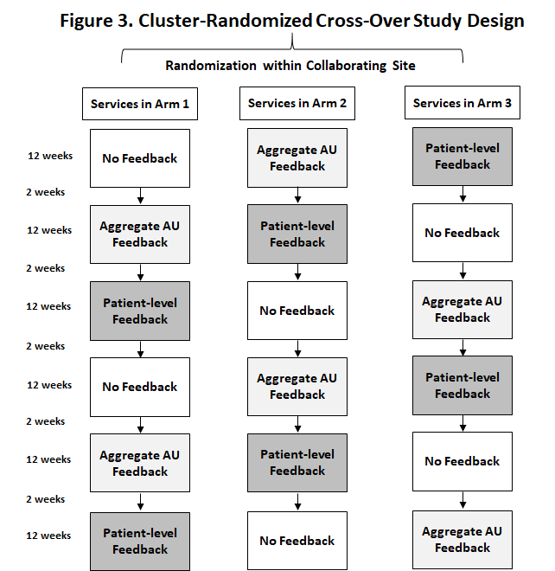
AU data feedback implementation: After study protocol review, finalization, AU data sources will be reviewed to ensure ability to attribute AU to service-lines consistently. Aggregate AU data feedback will be provided on a biweekly basis electronically (Fig. 2).

Statistical Analysis Plan: Patient demographic and clinical characteristics will be summarized by team and intervention arm. Between group comparisons will use Wilcoxon or Kruskal-Wallis test for continuous variables and Pearson’s chi-squared test for categorical variables. Primary and secondary outcomes will be compared between study arms using a generalized linear mixed effects model including service as a random effect and treatment arm, demographic, and clinical patient characteristics as fixed effects. Unit of measure will be patient level DOT/LOS to leverage the benefits of the cluster cross over design from which DOT/1000 (CDC metric) will be reported for generalizability. For Aim 3, a Wilcoxon test will be used to compare survey responses between the aggregate and patient-level feedback methods, and a Bonferroni correction for specific between group differences will be used.

Sample Size Justification: Based on prior data collected from our general medicine services, we estimate that our study would enroll 7873 total encounters per study arm. Additionally, we estimate that in the baseline arm, the average encounter-level proportion of LOS classified as AU days is 0.471. Assuming a standard deviation in this outcome of no greater than .5, we estimate that we have 80% power to detect a true reduction to 0.449 (0.022 absolute reduction, 4.7% relative reduction). The addition of two additional sites of similar size to VUMC would increase the estimated encounters per study arm to 23619. Under the same assumptions described above, this would provide 80% power to detect a true reduction to 0.458 (0.013 absolute reduction, 2.8% relative reduction). These calculations assume a two-sided type 1 error rate of 5%.

Potential Limitations and Alternative Approaches: This study is powered for the primary outcome only and may have insufficient power to detect differences in secondary outcomes and subgroup analyses. Degree of implementation may vary between sites impacting clinician awareness of AU data. Educational materials describing direct AU data feedback methodology will be standardized prior to intervention start. There may be regional or site-specific differences in acceptance of surveillance data feedback or foundational ASP engagement which may affect receipt of AU data intervention. We will attempt to adjust for type of baseline ASP activities as detailed by the CDC core element assessment tool¹³² completed prior to study initiation. We will not have the ability to follow-up patients after hospital discharge to evaluate outcomes that may not occur during index hospitalization.

Study Timeline

 | Year 1 |  |  |  | Year 2 |  |  |  | Year 3 |  |  |  | Year 4
Quarter | 1 | 2 | 3 | 4 | 1 | 2 | 3 | 4 | 1 | 2 | 3 | 4 | 1 | 2 | 3 | 4
Collaborative Project #2
Protocol finalization
Implementation resources finalization
Data Standardization
AU Feedback Interventions
Analysis
Presentation/publication of findings

BIBLIOGRAPHY/REFERENCES CITED

1. Pollack LA, Srinivasan A. Core Elements of Hospital Antibiotic Stewardship Programs from the Centers for Disease Control and Prevention. Clin Infect Dis 2014;59 Suppl 3:S97-100.
2. Davey P, Marwick CA, Scott CL, et al. Interventions to Improve Antibiotic Prescribing Practices for Hospital Inpatients. Cochrane Database Syst Rev 2017;2:CD003543.
3. Barlam TF, Cosgrove SE, Abbo LM, et al. Implementing an Antibiotic Stewardship Program: Guidelines by the Infectious Diseases Society of America and the Society for Healthcare Epidemiology of America. Clin Infect Dis 2016;62:e51-77.
4. Roden DM, Pulley JM, Basford MA, et al. Development of a Large-Scale De-Identified DNA Biobank to Enable Personalized Medicine. Clin Pharmacol Ther 2008;84:362-9.
5. Dare RK, Tewell C, Harris B, et al. Effect of Statin Coadministration on the Risk of Daptomycin-Associated Myopathy. Clin Infect Dis 2018;67:1356-63.
6. Kirby JC, Speltz P, Rasmussen LV, et al. Phekb: A Catalog and Workflow for Creating Electronic Phenotype Algorithms for Transportability. J Am Med Inform Assoc 2016;23:1046-52.
7. Phekb. What Is the Phenotype Knowledgebase? Accessed on February 25, 2020 at Https://Phekb.Org/.
8. Kho AN, Hayes MG, Rasmussen-Torvik L, et al. Use of Diverse Electronic Medical Record Systems to Identify Genetic Risk for Type 2 Diabetes within a Genome-Wide Association Study. J Am Med Inform Assoc 2012;19:212-8.
9. Teixeira PL, Wei WQ, Cronin RM, et al. Evaluating Electronic Health Record Data Sources and Algorithmic Approaches to Identify Hypertensive Individuals. J Am Med Inform Assoc 2017;24:162-71.
10. Feng Q, Wei WQ, Chaugai S, et al. A Genetic Approach to the Association between Pcsk9 and Sepsis. JAMA Netw Open 2019;2:e1911130.
11. Wei WQ, Feng Q, Weeke P, et al. Creation and Validation of an Emr-Based Algorithm for Identifying Major Adverse Cardiac Events While on Statins. AMIA Jt Summits Transl Sci Proc 2014;2014:112-9.
12. Hripcsak G, Ryan PB, Duke JD, et al. Characterizing Treatment Pathways at Scale Using the Ohdsi Network. Proc Natl Acad Sci U S A 2016;113:7329-36.
13. Hripcsak G, Shang N, Peissig PL, et al. Facilitating Phenotype Transfer Using a Common Data Model. J Biomed Inform 2019;96:103253.
14. Shang N, Liu C, Rasmussen LV, et al. Making Work Visible for Electronic Phenotype Implementation: Lessons Learned from the Emerge Network. J Biomed Inform 2019;99:103293.
15. Newton KM, Peissig PL, Kho AN, et al. Validation of Electronic Medical Record-Based Phenotyping Algorithms: Results and Lessons Learned from the Emerge Network. J Am Med Inform Assoc 2013;20:e147-54.
16. Wei WQ, Bastarache LA, Carroll RJ, et al. Evaluating Phecodes, Clinical Classification Software, and Icd-9-Cm Codes for Phenome-Wide Association Studies in the Electronic Health Record. PLoS One 2017;12:e0175508.
17. Banda JM, Seneviratne M, Hernandez-Boussard T, Shah NH. Advances in Electronic Phenotyping: From Rule-Based Definitions to Machine Learning Models. Annu Rev Biomed Data Sci 2018;1:53-68.
18. Anesi JA, Lautenbach E, Nachamkin I, et al. The Role of Extended-Spectrum Cephalosporin-Resistance in Recurrent Community-Onset Enterobacteriaceae Urinary Tract Infections: A Retrospective Cohort Study. BMC Infect Dis 2019;19:163.
19. Lodise TP, Bonine NG, Ye JM, Folse HJ, Gillard P. Development of a Bedside Tool to Predict the Probability of Drug-Resistant Pathogens among Hospitalized Adult Patients with Gram-Negative Infections. BMC Infect Dis 2019;19:718.
20. Song JY, Jeong IS. Development of a Risk Prediction Model of Carbapenem-Resistant Enterobacteriaceae Colonization among Patients in Intensive Care Units. Am J Infect Control 2018;46:1240-4.
21. Weinstein EJ, Han JH, Lautenbach E, et al. A Clinical Prediction Tool for Extended-Spectrum Cephalosporin Resistance in Community-Onset Enterobacterales Urinary Tract Infection. Open Forum Infect Dis 2019;6:ofz164.
22. Lee CH, Chu FY, Hsieh CC, et al. A Simple Scoring Algorithm Predicting Extended-Spectrum Beta-Lactamase Producers in Adults with Community-Onset Monomicrobial Enterobacteriaceae Bacteremia: Matters of Frequent Emergency Department Users. Medicine (Baltimore) 2017;96:e6648.
23. CDC. Antibiotic Resistance Threats in the United States, 2019. Atlanta, GA: U.S. Department of Health and Human Services2019.
24. Zhao J, Feng Q, Wu P, et al. Learning from Longitudinal Data in Electronic Health Record and Genetic Data to Improve Cardiovascular Event Prediction. Sci Rep 2019;9:717.
25. Zhao J, Zhang Y, Schlueter DJ, et al. Detecting Time-Evolving Phenotypic Topics Via Tensor Factorization on Electronic Health Records: Cardiovascular Disease Case Study. J Biomed Inform 2019;98:103270.
26. Paul P, Slayton RB, Kallen AJ, Walters MS, Jernigan JA. Modeling Regional Transmission and Containment of a Healthcare-Associated Multidrug-Resistant Organism. Clin Infect Dis 2020;70:388-94.
27. Ray MJ, Lin MY, Weinstein RA, Trick WE. Spread of Carbapenem-Resistant Enterobacteriaceae among Illinois Healthcare Facilities: The Role of Patient Sharing. Clin Infect Dis 2016;63:889-93.
28. Ellingson KD, Noble BN, Tran D, et al. Compliance with Statewide Regulations for Communication of Patients' Multidrug-Resistant Organism and Clostridium Difficile Status During Transitions of Care. Am J Infect Control 2019.
29. Octaria R, Smith N, Paul P, Chan A, Slayton R, Kainer M. Identification of Facilities at-Risk of Receiving Patients Colonized with Carbapenem-Resistant Enterobacteriaceae (Abstract 9448). Council of State and Territorial Epidemiologists Annual Conference; 2018 Presented on June 13, 2018.
30. Rstudio. Rstudio: Integrated Development for R. Accessed on February 27, 2020 at Http://Www.Rstudio.Com/.
31. Talbot TR, Johnson JG, Fergus C, et al. Sustained Improvement in Hand Hygiene Adherence: Utilizing Shared Accountability and Financial Incentives. Infect Control Hosp Epidemiol 2013;34:1129-36.
32. Centers for Disease Control and Prevention. About Antibiotic Resistance. Accessed on February 25, 2020 at Https://Www.Cdc.Gov/Drugresistance/About.Html.
33. Olesen SW, Barnett ML, MacFadden DR, et al. The Distribution of Antibiotic Use and Its Association with Antibiotic Resistance. Elife 2018;7.
34. Duffy E, Ritchie S, Metcalfe S, Van Bakel B, Thomas MG. Antibacterials Dispensed in the Community Comprise 85%-95% of Total Human Antibacterial Consumption. J Clin Pharm Ther 2018;43:59-64.
35. Gerber JS, Prasad PA, Fiks AG, et al. Durability of Benefits of an Outpatient Antimicrobial Stewardship Intervention after Discontinuation of Audit and Feedback. JAMA 2014;312:2569-70.
36. Gerber JS, Prasad PA, Fiks AG, et al. Effect of an Outpatient Antimicrobial Stewardship Intervention on Broad-Spectrum Antibiotic Prescribing by Primary Care Pediatricians: A Randomized Trial. JAMA 2013;309:2345-52.
37. Meeker D, Linder JA, Fox CR, et al. Effect of Behavioral Interventions on Inappropriate Antibiotic Prescribing among Primary Care Practices: A Randomized Clinical Trial. JAMA 2016;315:562-70.
38. Boardman C iIHI, assignee. System and method for estimating product distribution using a product specific universe. US patent 7,174,304.February 6, 2007., .
39. Staub MB, Ouedraogo Y, Evans CD, et al. Analysis of a High-Prescribing State's 2016 Outpatient Antibiotic Prescriptions: Implications for Outpatient Antimicrobial Stewardship Interventions. Infect Control Hosp Epidemiol 2019:1-8.
40. Katz SE, Staub M, Ouedraogo Y, et al. Population-Based Assessment of Patient and Provider Characteristics Influencing Pediatric Outpatient Antibiotic Use in a High Antibiotic-Prescribing State. Infect Control Hosp Epidemiol 2020:1-6.
41. Bauchner H, Pelton SI, Klein JO. Parents, Physicians, and Antibiotic Use. Pediatrics 1999;103:395-401.
42. Mangione-Smith R, Elliott MN, Stivers T, McDonald LL, Heritage J. Ruling out the Need for Antibiotics: Are We Sending the Right Message? Arch Pediatr Adolesc Med 2006;160:945-52.
43. Evans CT, Rogers TJ, Weaver FM, Burns SP. Providers' Beliefs and Behaviors Regarding Antibiotic Prescribing and Antibiotic Resistance in Persons with Spinal Cord Injury or Disorder. J Spinal Cord Med 2011;34:16-21.
44. Dempsey PP, Businger AC, Whaley LE, Gagne JJ, Linder JA. Primary Care Clinicians' Perceptions About Antibiotic Prescribing for Acute Bronchitis: A Qualitative Study. BMC Fam Pract 2014;15:194.
45. Sanchez GV, Roberts RM, Albert AP, Johnson DD, Hicks LA. Effects of Knowledge, Attitudes, and Practices of Primary Care Providers on Antibiotic Selection, United States. Emerg Infect Dis 2014;20:2041-7.
46. Szymczak JE, Feemster KA, Zaoutis TE, Gerber JS. Pediatrician Perceptions of an Outpatient Antimicrobial Stewardship Intervention. Infect Control Hosp Epidemiol 2014;35 Suppl 3:S69-78.
47. Yates TD, Davis ME, Taylor YJ, et al. Not a Magic Pill: A Qualitative Exploration of Provider Perspectives on Antibiotic Prescribing in the Outpatient Setting. BMC Fam Pract 2018;19:96.
48. Zetts RM, Stoesz A, Smith BA, Hyun DY. Outpatient Antibiotic Use and the Need for Increased Antibiotic Stewardship Efforts. Pediatrics 2018;141.
49. Damschroder LJ, Aron DC, Keith RE, Kirsh SR, Alexander JA, Lowery JC. Fostering Implementation of Health Services Research Findings into Practice: A Consolidated Framework for Advancing Implementation Science. Implement Sci 2009;4:50.
50. Petursson P. Gps' Reasons for "Non-Pharmacological" Prescribing of Antibiotics. A Phenomenological Study. Scand J Prim Health Care 2005;23:120-5.
51. Gu Y, Fujitomo Y, Soeda H, et al. A Nationwide Questionnaire Survey of Clinic Doctors on Antimicrobial Stewardship in Japan. J Infect Chemother 2020;26:149-56.
52. Kabba JA, Tadesse N, James PB, et al. Knowledge, Attitude and Antibiotic Prescribing Patterns of Medical Doctors Providing Free Healthcare in the Outpatient Departments of Public Hospitals in Sierra Leone: A National Cross-Sectional Study. Trans R Soc Trop Med Hyg 2020.
53. Butler CC, Rollnick S, Pill R, Maggs-Rapport F, Stott N. Understanding the Culture of Prescribing: Qualitative Study of General Practitioners' and Patients' Perceptions of Antibiotics for Sore Throats. BMJ 1998;317:637-42.
54. Chaw PS, Schlinkmann MKM, Raupach-Rosin H, et al. Knowledge, Attitude and Practice of Gambian Health Practitioners Towards Antibiotic Prescribing and Microbiological Testing: A Cross-Sectional Survey. Trans R Soc Trop Med Hyg 2017;111:117-24.
55. Schneider S, Salm F, Vincze S, et al. Perceptions and Attitudes Regarding Antibiotic Resistance in Germany: A Cross-Sectoral Survey Amongst Physicians, Veterinarians, Farmers and the General Public. J Antimicrob Chemother 2018;73:1984-8.
56. Linder JA, Doctor JN, Friedberg MW, et al. Time of Day and the Decision to Prescribe Antibiotics. JAMA Intern Med 2014;174:2029-31.
57. Gjelstad S, Straand J, Dalen I, Fetveit A, Strom H, Lindbaek M. Do General Practitioners' Consultation Rates Influence Their Prescribing Patterns of Antibiotics for Acute Respiratory Tract Infections? J Antimicrob Chemother 2011;66:2425-33.
58. Beebe TJ, Jacobson RM, Jenkins SM, Lackore KA, Rutten LJF. Testing the Impact of Mixed-Mode Designs (Mail and Web) and Multiple Contact Attempts within Mode (Mail or Web) on Clinician Survey Response. Health Serv Res 2018;53 Suppl 1:3070-83.
59. Drekonja DM, Filice GA, Greer N, et al. Antimicrobial Stewardship in Outpatient Settings: A Systematic Review. Infect Control Hosp Epidemiol 2015;36:142-52.
60. Hansen MJ, Carson PJ, Leedahl DD, Leedahl ND. Failure of a Best Practice Alert to Reduce Antibiotic Prescribing Rates for Acute Sinusitis across an Integrated Health System in the Midwest. J Manag Care Spec Pharm 2018;24:154-9.
61. Jindai K, Goto M, MacKay K, et al. Improving Fluoroquinolone Use in the Outpatient Setting Using a Patient Safety Initiative. Infect Control Hosp Epidemiol 2018;39:1108-11.
62. Shively NR, Buehrle DJ, Wagener MM, Clancy CJ, Decker BK. Improved Antibiotic Prescribing within a Veterans Affairs Primary Care System through a Multifaceted Intervention Centered on Peer Comparison of Overall Antibiotic Prescribing Rates. Antimicrob Agents Chemother 2019;64.
63. Hemkens LG, Saccilotto R, Reyes SL, et al. Personalized Prescription Feedback Using Routinely Collected Data to Reduce Antibiotic Use in Primary Care: A Randomized Clinical Trial. JAMA Intern Med 2017;177:176-83.
64. Ward MJ, Chavis B, Banerjee R, Katz SE, Anders S. Antimicrobial Stewardship in Pediatric Acute Care Settings with User Centered Design Feedback. Applied Clincial Informations (in submission) 2020.
65. Brunner J, Chuang E, Goldzweig C, Cain CL, Sugar C, Yano EM. User-Centered Design to Improve Clinical Decision Support in Primary Care. Int J Med Inform 2017;104:56-64.
66. Minoletti S, Rapisarda R, Giraldo L, et al. User-Centered Design of a Pediatric Vaccination Module for Patients. Stud Health Technol Inform 2019;264:1096-100.
67. Constantine L LL, Constantine LL, Lockwood LAD. An Agile Approach to Integrating Users, User Interfaces, and Usability into Software Engineering Practice.,.
68. Weiner BJ, Lewis CC, Stanick C, et al. Psychometric Assessment of Three Newly Developed Implementation Outcome Measures. Implement Sci 2017;12:108.
69. Proctor EK, Landsverk J, Aarons G, Chambers D, Glisson C, Mittman B. Implementation Research in Mental Health Services: An Emerging Science with Conceptual, Methodological, and Training Challenges. Adm Policy Ment Health 2009;36:24-34.
70. Halasa NB, Williams JV, Wilson GJ, Walsh WF, Schaffner W, Wright PF. Medical and Economic Impact of a Respiratory Syncytial Virus Outbreak in a Neonatal Intensive Care Unit. Pediatr Infect Dis J 2005;24:1040-4.
71. Hall CB, Douglas RG, Jr., Geiman JM, Messner MK. Nosocomial Respiratory Syncytial Virus Infections. N Engl J Med 1975;293:1343-6.
72. Sartor C, Zandotti C, Romain F, et al. Disruption of Services in an Internal Medicine Unit Due to a Nosocomial Influenza Outbreak. Infect Control Hosp Epidemiol 2002;23:615-9.
73. Voirin N, Barret B, Metzger MH, Vanhems P. Hospital-Acquired Influenza: A Synthesis Using the Outbreak Reports and Intervention Studies of Nosocomial Infection (Orion) Statement. J Hosp Infect 2009;71:1-14.
74. Taylor G, Mitchell R, McGeer A, et al. Healthcare-Associated Influenza in Canadian Hospitals from 2006 to 2012. Infect Control Hosp Epidemiol 2014;35:169-75.
75. Yokoe DS, Anderson DJ, Berenholtz SM, et al. A Compendium of Strategies to Prevent Healthcare-Associated Infections in Acute Care Hospitals: 2014 Updates. Infect Control Hosp Epidemiol 2014;35 Suppl 2:S21-31.
76. Talbot TR, Babcock H, Caplan AL, et al. Revised Shea Position Paper: Influenza Vaccination of Healthcare Personnel. Infect Control Hosp Epidemiol 2010;31:987-95.
77. Talbot TR, Dellit TH, Hebden J, Sama D, Cuny J. Factors Associated with Increased Healthcare Worker Influenza Vaccination Rates: Results from a National Survey of University Hospitals and Medical Centers. Infect Control Hosp Epidemiol 2010;31:456-62.
78. Talbot TR. Improving Rates of Influenza Vaccination among Healthcare Workers: Educate; Motivate; Mandate? Infect Control Hosp Epidemiol 2008;29:107-10.
79. Talbot TR. Do Declination Statements Increase Health Care Worker Influenza Vaccination Rates? Clin Infect Dis 2009;49:773-9.
80. Esbenshade JC, Edwards KM, Esbenshade AJ, et al. Respiratory Virus Shedding in a Cohort of on-Duty Healthcare Workers Undergoing Prospective Surveillance. Infect Control Hosp Epidemiol 2013;34:373-8.
81. Spires SS, Talbot HK, Pope CA, Talbot TR. Paramyxovirus Outbreak in a Long-Term Care Facility: The Challenges of Implementing Infection Control Practices in a Congregate Setting. Infect Control Hosp Epidemiol 2017;38:399-404.
82. Staub M, Downs L, England J, et al. Rapid Containment of a Human Parainfluenza Virus Type 3 Outbreak in a Stem Cell Transplant Clinic (Abstract 270). Society for Healthcare Epidemiology of America (SHEA) Annual Spring Meeting; 2019 Presented on April 26, 2019.
83. Hartman L, Zhu Y, Edwards KM, Griffin MR, Talbot HK. Underdiagnosis of Influenza Virus Infection in Hospitalized Older Adults. J Am Geriatr Soc 2018;66:467-72.
84. Kim L, Rha B, Abramson JS, et al. Identifying Gaps in Respiratory Syncytial Virus Disease Epidemiology in the United States Prior to the Introduction of Vaccines. Clin Infect Dis 2017;65:1020-5.
85. Lindegren ML, Griffin MR, Williams JV, et al. Antiviral Treatment among Older Adults Hospitalized with Influenza, 2006-2012. PLoS One 2015;10:e0121952.
86. Miller EK, Linder J, Kraft D, et al. Hospitalizations and Outpatient Visits for Rhinovirus-Associated Acute Respiratory Illness in Adults. J Allergy Clin Immunol 2016;137:734-43 e1.
87. Nesmith N, Williams JV, Johnson M, Zhu Y, Griffin M, Talbot HK. Sensitive Diagnostics Confirm That Influenza C Is an Uncommon Cause of Medically Attended Respiratory Illness in Adults. Clin Infect Dis 2017;65:1037-9.
88. Poehling KA, Caspard H, Peters TR, et al. 2015-2016 Vaccine Effectiveness of Live Attenuated and Inactivated Influenza Vaccines in Children in the United States. Clin Infect Dis 2018;66:665-72.
89. Widmer K, Griffin MR, Zhu Y, Williams JV, Talbot HK. Respiratory Syncytial Virus- and Human Metapneumovirus-Associated Emergency Department and Hospital Burden in Adults. Influenza Other Respir Viruses 2014;8:347-52.
90. Widmer K, Zhu Y, Williams JV, Griffin MR, Edwards KM, Talbot HK. Rates of Hospitalizations for Respiratory Syncytial Virus, Human Metapneumovirus, and Influenza Virus in Older Adults. J Infect Dis 2012;206:56-62.
91. Chaves SS, Lynfield R, Lindegren ML, Bresee J, Finelli L. The Us Influenza Hospitalization Surveillance Network. Emerg Infect Dis 2015;21:1543-50.
92. Magill SS, O'Leary E, Janelle SJ, et al. Changes in Prevalence of Health Care-Associated Infections in U.S. Hospitals. N Engl J Med 2018;379:1732-44.
93. Jacob P, Legrand J, Talbot TR. A Best Practice Alert to Reduce Inappropriate Testing for Clostridium Difficile in the Setting of Prior Laxative Use (Abstract 307). Society for Healthcare Epidemiology of America (SHEA) Annual Spring Meeting; 2019 Presented on April 24, 2019.
94. Self WH, Semler MW, Wanderer JP, et al. Balanced Crystalloids Versus Saline in Noncritically Ill Adults. N Engl J Med 2018;378:819-28.
95. Semler MW, Self WH, Wanderer JP, et al. Balanced Crystalloids Versus Saline in Critically Ill Adults. N Engl J Med 2018;378:829-39.
96. Turner RM, White IR, Croudace T, Group PIPS. Analysis of Cluster Randomized Cross-over Trial Data: A Comparison of Methods. Stat Med 2007;26:274-89.
97. Fleming-Dutra KE, Hersh AL, Shapiro DJ, et al. Prevalence of Inappropriate Antibiotic Prescriptions among Us Ambulatory Care Visits, 2010-2011. JAMA 2016;315:1864-73.
98. Centers for Disease Control and Prevention. Antibiotic Use in Outpatient Settings, 2017. Accessed on February 27, 2020 at Https://Www.Cdc.Gov/Antibiotic-Use/Stewardship-Report/Outpatient.Html.
99. Palms DL, Hicks LA, Bartoces M, et al. Comparison of Antibiotic Prescribing in Retail Clinics, Urgent Care Centers, Emergency Departments, and Traditional Ambulatory Care Settings in the United States. JAMA Intern Med 2018;178:1267-9.
100. Kirkpatrick GL. The Common Cold. Prim Care 1996;23:657-75.
101. Blaschke AJ, Shapiro DJ, Pavia AT, et al. A National Study of the Impact of Rapid Influenza Testing on Clinical Care in the Emergency Department. J Pediatric Infect Dis Soc 2014;3:112-8.
102. Poehling KA, Zhu Y, Tang YW, Edwards K. Accuracy and Impact of a Point-of-Care Rapid Influenza Test in Young Children with Respiratory Illnesses. Arch Pediatr Adolesc Med 2006;160:713-8.
103. Green DA, Hitoaliaj L, Kotansky B, Campbell SM, Peaper DR. Clinical Utility of on-Demand Multiplex Respiratory Pathogen Testing among Adult Outpatients. J Clin Microbiol 2016;54:2950-5.
104. Jennings LC, Skopnik H, Burckhardt I, Hribar I, Del Piero L, Deichmann KA. Effect of Rapid Influenza Testing on the Clinical Management of Paediatric Influenza. Influenza Other Respir Viruses 2009;3:91-8.
105. Gardiner BJ, Parker CEV, Rabson AR, Snydman DR, Doron S. Evaluation of a Two-Stage Testing Algorithm for the Diagnosis of Respiratory Viral Infections. Diagn Microbiol Infect Dis 2018;91:319-23.
106. Rogers BB, Shankar P, Jerris RC, et al. Impact of a Rapid Respiratory Panel Test on Patient Outcomes. Arch Pathol Lab Med 2015;139:636-41.
107. Rappo U, Schuetz AN, Jenkins SG, et al. Impact of Early Detection of Respiratory Viruses by Multiplex Pcr Assay on Clinical Outcomes in Adult Patients. J Clin Microbiol 2016;54:2096-103.
108. Subramony A, Zachariah P, Krones A, Whittier S, Saiman L. Impact of Multiplex Polymerase Chain Reaction Testing for Respiratory Pathogens on Healthcare Resource Utilization for Pediatric Inpatients. J Pediatr 2016;173:196-201 e2.
109. Bonner AB, Monroe KW, Talley LI, Klasner AE, Kimberlin DW. Impact of the Rapid Diagnosis of Influenza on Physician Decision-Making and Patient Management in the Pediatric Emergency Department: Results of a Randomized, Prospective, Controlled Trial. Pediatrics 2003;112:363-7.
110. Doan QH, Kissoon N, Dobson S, et al. A Randomized, Controlled Trial of the Impact of Early and Rapid Diagnosis of Viral Infections in Children Brought to an Emergency Department with Febrile Respiratory Tract Illnesses. J Pediatr 2009;154:91-5.
111. Doan Q, Enarson P, Kissoon N, Klassen TP, Johnson DW. Rapid Viral Diagnosis for Acute Febrile Respiratory Illness in Children in the Emergency Department. Cochrane Database Syst Rev 2014:CD006452.
112. Vos LM, Bruning AHL, Reitsma JB, et al. Rapid Molecular Tests for Influenza, Respiratory Syncytial Virus, and Other Respiratory Viruses: A Systematic Review of Diagnostic Accuracy and Clinical Impact Studies. Clin Infect Dis 2019;69:1243-53.
113. Quickstats: Percentage* of Office-Based Primary Care Physicians Accepting New Patients, by Source of Payment Accepted - National Electronic Health Records Survey, 2015. MMWR Morb Mortal Wkly Rep 2017;66:766.
114. Fillmarray Respiratory Panle (Rp) Ez Quick Guide: Clia Complexity-Waived for Nasopharyngeal Swab (Nps) Specimens for in Vitro Diagnostic Use. BioFire Diagnostics; 2017.
115. Chua KP, Fischer MA, Linder JA. Appropriateness of Outpatient Antibiotic Prescribing among Privately Insured Us Patients: Icd-10-Cm Based Cross Sectional Study. BMJ 2019;364:k5092.
116. Shigayeva A, Green K, Raboud JM, et al. Factors Associated with Critical-Care Healthcare Workers' Adherence to Recommended Barrier Precautions During the Toronto Severe Acute Respiratory Syndrome Outbreak. Infect Control Hosp Epidemiol 2007;28:1275-83.
117. Policy Statement on Antimicrobial Stewardship by the Society for Healthcare Epidemiology of America (Shea), the Infectious Diseases Society of America (Idsa), and the Pediatric Infectious Diseases Society (Pids). Infect Control Hosp Epidemiol 2012;33:322-7.
118. CDC. Core Elements of Hospital Antibiotic Stewardship Programs. In: US Department of Health and Human Services C, ed. Atlanta, GA 2019.
119. Hallsworth M, Chadborn T, Sallis A, et al. Provision of Social Norm Feedback to High Prescribers of Antibiotics in General Practice: A Pragmatic National Randomised Controlled Trial. Lancet 2016;387:1743-52.
120. Buehrle DJ, Shively NR, Wagener MM, Clancy CJ, Decker BK. Sustained Reductions in Overall and Unnecessary Antibiotic Prescribing at Primary Care Clinics in a Veterans Affairs Healthcare System Following a Multi-Faceted Stewardship Intervention. Clin Infect Dis 2019.
121. Navathe AS, Emanuel EJ. Physician Peer Comparisons as a Nonfinancial Strategy to Improve the Value of Care. Jama 2016;316:1759-60.
122. Tamma PD, Avdic E, Keenan JF, et al. What Is the More Effective Antibiotic Stewardship Intervention: Preprescription Authorization or Postprescription Review with Feedback? Clin Infect Dis 2017;64:537-43.
123. MacBrayne CE, Williams MC, Levek C, et al. Sustainability of Handshake Stewardship: Extending a Hand Is Effective Years Later. Clin Infect Dis 2019.
124. Greene MH, Nesbitt WJ, Nelson GE. Antimicrobial Stewardship Staffing: How Much Is Enough? Infect Control Hosp Epidemiol 2020;41:102-12.
125. Livorsi DJ, Heintz B, Jacob JT, Krein SL, Morgan DJ, Perencevich EN. Audit and Feedback Processes among Antimicrobial Stewardship Programs: A Survey of the Society for Healthcare Epidemiology of America Research Network. Infect Control Hosp Epidemiol 2016;37:704-6.
126. Centers for Disease Control and Prevention. Antimicrobial Use and Resistance (Aur) Module, 2020. Accessed on February 29, 2020 at Https://Www.Cdc.Gov/Nhsn/Pdfs/Pscmanual/11pscaurcurrent.Pdf.
127. McIntyre MT, Naik L, Bell CM, Morris AM. Development and Assessment of a Physician-Specific Antimicrobial Usage and Spectrum Feedback Tool. Open Forum Infect Dis 2017;4:ofx124.
128. Ray WA, Schaffner W, Federspiel CF. Persistence of Improvement in Antibiotic Prescribing in Office Practice. Jama 1985;253:1774-6.
129. Hickson GB, Federspiel CF, Pichert JW, Miller CS, Gauld-Jaeger J, Bost P. Patient Complaints and Malpractice Risk. JAMA 2002;287:2951-7.
130. Lines TH, Nesbitt WJ, Nelson GE. Driving Antimicrobial Use Improvement: Attitudes of Providers of Adult Hospital Care on Optimal Attribution and Feedback. Infect Control Hosp Epidemiol 2018;39:983-5.
131. Gerber JS, Hersh AL, Kronman MP, Newland JG, Ross RK, Metjian TA. Development and Application of an Antibiotic Spectrum Index for Benchmarking Antibiotic Selection Patterns across Hospitals. Infect Control Hosp Epidemiol 2017;38:993-7.
132. Centers for Disease Control and Prevention. The Core Elements of Hospital Antibiotic Stewardship Programs: Antibiotic Stewardship Program Assessment Tool, 2019 Accessed on February 29, 2020 at Https://Www.Cdc.Gov/Antibiotic-Use/Healthcare/Pdfs/Assessment-Tool-P.Pdf.

