Vanderbilt Symposium on
Implementation Research in the Learning Health System

Location
The Engineering and Science Building (ESB) is located on the corner of 25th and Garland.
1212 25th Ave S., Rooms 044/048 & 001, lower level | Map
Building entrances located on Garland, Highland, and 25th Avenues.

Walking Directions
- From VUMC main campus and the VA, take 24 Ave S. to either Garland Ave or Highland Ave.
- From 2525 West End, take Kensington Pl, to 25th Ave S, then turn on to Garland Ave.
- From the 25th Ave garage, cross Highland Ave to access ESB.
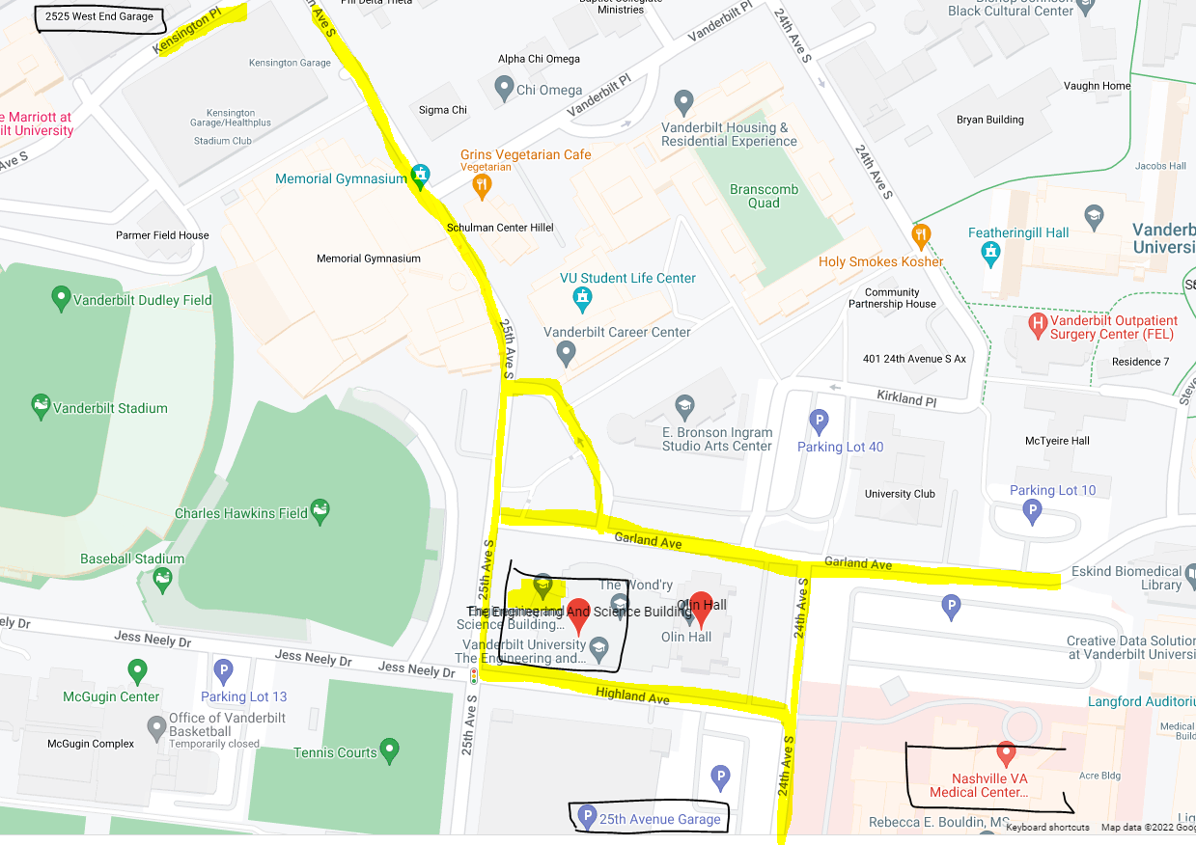

Parking
- We anticipate that most employees will park in their designated lots.
- There is paid parking in the 25th Ave. garage (closest to ESB).
- There is paid parking in the 2525 Kensington and West End garages through Metropolis – the daily maximum is $20.
- You may also purchase a single day pass for the N Lot pr the South Garage (Roof Level): https://www.vumc.org/med-center-parking/single-day-hangtags.

