Vanderbilt Symposium on
Implementation Research in the Learning Health System

Location
The Engineering and Science Building (ESB) is located on the corner of 24th and Garland.
2414 Highland Ave, Upstairs Lobby and Rooms 044/048 lower level | Map
Building entrances located on Garland and Highland Avenue (X on map).
(*the 25th Avenue entrance is closed due to construction*)

Walking Directions
- From VUMC main campus and the VA, take 24 Ave S. to either Garland Ave or Highland Ave.
- From 2525 West End, take Kensington Pl, to 25th Ave S then turn on to the Student Life Center driveway and cross Garland Avenue to the ESB entrance.
- From the 25th Ave garage, cross Highland Ave to access ESB.
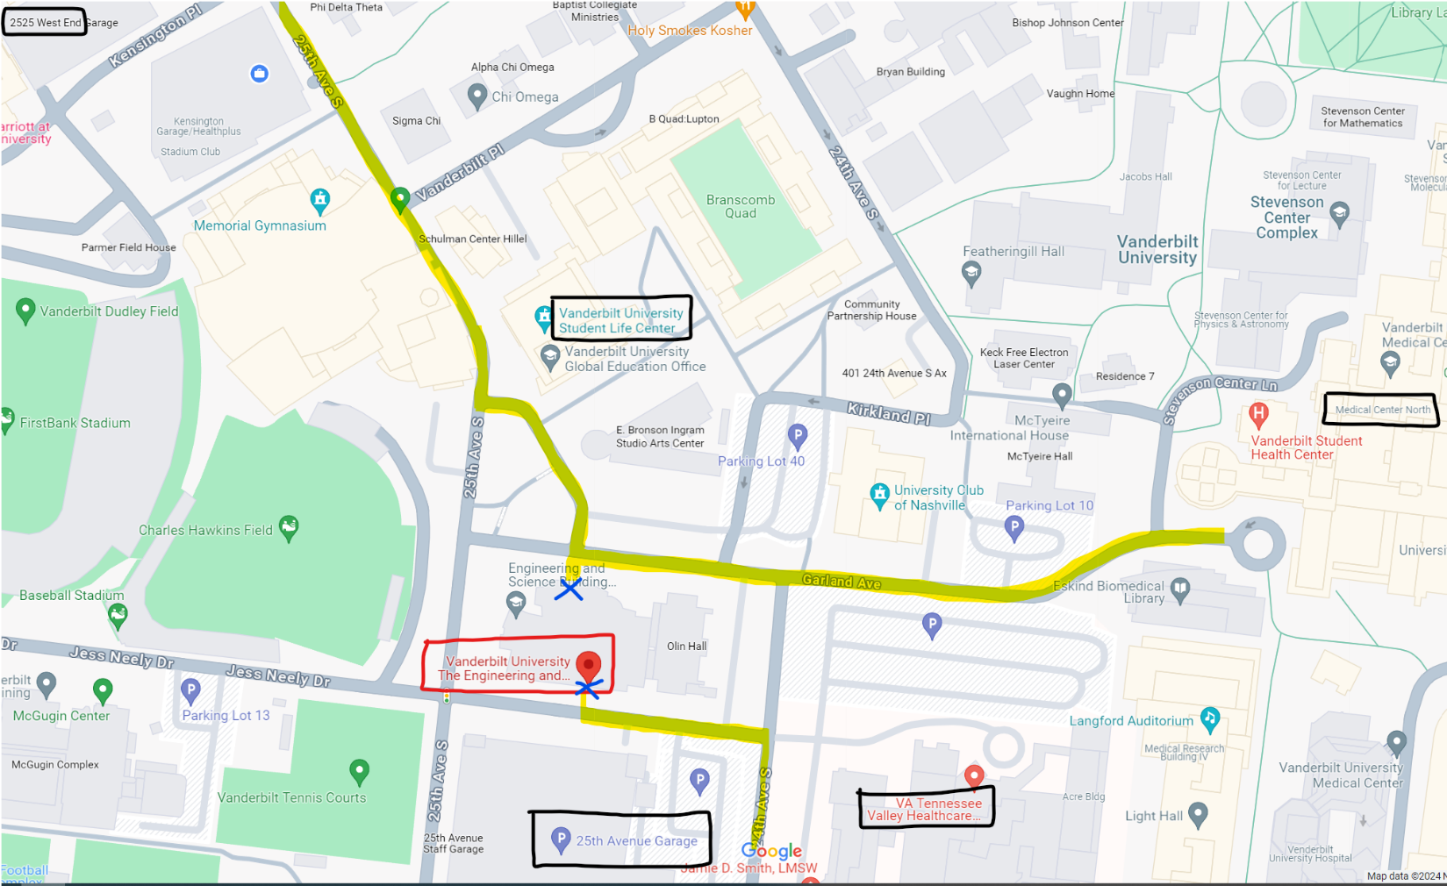

Parking
- We anticipate that most employees will park in their designated lots.
- There is paid parking in the 25th Ave. garage on Highland Avenue through ParkMobile (closest to ESB).
- There is paid parking in the 2525 Kensington and West End garages through Metropolis.
- You may also purchase a single day pass for the N Lot pr the South Garage (Roof Level): https://www.vumc.org/med-center-parking/single-day-hangtags.

