FACILITIES

The present proposal encompasses a collaborative effort between the clinical facilities at the Vanderbilt Department of Neurology and the technical development and methodological expertise from the Vanderbilt University Institute of Imaging Science.

I. The Vanderbilt University Institute of Imaging Science (VUIIS)

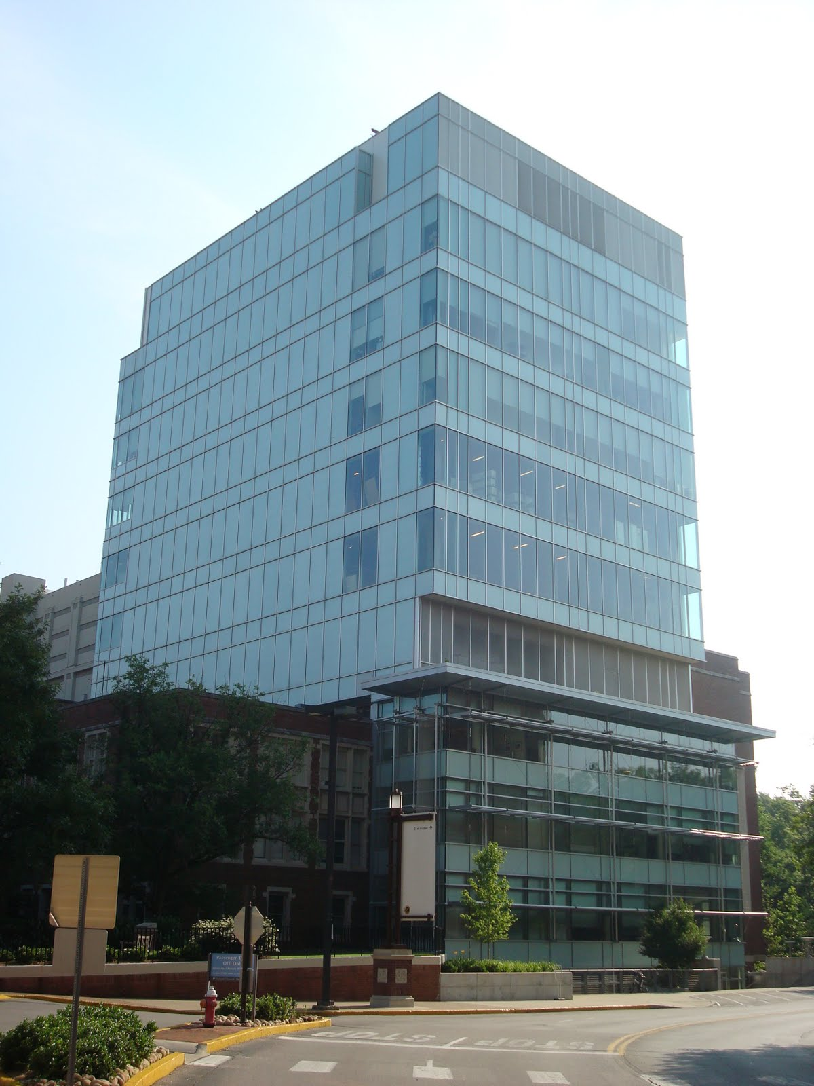
Overview. The Vanderbilt University Institute of Imaging Science (VUIIS) is a university-wide interdisciplinary initiative that unites scientists whose interests span the spectrum of imaging research, from the underlying physics of imaging techniques to the application of imaging tools, to address fundamental biological problems of medical relevance. VUIIS faculty are active in developing novel methods of imaging to obtain new types of information as well as in applying current methods to study a wide range of biomedical questions. VUIIS investigators pursue research in developing new imaging methods as well as applications in cancer, neuroscience, metabolic disorders, cardiovascular disease, and other areas.
The VUIIS has a core program of research related to developing new imaging technology based on advances in physics, engineering, and computer science. It promotes applied research in collaboration with biomedical scientists and physicians who ask important questions that imaging can address. In addition to high-field MRI and MR spectroscopy in human subjects, the VUIIS offers state-of-the-art options for small animal imaging in all modalities. Vanderbilt has just completed a four-floor, state-of-the-art facility adjacent to Medical Center North to house the VUIIS. The $28 million project ($21 million for construction) provides a 41,000-square-foot facility to integrate current activities in imaging research and provide research space for 24 faculty members and more than 60 graduate students and postdoctoral fellows in biomedical science, engineering, and physics.
The 41,000 square foot Vanderbilt University Institute of Imaging Science (VUIIS) building.

VUIIS Resources

[A] Center for Human Studies

The Center for Human Studies houses a Philips PET/CT system, two Philips 3.0T scanners and a human 7.0T Achieva scanner. Complementary modalities available in the core include simultaneous EEG measurements, Near-Infrared Optical Tomography, and ancillary equipment for generating and presenting visual stimuli for functional imaging experiments. For video presentation, an inside-the-scanner-room XGA Avotec projector, Epson DLP projector, or a pair of XGA-compatible high-resolution goggles for video stimulus presentation can be used, along with headphones for audio stimulus presentation, a microphone, and an infrared eye tracker. Nurses are available through the Vanderbilt General Clinical Research Center for experiments that require invasive procedures or nursing assistance. Image analysis may be performed using a Linux cluster of dual processor workstations and various Sun and SGI workstations. The Human Imaging Core is under the direction of a full-time Systems Administrator, and the computers are devoted exclusively to analysis of MRI data, which are transferred by high-speed network from the scanning facility. A variety of fMRI analysis software packages are available, along with generic programming languages for more individual analysis.

The two Philips 3.0T MRI scanners are state-of-the-art systems with superior gradient performance (80 mT/m gradient strength, 200T/m/s slew-rate), 32 independent digital receiver channels and physiological monitoring. Audio/visual presentation hardware and software are available for functional MRI studies. The number and types of RF coils are constantly being expanded. Multinuclear spectroscopy (primarily ¹³C and ³¹P), with proton decoupling are available. Of particular relevance to this proposal is a 16-channel torso array coil, compatible with the dual RF-transmit body coil, that we have already demonstrated can be used to achieve high signal-to-noise ratio images of axillary lymphatic nodes over a large spatial range.

The Philips Achieva 7.0T MRI is one of approximately 60 ultra high field human MR instruments worldwide. This research system has 32 independent digital receiver channels and physiological monitoring. A 32-channel receive/volume transmit head coil has recently been incorporated, allowing exquisite anatomical, functional and spectroscopic data collection with high SENSE acceleration factors.

Mock scanner
This laboratory consists of an inactive scanner identical to that of our research systems and includes an audio system for playing reproductions of scanner noises and a system for presenting visual stimuli. This laboratory is designed to introduce patients, particularly children, to what to expect while in the actual scanner and to screen for claustrophobia. In this environment, the patient can communicate with the technician via a button box. The mock scanner is located on the first floor near the research magnets.

Subject preparation and recovery suite
This suite consists of two patient beds, lavatory, and shower that are designed to allow patient preparations e.g. infusions of C13 labeled glucose, and recovery following MR scanning.

Electronic and machine shops (740 sq.ft.)
These areas are located on the same floor as the small animal imaging center. The electronic shop houses digital and analog oscilloscopes, an HP network analyzer and other instrumentation for the measurement of electrical signals. This shop is stocked with a wide array of circuit components for the construction and repair of the instrumentation used throughout VUIIS. The machine shop includes a milling machine, a lathe, a bandsaw and a wide array of hand tools. The machine shop uses computer drafting programs (Vectorworks and Solidworks) for design of MR coils, probes, stereotactic frames for animal studies as well as for constructing frame works in chemistry lab.

[B] Center for Image Analysis

The CIA was established to develop, support and apply algorithms for the processing and analysis of images produced within the VUIIS. Common functions supported include the analysis of human structural and functional MR data, the development of algorithms for rigid and non-rigid coregistration between images and between modalities, image segmentation, quantification of imaging data, correction of image distortions, and image restoration.

Computer and Data analysis laboratories (1200 sq.ft)
VUIIS maintains three computer labs dedicated to image analysis. These labs contain Sun and SGI workstations, a Linux cluster, and several PCs and Macs. Matlab, Mathematica, and IDL are available for data analysis and simulations. Specialized image analysis software includes Amira, AMIDE, AsiPro, Brain Voyager, SPM, Analyze, and pMOD, as well as numerous other programs and utilities developed in-house. The CIA is directed by a full time member of the faculty member and is staffed with two programmers and three postdoctoral scientists as well as three image analysts.

[C] Other Spaces

Faculty and administrative area
All faculty and administrative offices are located on the fourth floor. Facilities in this area include color laser printers, fax machines, color copy machines, and a faculty and staff lounge. Each faculty member is equipped with a printer, computer and table, drawers, book shelves and a whiteboard. This floor also has a small conference room, complete with audio-visual presentation electronics, and a small kitchenette.

Offices
Shared offices are scattered throughout the second and fourth floors to house staff, graduate students, fellows and other trainees. All faculty have individual offices. Computer labs, wet labs, animal imaging facilities, the electric and fabrication shops and personnel are located within the same building. Close proximity of these components makes efficient use of space and time and allows a free flow of ideas with each of the collaborators.

Conference and classroom
A large classroom is on the first floor of the center, and it is equipped with audio and video devices and tapes for purpose of training and interactions via conference and meetings. The room could hold up to 60 people and it is frequently used for seminars and for graduate, postdocs and faculty to meet. Two other smaller conference rooms are on the lower and fourth levels of the building.

[D] Support Personnel within VUIIS

VUIIS provides a core staff that is available for the faculty and all trainees for assistance with imaging and educational activities. They include personnel for training and operating the imaging equipment, for supporting animal preparations, for administrative help and for other technical support.

II. The Vanderbilt University Medical Center (VUMC) and Vanderbilt Lymphedema Therapy Clinic

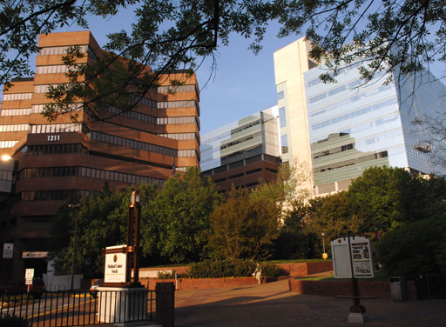
The VUMC has built a strong reputation as a leader in medical education, research and patient care throughout the Southeast and the nation over the course of its 135-year history. VUMC is an 815-bed general medical and surgical facility with 49,103 admissions last year. At its heart VUMC is driven by discovery and the translation of new knowledge into innovation in both patient care and graduate education for basic and clinical scientists. The School of Medicine awarded its first medical degrees in 1875 and now ranks 15th among 125 medical schools in U.S. News & World Report’s most recent survey.
Within VUMC, The Vanderbilt Clinical Neurosciences Institute is a national leader in caring for patients with disorders of the brain. This institute is one of the largest of its kind both nationally and internationally. While the Neurosciences Institute spans a range of cognitive disorders, of particular relevance to this proposal is The Stroke Center, which consists of 10 dedicated faculty members with the common goal of ensuring comprehensive stroke care services including outpatient clinical appointments, emergency services, hospitalization and rehabilitation. Three of these faculty members frequently treat patients with intracranial atherosclerotic disease. Finally, the Stroke Center works closely with the Nashville Emergency Medical Services (NEMS) unit and the Vanderbilt Emergency Department to quickly identify and treat the symptoms of a stroke. LifeFlight is also available for the emergency air transport of an acute stroke patient. The Vanderbilt Radiology Department is equipped with the state-of-the-art imaging equipment, including two 3T MR scanners, three 1.5T MR scanners, five multi-detector CT scanners, PET and bi-plane digital angiography, and TCD equipment. The Neuroradiology Department supports neurology, neurosurgery, and ENT practices and all departments that have need of sophisticated neuroimaging. Importantly, the 3T Philips scanners in the Radiology Department are nearly identical in software and hardware configuration as the research Philips scanners in VUIIS, thereby allowing for sequences to be easily exchanged. The Section of Neuroradiology is staffed by eight board-certified neuroradiologists, with interests which include pediatric neuroradiology, neurodegerative diseases, head and neck imaging, and brain and spine tumors. Neuroradiologists perform procedures including angiograms, epidural steroid injections, myelograms, selective nerve blocks, lumbar punctures, blood patches, and facet injections. Ongoing neuroradiology research at Vanderbilt is central to the department’s mission of extending patient care standards and includes projects in schizophrenia, PET imaging, tumor imaging, and Parkinson's Disease. Imaging and research is supported by a strong radiological sciences division that includes over 30 Ph.D. trained scientists who support clinical investigation, and teach radiological physics and engineering.
Vanderbilt University Medical Center
Vanderbilt lll
Below are recent volumes for stroke patients treated at Vanderbilt University Medical Center:

Year | Ischemic strokes | Hemorrhagic strokes | Total combined strokes
2008 | 383 | 224 | 607
2009 | 364 | 197 | 561
2010 | 451 | 196 | 647
2011 | 502 | 221 | 723
2012 | 548 | 242 | 790
2013 | 633 | 257 | 890
2014 | 631 | 221 | 852
2015 | 623 | 221 | 844

Therefore, VUMC sees a large volume of stroke patients annually, and therefore is well-suited for this study.

The Vanderbilt Stallworth Rehabilitation Hospital

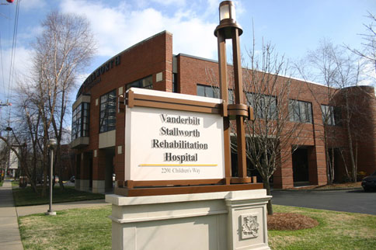
Vanderbilt Stallworth Rehabilitation Hospital is an 80-bed inpatient rehabilitation hospital that offers comprehensive inpatient rehabilitation services designed to return patients to leading active and independent lives. The hospital opened in November of 1993 and is a joint venture between Vanderbilt University Medical Center and HealthSouth, one of the nation’s leading rehabilitation services provider.
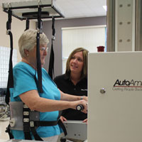
The hospital provides a wide range of physical rehabilitation services, a vast network of highly-skilled physicians and therapists, and the most innovative equipment and rehabilitation technology, ensuring that all patients have access to the highest quality care.
Vanderbilt Stallworth serves patients throughout the Southeast including all of Middle Tennessee. In addition to caring for general rehabilitation diagnoses, Stallworth has specialized inpatient programs for stroke. Stroke rehabilitation combines specialty therapy for a coordinated treatment plan, improving symptoms, overcoming difficulties and increasing independence for stroke patients. Not only has Stallworth achieved Center of Excellence status within the Healthsouth network of hospitals, the hospital has achieved Joint Commission disease-specific certification for both our Stroke and Spinal Cord Injury Rehabilitation programs.
Therefore, in addition to patients that may be recruited from the Vanderbilt University Hospital, Vanderbilt Stallworth Rehabilitation Hospital represents an additional avenue for recruiting stroke patients for this study. Vanderbilt Stallworth Rehabilitation Hospital is located on the Medical Center Campus and is easily accessible to the VUIIS.

The Vanderbilt Center for Quantitative Sciences (VCQS)

The Vanderbilt Center for Quantitative Sciences (VCQS) is comprised of approximately 15 primary faculty members and was assembled to provide state-of-the-art statistical support to Vanderbilt University investigators, projects and participants. The VCQS works with Vanderbilt investigators to define objectives and endpoints, analyze pilot data, select appropriate study designs, devise a blinding and randomization scheme, plan interim analyses, determine early stopping rules, compute an adequate sample size with concern for the clinical as well as statistical significance, estimate the time required to accrue the total patient population, and specify the statistical methods. The director of VCQS, Dr. Yu Shyr, has agreed to be personally involved in this project and to oversee the statistical analysis of results.

In terms of facilities, VCQS offices and computer spaces are located primarily on the 5th floor of the Preston Building within the Vanderbilt-Ingram Cancer Center. This environment includes office spaces, a conference room, and storage space
The network includes fourteen Intel Xeon Quad core workstations, seventeen Intel Xeon workstations, eight Intel Pentium 4 workstations, two Intel Core2 Quad core workstations, two dual processor AMD Opteron 275 workstations, two Intel Xeon eight core servers with 64 and 24 gigabytes of memory, two Dual Intel Xeon 6 core with 48 and 128 gigabytes of memory, and Dual 12 core AMD server with 256 gigabytes of memory. Each computer has Hewlett Packard LaserJet 4 Plus and 4L printers attached for local use. These 46 computers contain more than 100 terabytes of storage capacity, which are backed up nightly by a Hewlett Packard Ultrium LTO3 40 tape backup system. All campus-wide servers are accessible from these computers via the network. Additional equipment for the center includes a database file-server, Konica Minolta C360 document scanner and corresponding software for document and data input, two Xerox copiers, and a fax machine.
Software available in the Center for Quantitative Sciences includes statistical packages such as R, S-PLUS, SAS, SPSS, STATA, StatXact, Resampling Stats, EGRET, EPICURE, CART, MARS, TREE-NET, NCSS, nQuery, EaSt, StudySize, and PASS. Conversion of statistical data is accomplished using DBMS/Copy or Open Database Connectivity Drivers and the accompanying software packages.
Other software includes MATLAB for algorithm development, data visualization, and numeric computation; IPA by Ingenuity for analyze and integrate high dimensional data; Mathematica for mathematical equations; DeltaGraph for producing high-quality statistical graphs; Python, an interpreted, interactive, object-oriented programming package; and Ox, an object-oriented matrix package with a comprehensive mathematical and statistical function library. The center also utilizes a full line of integrated Microsoft products such as Microsoft Visual C#, Access, Excel, Word, and PowerPoint. These products support data sharing and object sharing to increase productivity.

