MAJOR EQUIPMENT

Vanderbilt University Institute of Imaging Science (VUIIS) Center for Human Imaging

3T, 94 cm Philips MR Imager/Spectrometers: The two 3.0T scanners offer a high performance gradient set with strengths up to 80 mT/m and slew-rates up to 200T/m/s. Both scanners have 32 receive channels. A standard quadrature T/R head coil, a 32-channel SENSE head coil, and a variety of other coils (phased array knee, torso, spine, cardiac, and surface coils) are available. Multinuclear support, along with proton decoupling capabilities, is available. The scanners are operated by registered radiological technologists and is supported by a faculty MR physicist. In addition, Philips Medical Systems supports an Applications Scientist at Vanderbilt. The 3.0T scanners are operated as full-time research instruments and not as clinical facilities.
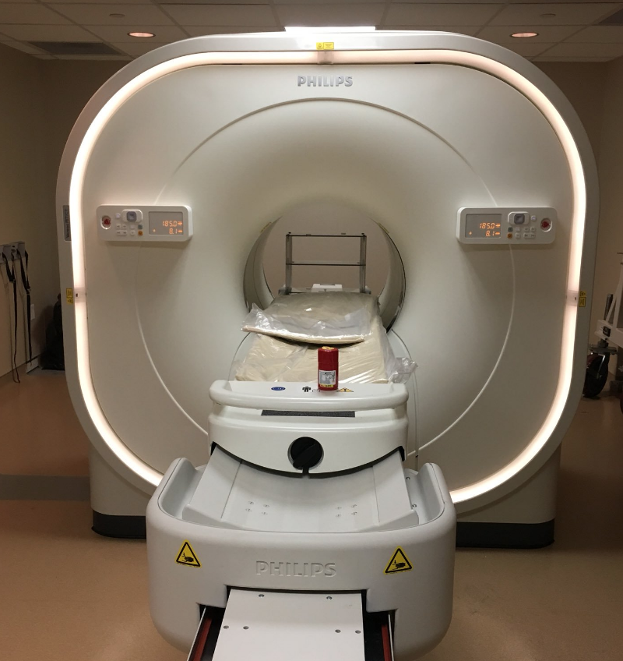

Philips Vereos PET/CT system installed in February 2018.
The Philips Vereos PET/CT. Housed within the VUIIS is a state-of-the art PET/CT scanner, installed in February of 2018, which utilizes digital photon counting technology to provide 310 ps time-of-flight resolution and also provides diagnostic quality CT with 64-slices. This system is a research-dedicated device and will be utilized for all PET scanning in this project, and is also supported by the VUIIS Human Imaging and Radiochemistry cores.

Non-MRI equipment available for evaluating lymphatic functioning. The below equipment will not be used specifically for the proposed aims, however is available for future lymphatic evaluation research directions. The lab of the PI contains a perometer to allow for fast and sensitive measurements of limb volume, a hand-held tissue dielectric device to allow for tissue dielectric to be quantified in all subjects, and a bioimpedance spectroscopy system (L-DEX) to allow for limb impedance ratios to be assessed. These pieces of equipment, together with the MRI equipment, allow for multiple measurements of lymphatic dysfunction to be assessed. Additionally, a patient preparation and therapy room is directly adjacent to the MRI suite. This room includes an adjustable patient bed, a changing area, and restroom.
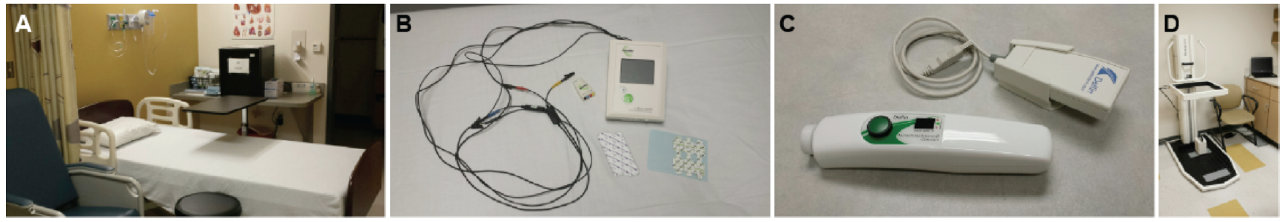
(A) Patient preparation room with therapy bed, (B) Bioimpedance spectroscopy system, (C) tissue dielectric measurement device, and (D) perometer. All equipment is available and has been applied in our prior studies of lymphatic dysfunction.

7T Philips Intera Achieva MR Imager/Spectrometer. The 7.0T human MRI scanner from Philips Medical Systems is designed to take advantage of increased SNR and spectral separations, while providing the flexibility to address the challenges of imaging at high field strengths. The magnet, manufactured by Magnex Scientific Ltd, has a 7T central field strength and <5 ppm peak-to-peak field variation over a 45 cm spherical volume. The bore size is 900 mm. It is equipped with 13 cryoshims (passive shims are used as needed to cancel higher order field errors). Room temperature shims include second order and third order coils. The Z2 shim is self-shielded and programmable to allow fast switching (for dynamic shimming applications). The gradient coils are self-shielded, force balanced, and water cooled, with a 58 cm patient aperture. They support imaging in a 40 cm field of view (FOV) in the X and Y directions, and 35 cm FOV in the Z direction. Maximum gradient strength is 40 mT/m with a slew rate of 200 mT/m/ms. There are two fully independent transmit channels, each capable of delivering 4 kW to radio frequency coils. Both channels are broadband. The two channels are combinable for a total of 8 kW at 300 MHz. The receiver currently has 32 independent proton channels, plus 4 supporting quadrature detection at 1H, 19F, 31P, 13C, and 23Na frequencies. Current radio frequency coils available or in production include a volume transmit/receive head coil, a volume transmit head coil, and 32 and 16 channel receive-only SENSE coils for 1H. The 7.0T scanner will not be used specifically in this proposal, however it may have relevance to high spatial resolution lymphatic imaging in the future.

Audio and Video Presentation Equipment: For video presentation, an inside-the-scanner-room XGA resolution Avotec projector, Epson DLP projector, or a pair of XGA-compatible LCD goggles for video stimulus presentation can be used. Headphones and a ceiling microphone for subject feedback and communication are available. Audio and video presentation is available at both the 3T and 7T scanners.
Center, directly adjacent to 3T MRI scan room, that allows for administering respiratory stimuli.
Gas Delivery Equipment: The Center for Quantitative Physiology and Cerebrovascular Reactivity is a Vanderbilt University Institute of Imaging Science resource for investigators seeking to perform controlled measurements of vascular reactivity using vasoactive gas stimuli. The facility is directly adjacent to the 3T and 7T scanners and has dedicated medical grade room air (21% O₂ / 79% N₂) and oxygen (100% O₂), in addition to standard hypercarbic gas mixtures consisting of hypercarbic normoxia (i.e., 5% CO₂ / 21% O₂ / 74% N₂) and hypercarbic hyperoxia (i.e., carbogen; 5% CO₂ / 95% O₂). Additional abilities are in place for researchers seeking to perform custom mixing of gases. The center is overseen by a director (Manus Donahue, PhD) and board-certified neuroradiologist (L Taylor Davis, MD), who is available for clinical consults. Standard gas delivery equipment: non-rebreathing facemasks, tubing, tube extensions, and nasal cannula. End-tidal and physiological monitoring equipment (BIOPAC Systems Inc.; Medtronic; and AcqKnowledge software) is available for real-time cardiac, respiratory, and end-tidal gas monitoring. Standard protocols are in place for assessing hemodynamic blood oxygenation level-dependent (BOLD) fMRI, cerebral blood flow (CBF)-weighted arterial spin labeling, and cerebral blood volume (CBV)-weighted vascular space occupancy responses stimuli
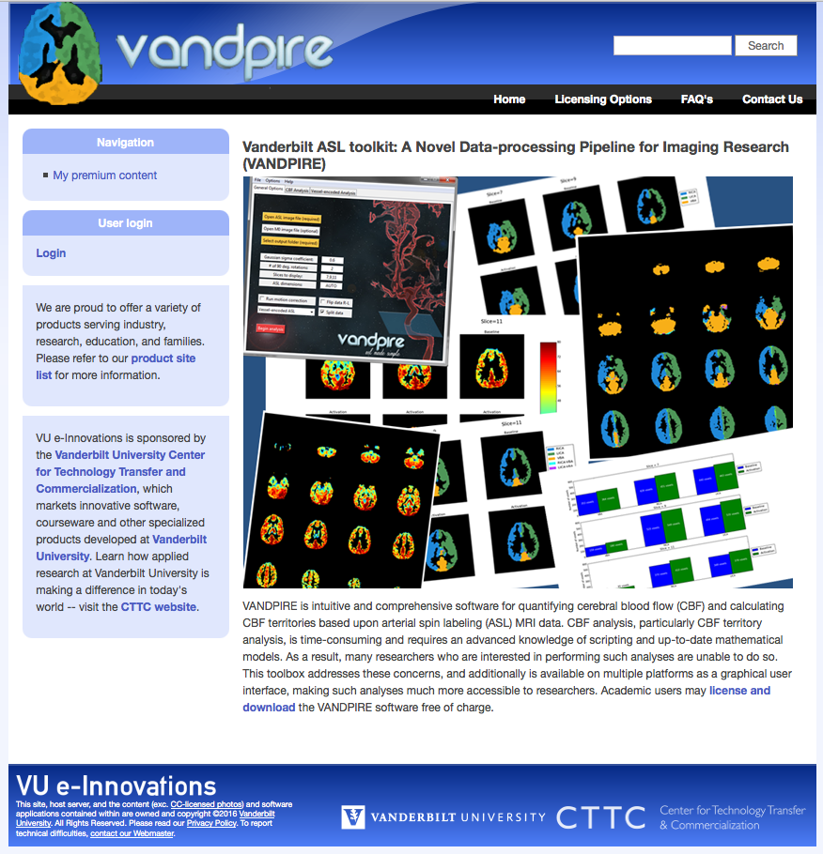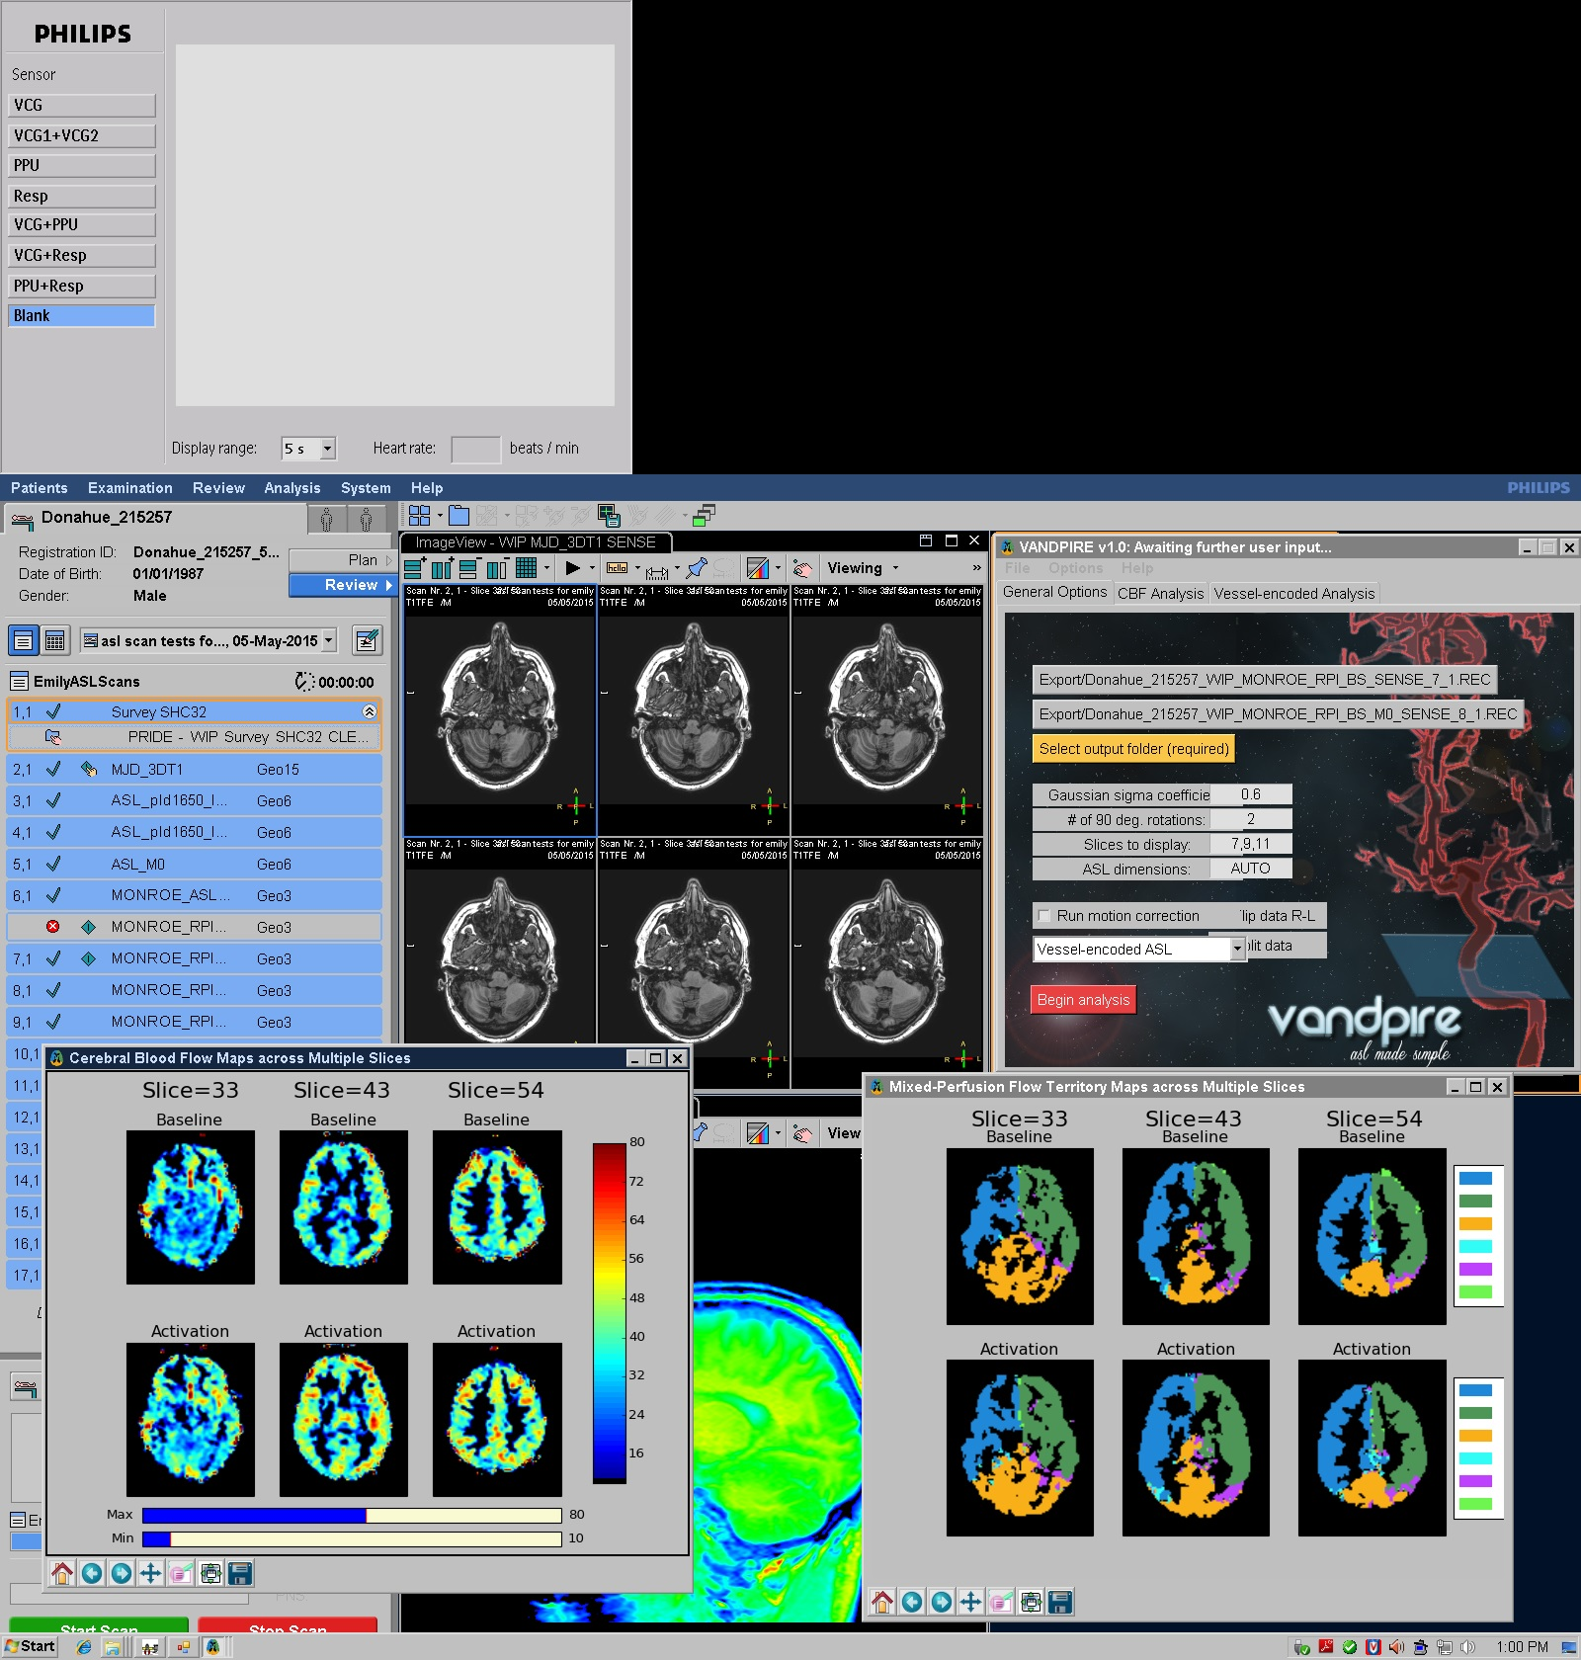

Software available for download from the Vanderbilt Technology Transfer Web site (left), as well as an example of this software running on the Philips scanner (right; shown are baseline and hypercapnic blood flow maps, along with flow territory mapping processing). This software will be adapted to incorporate lymphatic flow velocity quantitation algorithms.
Software for Processing Functional Data. In-house software has been developed in the lab of Dr. Manus Donahue to allow for processing of circulation parameters, both on the scanner console as well as offline. Executables are available for Mac, Windows, and Linux operating systems and source code (Python) is also made freely available. To left are examples of the freely available software from the Vanderbilt Technology Transfer Web site as well as a screen shot of this software running in real time on the Philips scanner.

