Why become a feeding assistant?
Training Requirements:
- 8-hour course
  - Eight webinars
  - Led by nurse, dietitian, & gerontologist

- Performance (Skills) or Written Evaluation

HOW DO I PARTICIPATE IN TRAINING?

- Contact:
  - training for non-nursing staff to assist residents with meals and snacks

become a Trained Feeding assistant

Improve your residents’ care experience…
- Residents receive more one-on- one time at meals and snacks when facilities utilize trained feeding assistants

- Residents enjoy the increased attention and social interaction

- CNAs comments on trained feeding assistants:
  - “The more [feeding assistants], the merrier; it allows us to spend more time with the residents”
- “Having them [feeding assistants] help means residents don’t have to wait as long to eat.

Improve sense of teamwork and morale among staff…
- Part of an “All Hands on Deck” philosophy

- CNAs at facilities with trained feeding assistants appreciated the teamwork approach to care (i.e., that everyone was working together for the residents)

Increase your interaction with residents…
- Get to know your residents better by helping them at meal or snack time

- Feedback from previous trained feeding assistants:
- “I love my residents”
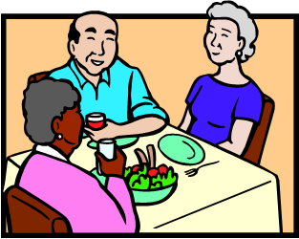
- “I enjoy interacting with residents at meal time”

