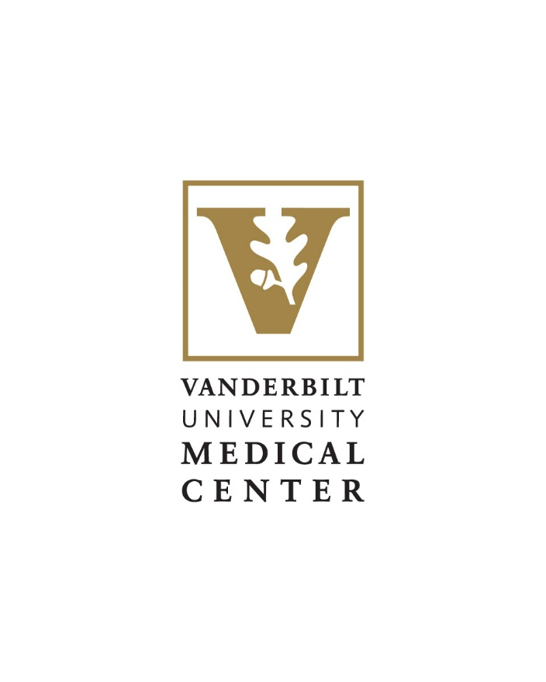
Position Overview:

Division Chief, Anesthesiology Critical Care Medicine
Department of Anesthesiology

We are an Equal Opportunity/Affirmative Action employer. All qualified applicants will receive consideration for employment without regard to race, sex, sexual orientation, gender identity, religion, color, national or ethnic origin, age, disability, military service, covered veteran status or genetic information.

The Opportunity
The Department of Anesthesiology at Vanderbilt University Medical Center is inviting applications or nominations for the high-profile role of Chief of the Anesthesiology Critical Care Medicine Division. The Division of Anesthesiology Critical Care Medicine (ACCM) is one of the premier clinical, educational, and research divisions in academic anesthesiology. It includes over 25 faculty members, 10 ACCM fellows, and 30 nurse practitioners. The Division is proud of the excellent clinical service it provides both in the ICU and in perioperative medicine, as well as its long tradition of medical education, research training, and faculty career development. The Division’s research portfolio includes successful NIH T32 and K-training grants and NIH R-level grants. We are seeking a nationally recognized academic leader with outstanding clinical acumen, excellence in education and research, and proven leadership skills to effectively inspire, manage, mentor, and develop faculty and staff and to further the division’s success, growth, and international reputation.
All candidates should be Board-certified, qualify for the rank of Associate Professor or Professor, and be eligible for a license to practice medicine in the state of Tennessee.

The Department
Our growth and success stem from Vanderbilt University Medical Center’s five-pillar commitment to excellence: people, service, quality, growth & finance, and innovation. Vanderbilt’s credo drives us to achieve excellence in healthcare, research, and education; we treat others as we wish to be treated; and we continuously evaluate and improve our performance. As the role of the anesthesiologist evolves into that of a perioperative consultant, our diverse team of experts remains at the forefront of knowledge and technology in patient care, research, and education.
Our values — compassion, creativity, commitment, and collaboration — are the keystones of our structure and systems Our patients are recovering faster and with greater comfort through implementation of Enhanced Recovery After Surgery (ERAS) protocols, a collaborative effort led by our faculty, our trainees, and our surgical colleagues. Our informatics infrastructure uses innovative data analyses to increase patient safety and clinician effectiveness.
Our investigators brought in more than $8 million in total extramural research funding in 2018-2019, including more than $3.8 million in awarded NIH grants — placing Vanderbilt Anesthesiology 14th among U.S. academic anesthesiology departments for NIH funding. The department’s research productivity, determined by publication in peer-reviewed journals, grant dollars, and on-going research studies, continues to be strong. Twenty-seven members of the department have been elected into the Association of University Anesthesiologists (AUA).
At a recent Annual Meeting of the American Society of Anesthesiologists, department members contributed more than 90 activities, including oral presentations, medically challenging cases, poster presentations, problem-based learning discussions, workshops, panel discussions, and refresher courses.
Our dedicated faculty is committed to equipping graduates for a promising future in anesthesiology. We offer training using cutting edge technology along with opportunities to improve systems of care. We provide a closely guided mentorship program, balancing clinical training and experience with a broad range of academics.
Our success can be attributed to the collaboration that occurs across Vanderbilt University Medical Center and beyond. Our clinical teams participated in more than 102,000 patient encounters last year; caring for patients along their journey to wellness within and beyond Vanderbilt’s traditional walls. The Vanderbilt Health Affiliated Network is the largest of its kind and growing rapidly, and our department is leading telemedicine and remote-presence projects that bring our expertise to more patients.

Leadership Job Description
Division Chief
Rev. 2019
The Division Chief reports to the Chair and Executive Vice Chair and plays an essential role in the clinical, educational, academic, and financial success of the Department. Within the department’s leadership structure, the Division Chief works with other Division Chiefs and the Vice Chairs to support the tripartite clinical, educational, and research missions of the Division and Department and serves as a leader and role model for the Department as a whole.
The specific roles of the Division Chief fall under the following broad categories:
I. Clinical Operations
The viability of the Department and its academic missions depends on efficient, timely, high-quality clinical service. The Division Chief is responsible for Divisional clinical operations and the shared obligations of Departmental clinical operations. The Division Chief acts as a clinical role model within the Division and across the Department.
In this role, the Division Chief will:
- Work with the Vice Chair of Clinical Affairs to determine Divisional and Departmental faculty manpower needs and cost-effective utilization of personnel.
- Work with the Department’s Assistant Director to keep the manpower spreadsheet up to date, regarding both faculty demand and supply.
- Manage the Divisional schedule, including clinical roles and call commitments of individual faculty, and vacation and academic/administrative time within the Division. This includes ensuring that there is an equitable distribution of clinical assignments, accounting for approved academic and administrative time, so that all Division faculty finish the academic year at or close to their target clinical commitment days; work with the Vice Chair of Clinical Affairs and Faculty Affairs when Division faculty are projected to exceed or will not meet their clinical commitment to ensure equitable distribution across the Division and Department whenever possible.
- Work with the Vice Chair of Clinical Affairs to determine month-to-month faculty scheduling, including sharing manpower outside of the Division (where appropriate) to balance Departmental manpower supply and demand.
- Be the primary liaison with surgical leadership and surgeons as well as other disciplines working in the subspecialty domain to provide high-quality care.
- Design, implement, facilitate, and/or lead, as necessary, clinical operational and quality improvement initiatives in the subspecialty domain.
- Conceive, facilitate, participate in, and/or lead, as necessary, multidisciplinary clinical operational and quality improvement initiatives in the subspecialty domain.
- Recommend new clinical services to the Chair and Executive Vice Chair, working with Department senior administration to determine the potential financial impact and benefits and risks to the Department and the Institution.
- Work with the Provider Support Services and the Vice Chair of Clinical Affairs in determining clinical privileges and credentialing/recredentialing processes.
- Participate as needed in morbidity & mortality, risk management, and event analyses involving Division faculty and activities.
- Provide access for faculty to SuveyVitals to assess patient satisfaction scores; help identify areas of improvement to increase patient satisfaction.
- Ensure compliance in billing, charge capture, medical records, and other clinical regulatory aspects of the Division.
- Participate in developing overall Departmental strategy and regularly assess and measure Divisional efforts and progress toward the agreed upon strategic objectives.
- Serve as a liaison between individual faculty and Departmental leadership, as well as institutional entities that affect work life and well-being (e.g., occupational health and safety, VUMC, and VU committees).
II. Faculty Development
Faculty Development spans the faculty “lifespan,” from initial recruiting to hiring and appointment, mentoring and promotion, advising on career direction, and preparation for retirement. Retention of faculty through enrichment, CME opportunities, and counseling is a vital function of the Division Chief. Close collaboration with the Vice Chair and Associate Vice Chair for Faculty Affairs is critical to this function.
In this role, the Division Chief will:
- Initiate discussions about, participate in, and facilitate recruiting efforts of faculty whose clinical and academic interests align with and complement the Division and the Department.
- Arrange and oversee new faculty onboarding, including orientation and training.
- Mentor faculty and promote their academic advancement; identify areas of opportunity for faculty to advance their careers both in and outside of the Division.
- Meet periodically (formally, at least once every 6 months) with each Division faculty member to discuss career goals and jointly formulate plans for advancement toward academic promotion and career fulfilment.
- Work with the Department of Anesthesiology Office of Faculty Affairs to ensure that all faculty have mentors and that regular mentoring activities occur.
- Assist faculty in their individual scholarly pursuits through facilitated networking with external colleagues and consultation on and review of specific ideas and products.
- Nominate worthy faculty for internal and external awards.
- Facilitate faculty access to internal and external professional speaking engagements (e.g., visiting professorships), committee memberships, and society leadership opportunities.
- Serve as a faculty promotion mentor under the oversight of the Department’s Office of Faculty Affairs.
- Actively participate in the Career Development Award (CDA) process, including pre-reviewing all Division faculty’s CDA applications, reviewing assigned CDA applications of other faculty, and attending the full day CDA review meeting.
- Work with faculty and the Department’s Office of Faculty Affairs to appropriately manage and schedule designated Career Development Awards throughout the academic year.
- Assist faculty with preparing their AAA applications.
- Manage overall relations and individual relationships with CRNAs, APNs, and other clinical staff.
III. Personnel Management
In this role, the Division Chief will:
- Counsel faculty regarding clinical professionalism issues and work with the Executive Vice Chair and Chair to solve any professionalism issues.
- Be aware of each faculty member’s clinical competence; recommend and provide oversight of OPPEs and FPPEs when indicated.
- In collaboration with the Vice Chair for Faculty Affairs and Chair, identify and help manage Divisional or Departmental issues that create a risk to Departmental or Institutional objectives.
- Assist faculty in managing life/work balance issues.
IV. Education
In this role, the Division Chief will:
- Facilitate and oversee Divisional educational activities for residents and medical students, including
  - Supporting all rotations and workshops primarily delivered by the Division faculty.
  - Coordinating all appointments for educational roles with the Vice Chair and Associate Vice Chair for Educational Affairs (e.g., resident rotation directors, School of Medicine appointments).
  - Ensuring faculty completion of trainee assessments in a timely manner using existing tools and encouraging refinement of assessment tools as needed.
  - Working with the Director of Medical Student Education to support faculty involvement with medical student education.
- Facilitate and oversee Divisional educational activities for fellows, including
  - Coordinating Fellowship Program Director and Associate Program Director appointments with the Core Program Director and the Vice Chair for Educational Affairs.
  - Supporting the Core PD with effective oversight of the Fellowship Program Director.
  - Assuring full implementation of ACGME regulations by the Fellowship Program Director.
  - Ensuring completion of trainee assessments/evaluations in a timely manner using existing tools and encouraging refinement of assessment tools as needed.
- Coordinate Continuing Professional Development (CPD) for Division faculty with the Vice Chair and Office of Educational Affairs, including
  - Assisting faculty in defining an annual CPD goal (i.e., knowledge or skill related to work as a clinician, educator, administrator, and/or scholar).
  - Facilitating the development of new CPD offerings for Division and Department faculty based on needs analyses.
  - Facilitating clinical scheduling to permit attendance at internal or external CPD events.
  - Working with the Office of Educational Affairs to obtain CME accreditation for all regularly occurring educational events in the Division (e.g., case conferences, journal clubs, workshops).
- Facilitate and oversee Divisional educational activities for other institutional learners in coordination with the Office of Educational Affairs.
- Support existing processes or create effective tools to assess the effectiveness of the educational activities of the Division (e.g., actionable feedback from all educators of trainees and learners).
V. Scholarship
In this role, the Division Chief will:
- Meet with faculty to foster their interest in and facilitate their conduct of scholarly activities that will enhance their career and the reputation of the Department and Institution, as well as contribute to our specialty and to society.
- Ensure that Division faculty comply with all research-related rules, laws, and regulations, including submission of clinical studies to VACRAC and PCRI, compliance with IRB regulations, registration with ClinTrials.gov, etc.
- Work with Vice Chair for Research to facilitate Divisional faculty initiated clinical and other scholarly activities, including access to PCRI, VAPIR, educational research, and statistical resources.
VI. Operations and Logistics
In this role, the Division Chief will:
- Approve faculty travel requests and reimbursement requests for meeting attendance and other expenses.
- Manage Divisional discretionary funds used for promotion of faculty development and morale-building, small capital equipment purchases, and other needs.
- Participate in developing overall Departmental strategy and regularly assess and measure Divisional efforts and progress toward the agreed upon strategic objectives.
- Participate in the Division Chief meetings and Departmental Leadership meetings and Retreats.
- Create an agenda for, chair, and assure effective minutes of monthly (at a minimum) Division meetings.
- Effectively manage and collaborate with administrative staff within the Division.

Key Department Leaders
Warren S Sandberg, MD, PhD
Chair, Department of Anesthesiology
Chief of Staff, Perioperative and Critical Care Services, Vanderbilt University Adult Hospital
Professor of Anesthesiology, Surgery and Biomedical Informatics

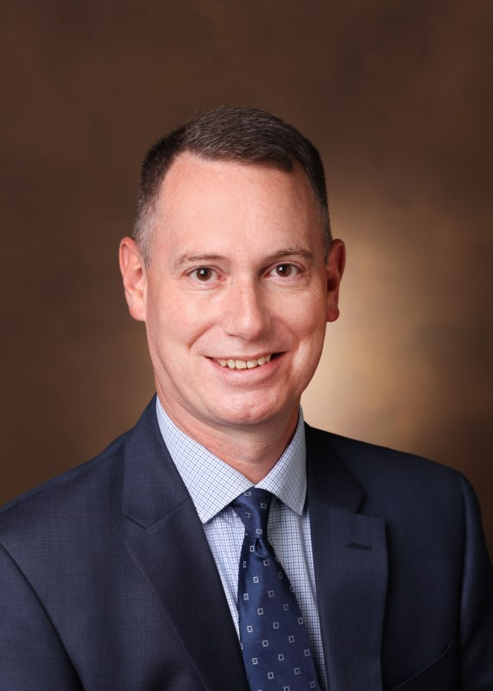  Brian J Gelfand, MD  Associate Vice Chair, Educational Affairs  Associate Professor of Anesthesiology and Surgery  Director, Residency | Amy Robertson, MD  Vice Chair, Clinical Affairs  Associate Professor
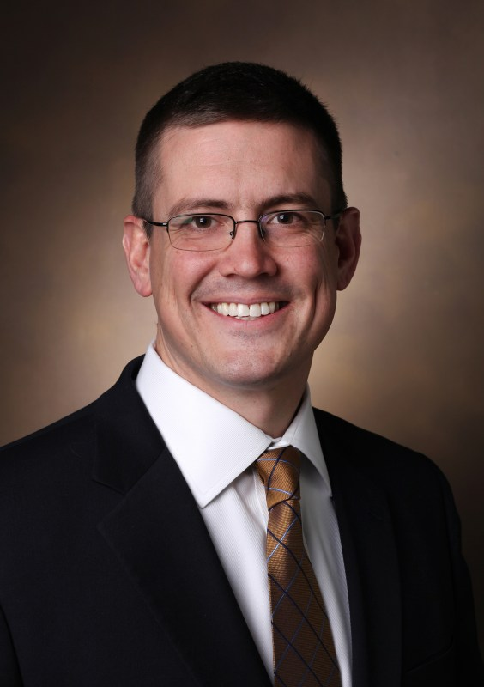  Matthew McEvoy, MD  Vice Chair, Educational Affairs  Professor | 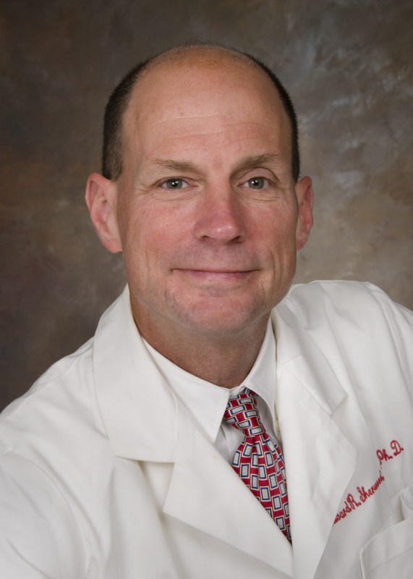  Edward Sherwood, MD, PhD  Vice Chair, Research  Cornelius Vanderbilt Chair in Anesthesiology  Professor
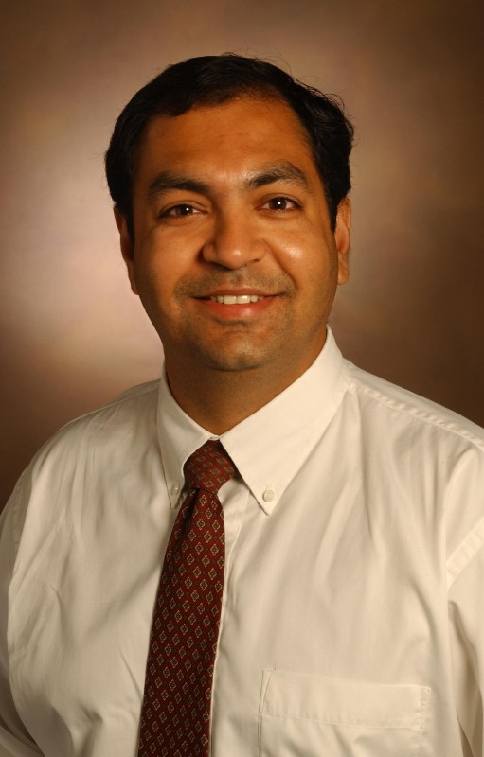  Pratik Pandharipande, MD, MSCI  Associate Vice Chair, Faculty Affairs  Chief, Anesthesiology Critical Care Medicine  Professor of Anesthesiology and Surgery  Veterans Affairs Anesthesiology Service | 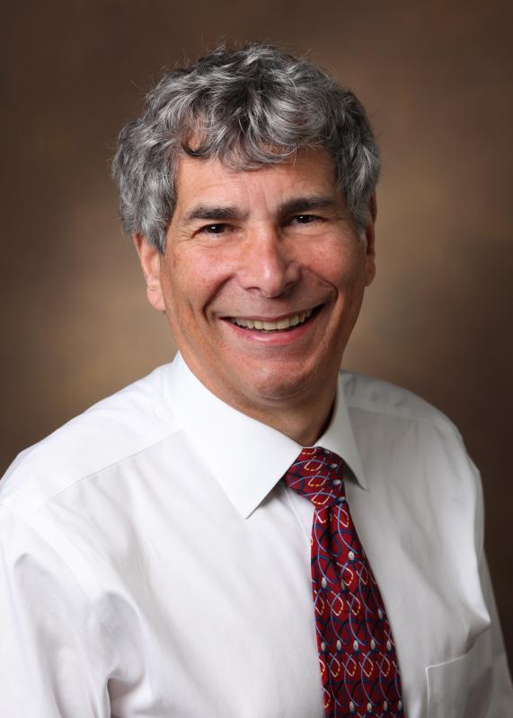  Matthew Weinger, MD  Vice Chair, Faculty Affairs  Professor of Anesthesiology, Biomedical Informatics, and Medical Education  Norman Ty Smith Chair, Patient Safety & Medical Simulation  Director, Center for Research and Innovation in Systems Safety
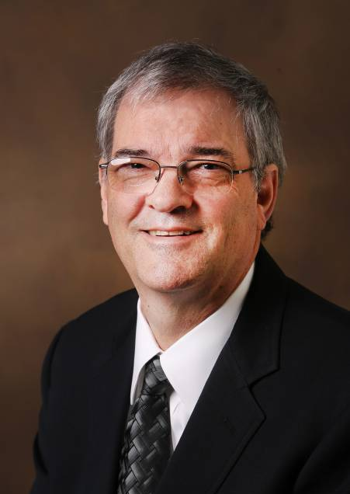  Mark Rice, MD  Executive Vice Chair, Anesthesiology  Professor | 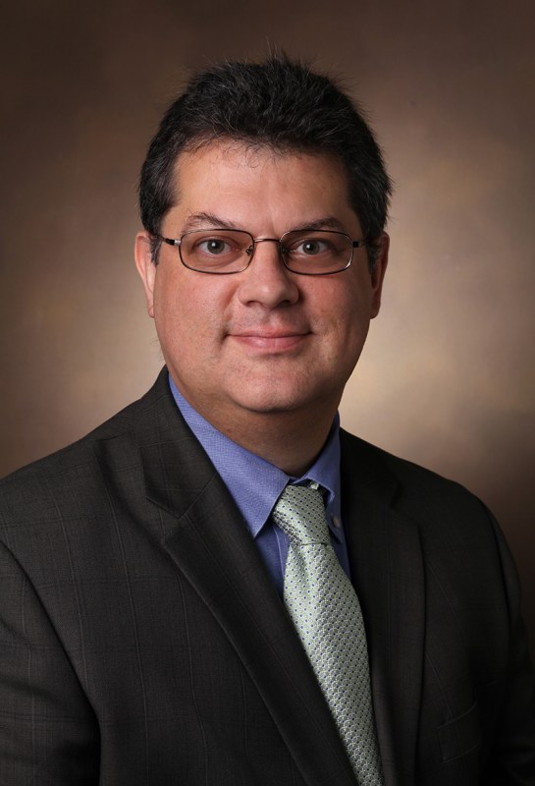  Stephen Doherty, MMHC, CMPE  Department Administrator
Current Faculty in the Division of Anesthesiology Critical Care Medicine
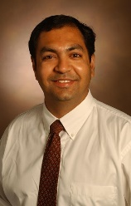  Pratik Pandharipande, MD, MSCI  Associate Vice Chair, Faculty Affairs  Chief, Anesthesiology Critical Care Medicine  Professor of Anesthesiology and Surgery Anesthesiology Critical Care Medicine  Veterans Affairs Anesthesiology Service | 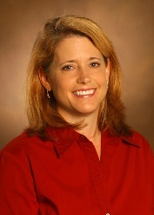  Liza Weavind, MBBCh, FCCM, MMHC  Associate Chief, Anesthesiology Critical Care Medicine  Professor of Anesthesiology and Surgery,  Anesthesiology Critical Care Medicine Multispecialty Adult Anesthesiology

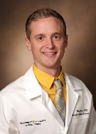  Bret Alvis, MD  Assistant Professor | 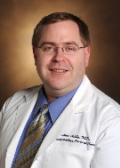  Nathan Ashby, MD  Assistant Professor of Clinical Anesthesiology | Arna Banerjee, MBBS  Associate Professor of Anesthesiology, Surgery, and Medical Education | Jon Barwise, MB, ChB  Associate Professor of Clinical Anesthesiology and Neurological Surgery
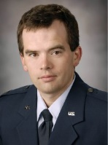  Clayne Benson, MD  Assistant Professor | 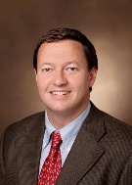  Josh Billings, MD  Associate Professor | 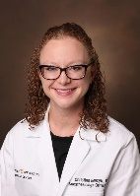  Christina Boncyk, MD  Assistant Professor | 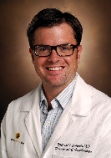  William Costello, MD  Assistant Professor of Clinical Anesthesiology
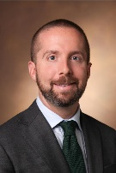  Robert Freundlich, MD, MS  Assistant Professor of Anesthesiology and Biomedical Informatics | 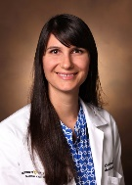  Christina Hayhurst, MD  Assistant Professor | 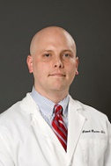  Patrick Henson, DO  Associate Professor of Clinical Anesthesiology | 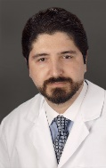  Antonio Hernandez, MD  Associate Professor
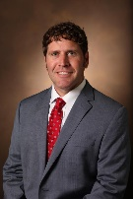  Christopher Hughes, MD  Associate Professor | Christina Jelly, MD  Assistant Professor | 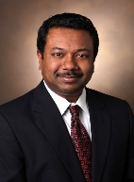  Avinash Kumar, MD  Professor of Anesthesiology and Neurology | 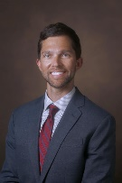  Phil Leisy, MD  Assistant Professor
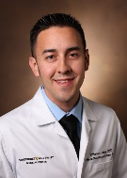  Marcos Lopez, MD  Assistant Professor | Tracy McGrane, MD, MPH  Assistant Professor of Clinical Anesthesiology | 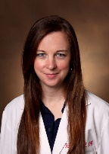  Merrick Miles, MD  Assistant Professor | 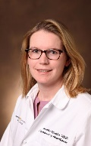  Dorothee Mueller, MD  Assistant Professor
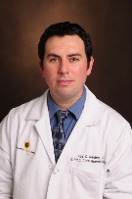  Roy Neely, MD  Assistant Professor of Clinical Anesthesiology | 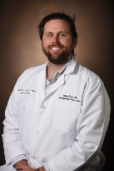  Andrew Reese, MD  Assistant Professor | Kimberly Rengel, MD  Assistant Professor | 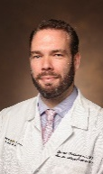  Joseph Schlesinger, MD  Associate Professor
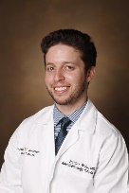  Jeremy Walco, MD  Assistant Professor | 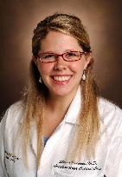  Sheena Weaver, MD  Assistant Professor

Selection Process Timeline
October 2019: Search Opened, Search Committee convened
October 2019 – March 2020: Applicant pool compiled
March 2020: Airport interviews
Applicants will be brought to campus for an interview with the search committee. Applicants will have the opportunity to ask the committee questions at the conclusion of the interview.
April – May 2020: Finalist interviews
Finalists will be invited back to campus for a multi-day agenda including one-on-one interviews with key leaders from the department and around VUMC. Finalists will also be expected to present their vision for the Anesthesiology Critical Care Medicine Division to the department leadership team, consisting of the executive committee and division chiefs.
June 2020 – September 2020: Target start date for new Division Chief

How to Apply
Please send a letter of introduction and current curriculum vitae to Dr. Warren Sandberg, Chair, Department of Anesthesiology.
Documents and any questions should be sent to jennifer.cook@vumc.org

Organizational Overview
Vanderbilt University Medical Center
Vanderbilt University Medical Center (VUMC) has built a strong reputation as a leader in medical education, research, and patient care throughout the nation over the course of its 145-year history. VUMC consists of the School of Medicine, the School of Nursing, and a growing array of inpatient hospitals and ambulatory facilities. At its heart, VUMC is driven by discovery and the immediate incorporation of new knowledge into innovation in patient care and physician and nurse education. It is a unified medical center with a unified strategy. Investments in clinical care, research, quality and patient safety, and customer service all reinforce each other.
VUMC is known for its highly-acclaimed teaching hospitals and its groundbreaking efforts in electronic medical records. Each year, VUMC clinicians provide more than 2.2 million ambulatory visits, perform more than 59,000 surgical procedures, and see 123,000 patients in its adult and pediatric Emergency Rooms. The Medical Center employs over 23,000 staff. Vanderbilt biomedical scientists in more than 100 laboratories conduct more than $500 million of federally and corporately sponsored research each year.
Vanderbilt University Medical Center's Mission: Through the exceptional capabilities and caring spirit of its people, Vanderbilt will lead in improving the healthcare of individuals and communities regionally, nationally and internationally. VUMC will combine our transformative learning programs and compelling discoveries to provide distinctive personalized care.
Jeff Balser, M.D., Ph.D., leads VUMC as President and CEO and also serves as Dean of the Vanderbilt University School of Medicine (VUSM).
Vanderbilt University School of Medicine (VUSM)
The School of Medicine awarded its first Vanderbilt medical degrees in 1875. Since the early days, a Vanderbilt medical education has been held in high esteem among its peer institutions, and that legacy continues.
The School of Medicine attracts the most accomplished and talented students in the country. They are drawn by the quality of the training, the excellence of the faculty, the collegial atmosphere between faculty and students, and the close personal attention that students receive. The School of Medicine ranks 17th out of 128 accredited medical schools, according to U.S. News & World Report’s annual ranking of graduate education programs and health disciplines released in the 2018 edition of America’s Best Graduate Schools. In addition, 10 of the School of Medicine’s clinical and basic sciences rank in the top 10 for NIH biomedical funding, including 4 of the top 5 programs.
Patient Care
Vanderbilt operates the only Level 1 Trauma Center, the only Level 4 Neonatal Intensive Care Unit, and the only Level 3 Burn Unit in its region. The LifeFlight helicopter ambulance service has nine helicopters, operated by Air Methods staffed with Vanderbilt Flight Paramedics and Nurses, along with an airplane transport and nine ground ambulances, and makes more than 3,600 missions a year. Vanderbilt also offers an organ transplantation center. Vanderbilt's first kidney transplant was in 1962; since then there have been more than 5,100 pediatric and adult kidney transplants. VUMC has also performed more than 2,000 liver transplants and over 1,450 heart and lung transplants. Among Vanderbilt’s other transplant milestones were Tennessee’s first pancreas transplant in 1985, the first successful heart-lung transplant in the state in 1987, the first pediatric heart transplant in the state in 1987, and the first triple organ transplant of heart, lungs and liver in 2000.
The Vanderbilt-Ingram Cancer Center is one of 49 National Cancer Institute–designated comprehensive cancer centers, and the only one in Tennessee that provides treatment for adult and pediatric cancers. The center is also a member of the National Comprehensive Cancer Network, a non-profit alliance of 27 centers focused on improving quality and efficiency of cancer care.
A principal referral center for physicians and patients throughout the region, Vanderbilt University Hospital (VUH), Monroe Carell Jr. Children’s Hospital at Vanderbilt, and the Vanderbilt Clinic consistently rank among the premier health care facilities in the United States. Vanderbilt is the only Tennessee health care provider with numerous adult and children’s specialties ranked among the nation’s top 50 by U.S. News & World Report.
In its 2018 rankings U.S. News & World Report named Vanderbilt’s specialty programs in heart and heart surgery; gynecology; cancer; kidney disease; neurology and neurosurgery; gastroenterology and GI surgery; geriatrics; ear, nose and throat; diabetes and endocrinology; orthopaedic surgery; respiratory disorders; and urology as among the best programs nationally. In 2006, Vanderbilt achieved designation as Nashville’s first Magnet hospital by the American Nurses Credentialing Center.
Vanderbilt University Hospital (VUH)
Vanderbilt University Hospital (VUH) is the adult general medical and surgical facility (including ObGyn) of the VUMC health system. VUH, Vanderbilt Psychiatric Hospital, and Stallworth Rehabilitation Hospital comprise over 800 adult beds total. VUH is a highly acclaimed teaching hospital, and it has made groundbreaking efforts in electronic medical records. Its emergency room has 70,000 visits each year. VUH is the only hospital in Tennessee to be named to the U.S. News Best Hospitals “Honor Roll” of the nation’s top 19 hospitals. VUH is consistently named among the nation’s top 100 hospitals by Thomson Reuter.
Monroe Carell Jr. Children’s Hospital at Vanderbilt
The Monroe Carell Jr. Children's Hospital at Vanderbilt's story begins in 1968 and, like any masterful work, its progress has occurred in marked phases. The hospital is the most comprehensive children’s hospital in the state and is dedicated to meeting the unique health care needs of children, from newborns to young adults, by providing primary and sub-specialty services. Constructed in 2004, expanded in 2012, and currently undergoing another major addition, the 267-bed hospital is a child-friendly place built on the science of healing. Children’s Hospital serves as a regional referral center and has been named among the nation’s Best Children’s Hospitals in U.S. News & World Report’s annual rankings, the only hospital in Tennessee ranked in 10 out of 10 pediatric specialty programs. In an annual survey by the Leapfrog Group, Children’s Hospital was also named one of ten pediatric “Top Hospitals” in the nation for providing excellent patient safety. The Fetal Clinic is based in the Children’s Hospital. A four-story expansion to the main tower is in progress.
This hospital was designed with the patient in mind: family friendly and sensitive to the fact that many people are involved in the healing process, not just medical professionals.
Vanderbilt Psychiatric Hospital
This facility provides inpatient and hospitalization services to children, adolescents, and adults with psychiatric and substance abuse problems. Services include 24-hour crisis assessment and a year-round accredited school for children and adolescents. The Hospital and the Department of Psychiatry support premier educational and research programs that are core to numerous programs in the neurosciences throughout VUMC.
Vanderbilt Wilson County Hospital (VWCH)
Purchased by VUMC in 2019, Vanderbilt Wilson County Hospital provides community-based care to the growing population in Wilson County. Anesthesiology provides coverage for a 4-room operating room in the main hospital, a three-room on campus ambulatory surgery center, labor and delivery, as well as back-up coverage for the ICU. Services are expected to grow as VWCH integrates in the VUMC network.

Nashville Info
Nashville’s history of country music has earned the city its fame as Music City, USA — but this metropolis is about more than tunes and twang. Visitors and residents enjoy great dining, entertainment, and cultural life. Because Nashville International Airport is a Southwest Airlines hub, travel to Nashville is convenient and inexpensive. With a growing population of 1.6 million people in the Metropolitan Statistical Area, Nashville has been nicknamed “Nowville” by GQ magazine and called the “It City” by The New York Times. It must be the southern hospitality that has this city growing, because Nashville has been named America’s friendliest city for three years in a row. A hub for massive and rapid economic growth, Nashville was named by Forbes magazine as one of the 25 cities most likely to have the country’s highest job growth over the next five years, named one of the best cities in the nation for work and family by Fortune magazine, and ranked No. 1 most popular city in the United States for corporate relocations by Expansion Management.
The city of Nashville proper spans 533 square miles, and the Metropolitan Statistical Area encompasses eight counties — Cheatham, Davidson, Dickson, Robertson, Rutherford, Sumner, Williamson, and Wilson. The climate is typically mild and pleasant, with few days a year being very cold or very hot.

